# Algorithm One

## Pseudocode

MAXSUBARRAY_ENUMERATION(A[1..n]):

best <- 0

for j <- 0 through n

for i <- 0 through j

cur = 0

for k in A[i..j]

cur = cur + A[k]

if cur > best

best <- cur

return best

## Run-time Analysis

$$\sum_{j=0}^{n}{\sum_{i=0}^{j}{\sum_{k=i}^{j}{1}}}$$

Ο ($n^{3}$)

## Experimental Run-time Analysis

Referring to the two graphs at the end of this document, you will see a linear and log-log plot of the experimental run-time of this algorithm.

# Algorithm Two

## Pseudocodex

MAXSUBARRAY_BETTER_ENUMERATION(A[1..n]):

best <- 0

for i = 1..n

for j = i..n

sum = sum + A[j]

if sum > best

best <- sum

return best

## Run-time Analysis

$$\sum_{j=0}^{n}{\sum_{i=0}^{j}{2}}$$

Ο ($n^{2}$)

# Algorithm Three

## Pseudocode

MAXSUBARRAY_DYNAMIC(A[1..n]):

best <- 0

for i <- 0 through n

cur = max (cur + i, 0)

best = max (best, cur)

return best

## Run-time Analysis

$$\sum_{i=0}^{n}{3}$$

Ο ($n$)

# Linear Plot

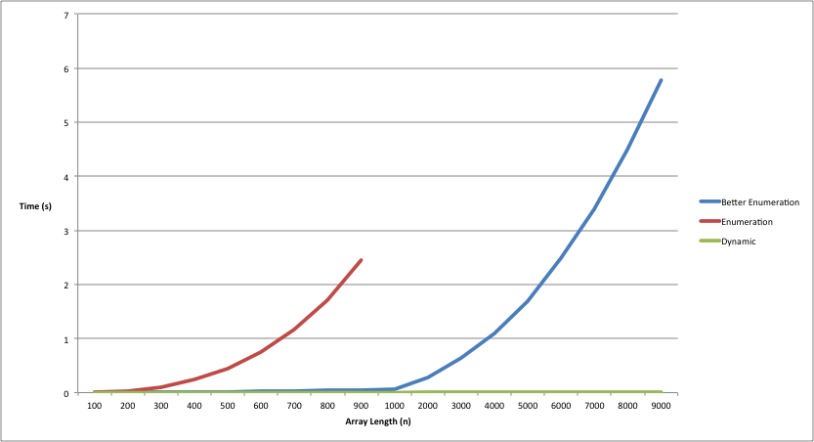

# Log-Log Plot

# 