Date {{DATE}}
{{BO_SERVICE_ADDRESS}}
RE: PARTY WALL ETC. ACT 1996

Regarding the above, you may recall that a Notice under Section {{FULL_NOTICE_RUNS}} of the Party Wall etc. Act 1996 was served upon you dated {{FULL_NOTICE_DATES}}.

Subsequently, I wrote to you on {{SECTION_10_NOTICE_DATE}} confirming that if you failed to appoint a Surveyor within 10 days, I would make an appointment on your behalf in accordance with Section 10(4)(b) of the Party Wall etc. Act 1996. Copies of all previous correspondence is attached.

The period of 10 days has now passed, and therefore I hereby appoint {{AO_SURVEYOR_NAME}} of {{AO_SURVEYOR_FIRM}} whose contact details are listed below to Act on your behalf in respect of the Notice served on you dated {{NOTICE_DATE}}.
I have booked an appointment to carry out a schedule of conditions of your property for {{SOC_DATE}}. If we do not hear from you prior to this date and access is not granted on the {{SOC_DATE}}, we will proceed to issue the Party Wall Award with access being denied.

I trust we will hear from you in due course.

Yours Sincerely
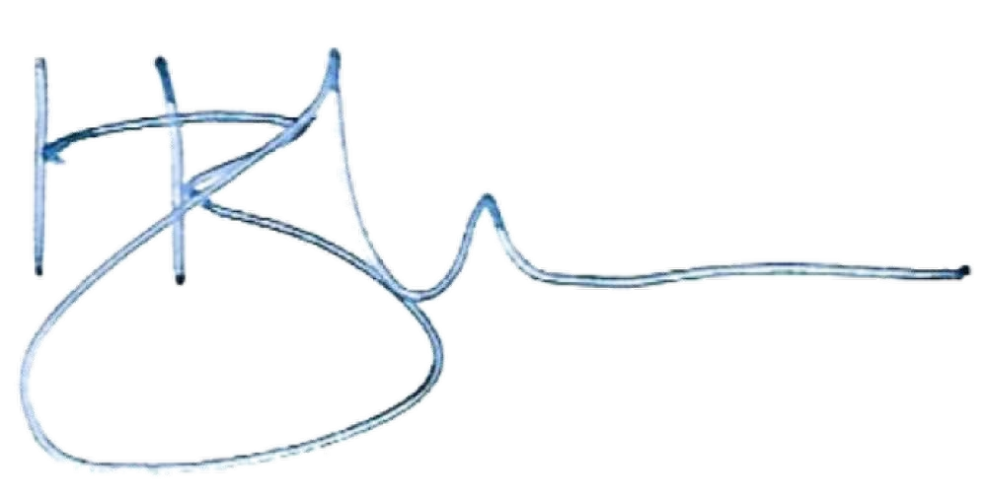

Itzik Darel ACIArb MIPWS

Enc: Appointment letter under 10(4)(b)
Enc: Notices served under section {{NOTICE_SECTION_FULL}} on {{NOTICE_DATE}}
Enc: Section 10 notice served {{SECTION_10_NOTICE_DATE}}

