# BASIC QUERIES

--1) retrive all the books in 'fiction' genre:

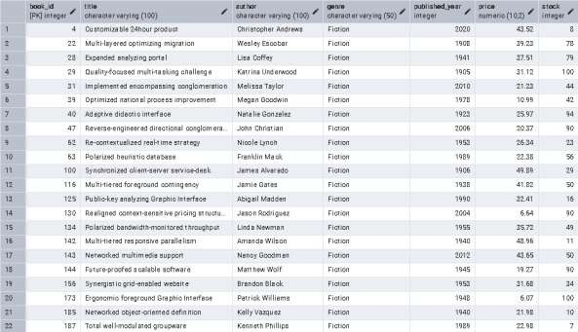

--2) find books published after the year 1950:

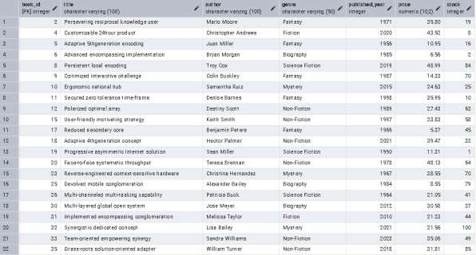

--3) list all the customers from 'canada':

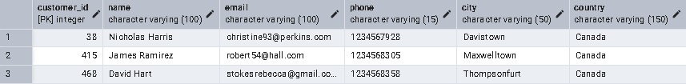

--4) show all orders placed in november 2023:

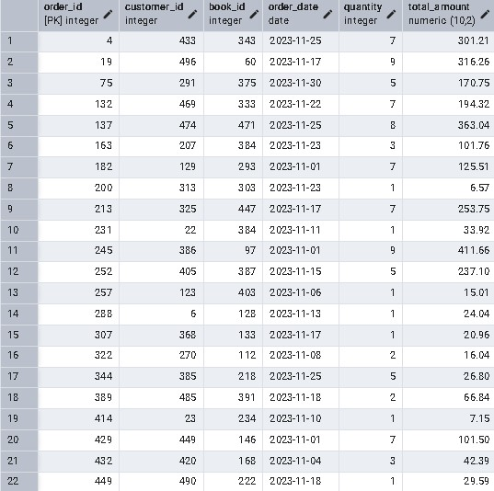

--5) retrive the total stock of books available:



--6) find the details of the most expensive book:



--7) show all the customers who ordered more than 1 quantity of book:

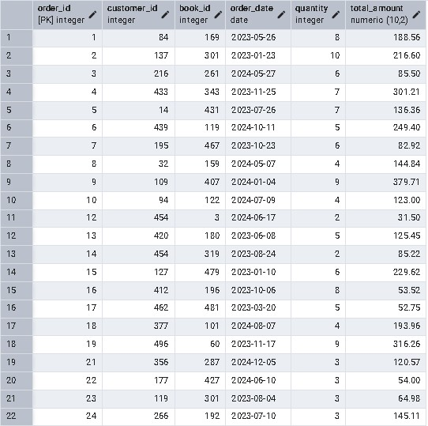

--8) retrive all the orders where the total amount exceeds $20:

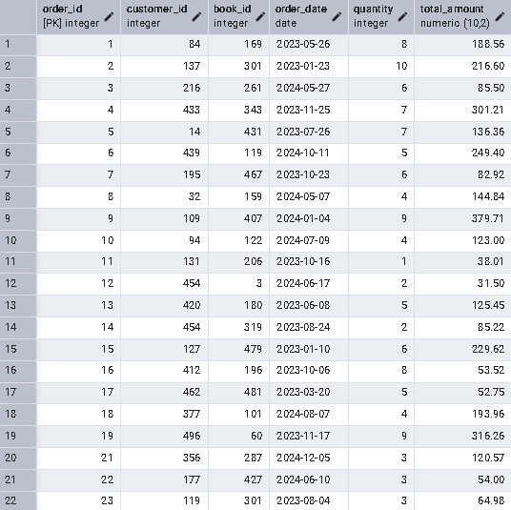

--9) list all the genre that are available in table Books:

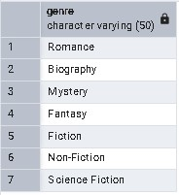

10) find the book with the lowest stock:

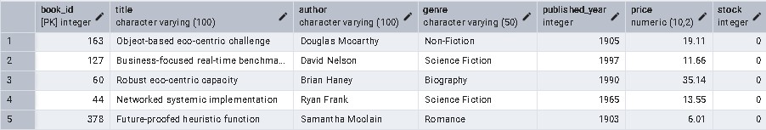

--11) calculate the total revenus generated from all orders:



# ADVANCED QUERIES

--1) retrive the total no. of books sold for each genre:

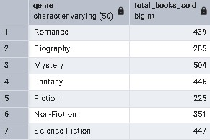

2) find the average price of books in the 'fantasy' genre:

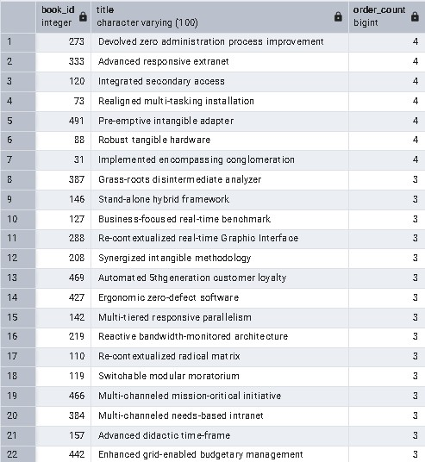

--3) list the customers who have placed atleast 2 orders:

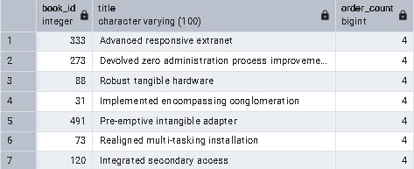

4) find the most frequently ordered book:



--5) show the top 3 most expensive books of 'Fantasy' genre:

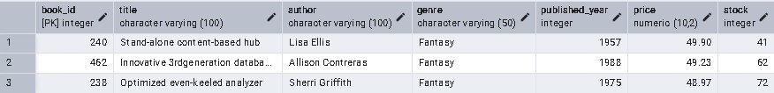

--6) retrive the total quantity of books sold by each author:

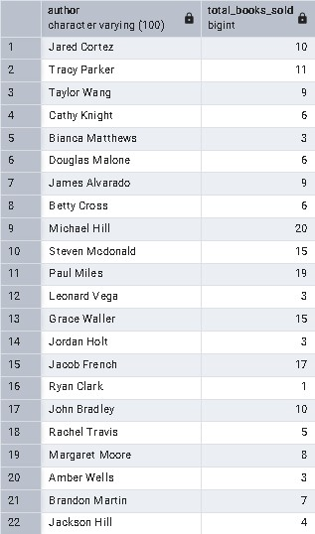

7) list the cities where the customers who spent over $30 are located:

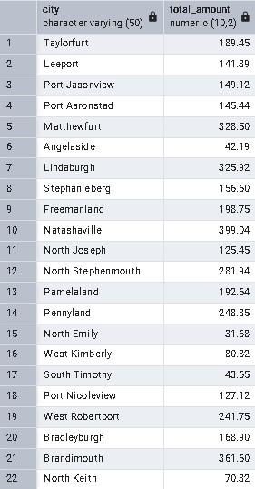

--8) find the customers who spent the most on orders:



9) calculate the stock remaining after fulfilling all the orders:

