Comprehensive Digital Evidence Acquisition and Command-Line Analysis using FTK Imager, WinPmem, and Volatility
EXPERIMENT NO: 01
DATE:
1. AIM
To perform a complete forensic acquisition and analysis lifecycle by imaging non-volatile storage using AccessData FTK Imager, capturing live volatile memory (RAM) using the WinPmem command-line utility, and analyzing the extracted memory dump using Volatility 3 commands via the PassMark Volatility Workbench.

2. SOFTWARE / TOOLS REQUIRED
- Operating System: Windows OS
- Forensics Tools:
  - AccessData FTK Imager (GUI for non-volatile physical drive imaging)
  - WinPmem (winpmem_mini_x64_rc2.exe) (CLI tool for volatile memory capture)
  - Volatility 3 Framework (vol.exe / PassMark Volatility Workbench V3.0)
- Hardware: Evidence PC/Workstation, Target Storage Drive (hp v221w 16GB USB Device).

3. DESCRIPTION
A thorough digital forensic investigation requires collecting both data at rest and data in motion using strict operational procedures.
- Non-Volatile Memory Acquisition: AccessData FTK Imager creates mathematically verifiable, bit-by-bit physical images of storage devices (saved as Raw/dd) without altering the original evidence.
- Volatile Memory (RAM) Acquisition: Command-line utilities like WinPmem load a specialized kernel driver (pme98A2.tmp) to read physical memory directly. Executing this via CMD writes active processes, network connections, and decrypted keys to a raw dump file (.raw).
- Volatile Memory Analysis (CLI): Volatility 3 is a framework for analyzing RAM dumps. By passing specific parameters and plugins (e.g., -f <image_path> windows.pslist.PsList) into the command line or workbench, investigators can reconstruct the system's live state and identify suspicious processes.

4. PROCEDURE
Part A: Acquiring Non-Volatile Memory (Disk Image) using FTK Imager
Step 1: Select the Source Type
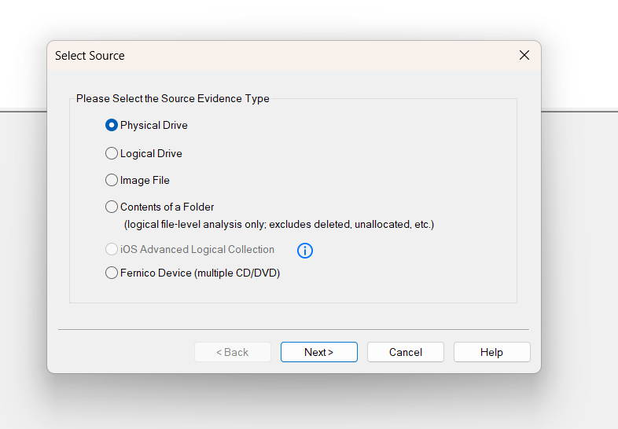
Open FTK Imager as an Administrator. Navigate to File > Create Disk Image. In the Select Source dialog, choose Physical Drive.
Figure 1: Selecting Physical Drive as the source evidence type

Step 2: Select the Specific Drive
Select the target evidence drive (\\.\PHYSICALDRIVE1 - hp v221w USB Device [16GB USB]) from the dropdown.
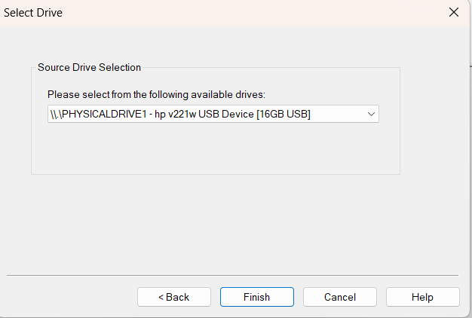
Figure 2: Selecting the target USB device for acquisition
Step 3: Choose the Image Type
Select Raw (dd) as the destination image type to create a pure bitstream copy.
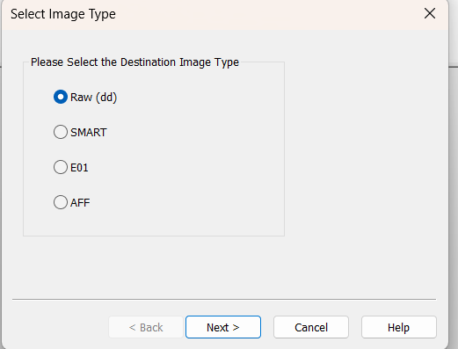
Figure 3: Configuring the destination image format to Raw (dd)
Step 4: Enter Evidence Item Information
Provide the standardized case details to maintain the chain of custody:
- Case Number: 99240040089
- Evidence Number: 1
- Unique Description: Examine
- Examiner: Inbathamizhan S

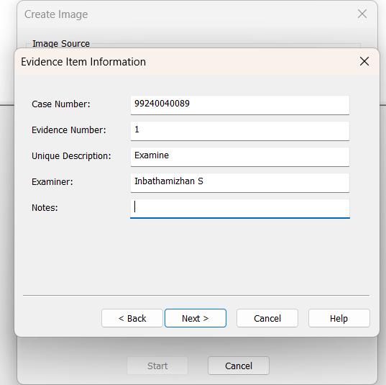
Figure 4: Entering the forensic case and examiner details

Step 5: Configure Image Destination
Set the destination folder to A:\DF\Digital_Forensics_Lab\Experiment-01-FTK-Imager\Results and the filename to Result. Set the Fragment Size to 20 MB and check Verify images after they are created.
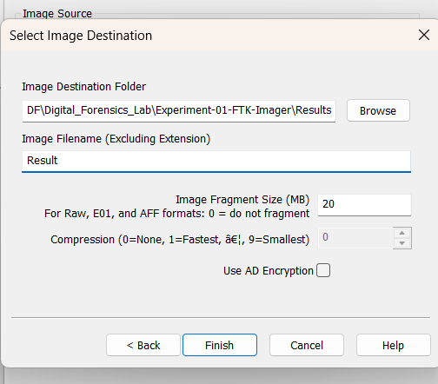
Figure 5: Setting the destination path, filename, and fragmentation size
Step 6: Monitor Acquisition Progress & Hash Verification
Click Start. Once complete, FTK Imager hashes the original drive and the newly created image. Review the Drive/Image Verify Results.
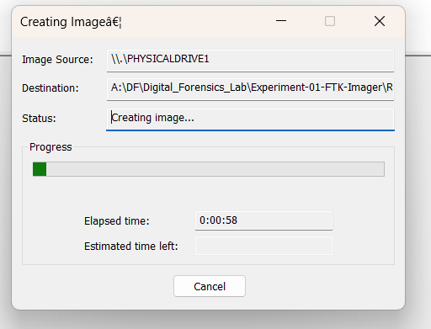
Figure 6: Disk imaging progress tracking
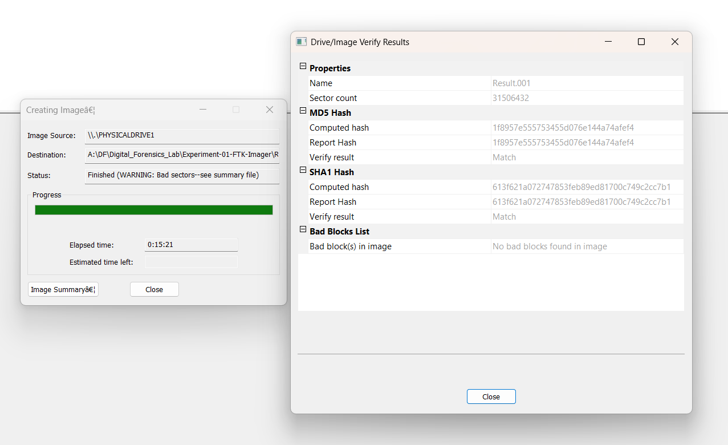
Figure 7: Successful verification of MD5 and SHA1 hashes
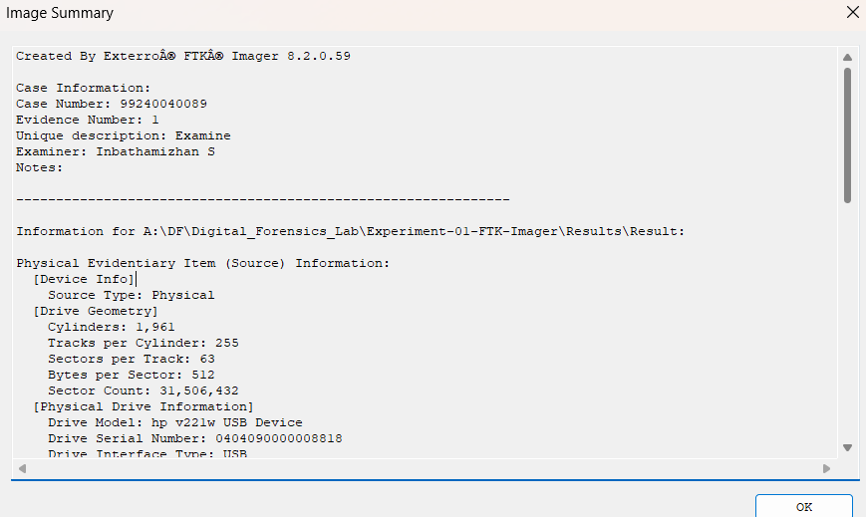Figure 8: Image Summary detailing the physical device geometry
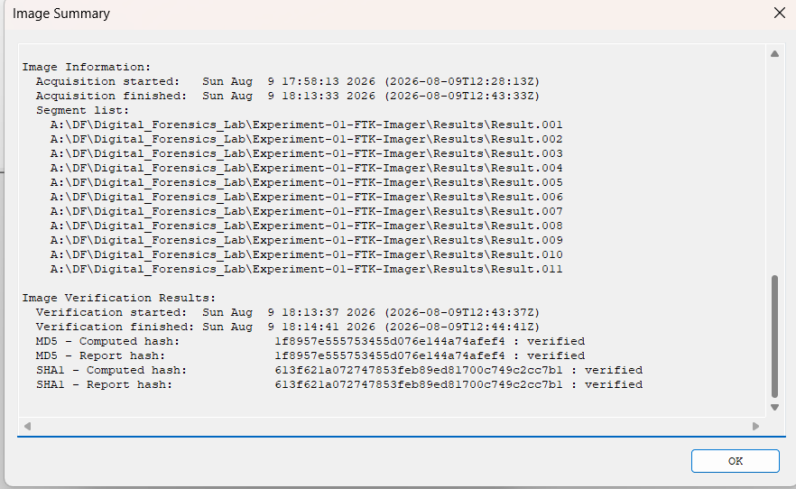Figure 9: Image Summary detailing the hash verification results and segment list

Part B: Acquiring Volatile Memory (RAM) using WinPmem CMD
Step 1: Launch Command Prompt
Press Win + R, type cmd, and press Ctrl + Shift + Enter to open the Command Prompt as an Administrator.
Step 2: Navigate to Directory
Use the cd command to navigate to the folder containing the WinPmem executable:
DOS
A:
cd \DF

Step 3: Check Available Parameters
Execute the help command to view the WinPmem usage parameters:
DOS
winpmem_mini_x64_rc2.exe -h

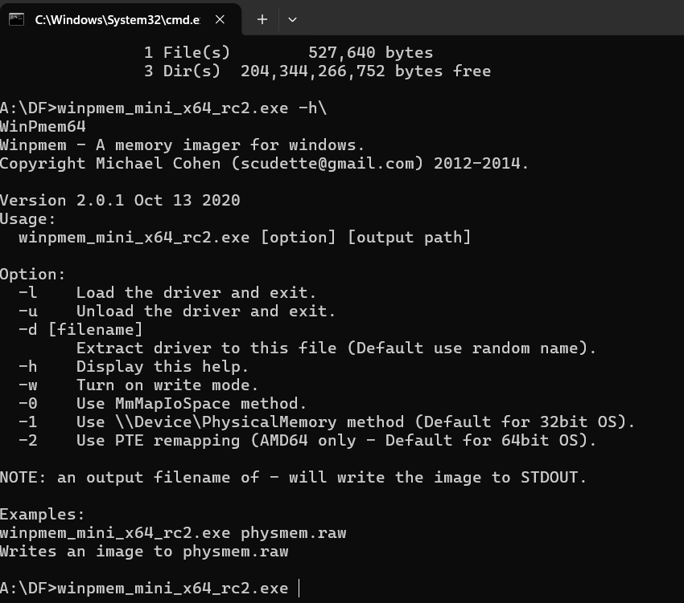Figure 10: Viewing the WinPmem help menu and available parameters

Step 4: Execute Memory Capture Command
Run the memory extraction command, specifying the output filename Inba.raw. The utility will map the physical memory and write it to the file:
DOS
winpmem_mini_x64_rc2.exe Inba.raw

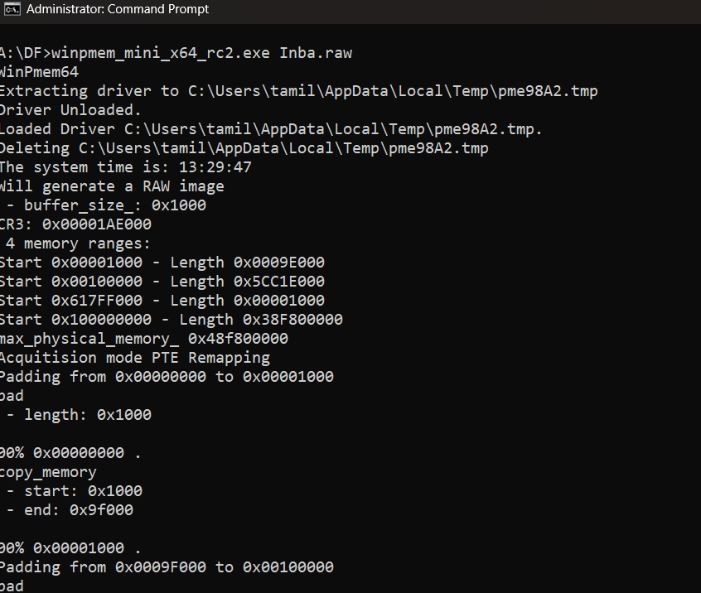Figure 11: Initializing WinPmem and loading the extraction driver
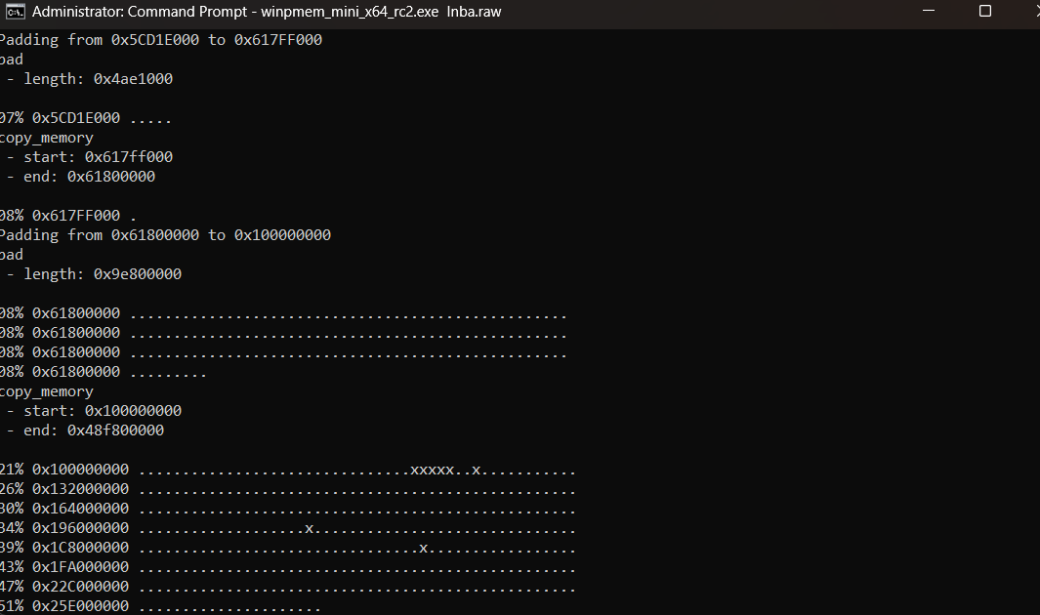Figure 12: Memory capture in progress
Step 5: Verification of Dump
Wait for the terminal to display Driver Unloaded. Navigate to the directory to verify the 18.2 GB Inba.raw file.
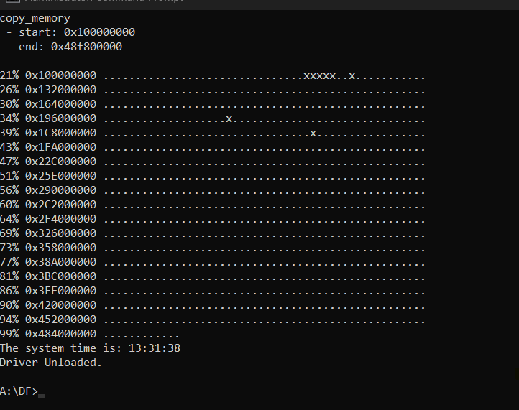Figure 13: Successful completion of the volatile memory capture
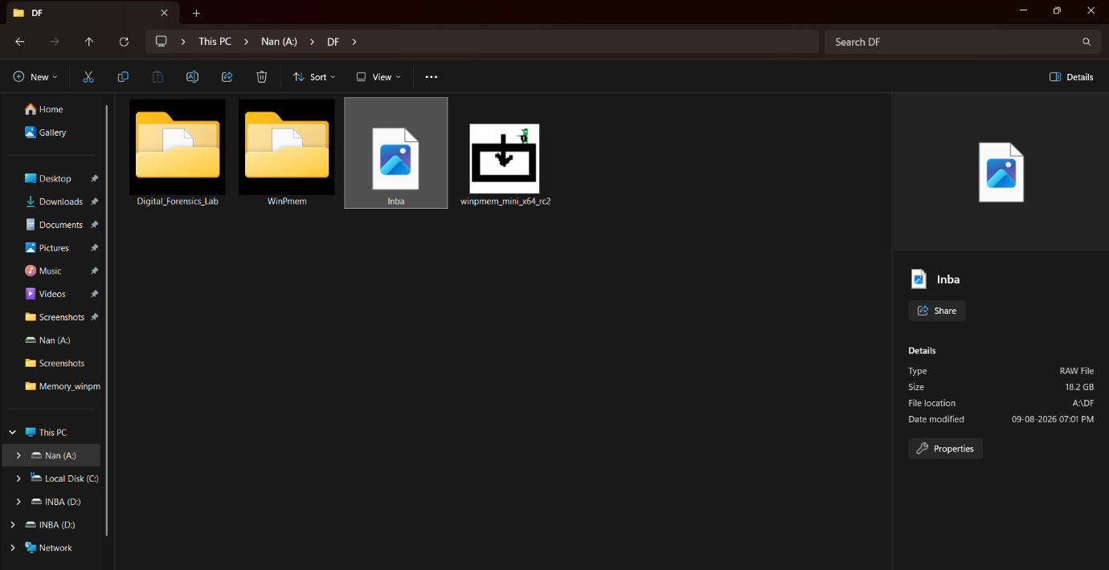
Figure 14: Verification of the generated Inba.raw memory dump file

Part C: Volatile Memory Analysis using Volatility CLI / Workbench

Step 1: Launch Volatility Environment
Open PassMark Volatility Workbench (which acts as a GUI frontend for vol.exe).
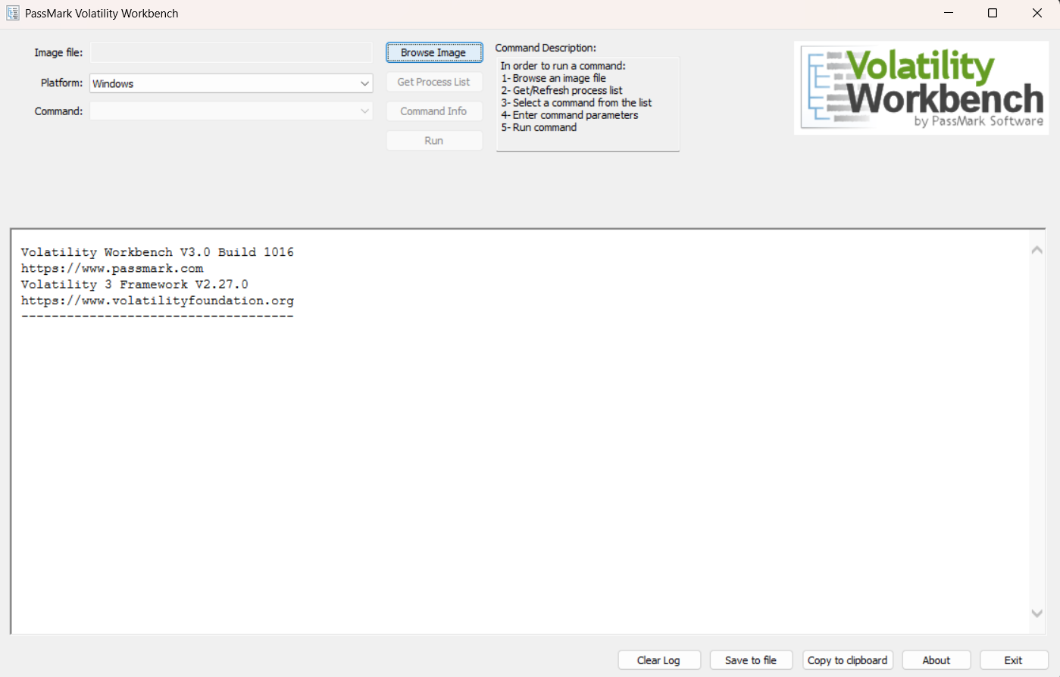Figure 15: The default interface of PassMark Volatility Workbench

Step 2: Construct and Execute the Volatility Command
To parse the captured memory and list the active processes, load A:\DF\Inba.raw via Browse Image, select the Windows platform, choose windows.pslist.PsList from the dropdown, and click Run.
The console executes the following command in the background:
DOS
"C:\Users\tamil\Downloads\VolatilityWorkbench\vol.exe" -f "A:\DF\Inba.raw" windows.pslist.PsList

Or
Use the workbench
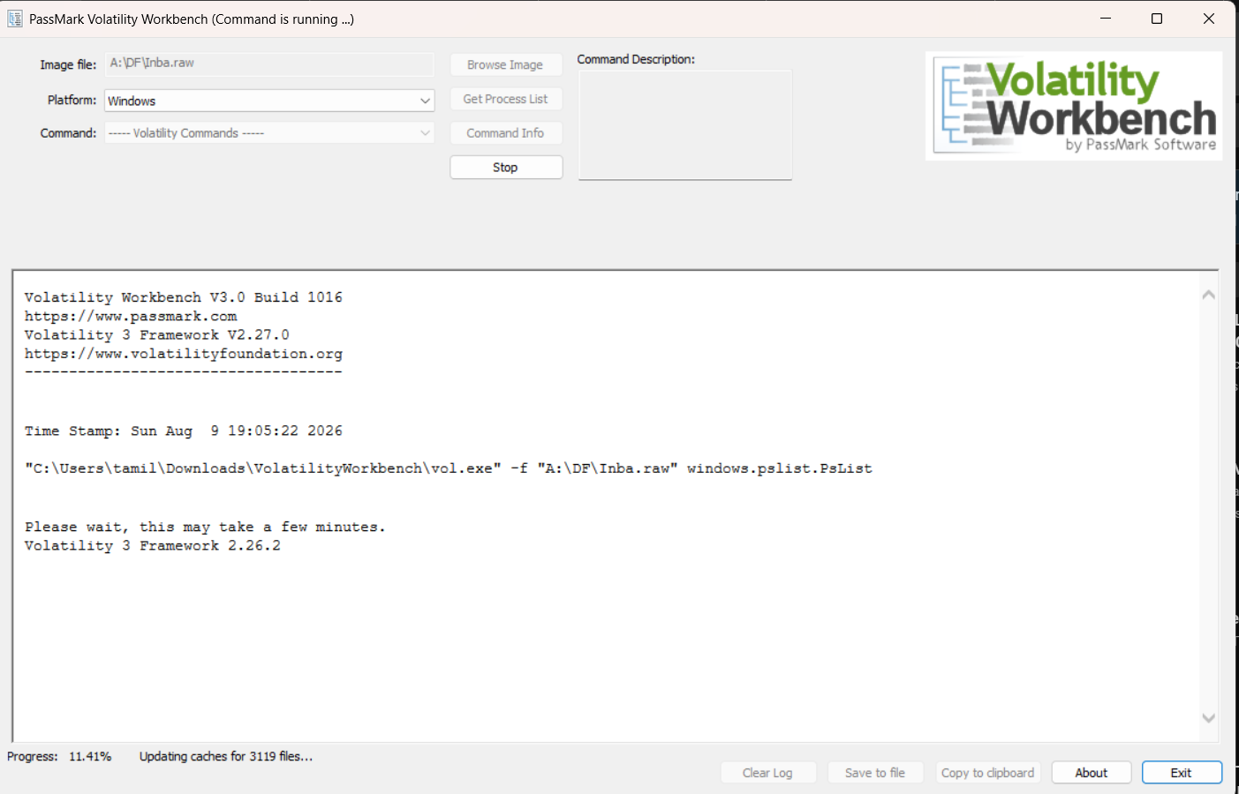Figure 17:Execution of Volatility for the Inba.raw image

5. OBSERVATIONS
1. FTK Imager Cryptographic Verification
FTK Imager generated a summary report mathematically confirming the non-volatile image data integrity:
- MD5 Hash: 1f8957e555753455d076e144a74afef4 : verified
- SHA1 Hash: 613f621a072747853feb89ed81700c749c2cc7b1 : verified

2. Memory Capture & CLI Parsing
The Inba.raw file was successfully written using the winpmem_mini_x64_rc2.exe command. When analyzed, Volatility parsed the _EPROCESS blocks in kernel memory. The resulting output log accurately detailed the Process IDs (PID), Parent Process IDs (PPID), Image File Names, and timestamps of all active programs:
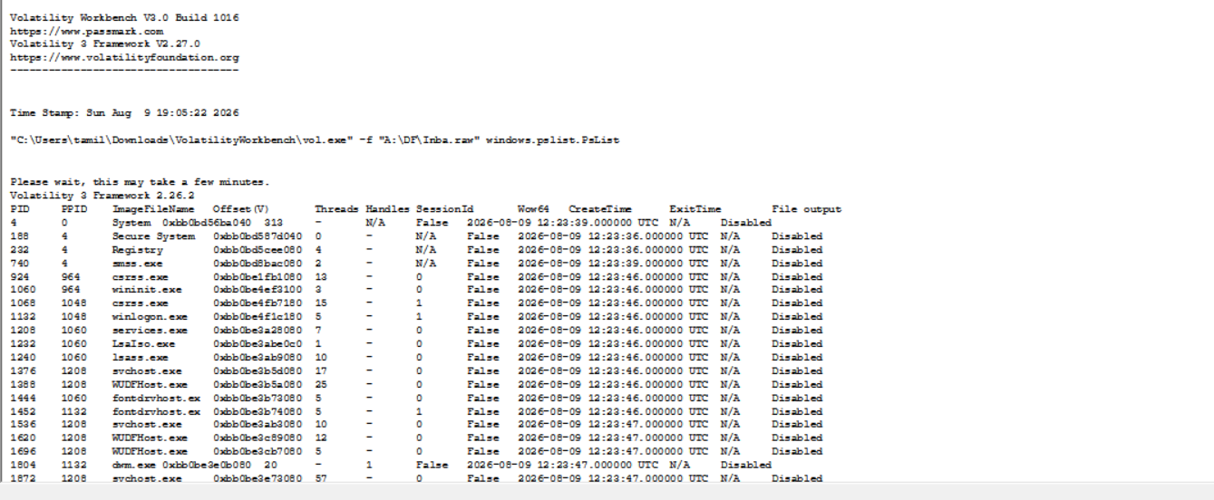Figure 18: Volatility Workbench execution log displaying the extracted Process List
Note: The log accurately shows winpmem_mini_x (PID 19448) actively running, reflecting the acquisition tool executing at the time of the capture.

6. RESULT
A complete digital forensics acquisition and analysis workflow was successfully executed via a combination of GUI and CLI tools. The target physical USB drive was securely imaged and verified using FTK Imager. Simultaneously, the system's live RAM was extracted via the Command Prompt using WinPmem. Finally, Volatility 3 command-line syntax was utilized to parse the raw memory file, successfully recovering critical live-state artifacts, including the process list and execution timestamps.

