Analyze Email Headers and Detect Email Spoofing using MHA (Mail Header Analyzer)
EXPERIMENT NO: 04
DATE:
1. AIM
To extract, analyze, and interpret email headers to trace an email's origin, verify its authenticity protocols (SPF, DKIM, DMARC), and detect potential spoofing or phishing attempts using Mail Header Analyzer (MHA) tools.

2. SOFTWARE / TOOLS REQUIRED
- Operating System: Windows, Linux, or macOS
- Email Client: Web browser accessing Gmail, Outlook, or Yahoo
- Analysis Tools: MXToolbox (Online Mail Header Analyzer), WHOIS IP Lookup

3. DESCRIPTION
Every email sent over the internet contains hidden metadata known as an Email Header. This header tracks the email's journey from the sender's server to the recipient's inbox and contains critical routing and authentication information. Analyzing these headers helps forensic investigators verify if an email is legitimate or spoofed.
Key Authentication Protocols:
- SPF (Sender Policy Framework): Checks if the sender's IP address is authorized to send emails on behalf of the claimed domain.
- DKIM (DomainKeys Identified Mail): A cryptographic signature that verifies the email content has not been altered in transit.
- DMARC (Domain-based Message Authentication, Reporting, and Conformance): A policy that uses both SPF and DKIM to authenticate the email and instruct the receiving server on how to handle failures.
4. PROCEDURE & OBSERVATIONS
Step 1: Accessing the Suspicious Email
- Log into your email account (e.g., Gmail) and locate the target email you wish to investigate (often found in the Spam or Inbox folder).
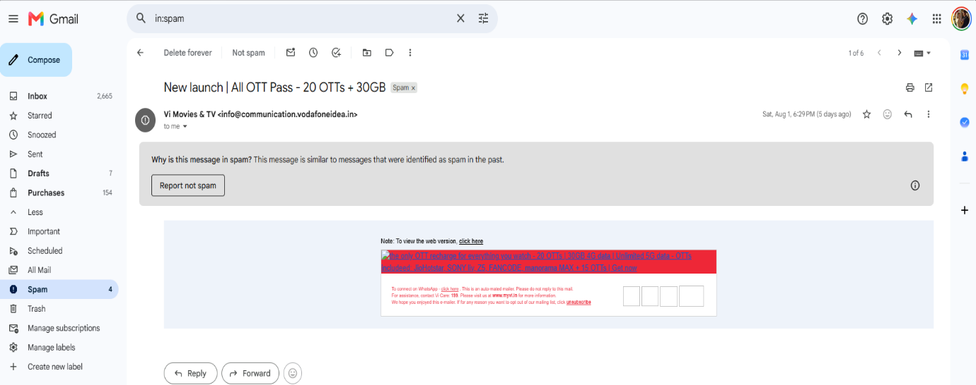
- Open the email to view the sender details and subject line.
Figure 1: Viewing the suspicious email in the Gmail Spam folder
Step 2: Extracting the Raw Email Header
- To view the hidden metadata in Gmail, click the three dots (More) in the upper right corner of the email and select "Show original". (For Outlook: File > Properties > Internet headers. For Yahoo: More > View raw message).
- Copy all the raw text provided. This text contains the Received fields, Message-ID, and authentication results.
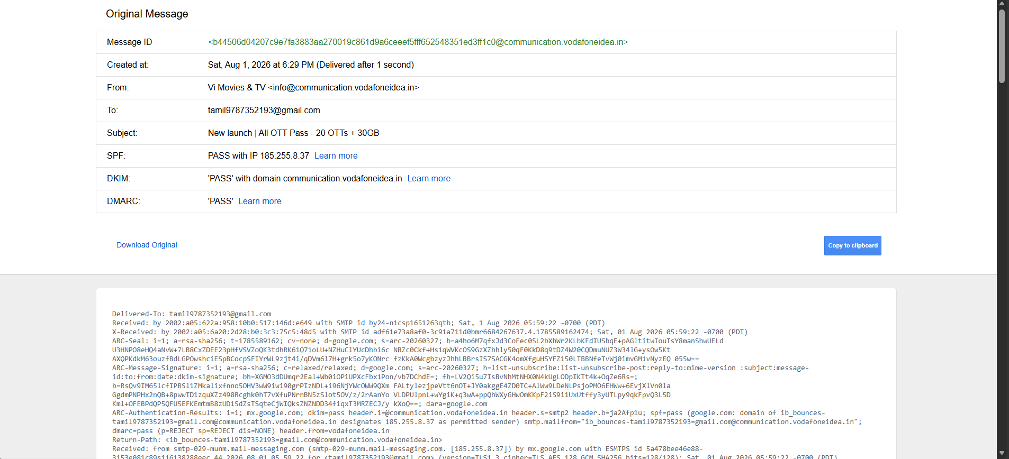Figure 2: Extracting the original raw message and email header data
Step 3: Analyzing the Header via MXToolbox
- Navigate to an online Mail Header Analyzer, such as MXToolbox.
- Paste the copied raw header text into the analysis tool and click Analyze.
- Review the Delivery Information and Relay Information to trace the chronological path (hops) the email took from the sending server to the receiving server. Check for unusual delays or suspicious routing.
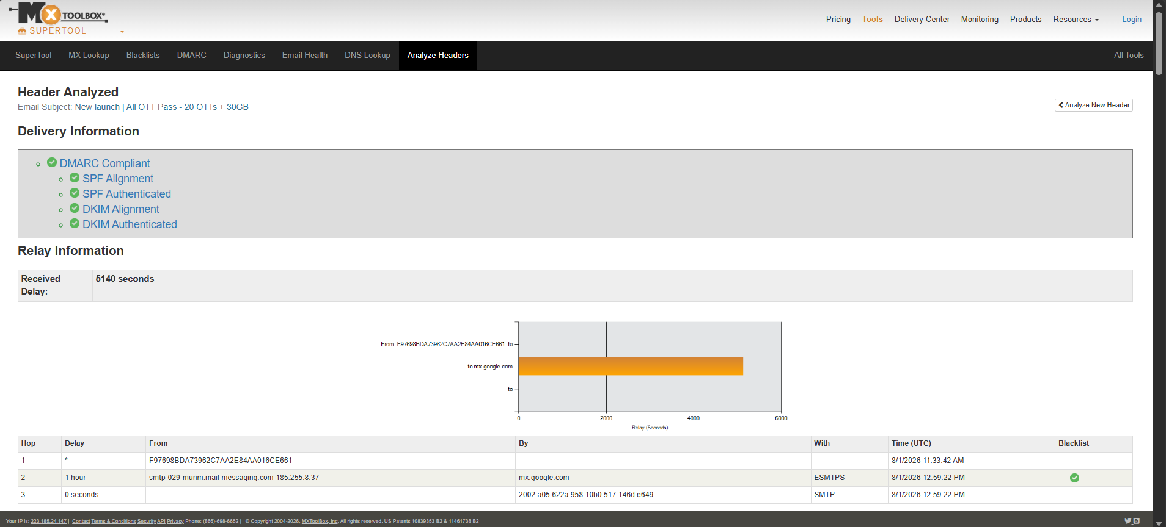Figure 3: MHA relay analysis showing chronological hops and delivery delays
Step 4: Examining SPF, DKIM, and DMARC Results
- Scroll down in the analyzer tool to inspect the authentication policies and Verify if the DMARC record is compliant.
- Check the SPF and DKIM alignment to ensure the sender's IP (185.255.8.37) was genuinely authorized by the domain (communication.vodafoneidea.in).
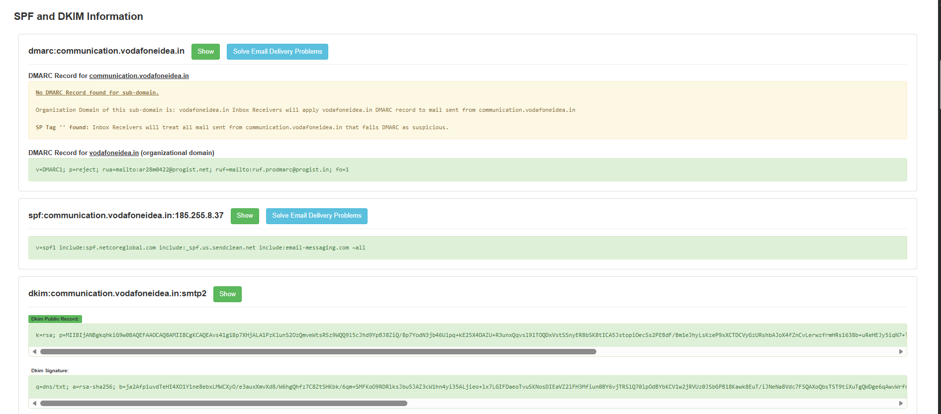Figure 4: Verification of SPF, DKIM, and DMARC cryptographic records
Step 5: IP Address and Hostname Verification
- Extract the primary sending IP address identified in the Received lines (185.255.8.37).
- Use a WHOIS lookup tool to identify the geographical location and ownership of the IP address.
- Determine if the registered organization matches the expected sender.
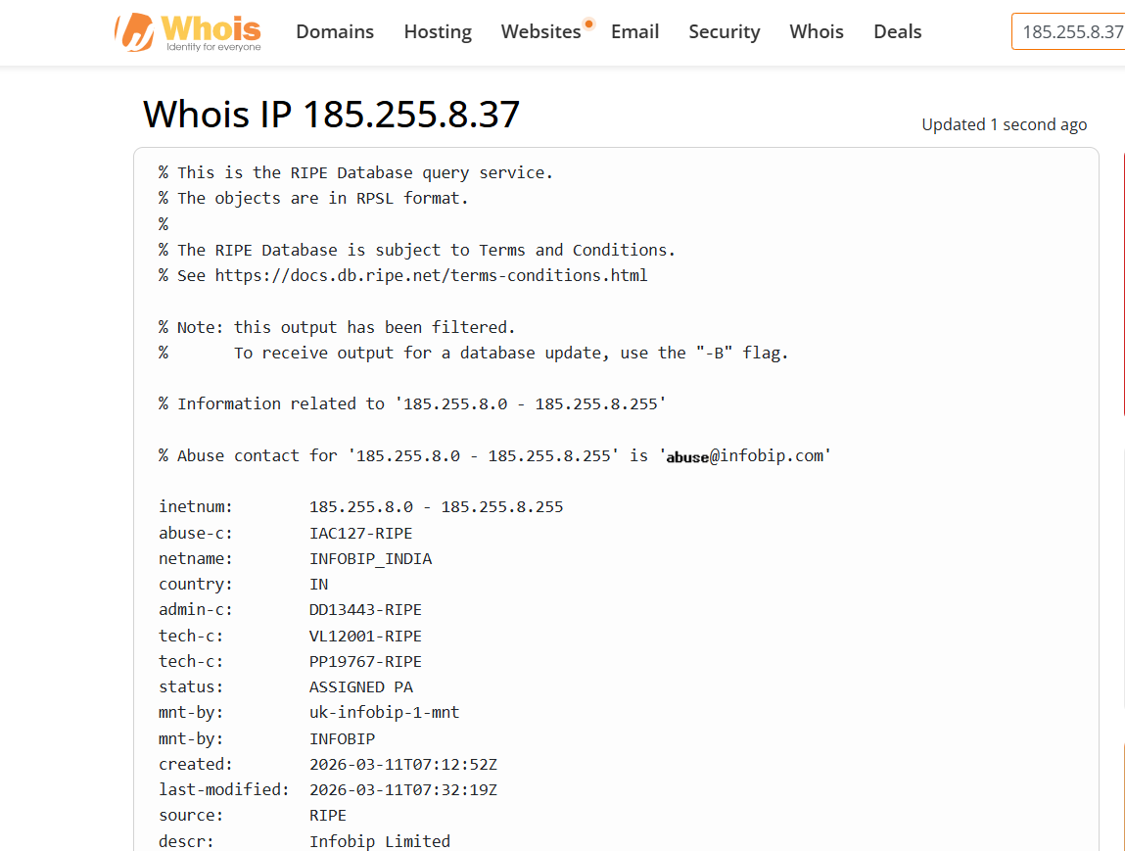Figure 5: WHOIS IP lookup revealing the hosting organization (INFOBIP_INDIA)
5. FORENSIC FINDINGS & ANALYSIS
Based on the header analysis conducted:
- Sender Domain: communication.vodafoneidea.in
- Sending IP Address: 185.255.8.37
- Authentication Status: The email PASSED all primary checks (SPF, DKIM, and DMARC). The IP address is officially authorized to send on behalf of the domain.
- WHOIS Verification: The IP belongs to INFOBIP_INDIA, a legitimate bulk SMS and email gateway service frequently used by telecom providers.
- Hop-by-Hop Routing Analysis: An examination of the chronological Received: lines reveals a logical network path from the originating server to Google’s MTAs, with no forged intermediate hops.
- Timestamp and Latency Verification: The timestamps at each server handoff indicate normal transit times, showing no suspicious network delays or rerouting.
- Message-ID Integrity: The Message-ID string follows the standard format expected from an enterprise mail server, ruling out the use of generic spam scripts.
- Return-Path Alignment: The Return-Path address correctly aligns with the sender's infrastructure, typical of legitimate bulk senders.
- X-Header & Spam Assessment: Custom X-Headers indicate that the email triggered spam filters due to promotional content heuristics, not because of a security protocol failure.
- Conclusion on Spoofing: Despite being flagged as spam by Gmail's automated content filters (likely due to promotional marketing content), the complete header analysis proves this email is cryptographically authentic and not spoofed. The sender identity is genuine.

6. RESULT
The email header was successfully extracted and analyzed using MXToolbox. Authentication protocols (SPF, DKIM, DMARC) and the originating IP address were manually verified, demonstrating how to trace email origins and detect potential spoofing.

