**PCS AUTOMATION**

Developed By -

**Name: ANUPRIYA SHARMA Reg. No: R210050100063**

**Student Id : S210050100048**

# NIIT

### PCS AUTOMATION

Batch Code : S210167

Start Date : 12.11.2020

End Date : 12.12.2020

Name of the Coordinator : LOPAMUDRA BERA

Name of the Developer : ANUPRIYA SHARMA

Date of Submission : 12.12.2020

# NIIT

###### **CERTIFICATE**

This is to certify that this report, titled **PCS AUTOMATION** embodies the original work done by **ANUPRIYA SHARMA**, in partial fulfilment of his course requirement at NIIT.

Coordinator : LOPAMUDRA BERA

### ACKNOWLEDGEMENT

I take this opportunity to express my profound gratitude and deep regards to my faculty, **LOPAMUDRA BERA** for her exemplary guidance, monitoring and constant encouragement throughout the course of this project. The blessing, help and guidance given by her time to time shall carry me a long way in the journey of life on which I am about to embark.

I am obliged to my project for the valuable information provided by her in my respective fields. I am grateful for their cooperation during the period of my assignment.

**-ANUPRIYA SHARMA**

### ABSTRACT

This project manages the entire process of allocating project to existing employees as per his/her skillset and roles as per there experience working in that company.

It’s also provides single window system to Employee, HR and Project Managers of a company to gather the skill specific requirements emerging in Projects.

### CONFIGURATION

Hardware- 4 GB RAM,

2GB GRAPHICS CARD,

1 TB HARD DISK,

INTEL 5TH GENERATION PROCESSOR

Operating - System- WINDOWS 10

Software - ECLIPSE 2019, MY SQL

.jar files - mySql-Connector,junit,hamcrest-core

### TABLE OF CONTENTS

Chapter 1- Introduction

1.0 Aim

1.1 Objectives

1.2 Case Study

Chapter 2- Project Requirement Specification

2.0 Literature Research

2.1 Statement of Requirements

2.2 Vision Document

2.3 Project Life Cycle Model

Chapter 3- Project Analysis

3.0 Project Plan

3.1 Risk Management Plan

3.2 Weekly Status Report

3.3 Storyboard

3.4 System Architecture

3.5 Business Process Model

3.6 Software Requirement Specification

3.7 High Level Use Case Diagrams

Chapter 4- Project Design

4.0 Low Level Use Case Diagrams

4.1 User Interface Design

4.2 Systems Input and Output Design

4.3 Database Structure

4.4 Entity Relationship Diagram

4.5 Data Model

4.6 Class Diagrams

4.7 Activity Diagrams

4.8 Sequence Diagrams

4.9 User-centered Interface Designs

4.10 Personas

4.11 Paper Prototypes

4.12 Web Interfaces

4.13 Change Request Form

Chapter 5- Project Implementation

5.0 Acceptance Plan

5.1 System Support Plan

Chapter 6- Project Testing

6.0 Test Plan

6.1 Test Cases

Chapter 7- Project Deployment

7.0 Training Plan

7.1 Component and Deployment Diagrams

7.2 Deployment Plan

7.3 Maintenance Request

7.4 Service Level Agreement

7.5 Maintenance Plan

Challenges

Observations

References

Appendix

### 

### AIM

To create an application that operates via online recruiting website. Which stored the information in Data Base and also we can retrieve data as per our requirement.

This application made work easy to assign projects to employees as per there skill and experience.

### OBJECTIVES

Following are the objectives to be achieved through Skill Mapping Application

* User registration
* Skill map
* Job Postings
* Profile Validation
* Recruitment

These objectives are to be automated which were previously done manually.

### STATEMENT OF REQUIREMENTS

**PROJECT OBJECTIVES**

|  |  |
| --- | --- |
| Title | PCS Automation |
| Subtitle | EmployeeSkill Management System |
| Author(s) | Anupriya Sharma |
| Author’s E-mail | anupriyasharma8161@gmail.com |
| Author’s Phone | 7908608161 |
| Description | Automated Consultancy Service |

**About Your Company**

**Professional Consultancy Services** (PCS) is a business consultancy which provides a wide range of business services to clients.

**Need for Process Automation**

* Adds consistency and quality to recruitment
* Improves the productivity of HR team
* Saves time by easing the workload
* Enables organizations to find the right talent

**Benefits**

* Improves the Recruitment Qualities.
* Pre-Screening of Candidates.

### PROJECT LIFE CYCLE MODEL

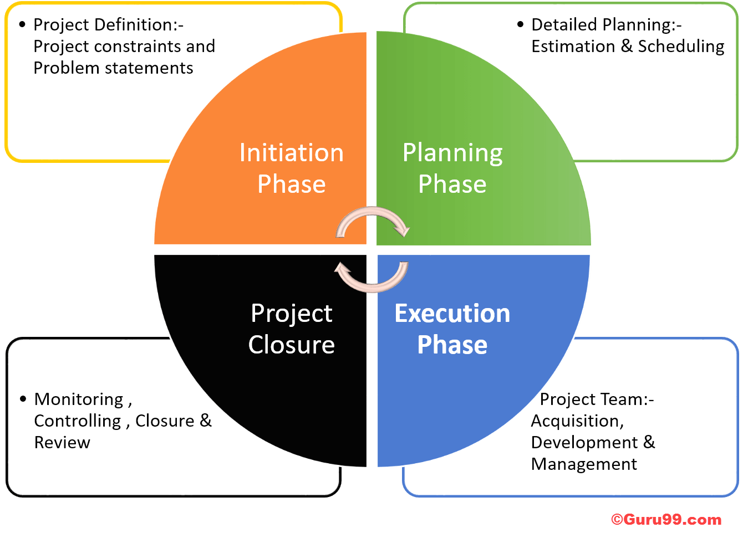

**The Initiation Phase:** The initiation phase aims to define and authorize the project.

**Vision: Automate the Selection Process**

**The Planning Phase:** The purpose of this phase is to lay down a detailed strategy of how the project has to be performed and how to make it a success.

Strategic Planning- overall approach to the project

Implementation Planning-ways to apply the decisions

**The Execution Phase:** In this phase, the decisions and activities defined during the planning phase are implemented.

**The Termination Phase:** This is the last phase of any project, and it marks the official closure of the project.

### SYSTEM ARCHITECTURE

Three Tier Architecture -

A **Presentation Layer** that sends content to browsers in the form of HTML/JS/CSS. This might leverage frameworks like React, Angular, Ember, Aurora, etc.

An **Application Layer** that uses an application server and processes the business logic for the application. This might be written in C#, Java, C++, Python, Ruby, etc.

A **Data Layer** which is a database management system that provides access to application data. This could be MSSQL, MySQL, Oracle, or PostgreSQL, Mongo, etc.

##### **SOFTWARE REQUIREMNETS SPECIFICATION**

Table of Contents

1. Introduction
   1. Purpose
   2. Scope
   3. Definitions, acronyms and abbreviations
   4. References
   5. Overview
2. General Description

2.1 Product perspective

2.2 Product functions

2.3 User characteristics

2.4 Constraints

2.5 Assumption and dependencies

1. Specific Requirements

3.1 Functional requirements

3.2 Non-functional requirements

3.3 External interface requirements

3.4 Performance requirements

3.5 Design constraints

3.6 Attributes

3.7 Other requirements

1. Appendices
2. Index

**EMPHOME**

* Employee can view his/her own information
* Employee can request to HR for Updating his/her information
* Employee apply for job assigned by the PME

**PMEHOME**

* PME can view Skill of the employee
* PME can add a new job for employee
* PME can view all project jobs

**HREHOME**

* HR can view employee information
* HR can update employee information
* HR can update requested skills of the employee