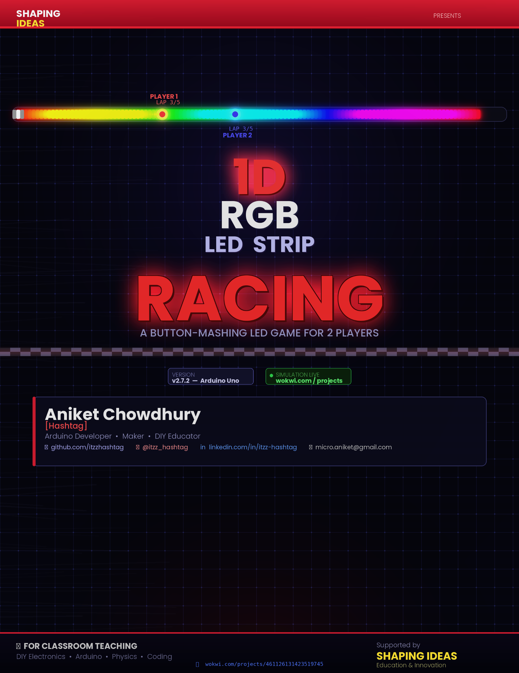
🏎️ 1D RGB LED Strip Racing

A Fun DIY Arduino Game for Everyone!

Version 2.7.1 — Arduino Uno Edition
Created by Aniket Chowdhury [Hashtag]
github.com/itzzhashtag
🔗 Try simulation on Wokwi

📚 Prepared for classroom teaching • DIY Electronics & Coding

Table of Contents
1.1 How the Game Works 3
2.1 Shopping Tip 5
3.1 Connection Table 6
3.2 Circuit Diagram 7
3.3 Wiring Tips for Students 7
4.1 Variation A — 4-Player Arduino Mega Edition 8
4.2 Variation B — ESP32 Wireless Remote Edition 9
4.3 Variation C — Turbo / Obstacle Mode 10
5.1 #define — Setting Game Constants 11
5.2 enum — Game States 11
5.3 struct — Player Data 11
5.4 Physics — Speed & Friction 12
5.5 Lap Detection 12
5.6 Libraries Used 12
6.1 Base Game (2 Players — Arduino Uno) 14
6.2 What the Lights Mean 14
6.3 Playing the Wireless (ESP32) Variation 14
6.4 Playing the 4-Player Variation 14
7.1 Easy Improvements (Beginner Level) 16
7.2 Intermediate Improvements 16
7.3 Advanced Improvements 16
8.0 Conclusion ……………………………………………………………………………………………………………………..17
9.1 About the Creator 18
9.2 Wokwi Simulation 18
9.3 Useful Resources 18
9.4 Acknowledgements 18

1. Project Overview
Welcome to 1D RGB LED Strip Racing! 🏁
This is a 2-player button-mashing racing game built with an Arduino Uno and a strip of colourful LEDs. Each player has one button — press it as fast as you can to make your car zoom along the LED track! First player to complete all the laps wins the race!

🎮 What Makes This Project Special?
✅ Simple to build — only a few parts needed
✅ Great introduction to Arduino, LED strips & sensors
✅ Fun for all ages — playable right after assembly
✅ Fully customisable — change colours, speed, laps & more
✅ Teaches coding basics: loops, variables, functions & game logic

1.1 How the Game Works
Imagine a racetrack made of 60 or more number of colourful LED lights arranged in a line (or circle if you bend the strip!). Each player is represented by a glowing dot:
- 🔴 Player 1 is Red
- 🔵 Player 2 is Blue

When you press your button, your car speeds up. When you stop pressing, it gradually slows down due 'friction'. The strip also shows a white start/finish line. Every time your dot passes the start line, you complete a lap. Complete 5 laps first — and you WIN! 🏆

There's also a cool countdown (3-2-1-GO!) with light animations and sound effects, plus a victory jingle when someone wins. Even if nobody plays for 60 seconds, the game plays a sad tune and resets! 😄

2. Components List
Here is everything you need to build this project. You can find all of these at any electronics hobby shop or online store like Amazon, Robu.in or Makerbazar.

Component | Qty | Arduino Pin | What it does
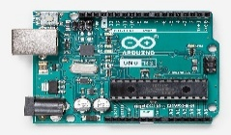  Arduino Uno R3 | 1× | — | The brain of the game! It runs all the code, reads button presses, and controls every LED and sound. Perfect starter board — no soldering required for most connections.
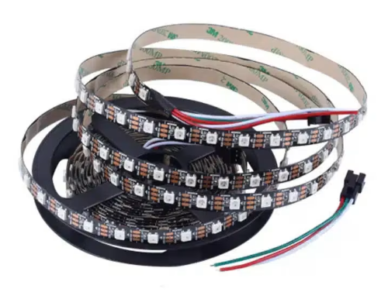  WS2812B LED Strip | 1× | Pin 6 | A strip of 60 smart RGB LEDs. Each LED can show any colour independently. These form the racing track! WS2812B means each LED has its own tiny chip built in.
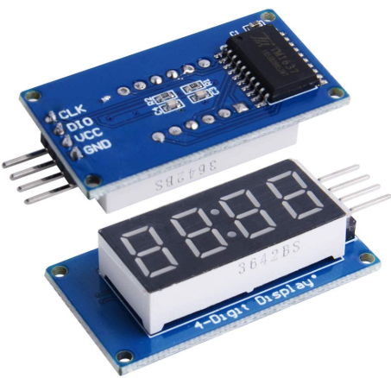  TM1637 4-Digit Display | 1× | Pins 10 & 11 | Shows the lap count for both players in real time. Only needs 2 wires to talk to the Arduino (CLK and DIO). Displays dashes, numbers, and a 'GO!' message.
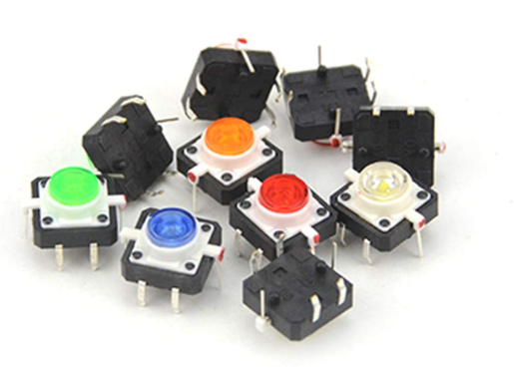  Tactile Push Button | 2× | Pins 2 & 3 | One button per player. Press it fast to accelerate your car! These use the Arduino's built-in pull-up resistors, so no extra resistors needed for buttons.
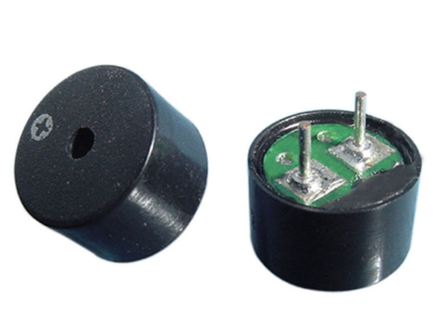  Passive Buzzer | 1× | Pin 8 | Plays all the game sounds: countdown beeps, lap sounds, the win jingle (Super Mario style!), and the sad timeout tune. A passive buzzer can play different pitches unlike active ones.
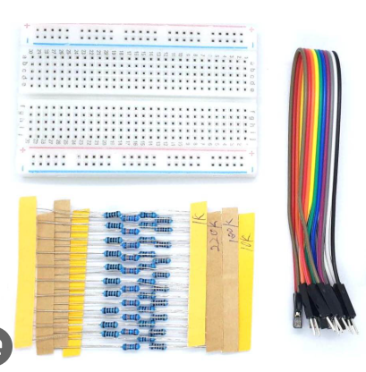  330Ω Resistor + Wires | 1× + set | LED data line | The resistor goes on the LED strip data wire (Pin 6 → LED). It protects the first LED from voltage spikes that can damage the WS2812B chips. Always include this!
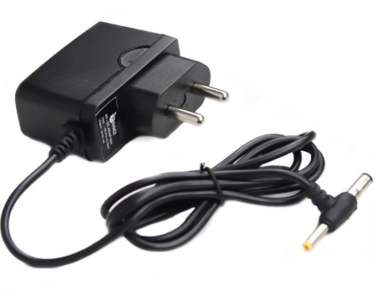  5V Power Supply | 1× | External | The LED strip draws much more current than the Arduino can supply. Use a separate 5V 2A (or higher) power supply for the strip. Connect GND wires together.

2.1 Shopping Tip

💰 Estimated Budget (India)
Arduino Uno R3 (clone) ................................ ₹300 – ₹500
WS2812B LED Strip 60 LEDs ............................ ₹200 – ₹350
TM1637 4-Digit Display ................................ ₹80 – ₹120
Push Buttons (pack of 10) ............................. ₹30 – ₹60
Passive Buzzer ........................................ ₹20 – ₹40
5V 2A Power Adapter ................................... ₹150 – ₹250
Jumper Wires + 330Ω Resistors ......................... ₹50 – ₹80
─────────────────────────────────────────────────────────────────
Total Approx. ......................................... ₹830 – ₹1400
Or just Ask your Lovely Guardian then its Free for you..!!

3. Circuit Diagram & Wiring

3.1 Connection Table
Connect everything to the Arduino Uno as shown in the table below:

Component | Component Pin | Arduino Pin | Notes
WS2812B Strip | DIN (Data In) | Pin 6 | 330Ω resistor in series on this wire
WS2812B Strip | VCC (+5V) | External 5V | Do NOT use Arduino 5V for full strip
WS2812B Strip | GND | GND (shared) | Connect to Arduino GND too
TM1637 Display | CLK | Pin 10 | Any digital pin works
TM1637 Display | DIO | Pin 11 | Any digital pin works
TM1637 Display | VCC | 5V (Arduino) | Display draws very little current
TM1637 Display | GND | GND
Player 1 Button | One leg | Pin 2 | Other leg to GND
Player 2 Button | One leg | Pin 3 | Other leg to GND
Buzzer (+) | Positive | Pin 8
Buzzer (–) | Negative | GND

3.2 Circuit Diagram
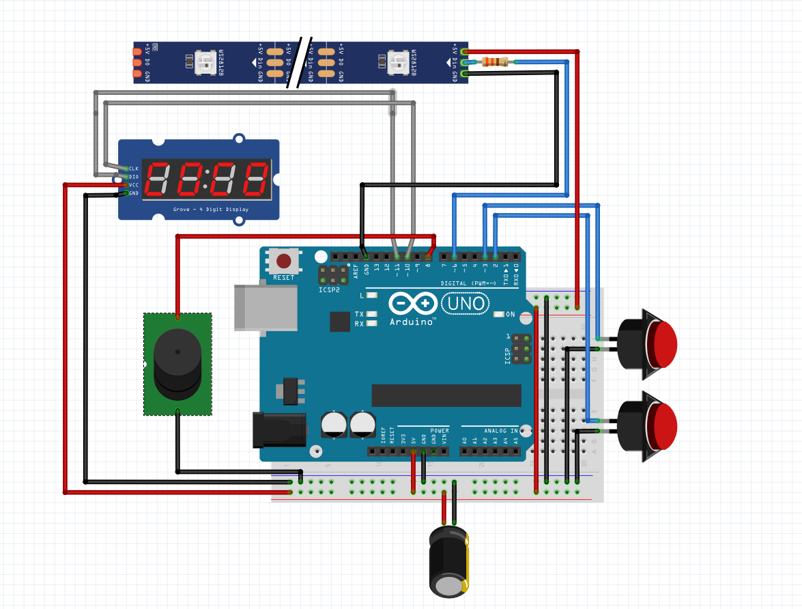

3.3 Wiring Tips for Students
- 🎨 Use coloured wires: Red for +5V, Black for GND, any colour for data/signals
- 📏 Keep wires short and neat — messy wires cause hard-to-find problems
- ⚡ Always double-check power connections before plugging in
- 🔌 The LED needs its OWN 5V supply If it’s a Longer Strip. UNO cannot power Many LEDs.
- 🛡️ Don't forget the 330Ω resistor on the LED data wire — it protects the strip
- 🔁 If LEDs show wrong colours, check your GND connection between power supplies

4. Game Variations
The base game supports 2 players on an Arduino Uno. Below are exciting variations you can build once you're comfortable with the basics!

4.1 Variation A — 4-Player Arduino Mega Edition
🎮 4-Player on Arduino Mega 2560
Board: Arduino Mega 2560 (has more pins!)
New parts: 2 more push buttons + 2 more LED strip segments (or longer strip)
Player colours: Red, Blue, Green, Yellow

Key changes to the code:

// ── Change these settings ──────────────────────────────
#define NUM_PLAYERS 4 // was 2
#define NUM_LEDS 80 // longer track for 4 players
#define TOTAL_LAPS 3 // fewer laps to keep it snappy

#define PIN_P1 2 // Player 1 button
#define PIN_P2 3 // Player 2 button
#define PIN_P3 18 // Player 3 button (Mega pin)
#define PIN_P4 19 // Player 4 button (Mega pin)

// ── Add more player colours ──────────────────────────────
const uint32_t PLAYER_COLOR[4] = {
0x00FF0000, // P1 — Red
0x000000FF, // P2 — Blue
0x0000FF00, // P3 — Green
0x00FFFF00, // P4 — Yellow
};

// ── Update readButton() to handle 4 buttons ─────────────
bool readButton(int i) {
if (i == 0) return digitalRead(PIN_P1) == LOW;
if (i == 1) return digitalRead(PIN_P2) == LOW;
if (i == 2) return digitalRead(PIN_P3) == LOW;
if (i == 3) return digitalRead(PIN_P4) == LOW;
return false;
}

💡 Note: The Arduino Mega has 54 digital pins vs 14 on the Uno — perfect for adding more players or features!

4.2 Variation B — ESP32 Wireless Remote Edition
📡 ESP32 with Bluetooth / Wi-Fi Buttons
Board: ESP32 DevKit (has built-in Bluetooth & Wi-Fi!)
New feature: Players use phone app or wireless buttons instead of wired ones
Extra library: BluetoothSerial (built into ESP32 Arduino core)

How it works: The ESP32 creates a Bluetooth serial connection. Players can connect with a simple BT terminal app on their phones and send '1' or '2' as button presses!

// ── ESP32 Wireless Version — Key additions ───────────────
#include <BluetoothSerial.h>

BluetoothSerial SerialBT;

void setup() {
SerialBT.begin("LED_RACER"); // Bluetooth device name
// ... rest of setup ...
}

// Replace risingEdge() with Bluetooth version:
bool risingEdge(int i) {
if (SerialBT.available()) {
char c = SerialBT.read();
if (c == '1' && i == 0) return true;
if (c == '2' && i == 1) return true;
}
// Fallback: still check physical buttons too
bool now = readButton(i);
bool edge = now && !players[i].prevBtn;
players[i].prevBtn = now;
return edge;
}

4.3 Variation C — Turbo / Obstacle Mode
Add excitement by changing these constants for a completely different feel:

Setting | Default | Turbo Mode | Effect
ACCEL | 0.20 | 0.40 | Cars accelerate much faster per press
FRICTION | 0.015 | 0.040 | Cars brake more — need constant tapping!
TOTAL_LAPS | 5 | 10 | Longer race, more endurance needed
TICK_MS | 5 | 3 | Faster game physics & rendering
RACING_INACTIVITY_MS | 60000 | 30000 | Less idle time before timeout

5. Code Basics & Key Concepts
You don't need to understand every line right away! Here are the most important coding ideas used in this project:

5.1 #define — Setting Game Constants
These are like labelled settings at the top of the code. Changing ONE number here changes the whole game behaviour — you never need to hunt through the code!

#define NUM_LEDS 60 // How many LEDs in your strip
#define TOTAL_LAPS 5 // Laps needed to win
#define ACCEL 0.20 // Speed boost per button press
#define FRICTION 0.015 // How fast cars slow down
#define TICK_MS 5 // Milliseconds per game frame

5.2 enum — Game States
The game is always in one of four states. Using an enum makes the code readable — it's like labelling stages of the game:

enum GameState {
STATE_IDLE, // Rainbow screen — waiting for a player
STATE_COUNTDOWN, // 3 - 2 - 1 - GO! animation
STATE_RACING, // Race is live!
STATE_WIN // Winner animation playing
};

5.3 struct — Player Data
A struct groups related information together. Each player has their own copy of this data:

struct PlayerState {
float speed; // Current speed (LEDs per tick)
float dist; // Total distance travelled
uint8_t laps; // Laps completed
bool prevBtn; // Was button pressed last frame?
};
PlayerState players[2]; // One for each player

5.4 Physics — Speed & Friction
This is real physics simulation in just 3 lines! Every game tick:

// When button pressed — boost speed
players[i].speed += ACCEL;

// Every tick — apply friction (exponential decay)
players[i].speed -= players[i].speed * FRICTION;

// Move the car forward
players[i].dist += players[i].speed;

💡 Note: This simulates a real race car! If you stop pressing, the car doesn't stop instantly — it gradually slows down, just like a real vehicle.

5.5 Lap Detection
Clever maths checks when a car crosses the start line:

// How far must you travel to complete the next lap?
uint32_t lapThreshold = (uint32_t)NUM_LEDS * (players[i].laps + 1);

// Has the car passed that threshold?
if ((uint32_t)players[i].dist >= lapThreshold) {
players[i].laps++; // Count the lap!
beep(600 + i * 100, 3); // Play a sound
}

5.6 Libraries Used

Library | Author | What it does
Adafruit NeoPixel | Adafruit Industries | Controls the WS2812B LED strip — set any pixel to any colour instantly
TM1637Display | Avishay Orpaz | Drives the 4-digit 7-segment display over just 2 wires

Install both via Arduino IDE → Tools → Manage Libraries → Search and install!

6. How to Play

6.1 Base Game (2 Players — Arduino Uno)

Step 1 | Power on the Arduino. The LED strip starts cycling rainbow colours — this is Idle Mode!
Step 2 | Either player presses their button to start the race.
Step 3 | Watch the countdown: 3 → 2 → 1 → GO! With lights and sounds!
Step 4 | Press your button as fast as possible to accelerate your colour dot along the track.
Step 5 | Every time your dot passes the white start/finish line, you complete a lap. The display shows your lap count.
Step 6 | First player to finish 5 laps wins! A green flash, the winner's colour, and the victory jingle plays! 🎵
Step 7 | Game returns to idle rainbow and waits for the next race!

6.2 What the Lights Mean
- 🌈 Rainbow cycling = Idle / Ready to start
- 🔴 → 🟠 → 🟢 Sweep animation = Countdown 3-2-1
- ⚪ Full white flash = GO!
- 🔴 Red dot = Player 1 car | 🔵 Blue dot = Player 2 car
- ⚪ White pixel = Start / Finish line
- 🟢 Green flash = Someone won the race!

6.3 Playing the Wireless (ESP32) Variation
- Connect your phone's Bluetooth to 'LED_RACER'
- Open any Bluetooth terminal app (e.g. Serial Bluetooth Terminal on Android)
- Send '1' to press Player 1 button, '2' for Player 2
- Two phones = two wireless players — no wires needed!

6.4 Playing the 4-Player Variation
- Same rules as 2-player, but now 4 coloured dots race!
- Each player gets their own button (Pins 2, 3, 18, 19 on the Mega)
- More players = more chaos = more fun! 🎉

🏆 Pro Tips for Winning
🔥 Rhythm tapping is faster than random mashing — find your groove!
👀 Watch your dot, not your opponent's — focus wins races!
⚡ Short rapid taps beat long slow presses every time
😌 Stay calm — nerves make you slow down!

7. Future Improvements
This project is just the beginning! Here are fantastic ideas for taking it further — some easy, some advanced:

7.1 Easy Improvements (Beginner Level)
- 🎨 Custom player colours — change PLAYER_COLOR values to any hex colour you like
- 🏁 More laps — increase TOTAL_LAPS for a longer, tougher race
- 🔊 New sounds — edit WIN_NOTES array to play a different victory tune
- 💡 Different LED brightness — change strip.setBrightness(50) in setup()
- ⏱️ Track best lap times using millis() and display on the TM1637

7.2 Intermediate Improvements
- 🌀 Circular LED ring — use a ring-shaped LED for a proper oval racetrack!
- ⛽ Pit stops — every 2 laps, player must hold button for 1 second to refuel before continuing
- 🚧 Obstacles — randomly light up orange LEDs as hazards; hitting one halves your speed
- 📊 Score history — add an SD card module to log race results and show a leaderboard
- 🔋 Battery power — add a LiPo battery and charging module for a portable wireless unit

7.3 Advanced Improvements
- 📱 Mobile app — build a custom Android/iOS app (using MIT App Inventor) to control settings wirelessly
- 🌐 Web dashboard — ESP32 hosts a web page showing live race stats using Wi-Fi
- 🤖 AI opponent — code a bot that automatically presses at random intervals to race against solo players
- 🎓 Multiplayer tournament bracket — auto-manage round-robin tournaments for classroom competitions

📚 Skills You Learn Building This Project
✅ Electronics: Circuits, resistors, power management, LED drivers
✅ Programming: Variables, loops, functions, structs, enums, state machines
✅ Physics: Speed, friction, acceleration (real maths in code!)
✅ Problem Solving: Debugging wiring issues, fixing software bugs
✅ Creativity: Customising colours, sounds, and gameplay rules

8. Conclusion
Congratulations on exploring the 1D RGB LED Strip Racing project! 🎊

What started as a simple idea — two players, two buttons, one LED strip — turned into a full game with physics simulation, sound effects, countdown animations, lap tracking, a winner ceremony, and even wireless remote control possibilities!

This project is a brilliant example of how electronics and programming come together to create something interactive and fun. Every component has a purpose. Every line of code does something. And most importantly — it's a game people actually want to play!

🌟 What We Covered
1. The concept: A button-mashing LED race game for 2+ players
2. Components: Arduino, WS2812B strip, TM1637 display, buttons & buzzer
3. Circuit wiring: How to connect everything safely
4. Variations: 4-player Mega edition, ESP32 wireless, turbo mode
5. Code concepts: defines, enums, structs, physics, and state machines
6. Gameplay: How to play all versions and pro tips for winning
7. Future ideas: From easy tweaks to advanced features

The most important lesson? Building something real is the best way to learn. You touched every piece of this system — power, data, logic, and output. That's exactly how professional engineers work!

Now go build it, play it, break it (on purpose!), fix it, and improve it. That's the DIY spirit! 🔧⚡🏎️

9. Credits & Resources

9.1 About the Creator
Aniket Chowdhury [Hashtag]
Arduino Developer • Maker • Educator
GitHub: github.com/itzzhashtag
Instagram: @itzz_hashtag
LinkedIn: itzz-hashtag
micro.aniket@gmail.com

9.2 Wokwi Simulation
Don't have the hardware yet? Try the fully working simulation in your browser!
🔗 https://wokwi.com/projects/461126131423519745

9.3 Useful Resources
- Arduino Official Site — arduino.cc
- Adafruit NeoPixel Guide — learn.adafruit.com/adafruit-neopixel-uberguide
- TM1637 Library — github.com/avishorp/TM1637
- Wokwi Arduino Simulator — wokwi.com
- Fritzing (circuit diagrams) — fritzing.org

9.4 Acknowledgements
Special thanks to the open-source Arduino community, Adafruit Industries for the NeoPixel library, and all the teachers and students who make DIY electronics exciting!

🏎️ Race you to the finish line! 🏎️
1D RGB LED Strip Racing v2.7.2 • Arduino Uno Edition • Made with ❤️ for makers everywhere

