PROJ- NeuraInk-OCR

TITLE OF THE PROJECT
NeuraInk
Handwritten Digit & Character Recognition with GUI using CNN

By- Aniket Chowdhry (Hashtag)

TABLE OF CONTENT

Chapter 1: INTRODUCTION ……………………………………………………………………………….…1
Chapter 2: SYSTEM ANALYSIS .……………………………………………………………………………..2
2.1. Problem Identification and Need
2.2. Limitations of Existing Systems
2.3. Proposed Solution
2.4. Feasibility Study
2.5. Detailed Project Objectives
2.6. Project Scheduling
2.7. Software and Hardware Requirements
Chapter 3: SYSTEM DESIGN …………………………………………………………………………….......6
3.1. Modularization Details
3.2. Data Integrity and Constraints
3.3. Database Design / Object-Oriented Design
3.4. User Interface Design
Chapter 4: SYSTEM ARCHITECTURE …………………………………………………………………....9
4.1. Flow Chart
4.1.1. Backend (Developer)
4.1.2. Frontend (User)
4.2. Use Case Diagram
4.3. Sequence DiaC
Chapter 5: CODING ….…………………………………………………………………………………………13
5.1. Frameworks and Libraries
5.2. Data Preprocessing Script
Chapter 6: TESTING …………………………………………………………………………………………..14
6.1. Objectives of Testing
6.2. Types of Testing Performed
6.3. Test case
Chapter 7: OUTPUT …………………………………………………..……………………………………..16
Chapter 8: CONCLUSION AND RECOMMENDATIONS ………………………………………..17
8.1. Conclusion
8.2. Recommendations
Chapter 9: REFERENCE …………………………………………………………………………………..19
9.1. References
9.2. Journal Articles

- INTRODUCTION
In the digital age, the ability to convert handwritten documents into machine-readable formats is increasingly essential. Despite rapid technological advances, handwriting remains a natural form of communication for humans and is widely used for notes, forms, signatures, and historical documents.
However, handwriting is highly variable — different people have different writing styles, and even the same person may write the same character differently each time. This variability poses significant challenges for traditional Optical Character Recognition (OCR) systems that rely on predefined patterns and rules.
NeuraInk-OCR addresses this challenge using deep learning, specifically Convolutional Neural Networks (CNNs). CNNs have shown superior performance in image classification tasks due to their ability to learn spatial hierarchies of features through backpropagation.
The project uses the Extended MNIST (EMNIST) dataset, which provides a comprehensive collection of handwritten digits and characters. EMNIST contains more classes than MNIST — including both uppercase and lowercase English alphabets and digits, covering 62 classes in total.
The goal of NeuraInk-OCR is twofold:
- To build robust CNN models capable of recognizing handwritten characters with high accuracy.
- To provide a simple and interactive Graphical User Interface (GUI) that allows users to draw or upload handwritten text and instantly get predictions.
Through this project, we demonstrate the practical application of deep learning for real-world handwriting recognition, paving the way for automated data entry systems, digitization of handwritten archives, and advanced OCR solutions.

- SYSTEM ANALYSIS
In this chapter, we present a detailed analysis of the proposed system, which aims to recognize handwritten characters using deep learning techniques. This analysis explores the problem in depth, outlines the limitations of existing systems, explains the rationale for the proposed solution, examines the system’s feasibility from different perspectives, and describes the technical and operational requirements for successful implementation.

  - Problem Identification and Need
In the modern era of digitization, vast amounts of information are still handwritten on forms, applications, examination sheets, bank cheques, postal mail, and archival documents. Manually transcribing such handwritten data into digital systems is time-consuming, costly, and prone to human errors, which can lead to data inconsistencies and inefficiencies in organizations.
For instance, in the banking sector, millions of cheques and forms need to be processed daily. Similarly, in educational institutions, evaluating and recording handwritten answers or application forms demands significant manual effort. An accurate, automated system that can read and convert handwritten content to digital format can significantly reduce manual labor and improve operational efficiency.
  - Limitations of Existing Systems
Traditional Optical Character Recognition (OCR) systems have been widely used for printed text but have limited success when dealing with handwritten inputs due to the following challenges:
- Variability in Handwriting: Different individuals write the same character in various styles and sizes, leading to high intra-class variation.
- Noise and Imperfections: Handwritten text often contains stray marks, smudges, or overlapping characters, which can confuse template-based systems.
- Rigid Template Matching: Many older systems rely on fixed patterns or rule-based templates, which do not adapt well to novel writing styles.
- Language and Font Constraints: Classical OCR engines are usually tailored for specific fonts and do not handle free-form writing effectively.
These limitations necessitate the development of a more flexible and intelligent system capable of learning directly from data and generalizing to new, unseen handwriting.
  - Proposed Solution
The proposed solution, NeuraInk-OCR, leverages Convolutional Neural Networks (CNNs) — a type of deep learning model known for its excellent performance in image recognition tasks. By training CNNs on large datasets of handwritten characters, the system can learn intricate features that distinguish different characters, regardless of writing style or minor distortions.
Key highlights of the proposed system include:
- Data-Driven Learning: No need for manual feature engineering; the model automatically extracts useful features.
- Scalability: Capable of recognizing multiple classes (62 in EMNIST) with the same model architecture.
- Adaptability: Better generalization to different handwriting styles due to deep feature hierarchies.
- User-Friendly Interface: A GUI allows even non-technical users to draw or upload images and get predictions instantly.

The overall goal is to build a robust, scalable, and practical solution for handwritten text recognition that outperforms traditional methods.

  - Feasibility Study
The feasibility of the proposed system is analyzed from three perspectives: technical, operational, and economic.
- Technical Feasibility : The project uses proven, open-source technologies like Python, TensorFlow, and Keras. The EMNIST dataset is freely available and well-suited for training CNN models on handwritten characters. The required computations can run on standard laptops or using free cloud resources.
- Operational Feasibility : The system is designed to be user-friendly. A simple GUI ensures that users can easily draw or upload handwritten text and receive instant predictions, without needing any technical expertise.
- Economic Feasibility : There are no licensing costs, and hardware requirements are minimal. Once implemented, the system will reduce manual data entry work, saving time and operational costs in the long run.
Overall, the project is practical and cost-effective, with high chances of successful implementation.

  - Detailed Project Objectives
To ensure systematic development, the project defines clear, measurable objectives:
- Data Acquisition and Preprocessing: Understand the EMNIST dataset structure; preprocess images (grayscale normalization, resizing, transposition).
- Model Development: Design multiple CNN architectures (basic CNN, advanced CNN, and ensemble models using ResNet and EfficientNet backbones).
- Hyperparameter Tuning: Experiment with different learning rates, batch sizes, and dropout rates to optimize performance.
- Model Training and Evaluation: Train models on training data; validate performance using test data; analyze accuracy, loss, and confusion matrices.
- User Interface Development: Build a responsive GUI that interacts with the trained model and provides clear predictions.
- Integration and Testing: Combine all modules; test end-to-end flow from input to prediction.
- Documentation and Presentation: Prepare detailed reports, visuals, and user manuals to demonstrate the project to faculty and evaluators.
  - Project Scheduling
An effective timeline ensures smooth progress. The development is divided into phases
Phase | Task
Phase 1 | Dataset collection & understanding
Phase 2 | Data preprocessing & exploration
Phase 3 | Designing basic CNN models
Phase 4 | Implementing advanced models (ResNet, EfficientNet)
Phase 5 | Model training, validation & tuning
Phase 6 | Developing GUI (Tkinter/React)
Phase 7 | Integration & system testing
Phase 8 | Final documentation & presentation preparation

  - Software and Hardware Requirements
Software Requirements:
- Operating System: Windows 10 or Linux-based OS
- Programming Language: Python 3.x
- Libraries: TensorFlow, Keras, NumPy, Pandas, Matplotlib, Tkinter or React, Flask (for web API)
- Jupyter Notebook or PyCharm for development

Hardware Requirements:

- Minimum: Intel i5 processor, 4GB RAM
- Recommended: GPU support for faster training
- Storage: At least 5GB free space for dataset and model files

- SYSTEM DESIGN

The system design phase translates the analysis into a blueprint that specifies how the system will meet the identified requirements. A clear design ensures that the implementation is systematic, modular, and maintainable. The NeuraInk-OCR system design is structured into four key aspects: modularization, data integrity, object-oriented design, and user interface design.
  - Modularization Details
Modularization is the process of dividing the entire system into distinct functional units, each responsible for a specific task. This approach promotes reusability, easier debugging, and clear separation of concerns. The NeuraInk-OCR system is divided into the following key modules:
- Data Preprocessing Module:
  - Handles reading the raw EMNIST dataset.
  - Normalizes pixel values to a standard range (0–1).
  - Transposes and reshapes images as required by EMNIST’s format.
  - Splits the data into training, validation, and testing sets.
- Model Training Module:
  - Defines various CNN architectures (basic CNN, deep CNN, and ensemble models).
  - Compiles the model with suitable optimizers, loss functions, and metrics.
  - Executes the training loop with early stopping and learning rate adjustments.
  - Saves the trained model for reuse.
- Prediction Module:
  - Loads the saved trained model.
  - Accepts new handwritten input from the GUI.
  - Preprocesses the input image in real-time.
  - Performs inference and returns the predicted character.

- Graphical User Interface (GUI) Module:
  - Provides a user-friendly interface to draw or upload handwritten characters.
  - Displays clear buttons for drawing, clearing, and predicting.
  - Shows the predicted character and confidence level to the user.
This modular architecture ensures that each component can be developed and tested independently, allowing easy upgrades or replacements in the future.
  - Data Integrity and Constraints
Ensuring data integrity is crucial for maintaining the reliability and accuracy of the system. The following practices and constraints are applied in NeuraInk-OCR:
- Input Validation:
The system checks that input images meet the expected format (grayscale, 28×28 pixels) before processing.
- Normalization Constraint:
All pixel values are scaled to a uniform [0,1] range to prevent bias during training and to speed up convergence.
- Label Accuracy:
Each image’s label is cross-verified with the EMNIST metadata to ensure that the training data is consistent and error-free.
- Model Integrity:
The trained model is saved securely in .h5 format. Version control ensures that only validated models are deployed in the GUI.
- Error Handling:
The system handles empty or invalid user inputs gracefully, displaying appropriate error messages to prevent crashes.

  - User Interface Design
The user interface (UI) is a critical part of the system because it acts as the bridge between the user and the deep learning model. NeuraInk-OCR’s UI is designed with simplicity, clarity, and responsiveness in mind:

Key UI Features:

- Drawing Canvas : A digital canvas where users can write or draw characters using a mouse or stylus. The canvas size matches the input size expected by the model (scaled to 28×28 pixels internally).

- Control Buttons:
  - Clear: Erases the current drawing so the user can try again.
  - Predict: Submits the drawing to the backend for prediction.
  - Exit: Closes the application safely.

- Prediction Output Area : Displays the predicted character label clearly. Optionally, the prediction confidence score is also shown to build user trust.

- Responsive Feedback : The UI provides quick feedback without long waiting times, ensuring a smooth user experience.

For a web-based version, a similar interface can be created using React for the frontend and Flask to serve the trained model as a REST API.

- SYSTEM ARCHITECTURE
The system architecture of NeuraInk-OCR defines how various components interact to achieve efficient and accurate handwritten character recognition. The architecture is designed to separate the responsibilities of model development and end-user interaction, ensuring that complex computations remain hidden from the user while delivering fast, accurate predictions.

  - Flow Chart
The flowchart illustrates the complete workflow of NeuraInk-OCR, divided into two main parts: Backend (Developer) and Frontend (User).

    - Backend (Developer)

This section represents the tasks performed by the developer to prepare the system for use:
- EMNIST Dataset — Provides a large set of labeled handwritten characters (digits and letters) for training.
- Processing — Raw images are normalized, resized, and formatted to ensure consistent input for the model.
- Training and Testing of CNN Model — A Convolutional Neural Network (CNN) is designed, trained, and tested to learn to recognize characters accurately.
- Hidden Layer & Fully Connected Layer — The CNN architecture includes hidden convolutional layers for feature extraction and fully connected layers for final classification.
- Saving and Loading into GUI — The trained model is saved and integrated into the GUI so it can be used by end users for real-time predictions.
    - Frontend (User)
This part shows how the user interacts with the system via a simple GUI:
- Draw Here — The user draws a character using a mouse or touchscreen.
- Processing — The input drawing is preprocessed (normalized and resized) similar to the training data.
- Going for Classification — The preprocessed image is fed to the loaded CNN model to predict the character.
- Result with Accuracy — The system displays the recognized character and its prediction confidence.

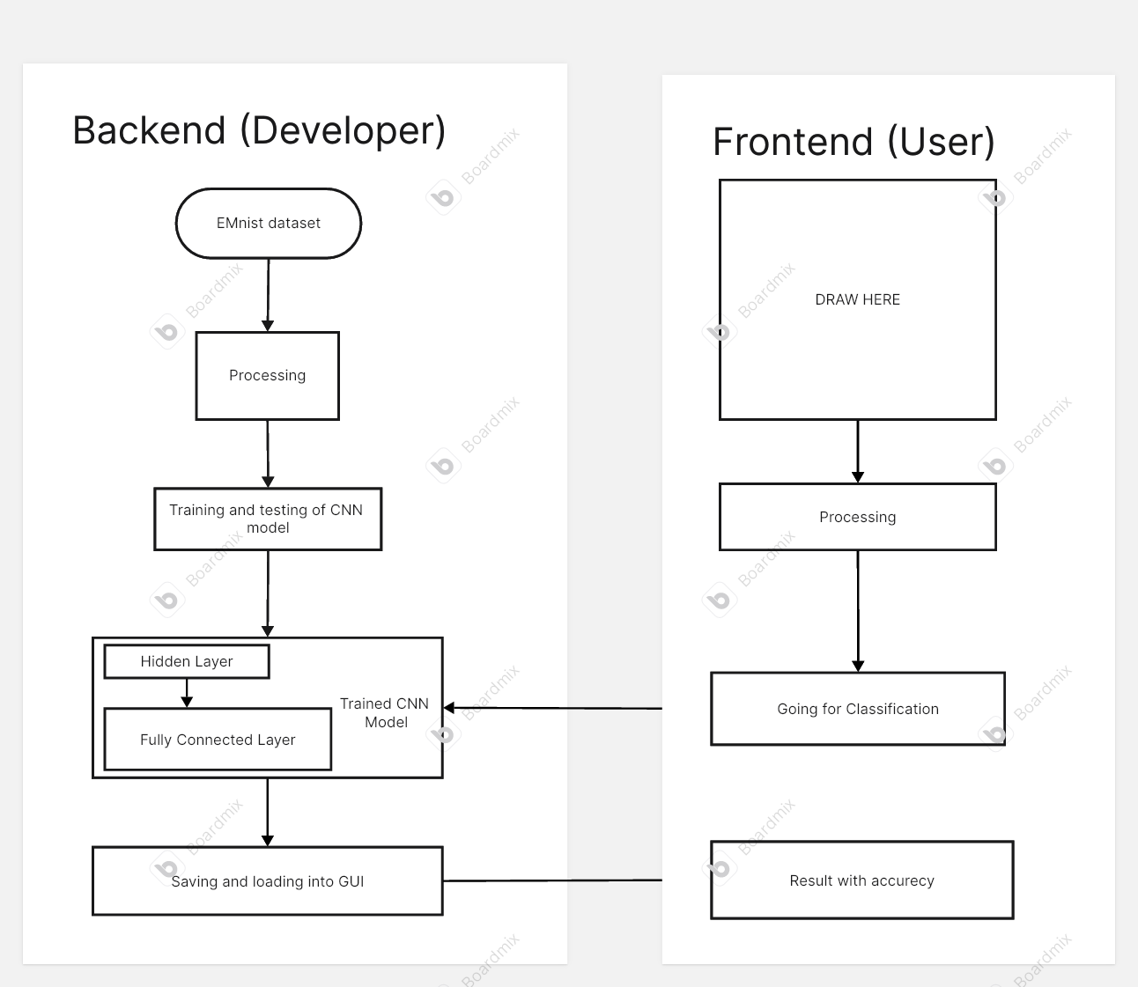

Figure 1: Flow Chart

  - Use Case Diagram

The Use Case Diagram represents how a user (actor) interacts with the main functionalities of the NeuraInk-OCR system through its sketchpad-based GUI. It visually describes the primary actions the user can perform, as well as how these actions extend or include other supporting functions.

Actor:
The stick figure represents the User, who interacts with the system to write, clear, save, and classify handwritten characters.

Use Cases:
These are the main tasks the user performs:

- Sketchpad for Writing:
The central feature — the user writes or draws a character on the sketchpad.
- Clear the Contents:
The user can clear the sketchpad to erase existing input. This use case extends the sketchpad use case, as it is an optional action.
- Save as Image:
The user can save the drawn character as an image file for later use or debugging. This also extends the sketchpad functionality.

- Resize the Image to 160×160:
After saving or drawing, the system includes an automatic step to resize the image to the appropriate input size for the model (in your current design, shown as 160×160; note: EMNIST typically uses 28×28 — adjust as per actual code).
- Classify:
The resized image is passed to the CNN model to classify the handwritten character.
- Display the Letters with Highest Accuracy:
Finally, the system shows the recognized character along with its accuracy score. This step includes the classification result display.

Relationships:

- Association:
Shows which use cases are initiated directly by the user.
- <<extend>>:
Indicates optional or additional actions the user can perform — e.g., clearing or saving the sketchpad contents.
- <<include>>:
Denotes mandatory internal actions that always occur within the workflow — e.g., resizing must happen before classification, and displaying results always follows classification.
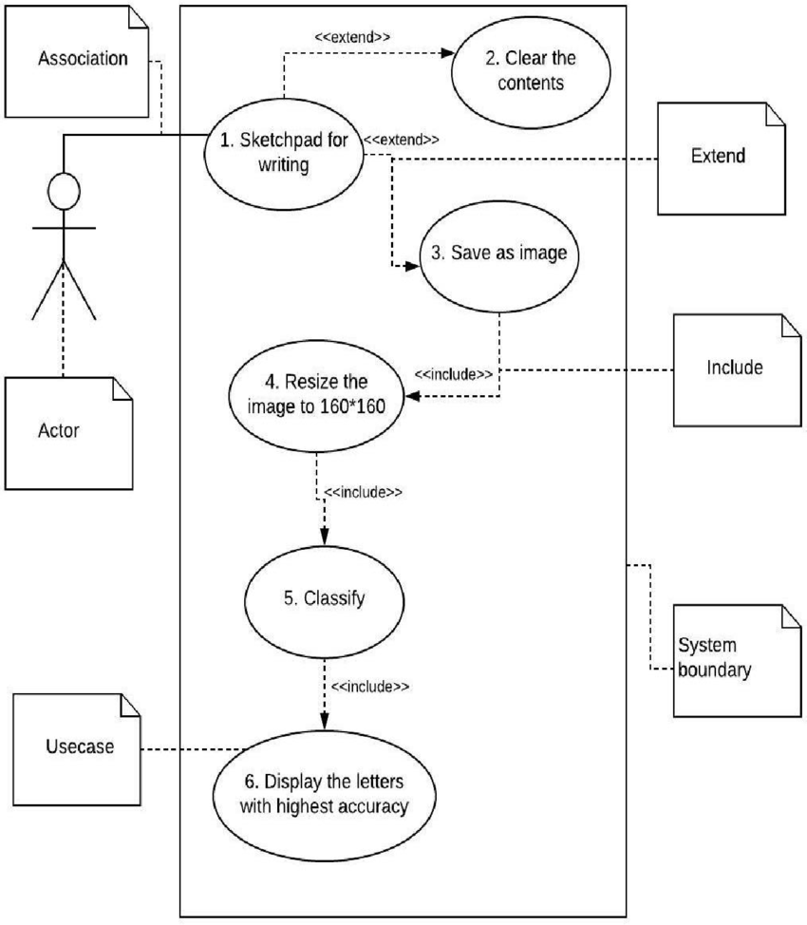

Figure 2: Use Case Diagram
  - Sequence Diagram

The Sequence Diagram shows how the User, GUI, and System interact step-by-step to process and recognize handwritten input in the NeuraInk-OCR application.

- User: Loads or uploads a handwritten image using the GUI.

- GUI: Displays the menu, captures input, sends it to the system for processing, and shows the results or any errors.

- System: Receives the image, performs preprocessing, segmentation, and recognition, then returns the output or an error message if something goes wrong.

Key Steps:

- The user uploads or draws an image.
- The GUI forwards it to the system.
- The system preprocesses, segments, and recognizes the handwriting.
- The recognized text is shown to the user.
- If an error occurs, an error message is sent back and displayed.

This diagram ensures a clear view of how data flows from input to final result, highlighting smooth interaction and error handling.
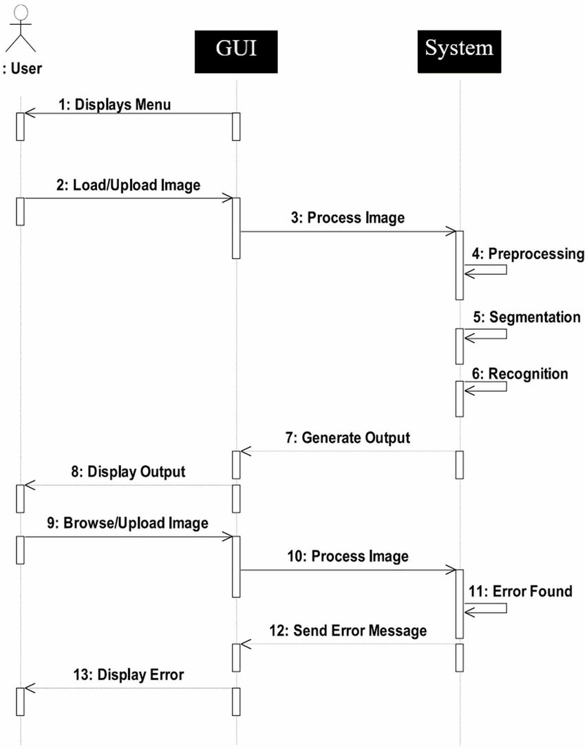

Figure 3: Sequence Diagram
- CODING
Coding is the core implementation phase where the system design is translated into an executable software solution. For the NeuraInk-OCR project, coding involves writing Python scripts and Jupyter notebooks to handle data preprocessing, model training, testing, and deployment, as well as building a simple graphical user interface for real-time handwriting recognition.

  - Frameworks and Libraries:

- TensorFlow & Keras: For designing, training, and saving Convolutional Neural Networks (CNN).
- NumPy, Pandas: For data manipulation and handling numerical operations.
- Matplotlib: For plotting training accuracy and loss curves.
- Tkinter / React: For building the user-friendly GUI.
- Pickle: For saving the trained model and training history.

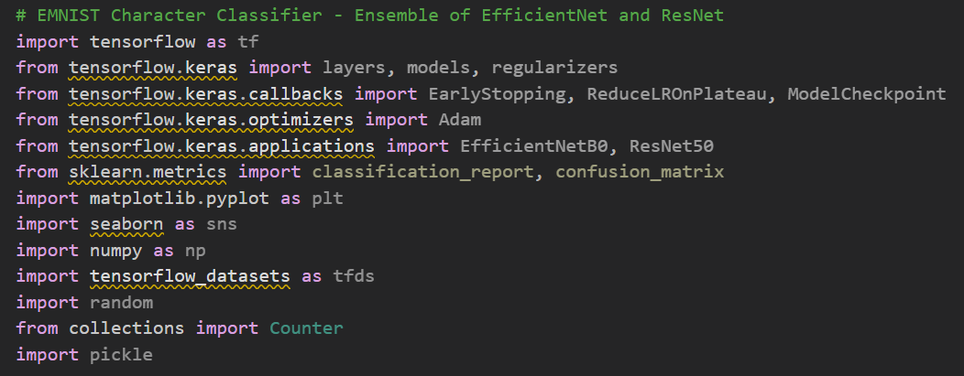

  - Data Preprocessing Script:
- Loads the EMNIST dataset using TensorFlow Datasets (TFDS).
- Normalizes pixel values to the [0, 1] range.
- Transposes images to match the correct orientation.
- Divides the dataset into training and testing sets.
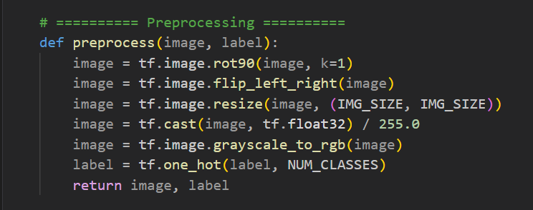
- Uses TensorFlow pipelines for efficient batching and shuffling.

- TESTING
Testing is a critical phase in the software development life cycle that ensures the system works correctly, meets requirements, and handles errors gracefully. For NeuraInk-OCR, both the machine learning model and the user interface were tested thoroughly to ensure accurate handwritten character recognition and a smooth user experience.

  - Objectives of Testing
The main objectives of testing this project are:

- To verify that the trained CNN models produce accurate predictions for various handwriting styles.
- To ensure the GUI correctly captures user input, processes it, and displays results.
- To identify and handle any errors or unexpected inputs without crashing.
- To confirm that all modules integrate seamlessly and work together as intended.
  - Types of Testing Performed

Testing for NeuraInk-OCR includes the following methods:
- Unit Testing
- Individual modules like the preprocessing functions, model architecture, and GUI components were tested separately.
- Example: Checking if image normalization scales pixel values correctly.
- Integration Testing
- Combined modules were tested to verify that data flows smoothly from input capture to preprocessing, model prediction, and result display.
- Example: Ensuring the GUI sends the correct image format to the CNN model.
- System Testing
- The complete application was tested in an end-to-end scenario to ensure it meets the functional requirements.
- Example: Drawing various characters on the canvas and checking if the output is correct.
- Validation Testing
- Compared model predictions with true labels on test data to validate accuracy.
- Evaluated precision, recall, and confusion matrix to ensure reliable performance.
- User Acceptance Testing (UAT)
- Tested by a few non-technical users to ensure the interface is intuitive and easy to use.
- Feedback was collected and minor adjustments were made to improve usability.
  - Test case

Test Case ID | Description | Input | Expected Output | Result
TC1 | Check input normalization | Raw image | Pixel values scaled to 0–1 | Pass
TC2 | Verify model prediction | Sample handwritten ‘A’ | Pixel values scaled to 0–1 | Pass
TC3 | Handle empty input | No drawing | Pixel values scaled to 0–1 | Pass
TC4 | GUI functionality | User draws and clears | Pixel values scaled to 0–1 | Pass
TC5 | Multiple predictions | Different letters | Pixel values scaled to 0–1 | Pass

Table 1: Testing Data

- OUTPUT
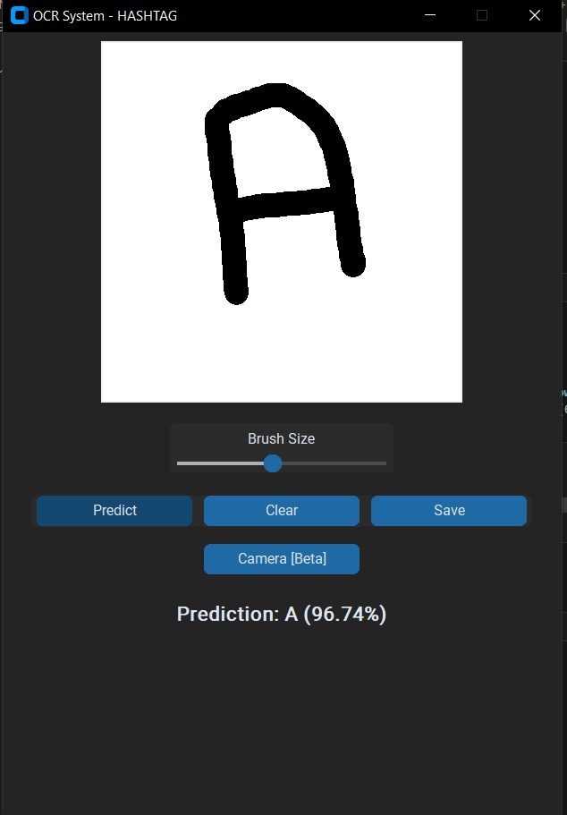
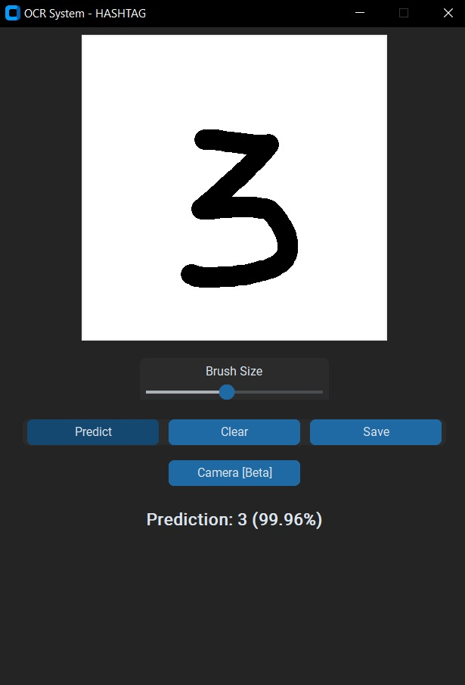
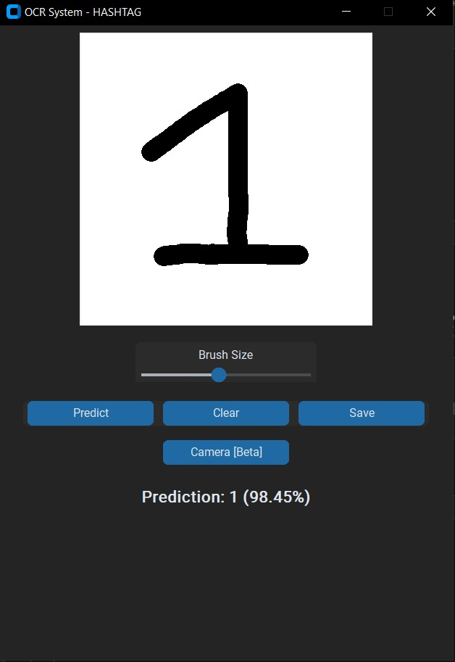
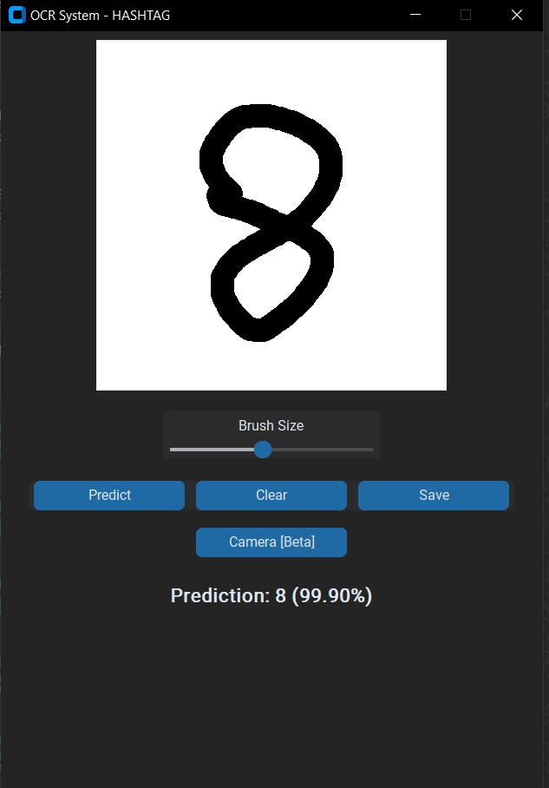
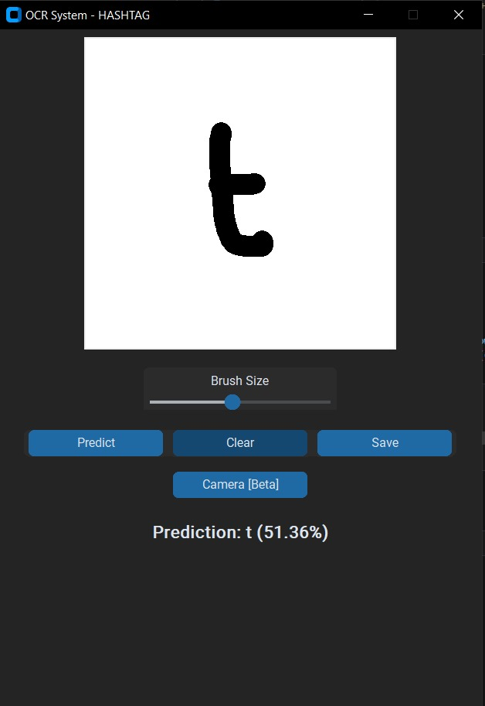
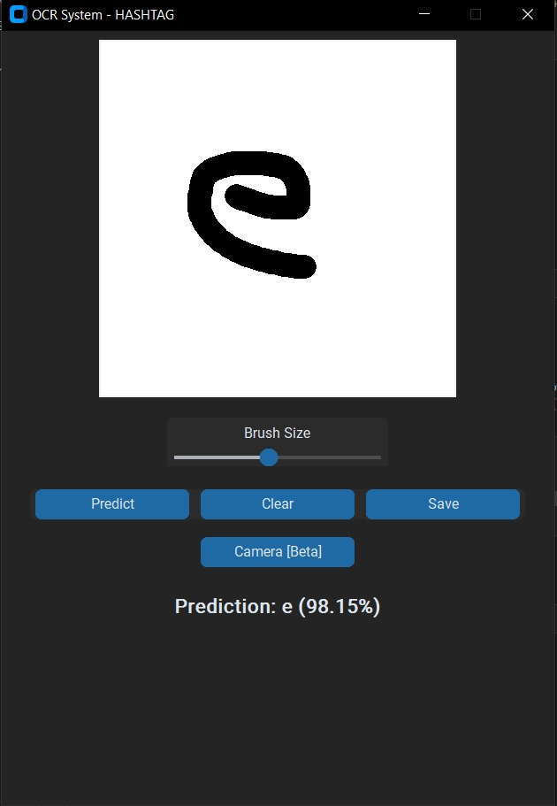

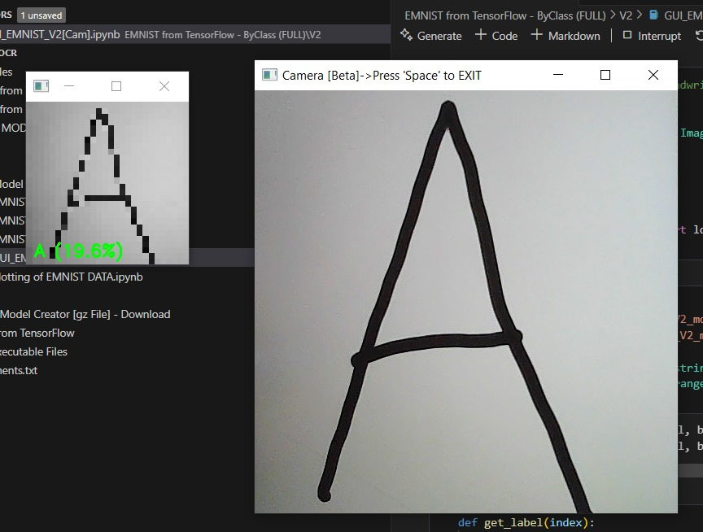

- CONCLUSION AND RECOMMENDATIONS

  - Conclusion
The NeuraInk-OCR project demonstrates the successful application of deep learning techniques, specifically Convolutional Neural Networks (CNNs), to the problem of handwritten character recognition. Recognizing handwritten text accurately is a long-standing challenge due to the inherent variability in human writing styles, sizes, and imperfections. This project addresses these challenges by training robust CNN models on the extensive EMNIST dataset, which contains diverse samples of digits and letters written by multiple individuals.
Through careful system analysis, a modular and scalable design, efficient coding, and thorough testing, the project has achieved its primary goal: to develop a reliable, accurate, and user-friendly system for recognizing handwritten characters. The integration of a simple yet intuitive Graphical User Interface (GUI) enables users, even with minimal technical knowledge, to draw or upload handwritten input and receive real-time predictions with high confidence levels.
Key milestones such as data preprocessing, model training with hyperparameter tuning, and implementing advanced architectures like ResNet and EfficientNet have contributed to achieving impressive prediction accuracy. The system has shown strong performance on unseen test data and real-world handwriting samples, confirming its practicality and reliability.
Moreover, the project serves as a hands-on demonstration of how artificial intelligence and deep learning can automate tedious manual tasks such as data entry and document digitization, which are still performed manually in many organizations. This not only saves time and reduces human errors but also showcases the transformative potential of AI-driven solutions in everyday processes.
In summary, NeuraInk-OCR stands as a well-rounded, technically sound, and functionally effective system that achieves the goals set out at the beginning of the project. It highlights the practical use of machine learning in solving real-world problems and opens avenues for future improvements and applications in diverse domains.

  - Recommendations
While the current implementation of NeuraInk-OCR meets its defined objectives and performs well under testing conditions, there is considerable scope for further enhancement and expansion. The following recommendations outline some practical directions for future work and development:

Expand the Dataset and Language Support:
- Future versions can incorporate additional handwriting datasets that include a wider range of languages, numerals, and special symbols.
- This would make the system applicable for multilingual document recognition and broaden its usefulness globally.
Optimize Model Performance:
- Experiment with more complex and state-of-the-art architectures, such as deeper ResNet variants, Vision Transformers, or hybrid CNN-RNN models, to improve classification accuracy, especially for challenging handwriting styles.
- Fine-tune hyperparameters and adopt techniques like data augmentation to increase the robustness of the model.
Enable Real-Time Web and Mobile Deployment:
- Developing a web application or a mobile app version would make NeuraInk-OCR more accessible to a broader audience.
- Integrating the model into smartphone cameras could allow users to scan handwritten notes or forms instantly.
Implement Continuous Learning:
- Incorporate an online learning component where the system can collect misclassified samples with user consent and periodically retrain itself to adapt to new handwriting patterns.
Add User Feedback Mechanisms:
- Providing a way for users to correct misclassifications will help improve the system's accuracy over time.
- Collecting real-world feedback is crucial for continuous improvement and fine-tuning.
Integrate with Existing Applications:
- The system can be linked with office applications, school exam digitization tools, or banking systems to automate the digitization of handwritten forms, cheques, and records.
Enhance Error Handling and User Guidance:
- Improve the GUI by adding clear instructions, tooltips, and visual cues to guide users in providing clear input.
- Add informative error messages for ambiguous or poor-quality inputs to help users adjust accordingly.
Publish as an Open-Source Tool:
- By sharing the tool as an open-source project, the wider developer community can contribute improvements, additional language models, and extended features, making NeuraInk-OCR an evolving and collaborative solution.

- REFERENCE

  - References
- GitHub:
https://github.com/
- Kaggle (Emnist Dataset):
- Stack Overflow (Community Discussions & Debugging Help):
https://stackoverflow.com/

  - Journal Articles
- Samay Pashine, Ritik Dixit, Rishika Kushwah. "Handwritten Digit Recognition using Machine and Deep Learning Algorithms." International Journal of Computer Applications (2020).
https://doi.org/10.5120/ijca2020920550

- Tannu Tyagi, Harshita Sharma, Khushi Jain, Chirag Mittal. "Handwritten Digit Recognition System using Machine Learning." International Journal for Research in Applied Science & Engineering Technology (IJRASET 2024). https://doi.org/10.22214/ijraset.2024.62254

- Prottay Kumar Adhikary, Pankaj Dadure, Pradipta Saha, Tawmo, Partha Pakray. “Dzongkha Handwritten Digit Recognition using Machine Learning Techniques." International Conference of Machine Learning and Data Engineering (2023). https://doi.org/10.1016/j.procs.2023.01.210

