Report
Of
Virtual Data Analysis Internship: E-Governance & Digital Services (An Advanced Excel Based Analytics Study)
Submitted
To
School of Computer Science and Engineering
IILM University, Greater Noida, U.P.
In partial fulfilment of the requirement of degree of
B.Tech CSE

By
Roll Number of Student: 25SCS1003003014
Name of Student: ARPIT LAMBA
Batch: 2026-27

Internship Completion Certificate


CANDIDATE'S DECLARATION
I, Arpit Lamba (Roll No. 25SCS1003003014), do hereby declare that the internship report titled "Virtual Data Analysis Internship: E-Governance & Digital Services (An Advanced Excel Based Analytics Study)" has been completed by me to fulfil the requirement for the award of the degree of Bachelor of Technology in Computer Science and Engineering. All the references used in this report have been duly quoted and acknowledged, and I have not taken as such any material from any other source without acknowledgement. I affirm that this report is my own original work, prepared on the basis of the virtual data-analysis internship undertaken with YuvaIntern, and that it has not been submitted to any other institute for any degree or diploma requirement. I shall be solely responsible for any kind of copyright violation in this regard.
Signature: ______________________
Student Name: Arpit Lamba
Roll No.: 25SCS1003003014

ACKNOWLEDGEMENT
I take this opportunity to express my sincere gratitude to everyone who supported me throughout this internship. I am thankful for the guidance, constructive feedback and encouragement extended to me during the course of this work, which was completed virtually under the Data Analysis internship track offered by YuvaIntern, in association with Henry Harvin Education and the National Skill Development Corporation (NSDC).
I would like to thank the mentors and program coordinators at YuvaIntern for structuring a well-defined, week-wise learning path on Advanced Excel and e-governance data analysis, and for their valuable inputs at each stage of the project. I am equally grateful to the faculty of the School of Computer Science and Engineering, IILM University, Greater Noida, U.P., for their continuous academic guidance and for giving me the opportunity to undertake this internship as part of my B.Tech curriculum.
Finally, I express my heartfelt gratitude to my parents and friends for their constant encouragement, patience and support, without which the successful completion of this internship and report would not have been possible.
Signature: ______________________
Student Name: Arpit Lamba
Roll No.: 25SCS1003003014

TABLE OF CONTENTS
1. Candidate's Declaration i
2. Acknowledgement ii
3. Internship Completion Certificate --
Table of Contents iii
List of Tables iv
List of Figures v
4. Project Description 1
4.1 Introduction 1
4.2 Organization Profile 2
4.3 Problem Statement 2
4.4 Project Objectives 3
4.5 Scope of the Project 3
4.6 Technologies and Tools Used 4
4.7 System Architecture 5
4.8 Methodology 6
4.9 Expected Outcomes 9
4.10 Certificates of Completion and Communication Proof 12
5. Bibliography / References 13

LIST OF TABLES
Table 4.1 Categories of Data Used in the E-Governance Analysis 7
Table 4.2 Illustrative Twelve-Month Operational Dataset 7
Table 4.3 Data Quality Checks and Controls 8
Table 4.4 KPI Scorecard – Annual Averages vs. Benchmarks 9
Table 4.5 Summary of Actionable Recommendations 10

LIST OF FIGURES
Figure 4.1 Data and Reporting Architecture Used Across the Internship 5
Figure 4.2 Illustrative Pivot-Table Summary: Service Completion Rate 8
Figure 4.3 Monthly Digital Service Demand and Completed Cases 9
Figure 4.4 Applications by Service (Dashboard Illustration) 11
Figure 4.5 Digital Service Usage: Historical Trend and Forecast 11

CHAPTER 4
PROJECT DESCRIPTION

4.1 Introduction
Digital government, commonly referred to as e-governance, is reshaping the manner in which citizens interact with public institutions. Services such as certificate issuance, licensing, pension disbursal, tax collection, grievance redressal and utility connections are increasingly delivered through online portals rather than physical counters. However, placing a service online does not automatically make it efficient, inclusive or trustworthy. Understanding whether a digital service is actually working for citizens requires structured data analysis: measuring how long services take, how reliable the underlying systems are, how satisfied citizens are, and where processes break down.
This report documents a Virtual Data Analysis Internship undertaken on the theme of E-Governance & Digital Services, completed remotely through the YuvaIntern platform (in association with Henry Harvin Education and the National Skill Development Corporation). The internship was structured as a progressive, week-wise project in which Microsoft Excel was used as the principal analytical tool. The work began with a strategic planning framework grounded in international digital-government research, moved through an Advanced Excel data-management and data-cleaning exercise, then a KPI dashboard-building exercise, followed by scenario analysis and predictive modelling, and concluded with a capstone performance evaluation that consolidated the findings of the earlier stages into a single decision-oriented report.
Because the internship was virtual and did not provide access to any live government database, all analysis was carried out on illustrative, self-prepared datasets that were deliberately designed to resemble real public-service records (application IDs, districts, services, processing times, citizen ratings and status fields). This approach kept the project reproducible and safe from a data-privacy perspective, while still requiring the same analytical discipline that a real e-governance data project would demand: framing a problem, sourcing credible reference material, cleaning and validating data, building measurable indicators, visualising results and translating findings into recommendations.
The remainder of this chapter describes the host organisation, the problem addressed, the objectives and scope of the internship project, the tools and system architecture used, the methodology followed across the different stages of work, and the outcomes and learning obtained by the end of the internship.

4.2 Organization Profile
The internship was completed through YuvaIntern, a virtual internship and experiential-learning platform that connects students with structured, project-based internship tracks that can be completed remotely. YuvaIntern issues certification for successfully completed internships in collaboration with Henry Harvin Education and carries endorsement from the National Skill Development Corporation (NSDC), a public-private undertaking under India's Ministry of Skill Development and Entrepreneurship that works to promote skill-development initiatives across the country.
Henry Harvin Education, the partner organisation associated with the certification, is a global upskilling and education-technology company that was established in 2013 and offers a large portfolio of live, instructor-led certification and diploma programmes spanning technology, data analytics, finance, management, digital marketing and allied domains. Alongside training delivery, Henry Harvin also provides project support, internship support and placement assistance to learners, positioning itself as a career- and competency-development organisation rather than a purely academic one. This internship track – Virtual Data Analysis Intern: E-Governance & Digital Services – was designed within this ecosystem to give learners hands-on, Excel-based analytical experience on a public-sector-oriented theme.

4.3 Problem Statement
Digital portals can still be difficult for citizens to use even after a service has been moved online: forms may be complicated, information may be requested more than once, processing may be slow, interfaces may not be accessible to all users, and feedback mechanisms may be weak or absent. Because internal government systems could not be accessed for this virtual internship, the project instead used publicly available information, secondary international benchmarking frameworks, and realistic illustrative datasets to study these problems from a data-analysis perspective.
The central problem statement guiding the internship was: How can publicly available data and structured analytical methods be used to identify performance gaps, inclusion barriers, data-quality problems and improvement opportunities in digital public services? This overarching question was broken down into five connected sub-questions that shaped the work across the internship weeks:
- What services and users are being studied?
- What data is available, and is it trustworthy?
- Which indicators best reflect service quality and accessibility?
- What patterns, delays or gaps can be detected in the data?
- Which evidence-based interventions should be prioritised?

4.4 Project Objectives
The internship was built around a set of strategic goals that were carried consistently across all stages of the work:
- Build an evidence base by creating a transparent inventory of public datasets, service portals, indicators and reference sources (OECD, World Bank, UN).
- Measure service performance in terms of availability, digital adoption, processing speed, first-time-right rate and reliability.
- Assess citizen centricity and inclusion by checking whether outcomes vary across districts, services or channels, and whether assisted-service options are needed.
- Strengthen data governance by documenting data ownership, definitions, refresh frequency, quality rules and limitations.
- Prioritise improvements by ranking issues using impact, evidence strength, feasibility and risk.
- Create a repeatable Excel-based reporting system – using tables, formulas, PivotTables, conditional formatting and dashboards – that could support ongoing monitoring rather than a one-time report.
At the level of individual internship weeks, these goals translated into specific objectives: designing a workbook structure capable of separating raw, cleaned and analytical data; detecting and correcting duplicate, missing or inconsistent records; building a KPI dashboard that a non-technical stakeholder could read in under a minute; using regression, scenario planning and Solver to forecast demand and test operating conditions; and finally, consolidating all indicators into a scorecard benchmarked against realistic service-level targets.

4.5 Scope of the Project
The scope of the internship was intentionally layered so that each week built on the previous one. The project used a four-part data strategy: international secondary sources (OECD Digital Government Policy Framework, World Bank GovTech Dataset and Maturity Index, UN E-Government Survey) for definitions and benchmarking context; illustrative service-level datasets designed to resemble government open-data releases; derived operational and citizen-feedback data linked through a common record identifier; and documentation/metadata treated as a data asset in its own right.
The work was organised into five connected modules, each represented by one of the internship deliverables reviewed in this report:
- Module 1 – Strategic Planning & Framework Design: research-based problem framing and an Advanced Excel project-control workbook (schedule, timeline, KPI framework, risk register, dashboard).
- Module 2 – Advanced Excel Data Management Plan: a workbook design for cleaning, validating and structuring public-service, operational and citizen-feedback data.
- Module 3 – Dashboard Documentation: a KPI dashboard converting raw service records into decision-ready visuals.
- Module 4 – Scenario Analysis & Predictive Modelling: regression-based forecasting, what-if scenarios, sensitivity analysis and Solver-based optimisation on a twelve-month illustrative dataset.
- Module 5 – Final Performance Evaluation: a capstone scorecard consolidating completion rate, processing time, uptime, satisfaction and SLA-resolution indicators against planning benchmarks.
The project was explicitly scoped to remain at an academic, demonstration level. It does not use, and was never intended to use, confidential or personally identifiable government data; all figures used in the illustrative datasets are hypothetical and constructed only to demonstrate the analytical method.

4.6 Technologies and Tools Used
Microsoft Excel served as the primary analytical environment throughout the internship, supplemented by Microsoft Word for documentation and publicly available international frameworks used as reference and benchmarking material. The Advanced Excel features used across the different modules included:
- Excel Tables – used to hold raw and cleaned data (e.g., the ServiceData table) so that formulas and charts expand automatically as records are added.
- Formulas and functions – XLOOKUP, COUNTIF/COUNTIFS, SUMIFS, AVERAGEIF/AVERAGEIFS, IFERROR, IFS, FILTER and UNIQUE – for validation, conditional counting and KPI calculation.
- Conditional formatting – colour scales and rule-based highlighting used to flag duplicate records, delayed cases and low citizen ratings.
- Data validation – drop-down lists and range checks used to prevent invalid statuses, dates or percentages from entering the model.
- PivotTables, PivotCharts and slicers – used (and recommended for scale-up) to summarise service performance by month, district, service type and channel.
- Regression analysis, Data Tables and Solver – used for trend-based forecasting, sensitivity analysis and constrained optimisation of an operating target.
- VBA macros – used conceptually for repeatable refresh and formatting automation (Macro_Control sheet).
- Charts – column, line and pie charts used to visualise workload, processing time and case-status distribution.
In addition to Excel itself, the project drew on publicly published digital-government frameworks – the OECD Digital Government Policy Framework and Digital Government Outlook, and the World Bank GovTech Dataset and GovTech Maturity Index – as reference material for defining indicators and benchmarks in a manner consistent with recognised international practice.

4.7 System Architecture
Rather than storing everything on a single worksheet, each workbook produced during the internship followed a layered architecture that separated raw data from cleaned data, analysis and reporting. This design reduces the risk of accidental changes to source information and creates a simple audit trail, since the original imported records are never edited directly. Figure 4.1 summarises the overall data-and-reporting architecture that was used consistently across the internship modules.
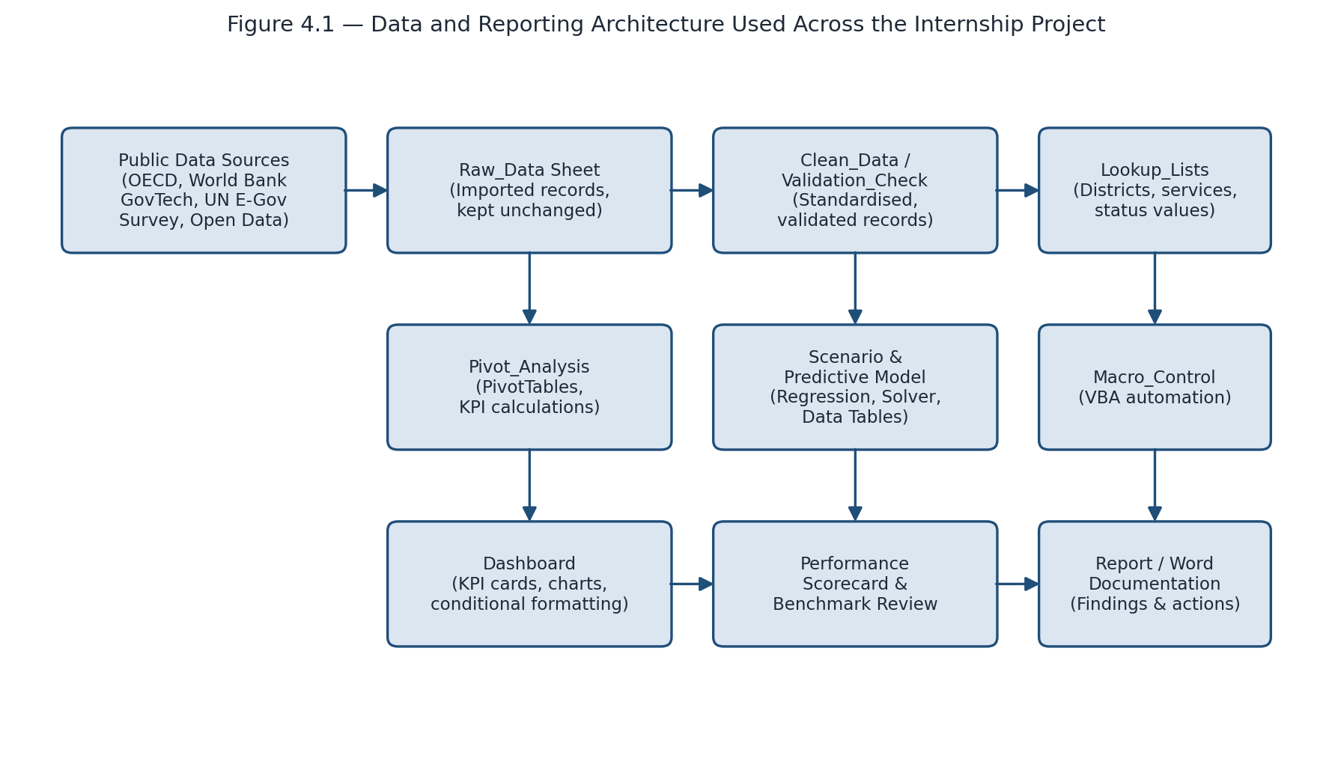
Figure 4.1: Data and Reporting Architecture Used Across the Internship Project
Public and illustrative source data first enters a Raw_Data sheet that is kept unchanged for reference. A Clean_Data / Validation_Check layer then applies standardisation rules (trimming text, correcting dates, flagging duplicates) with the help of a Lookup_Lists sheet that stores approved district, service and status values. From this cleaned layer, two parallel analytical paths were used depending on the internship module: a Pivot_Analysis path for descriptive KPI summarisation, and a Scenario & Predictive Model path for regression-based forecasting and Solver-based optimisation. Both paths ultimately feed a Dashboard / Performance Scorecard, which is finally translated into a written report documenting findings and recommended actions. A Macro_Control sheet supports repeatable refresh and formatting tasks so that the workbook can be reused with new data in future reporting cycles.

4.8 Methodology
A consistent five-stage methodology was applied across the internship, adapted slightly for each module's specific focus (data management, dashboarding, or predictive modelling):
- Stage 1 – Research and Scoping: reviewing authoritative public frameworks (OECD, World Bank GovTech, UN E-Government Survey) and defining the specific service, users and questions to be analysed.
- Stage 2 – Data Inventory and Dictionary: listing available datasets/fields and defining every KPI, unit, valid value and missing-value rule before analysis begins.
- Stage 3 – Data Preparation: cleaning duplicates, standardising text and dates, validating ranges, and preserving a raw, unedited copy of the source data.
- Stage 4 – Analysis: applying descriptive statistics, trend analysis, segmentation, benchmarking, process analysis and data-quality/risk analysis; for the predictive-modelling module this stage additionally included regression, what-if scenario comparison (best-case, most-likely, worst-case), Data Table sensitivity analysis and Solver-based optimisation.
- Stage 5 – Dashboarding, Interpretation and Reporting: building PivotTables, charts, conditional formatting and KPI cards; interpreting results against benchmarks; and converting findings into prioritised, owner-assigned recommendations.
This structure mirrors the twelve-step implementation plan defined at the start of the internship (scope → research → data inventory → data dictionary → data preparation → exploratory analysis → inclusion/risk review → dashboard → recommendations → quality assurance → documentation → monitoring), which was used as a checklist while producing each weekly deliverable. Data-quality checks were embedded throughout rather than treated as a final step; Table 4.3 (Section 4.9) summarises the specific checks and Excel methods used.
For the scenario-analysis and predictive-modelling module specifically, a twelve-month illustrative dataset (sampled in Table 4.2) covering service requests, average processing time, system uptime and citizen satisfaction was used to build a simple linear regression forecast, compare best-case/most-likely/worst-case operating scenarios, run a two-variable Data Table for sensitivity analysis, and use Solver to identify a feasible staffing/processing target under defined constraints.
Month | Service Requests | Avg. Processing Time (min) | System Uptime (%) | Citizen Satisfaction (%)
January | 4,200 | 18.5 | 96.2 | 72
March | 4,700 | 17.4 | 96.8 | 74
May | 5,300 | 16.2 | 97.3 | 76
July | 5,900 | 15.1 | 97.8 | 78
September | 6,600 | 14.0 | 98.1 | 80
November | 7,350 | 13.1 | 98.4 | 82
December | 7,800 | 12.7 | 98.6 | 83
Table 4.2: Illustrative Twelve-Month Operational Dataset (used for trend and predictive analysis)
Before this dataset could be analysed, it was checked against the data-quality and categorisation approach defined in the data-management module. Table 4.1 shows how the underlying service, operational and feedback data were categorised, and Table 4.3 shows the specific validation checks applied.
Data Category | Examples | Key Attributes | Purpose
Public service records | Certificates, pensions, licenses | Record ID, service, district, application date, status, completion date | Track applications and service delivery
Operational logs | Staff actions, processing stages | Officer ID, action time, stage, department, remarks | Measure workload and delays
Citizen feedback | Ratings, complaints, suggestions | Feedback ID, Record ID, rating, category, comment, date | Understand satisfaction and recurring issues
Table 4.1: Categories of Data Used in the E-Governance Analysis

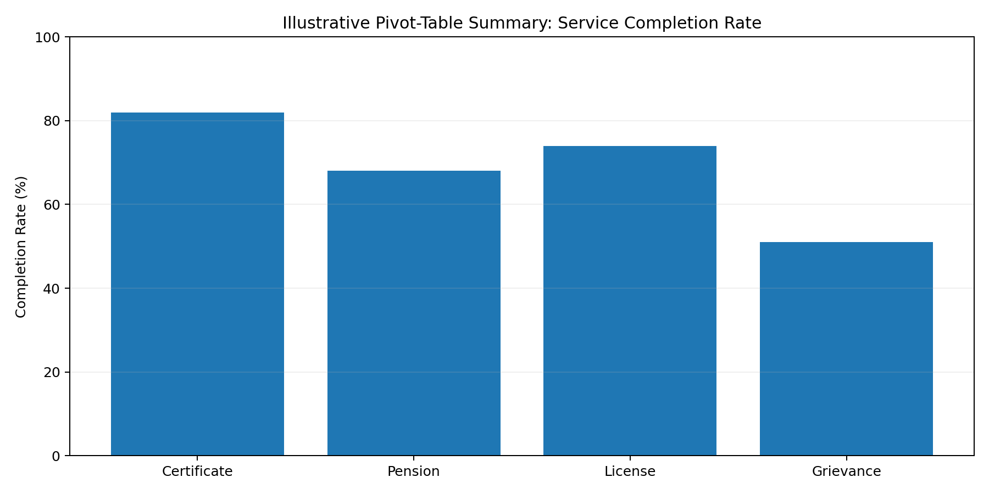
Figure 4.2: Illustrative Pivot-Table Summary – Service Completion Rate by Service Type
Figure 4.2 illustrates the kind of PivotTable-driven summary the data-management workbook was designed to produce: comparing completion rates across service categories (certificate, pension, license and grievance services) so that management attention can be directed toward the weakest-performing category – grievance handling in this illustration.
Check | Excel Method | Expected Action
Duplicate Record ID | COUNTIF / Conditional Formatting | Review and merge or remove confirmed duplicates
Missing mandatory value | COUNTBLANK / IF | Flag the record for correction
Invalid status | Data Validation / XLOOKUP | Replace with an approved category
Wrong date sequence | IF formula | Review application and completion dates
Long processing time | IF + Conditional Formatting | Investigate the delay
Low citizen rating | Rating rule + PivotTable | Review related complaints
Table 4.3: Data Quality Checks and Controls

4.9 Expected Outcomes
Applying the dashboard and scorecard approach to the illustrative twelve-month dataset produced a consistent and encouraging performance picture. Monthly digital service requests rose from 4,200 in January to 7,800 in December, while completed cases rose from 3,980 to 7,540 over the same period – showing that the platform absorbed substantially more workload by year-end. At the same time, average processing time fell from 18.5 minutes to 12.7 minutes, system uptime improved from 96.2% to 98.6%, citizen satisfaction rose from 72% to 83%, and monthly complaints fell from 310 to 212, with SLA resolution improving from 78% to 89%.
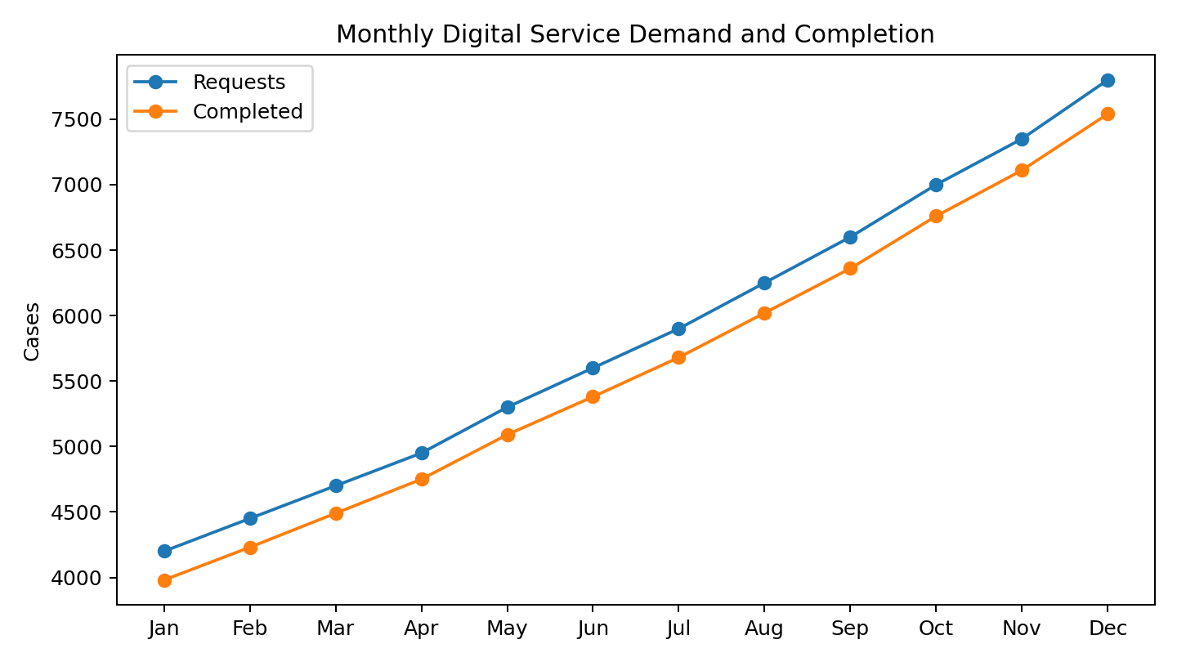
Figure 4.3: Monthly Digital Service Demand and Completed Cases
Table 4.4 summarises the resulting annual KPI averages against the planning benchmarks that were defined at the start of the evaluation. The comparison shows that a single end-of-year snapshot and a full-year average can tell different stories – December alone would suggest that nearly every target is met, while the annual average reveals that early-year performance was weaker, reinforcing the internship's broader lesson that dashboards should show trend as well as current status.
KPI | Annual Average | Benchmark | December (Latest Month)
Completion rate | 96.0% | ≥ 95% | 96.7%
Avg. processing time | 15.5 min | ≤ 15 min | 12.7 min
System uptime | 97.5% | ≥ 98% | 98.6%
Citizen satisfaction | 77.5% | ≥ 80% | 83%
SLA resolution | 83.5% | ≥ 85% | 89%
Table 4.4: KPI Scorecard – Annual Averages vs. Benchmarks
On the basis of this analysis, the internship converted findings into a short list of actionable, owner-assignable recommendations, summarised in Table 4.5, covering capacity planning, reliability management, process improvement, citizen-experience tracking, SLA monitoring, dashboard governance and ongoing data-quality control.
Recommendation Area | Suggested Action
Capacity planning | Use monthly demand and peak-period trends to plan server, network and staffing capacity.
Reliability management | Set dashboard alerts for uptime below target and maintain tested backup/recovery procedures.
Process improvement | Investigate services with above-target processing times and remove repeated data entry or unnecessary approval steps.
Citizen experience | Track satisfaction by service type and prioritise services receiving the most complaints.
SLA monitoring | Create an exception report for cases approaching their SLA deadline and escalate overdue cases.
Data quality & governance | Assign a KPI owner, maintain a data dictionary, and apply validation/duplicate checks continuously.
Table 4.5: Summary of Actionable Recommendations

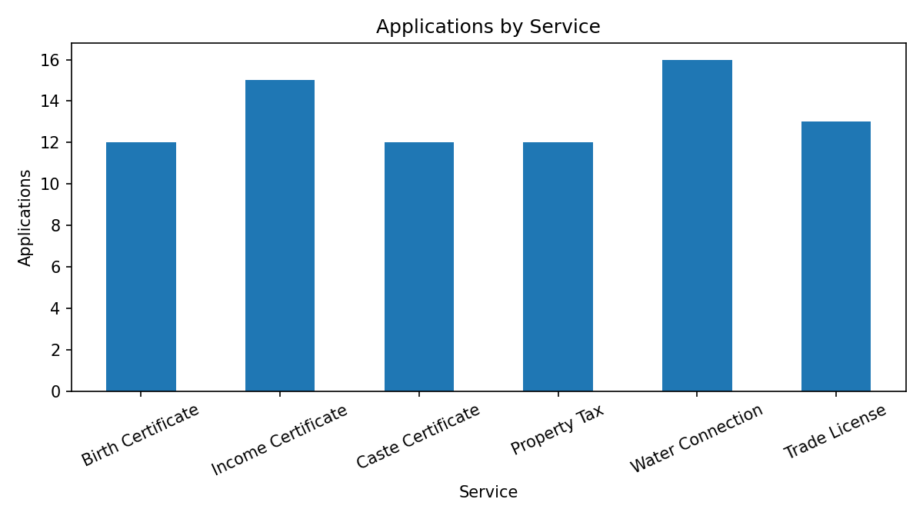
Figure 4.4: Applications by Service (Dashboard Illustration)
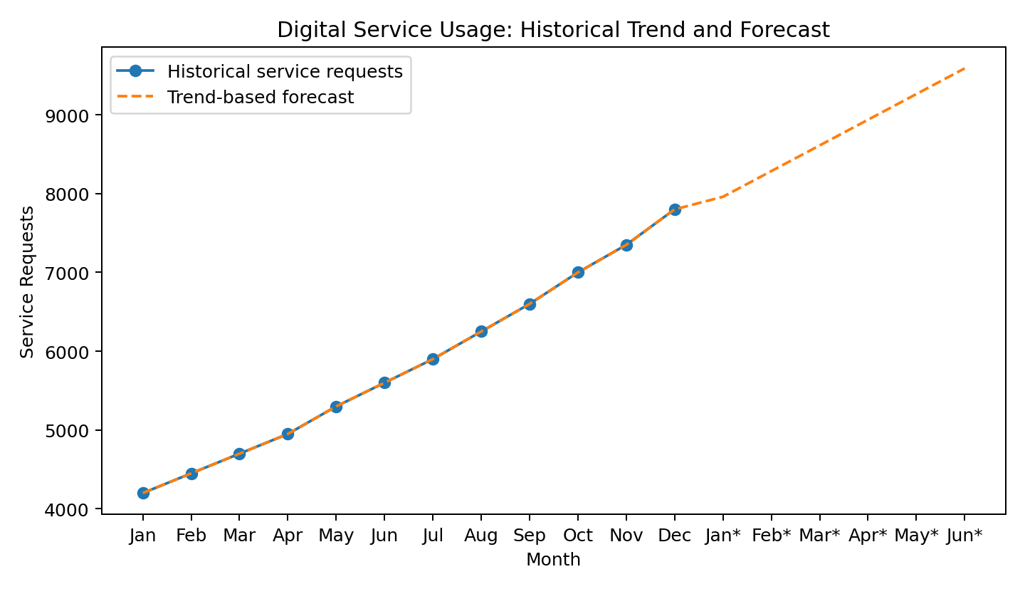
Figure 4.5: Digital Service Usage – Historical Trend and Forecast
Beyond the specific numerical results, the internship produced several durable outcomes at a skills level. These include working proficiency in Advanced Excel features (Tables, PivotTables/PivotCharts, XLOOKUP, COUNTIFS/SUMIFS/AVERAGEIFS, conditional formatting, data validation, Solver and regression-based forecasting); the ability to design a layered, auditable workbook architecture that separates raw data from cleaned and reported data; practical experience translating a broad public-policy problem into measurable KPIs; and familiarity with recognised international digital-government frameworks (OECD Digital Government Policy Framework, World Bank GovTech Maturity Index, UN E-Government Survey) that can be applied to future, real-world e-governance or public-sector analytics projects.

4.10 Certificates of Completion and Communication Proof
The certificate of experience issued on successful completion of this internship is attached as Chapter 3 of this report ("Internship Completion Certificate"). The certificate was issued by YuvaIntern, in association with Henry Harvin Education and the National Skill Development Corporation (NSDC), and carries the following details:
- Intern Name: Arpit Lamba
- Role: Virtual Data Analysis Intern – E-Governance & Digital Services
- Certificate Number: YI/2026/211570/459799
- Date of Issue: October 18, 2026
- Issued by: Kounal Gupta, Founder, YuvaIntern.com
This certificate, together with the four weekly project deliverables summarised in this chapter (the Strategic Planning & Framework Design report, the Advanced Excel Data Management Plan, the Dashboard Documentation, the Scenario Analysis & Predictive Modelling report, and the Final Performance Evaluation report), constitutes the complete body of work produced during the internship.

CHAPTER 5
BIBLIOGRAPHY / REFERENCES
OECD (2020). The OECD Digital Government Policy Framework: Six Dimensions of a Digital Government. Available at: https://www.oecd.org/en/publications/the-oecd-digital-government-policy-framework_f64fed2a-en.html
OECD (2026). Digital Government Outlook 2026 – Strengthening Digital Public Infrastructure and Data Governance. Available at: https://www.oecd.org/en/publications/2026/06/digital-government-outlook_4585678e/full-report/strengthening-digital-public-infrastructure-and-data-governance_2c7323c7.html
OECD (2026). The OECD Going Digital Integrated Policy Framework 2026. Available at: https://www.oecd.org/en/publications/the-oecd-going-digital-integrated-policy-framework-2026_0254ae07-en.html
World Bank. GovTech: Putting People First. Available at: https://www.worldbank.org/en/programs/govtech
World Bank. GovTech Dataset / Data Catalog. Available at: https://datacatalog.worldbank.org/search/dataset/0037889/govtech-dataset
World Bank. GovTech Maturity Index. Available at: https://www.worldbank.org/en/programs/govtech/gtmi
World Bank. Digital Government. Available at: https://www.worldbank.org/en/topic/digital/brief/digital-government
United Nations Department of Economic and Social Affairs. UN E-Government Survey (used as a reference benchmarking framework for citizen-facing digital service indicators).
Henry Harvin Education. Corporate and programme information, including internship, project-support and certification services. Available at: https://www.henryharvin.com/
YuvaIntern. Virtual Data Analysis Internship Programme – E-Governance & Digital Services track. Available at: https://yuvaintern.com/
Microsoft Corporation. Microsoft Excel product documentation – Tables, PivotTables, XLOOKUP, Data Validation, Conditional Formatting and Solver reference. Available at: https://support.microsoft.com/excel

