**Mallidi Akhil Reddy**

# PROFILE ABOUT ME

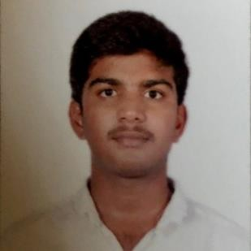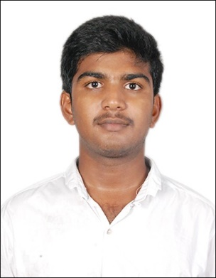

I am looking for place where I can use my knowledge to serve the organisation and evolve continuously through learning.

 **EDUCATION**

# Bachelor of Engineering / Bachelor of Technology



Sathyabama Institute of Science and Technology

8.75 [CGPA] Chennai, Tamil Nadu

*Pursuing*

 Mallidi Akhil Reddy  Tossipudi, Andhra

Pradesh

 +91 9840290129

 [akhilmallidi.98@gmail.c](mailto:akhilmallidi.98@gmail.c)om

 https:/[/www.linkedin.co](http://www.linkedin.co/) m/in/itzzmeakhi/

# Intermediate

Sri Chaitanya Junior Kalasala Obtained 95%

Vijayawada, Andhra Pradesh

# High School

Sri Chaitanya Techno School Obtained 9.8 CGPA Rajahmundry, Andhra Pradesh

*Graduated May 2015*

*Graduated May 2013*

# TRAINING & CERTIFICATIONS

Data Analyst Nanodegree Udacity, completed by 2018. Introduction to Modern Application Development NPTEL, 2016

Front End Development Program

Free Code Camp, 2017 Web Designing

Fita, 2018 Python

Besant Technologies, 2017 Intro to SQL for Data Science Course DataCamp, 2018

# SKILLS

Quick Learner Time Management Self Motivation Team Work

 **WORK EXPERIENCE**

# Technical Lead

*Nov 2017*

*- Curr*



**Team Meraki**

Nov2017 - Current

We are about a number of six. With a common motive among us to create awareness among students, we formed as a group. Later many of our friends from our college joined with us. I have worked as Technical Lead for Team Meraki. With all my team support, we

developed a website for Team Meraki.

**Here is the link of the website:** [http://teammeraki.in](http://teammeraki.in/)

# ENGINEERING/TECHNOLOGY

**Languages –** C, C++, Python

**Web Components –** HTML, CSS, Javascript, Jquery, PHP, Bootstrap

**Database –** MySQL

**Development Tools –** Sublime Text, Github, Terminal, Eclipse

# EXTRA CURRICULAR ACTIVITIES

Organized environmental awareness meet for students in our college on behalf of Team Meraki ( Voluntary Organisation).

Worked as Brand Manager for Intern Theory Career Solutions LLP**.**

# LANGUAGES

**Telugu English**

**Hindi**

 **PERSONAL INTERESTS**

Reading Novels Travelling Online Classes Playing Cricket Photography

# PERSONAL INFORMATION

**Birthday**

March 26, 1998

**Gender**

Male

**Marital Status**

Single

**Father's Name**

Mallidi Venkata Reddy

**Nationality**

India

 **PROJECTS**

# Project Buddy - A Social Networking Site



**Period: May 2018 - June 2018**

Buddy is a web-based application that was developed using PHP and MySQL. It offers many features to its users like they can add/remove their friends, post on the wall, can like the posts, can update their profile.

# Project Investigating TMDB Movie dataset using Numpy, Pandas and Matplotlib

**Period: June 2018 - June 2018**

This project was done as a part of the Data Analyst Nanodegree program in Udacity. Five steps of Data Analysis process are performed on movie dataset, to view patterns among them and to visualize correlations among the data.

# Project News Scrapping from

**College Website**

**Period: May 2018 - May 2018**

To keep updated with the news that was published on the college website, we should browse it daily. So to automate this process, I developed a python program that scraps the news and links published on the college website at 9 PM daily and sends me a CSV file to my mail.

# Project Us Bike Share Data Analysis

**Period: May 2018 - May 2018**

This project was done as a part of Data Analyst Nanodegree program. Us bike share data of three cities are analyzed and patterns like most popular route, frequent stations are analyzed.

# REFERENCES

Padala Venkata Rama Reddy Vice President Software, PHAZR Bangalore

Email: [reddy_padala@yahoo.co.in](mailto:reddy_padala@yahoo.co.in) Ph: +91 9441817482

 **DECLARATION**

I, Mallidi Akhil Reddy, hereby declare that the information contained herein is true and correct to the best of my knowledge and belief.

# Mallidi Akhil Reddy Chennai, Tamil Nadu Date: