**Modular Machines that Make:**

**Instructions for Building and Programming**

**Building Your Machine**

Use the template files and build instructions provided here:

<http://monograph.io/james/m-mtm>

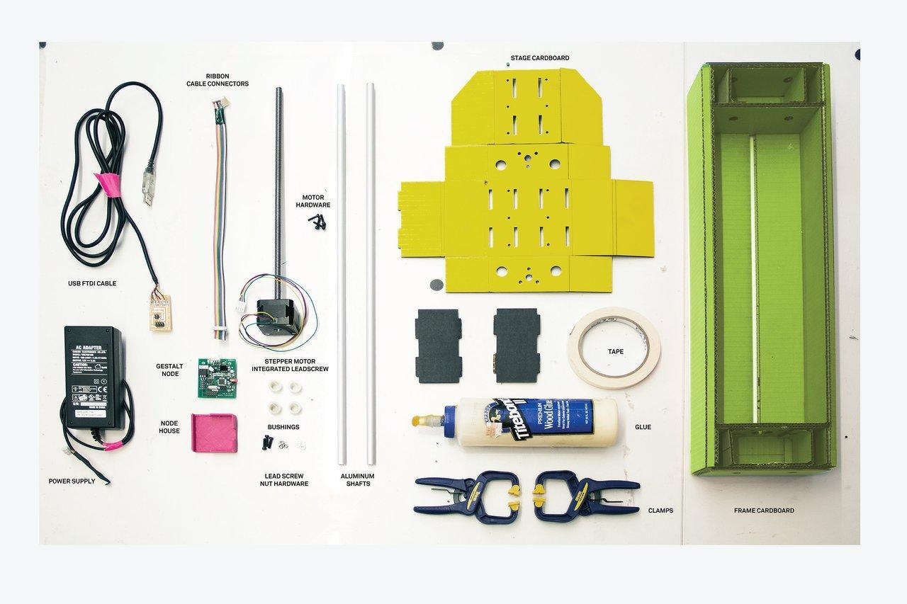

***Note that your power supply must be 12V, 1.25A to 2A!***

**Programming Your Machine (Ubuntu)**

**Setup**

All the items needed for unpacking are listed below and should be in the same directory as the instructions.

- pygstalt-master.zip https://github.com/nadya/pygestalt

- pyserial-2.7.tar.gz https://pypi.python.org/pypi/pyserial/2.7

Create a folder in the desired location. These instructions will place the folder on the desktop labeled gestalt_machines. Note that every time a “$” is shown in this tutorial, you will type the following statements into the terminal. Furthermore, you may copy the commands by highlighting and right clicking to copy and right where you want to place and right click and paste.

Open terminal and by default you should be in the directory "/home”

Create a directory to place your files in:

$ mkdir Desktop/gestalt_machines

("mkdir" stands for make directory.)

In terminal, navigate to the new directory that you just created:

$ cd Desktop/gestalt_machines/

Copy the zip files into this directory.

Do a sanity check from the terminal to see what files are in the current directory.

$ ls

There should be two zip files in the directory.

Now unzip pyserial-2.7 with the below commands

$ tar -xzf pyserial-2.7.tar.gz

$ cd pyserial-2.7

$ sudo python setup.py install

You will be prompted to enter password for the computer account you're currently logged in to, so type it in.

Then move up one directory, back into the gestalt_machines folder. Make sure to remember the two dots afterwards.

$ cd ..

Now unzip the pygestalt-master.zip

$ unzip pygestalt-master.zip

Install pygestalt-master

$ cd pygestalt-master/

$ sudo python ./setup.py install

Now your computer should be ready to rock and roll.

**Loading the Firmware (NOT TYPICAL- only do this step if you board has not yet been programmed)**

Connect the node to the computer via the FTDI cable and the AVR ISP as shown. **Make sure to connect your FabNET adapter board to power last.**

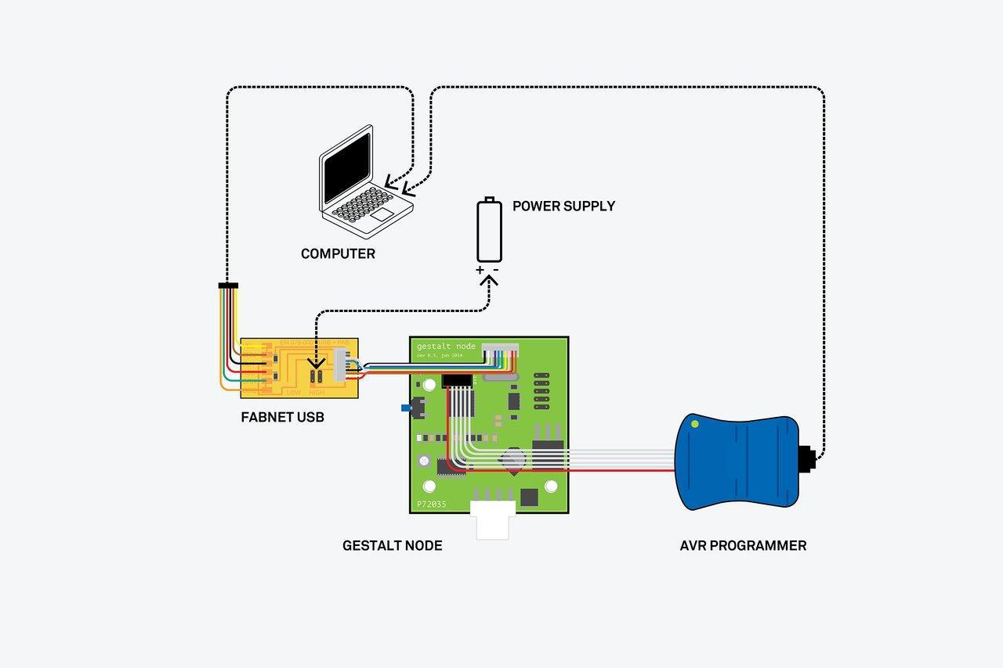

*Note that this diagram is slightly inaccurate and the red voltage indicator on the AVR ISP should be on the left hand side, but needs to connect from the top not the bottom.*

Download the firmware from here: <https://github.com/imoyer/086-005>

Unzip the folder and save it to your desktop

Navigate to this new folder

$ cd Desktop/086-005-master

Open the makefile in nano editor

$ Nano Makefile

Find this section of the code:

# uncomment to program application

# avrdude - e - c avrisp2 - P usb - p m328p - U flash:w: 086-005a.hex

Remove the comment mark (#) so that the code reads as follows:

# uncomment to program application

avrdude - e - c avrisp2 - P usb - p m328p - U flash:w: 086-005a.hex

Save your changes and exit the nano editor.

Set the fuses:

$ sudo make program-avrisp2-fuses

Burn the bootloader:

$ sudo make program-avrispAH2

Now we are ready to test the boards!

**Running a Single Node**

See the image above. Connect the node to the computer via the FTDI cable as shown. **However, do not connect power until you are ready to run. Also note that you do NOT need the AVR programmer if the firmware is already installed on the boards.**

Navigate to the correct directory- pygestalt-master

$ cd Desktop/Gestalt_Machines/pygestalt-master

Now change directory using the below command.

$ cd examples/machines/htmaa/

Next open single_node.py in your favorite text editor to check the USB port number.

Do this by opening the Gestalt_Machines folder using the GUI and navigate to pygestalt-master/examples/machines/htmaa/ and double clicking on single_node.py

Go back to the terminal to list all the USB devices.

The below command will list the USB devices connected to the computer.

$ ls /dev/ttyUSB*

**By default the device is ttyUSB0, however, this may change if unplugged and replugged.** Make sure the connected device and the single_node.py are the same. If they are not modify the single_node.py to what the device is by changing the portName.

-----single_node.py code snippet start-------

else: self.fabnet = interfaces.gestaltInterface('FABNET', interfaces.serialInterface(baudRate = 115200, interfaceType = 'ftdi', portName = '/dev/**ttyUSB0**'))

-----single_node.py code snippet end-------

**Now, connect power correctly, this is crucial to get correct otherwise you may permanently damage your boards. Remember, only connect power after all of your boards are connected to the computer. Refer to the diagram above.**

To run the file, type:

$ python single_node.py

Purple light on the node is flashing. If the node is not identified in a short amount of time it will time out and retry.

The terminal should look something like below and a purple light on the node should be lit.

----------

single_node.py: Warning: setting persistence without providing a name to the virtual machine can result in a conflict in multi-machine persistence files.

FABNET: port /dev/ttyUSB0 connected succesfully.

X Axis: please identify me on the network.

----------

Push the button on the node and the servo should now go through the steps in the program.

You did it!

Note that running a file creates a test.vmp file in the same folder. If you want to re-run the python module, you will need to first delete this test.vmp file.

**Troubleshooting**

IF you run into problems, here are some common errors and possible solutions.

-------error 1------------

X Axis: Could not reach virtual node. Retrying

-------error 1------------

- power may not be connected

-------error 2------------

Warning: setting persistence without providing a name to the virtual machine can result in a conflict in multi-machine persistence files.

FABNET: error opening serial port /dev/ttyUSB0

X Axis: please identify me on the network.

FABNET: serialInterface is not connected.

-------error 2------------

- the portName may be incorrect

- the USB plug may not be plugged in

-------error 3 if it retries quickly < one second------------

Warning: setting persistence without providing a name to the virtual machine can result in a conflict in multi-machine persistence files.

FABNET: port /dev/ttyUSB1 connected succesfully.

X Axis: Could not reach virtual node. Retrying (#2)

X Axis: Could not reach virtual node. Retrying (#3)

X Axis: Could not reach virtual node. Retrying (#4)

......

-------error 3 if it retries quickly < one second------------

- The fabnet may be unplugged to a node

**Running Multiple Nodes**

If you are running multiple nodes, make sure they are properly “daisy chained” together, referring to the diagram below. **Again, double-check all of your connections before you connect your power supply!**

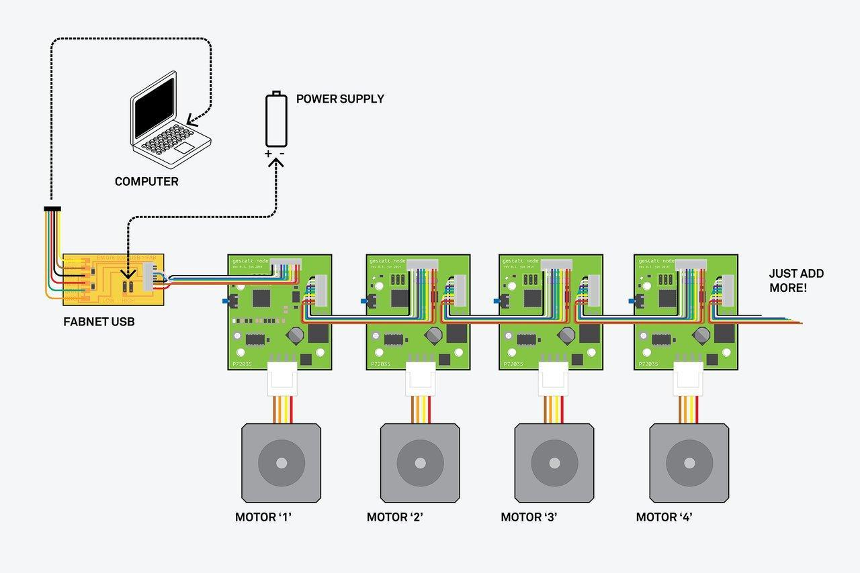

Lastly, make sure to change the name of the USB port in your Python script as you did in the “Running a Single Node” example.