|  |  |
| --- | --- |
| **Name:** Buo, Mark Jomar B. | **Date:** 06-12-2016 |
| **Course/Section:** CPE232/CPE42FC1 | **Instructor:** Engr. Clifford Arambala |
| **Activity 3 – Install and Configure Windows Server 2008 Active Directory** | |

* Intended Learning Outcomes

To be able to install and configure active directory in Windows Server 2008 R2

* Materials

1. Personal Computer
2. GNS3 Software
3. Virtual Box with installed Windows Server 2008 R2 and Windows 7 and cloned client PC.

* Output:

- GNS3 Setup:

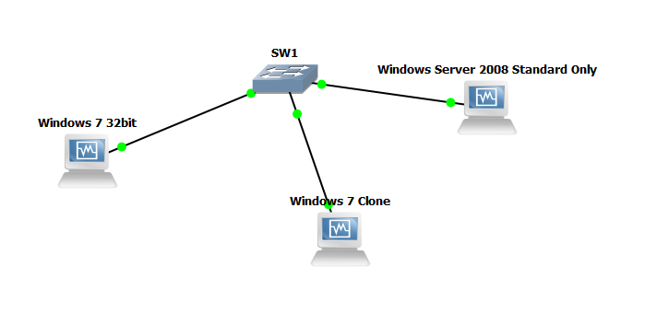

- Successfully joined to the domain:

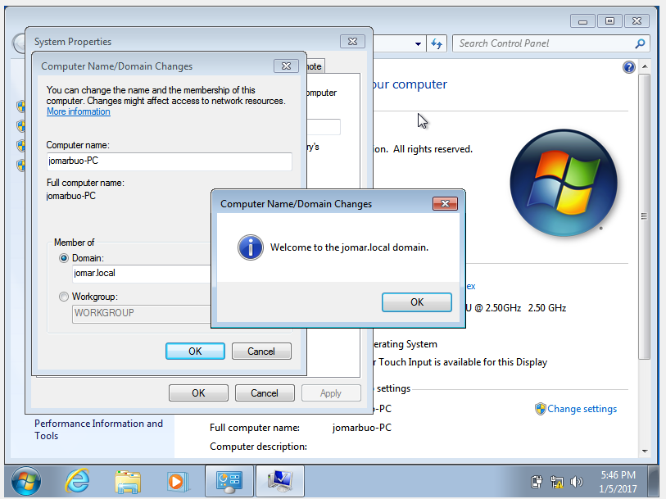

- After rebooting the client PC:

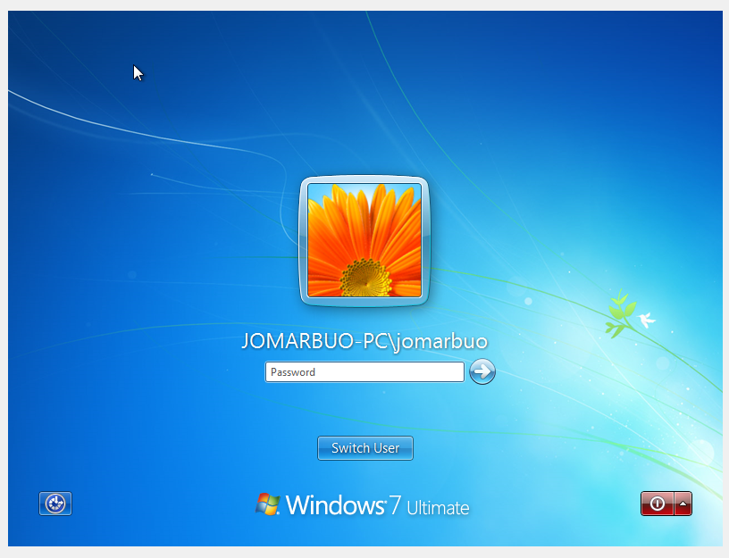

-Checking the lists of clients that has joined the domain in Windows Server:

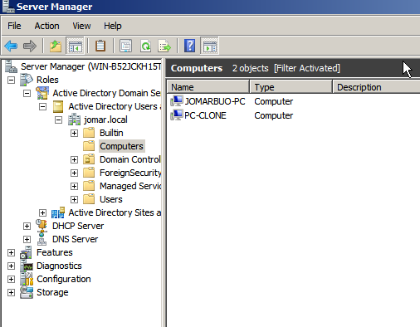

- Created new user:

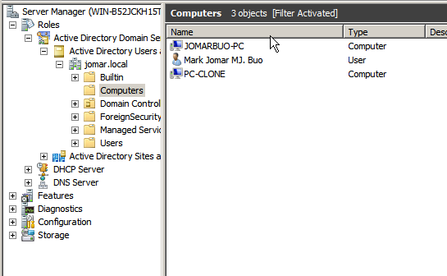

- Checking the new created user:

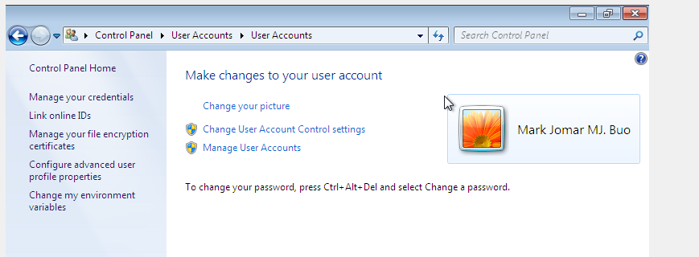

* Conclusion

Active directory looks like creating LDAP but much more easier to create because it has minimal steps to install.