GDPR Extension for Magento

Manual

# How to integrate the CMP into a Magento Shop?

**Please note:** The plugin is only tested for Magento 2.x

In order to integrate the CMP-Code into a Magento Shop please follow these steps:

1. Download our plugin: [consentmanager_magento2.zip](https://plugins.consentmanager.net/consentmanager_magento2.zip) or install the plugin from the Magento App store (skip next steps)
2. Upload the content to the folder app/code/consentmanager/cmp
3. Enter following commands to install module:  
   php bin/magento setup:upgrade
4. Enable and configure CMP in Magento Admin under Consent Manager Provider > Settings

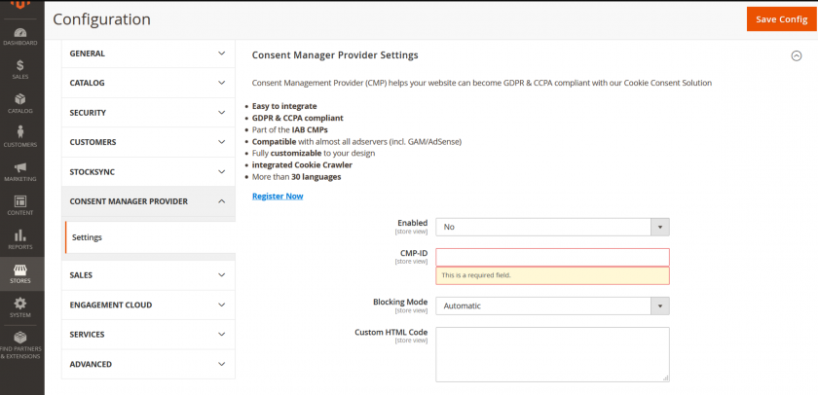

## Configuration

In order to configure the extension please insert the following fields:

* CMP-ID: ID of the CMP to show on your website. You can find the CMP-ID in your consentmanager account under **Menu > Get codes**
* Blocking Mode: Choose automatic or semi-automatic blocking
* Custom HTML Code: (optional) can be used in order to set further configuration options for the CMP (usually not necessary).