**IUCEE Student Chapter Competitions 2026 - Project Proposal**

**PROJECT TITLE:** REVALUE – Turn waste into worth.

**TEAM NAME**: ECOCREW.

**COLLEGE NAME**: ANURAG UNIVERSITY.

**IUCEE STUDENT CHAPTER**: ANURAG UNIVERSITY IUCEE STUDENT CHAPTER(AUISC).

**TEAM MEMBERS:**

| Ram Swaroop | AI ML | 4th year |
| --- | --- | --- |
| G. Rachitha Reddy | CSE | 3rd year |
| N Sree Himavant Raju | CSE | 3rd year |
| D.Ashritha Reddy | CSE | 3rd year |
| K.Aishwarya | CSE | 3rd year |

**FACULTY MENTOR:** Dr. D.Narendhar Singh, Associate professor ECE, Anurag

University.

**Gmail:** [**narendarsinghece@anurag.edu.in**](mailto:narendarsinghece@anurag.edu.in)

**SUBMISSION DATE:** JUNE 30, 2025.

**SELECTED SDG TARGETS:**

* **SDG NO-6:**

**Target:** By 2030, improve water quality by reducing pollution, eliminating dumping and minimizing release of hazardous chemicals and material, halving the proportion of untreated wastewater and substantially increasing recycling and safe reuse globally.

* **SDG NO-11:**

**Target:** By 2030, reduce the adverse per capita environmental impact of cities, including by paying special attention to air quality and municipal and other waste management.

* **SDG NO-12:**

**Target:** By 2030, substantially reduce waste generation through prevention, reduction, recycling and reuse.

**PROBLEM STATEMENT:**

An Indian urban household generates 50-60% of biodegradable waste and 20-30% of recyclable waste, yet only 25–30% of total waste is properly segregated and processed. 70–75% ends up in landfills, open dumping grounds, burning waste materials and water bodies (in worst cases). As we can see only a little amount of waste is being used due to lack of source segregation (wet/dry not separated), low public awareness, poor waste collection and transportation systems, insufficient infrastructure for composting and recycling and no incentives for households to reduce/reuse/recycle.

**ABSTRACT:**

Lack of proper waste disposal is an increasing issue as many people dispose of different waste types like wet waste, dry waste, electronic waste, and plastic on roadside areas and open spaces. It results in the creation of unregulated dump yards, largely contributing to environmental degradation. These dump places not only ruin the visual beauty of environments but also lead to serious pollution of air, land, and water. In the long run, it may lead to health risks for local communities, damage wildlife, and intensify the general ecological impact.

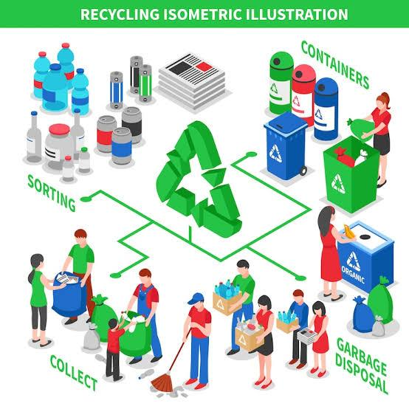

**PROPOSED SOLUTION & OBJECTIVES:**

**Proposed Solution:**

To address the issue of improper waste disposal, we are developing a user-friendly mobile application that bridges the gap between households and recycling facilities. A major reason people avoid proper disposal is the inconvenience or laziness in depositing waste into municipal trucks. At the same time, many recycling companies are actively seeking raw materials like organic waste, plastic, electronics and glass for processing.

Our app enables households to book scheduled pickups for various types of waste such as organic waste, wet waste, dry waste, electronic waste, plastic and glass bottles right from their homes. Upon booking a slot users must specify the type of waste being given. This helps streamline the collection, segregation and delivery of waste to the appropriate recycling partners.

To encourage active participation, the app offers a reward-based system. Users earn points each time they provide waste, which can be redeemed for coupons and benefits such as discounts on food delivery platforms (e.g., Zomato, Swiggy) or movie tickets on platforms like PVR or District. This incentive-driven model not only motivates users to dispose of waste responsibly but also promotes a sustainable recycling ecosystem by connecting households with certified recyclers. Money earned through recycling will be used to support the maintenance and continued development of the app and employees.

**Objectives:**

* By 2030, dump yards should be minimised.
* By 2030, burning of waste should be abolished.
* By 2030, everyone should practice a habit of recycling the waste.
* By 2030, dumping of waste into water bodies should be banned.

**PROOF OF CONCEPT:**

* As there is so much waste generated and customers can simply sell their household waste online.
* Customers are profited by gaining coupons whenever they sell the waste.
* The money obtained by recycling the waste can be used to maintain the app and employees.
* We can find recycle centres, but people don't really use them, through this app they can recycle products easily.
* Mostly no one is willing to invest time and recycle the waste products in their house, to encourage people we are offering them coins that can unlock coupons.

**EXPECTED OUTCOMES:**

**Short-Term Outcomes:**

* Reduction in Roadside Dumping.
* Improved Waste Segregation at Source.
* Awareness of Proper Waste Disposal Practices.

**Long-Term Outcomes:**

* Sustained Community Behaviour Change.
* Improved Public Health and Sanitation.
* Reduction in Environmental Pollution.

**RESOURCES REQUIRED:**

* We need delivery agents as per the requirement.
* We need waste recycling centres with respect to the type of waste we obtain.
* Mentorship for building a mobile app.
* Partnership with companies like swiggy, zomato, PVR movies etc.
* We need technologies like web applications, cloud technologies.
* We estimate a monthly earning of approximately ₹200 to ₹700 from each household. With 30 households, the total monthly revenue could reach up to ₹20,000.
* If 22 redemptions of the coupons can happen in a month we can earn up to ₹870/month. (this may vary up on growth of the company).

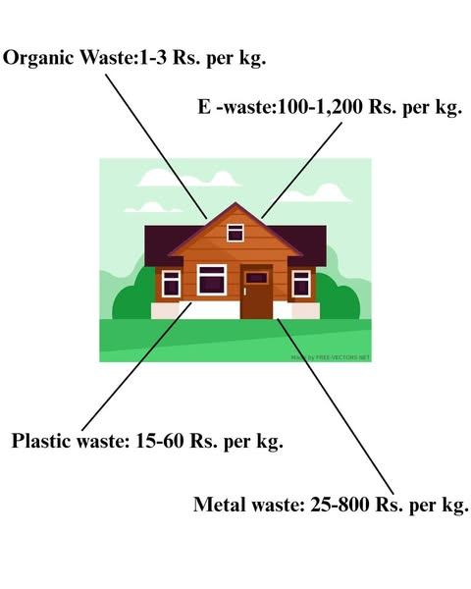  
  
**TEAM LEAD CONTACTS:**

Ram Swaroop - +91 6301 557 117

Gmail ID- 22eg107c48@anurag.edu.in