**IASF 2026 – Project Abstract**

**1. Title Page**

**Project Title:** Path to Power  
**Team Name:** Team Neuron  
**College Name:** Anurag University  
**Student chapter:** Anurag university IUCEE student chapter

**2. Chosen SDG Target**

**SDG 7:** Ensure access to affordable, reliable, sustainable, and modern energy for all.  
**Target 7.1:** By 2030, ensure universal access to affordable, reliable, and modern energy services.

**3. Problem Statement**

Disruptions in street lighting affect safety and mobility. To reduce grid load and save electricity, there is a growing need for decentralized, sustainable energy solutions. Using piezoelectric systems to harvest energy from footsteps and vehicles offers a practical, cost-effective way to power streetlights or charging stations in railway stations, especially in off-grid or low-resource areas.

**4. Abstract**

India’s rising energy demand and a 14 GW power deficit in 2024 cause frequent outages in rural areas, impacting public services like street lighting. These outages create safety risks, limit evening activities, and put extra pressure on the power grid. This project offers a low-cost, sustainable solution using piezoelectric tiles that capture mechanical energy from footsteps or slow-moving carts. The electricity generated is stored and used to power LED streetlights, creating an off-grid, reliable lighting system. This reduces grid stress, improves rural infrastructure, and encourages clean energy use. The system is scalable, modular, and community-focused, supporting India’s sustainability and energy resilience goals.

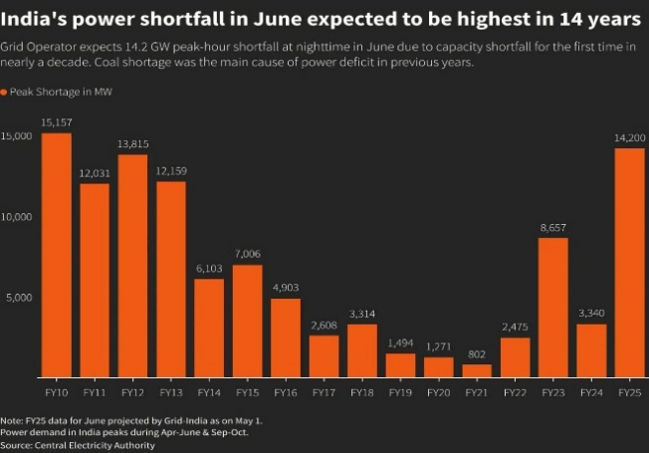 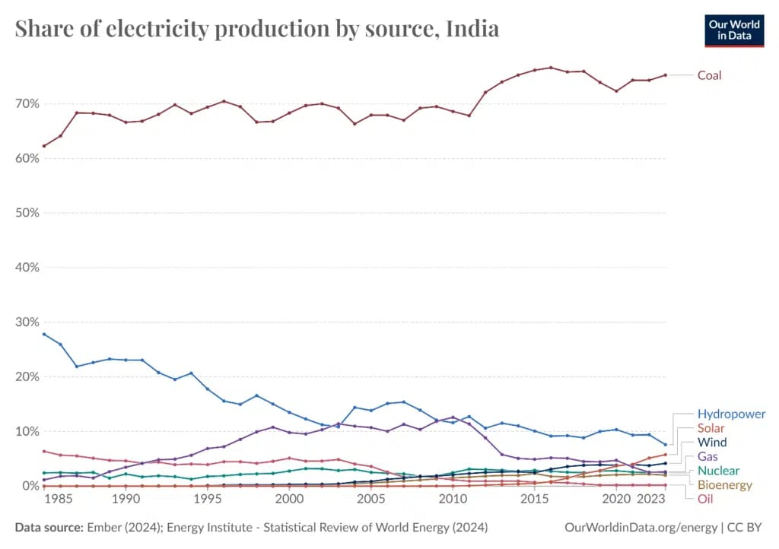

**5. Proposed Solution & Objectives**

**Proposed Solution:**  
Install piezoelectric energy-harvesting tiles on village pathways or at railway stations to convert mechanical pressure into electricity, which powers nearby LED streetlights and charging stations.

**Objectives:**

* Provide sustainable, off-grid street lighting and charging facilities in rural areas.
* Reduce dependence on the main power grid.
* Use clean, renewable mechanical energy.
* Improve safety and extend usable hours for villagers and travelers.

**6. Detailed Explanation of the Solution**

**Working Principle:**

1. Piezoelectric materials in pathway tiles generate voltage when stepped on or pressed by carts.
2. A bridge rectifier converts the AC output into DC.
3. Energy is stored in rechargeable batteries or supercapacitors.
4. Stored energy powers LED streetlights or charging ports, which may include motion sensors for efficiency.

**Workflow:**  
[Mechanical Pressure] → [Piezoelectric Tile] → [Rectifier Circuit] → [Battery] → [LED Light + Motion Sensor]

**Interdisciplinary Aspects:**

* **Electrical Engineering:** Energy conversion and circuit design
* **Mechanical Engineering:** Tile structure and material optimization
* **Civil Engineering:** Installation planning and durability
* **Design Thinking:** User-centered, community-focused innovation

**7. Proof of Concept**

**Prototype:**

1. Three piezoelectric tile units mounted on an acrylic base.
2. Output ranges from 5 to 20V with pressure; connected to a 12V battery.
3. Powered a 10W LED for over five hours after daily use.

**Technologies Used:**

* Piezo discs (recycled from buzzers)
* Rechargeable Li-ion battery
* Bridge rectifier and basic charge controller
* Motion-activated LED light module

**Initial Testing Results:**

* Effective in areas with foot traffic like schools, pathways, and entrances
* Improved power efficiency with motion-based activation

**8. Expected Outcomes**

**Short-Term:**

* Functional pilot tested on a village pathway
* Increased awareness and interest in clean energy solutions

**Long-Term:**

* Scalable smart village lighting systems
* Reduced consumption of grid energy
* Improved safety and mobility at night in rural areas

**Environmental Impact:**

* Renewable and non-polluting energy solution

**Social Impact:**

* Better access and security for rural communities

**Economic Impact:**

* Low maintenance and operating costs
* Reduced government expenses on rural electrification

**9. Resources Required**

| **Component** | **Description** | **Approx. Cost (INR)** |
| --- | --- | --- |
| Piezoelectric Tiles | Energy generation | ₹100–300 each |
| Bridge Rectifier Diodes | AC to DC conversion | ₹10–20 |
| Rechargeable Battery | Stores generated power | ₹500–1000 |
| LED Streetlight (10–20W) | Energy-efficient lighting | ₹300–500 |
| Motion Sensor (Optional) | Power-saving component | ₹100–150 |
| Tile Base & Housing | Acrylic or steel base | ₹300–400 |
| Charge Controller | Battery protection | ₹200–300 |

**Estimated Total (per unit):** ₹1500–2500 (Prototype scale)

**Expertise Needed:**

* Energy Systems Engineer
* Fabrication Mentor
* Community Outreach Advisor

**10. Team Details**

| **Name** | **Department** | **Year** | **Role** |
| --- | --- | --- | --- |
| M. Chinmayee | CSE | III | Team Lead |
| D. Sumad Reddy | ECE | IV |  |
| Srivarsha Bollampalli | CSE | III |  |
| G. Greshmi Ratna | CSE | III |  |
| Anwesha Sahu | CSE | III |  |

**Faculty Mentor:**  
Name: Dr. Narendhar Singh  
Designation: Associate Professor, ECE  
Email: [narendarsinghece@anurag.edu.in](mailto:narendarsinghece@anurag.edu.in)