Supplementary materials

Table S1 Schizophrenia studies for coordinate network mapping
 | Author, year | Modality | Contrast | Smooth kernel
1 | Zhao et al，2018 ¹ | MRI, atrophy | SZ vs Controls | 6
2 | Zhang et al，2017 ² | MRI, atrophy | SZ vs Controls | 4
3 | Yue et al，2016 ³ | MRI, atrophy | SZ vs Controls | 8
4 | Poletti et al，2016 ⁴ | MRI, atrophy | SZ vs Controls | 8
5 | Filippi et al，2014 ⁵ | MRI, atrophy | SZ vs Controls | N.A.
6 | Schuster et al，2012 ⁶ | MRI, atrophy | SZ vs Controls | 8
7 | Berge et al，2011 ⁷ | MRI, atrophy | SZ vs Controls | 8
8 | Venkatasubramanian et al，2010 ⁸ | MRI, atrophy | SZ vs Controls | 12
9 | Liu et al，2009 ⁹ | MRI, atrophy | SZ vs Controls | 8
10 | Meisenzahl et al，2008 ¹⁰ | MRI, atrophy | SZ vs Controls | 12
11 | Bonilha et al，2008 ¹¹ | MRI, atrophy | SZ vs Controls | 10
12 | Kwasaki et al，2007 ¹² | MRI, atrophy | SZ vs Controls | 12
13 | Chua et al，2007 ¹³ | MRI, atrophy | SZ vs Controls | 4.4
14 | Bassitt et al，2007 ¹⁴ | MRI, atrophy | SZ vs Controls | 12
15 | Jayakumar et al，2005 ¹⁵ | MRI, atrophy | SZ vs Controls | 12
16 | Salgado-Pineda et al，2004 ¹⁶ | MRI, atrophy | SZ vs Controls | 8
17 | Kawasaki et al，2004 ¹⁷ | MRI, atrophy | SZ vs Controls | 12
18 | Salgado-Pineda et al，2003 ¹⁸ | MRI, atrophy | SZ vs Controls | 8
19 | Job et al，2002 ¹⁹ | MRI, atrophy | SZ vs Controls | 8
20 | Sigmundsson et al，2001 ²⁰ | MRI, atrophy | SZ vs Controls | N.A.
21 | Paillere-Martinot et al，2001 ²¹ | MRI, atrophy | SZ vs Controls | 10

Table S2 Non-psychiatry studies for specificity analysis
 | Reference | Imaging Modality | Contrast
Alzheimer’s Disease (AD)
1 | Baron et al., 2001 ²² | MRI, atrophy | AD vs Controls
2 | Boxer et al., 2003 ²³ | MRI, atrophy | AD vs Controls
3 | Boxer et al., 2003 ²⁴ | MRI, atrophy | AD vs Controls
4 | Bozzali et al., 2006 ²⁵ | MRI, atrophy | AD vs Controls
5 | Grossman et al., 2004 ²⁶ | MRI, atrophy | AD vs Controls
6 | Ohnishi et al., 2001 ²⁷ | MRI, atrophy | AD vs Controls
7 | Irish et al., 2013²⁸ | MRI, atrophy | AD vs Controls
8 | Zahn et al., 2005 ²⁹ | MRI, atrophy | AD vs Controls
Frontotemporal Dementia (FTD)
1 | Amanzio et al., 2016 ³⁰ | MRI, atrophy | FTD vs Controls
2 | Baez et al., 2016 ³¹ | MRI, atrophy | FTD vs Controls
3 | Baez et al., 2016 ³² | MRI, atrophy | FTD vs Controls
4 | Boccardi et al., 2005 ³³ | MRI, atrophy | FTD vs Controls
5 | Dermody et al., 2016 ³⁴ | MRI, atrophy | FTD vs Controls
6 | Flanagan et al., 2016 ³⁵ | MRI, atrophy | FTD vs Controls
7 | Grossman et al., 2004 ²⁶ | MRI, atrophy | FTD vs Controls
8 | Irish et al., 2013 ²⁸ | MRI, atrophy | FTD vs Controls
9 | Irish et al., 2014 ³⁶ | MRI, atrophy | FTD vs Controls
10 | Irish et al., 2016 ³⁷ | MRI, atrophy | FTD vs Controls
11 | Kanda et al., 2008 ³⁸ | MRI, atrophy | FTD vs Controls
12 | Kipps et al., 2009 ³⁹ | MRI, atrophy | FTD vs Controls
13 | Luis et al., 2016 ⁴⁰ | MRI, atrophy | FTD vs Controls
14 | Mandelli et al., 2016 ⁴¹ | MRI, atrophy | FTD vs Controls
15 | Massimo et al., 2013 ⁴² | MRI, atrophy | FTD vs Controls
16 | Ossenkoppele et al., 2015 ⁴³ | MRI, atrophy | FTD vs Controls
17 | Pardini et al., 2009 ⁴⁴ | MRI, atrophy | FTD vs Controls
18 | Tu et al., 2005 ⁴⁵ | MRI, atrophy | FTD vs Controls
19 | Whitwell et al., 2011 ⁴⁶ | MRI, atrophy | FTD vs Controls
20 | Wong et al., 2016 ⁴⁷ | MRI, atrophy | FTD vs Controls
21 | Zamboni et al., 2008 ⁴⁸ | MRI, atrophy | FTD vs Controls
Corticobasal Syndrome (CS)
1 | Boxer et al., 2006 ⁴⁹ | MRI, atrophy | CS vs Controls
2 | Garraux et al, 2000 ⁵⁰ | MRI, atrophy | CS vs Controls
3 | Gross et al., 2010 ⁵¹ | MRI, atrophy | CS vs Controls
4 | Grossman et al., 2004 ²⁶ | MRI, atrophy | CS vs Controls
5 | Huey et al., 2009 ⁵² | MRI, atrophy | CS vs Controls
6 | Hosaka et al., 2002 ⁵³ | MRI, atrophy | CS vs Controls
7 | Huh et al., 2005 ⁵⁴ | MRI, atrophy | CS vs Controls
8 | Lee et al., 2011 ⁵⁵ | MRI, atrophy | CS vs Controls
9 | McMillan et al., 2016 ⁵⁶ | MRI, atrophy | CS vs Controls
10 | Morgan et al., 2011 ⁵⁷ | MRI, atrophy | CS vs Controls
11 | Pardini et al., 2009 ⁴⁴ | MRI, atrophy | CS vs Controls
12 | Wolpe et al., 2014 ⁵⁸ | MRI, atrophy | CS vs Controls
Progressive Non-Fluent Aphasia (PNFA)
1 | Gorno-Tempini et al, 2004 ⁵⁹ | MRI, atrophy | PNFA vs Controls
2 | Gorno-Tempini et al, 2006 ⁶⁰ | MRI, atrophy | PNFA vs Controls
3 | Grossman et al., 2004 ²⁶ | MRI, atrophy | PNFA vs Controls
4 | Hu et al., 2010 ⁶¹ | MRI, atrophy | PNFA vs Controls
5 | Nestor et al, 2003 | MRI, atrophy | PNFA vs Controls
6 | Pereira et al, 2009 | MRI, atrophy | PNFA vs Controls
7 | Wilson et al, 2010 | MRI, atrophy | PNFA vs Controls
8 | Zahn et al, 2005 | MRI, atrophy | PNFA vs Controls

Table S3 Shared network localization across schizophrenia patients (overlap threshold = 0.8, n = 91).
Overlap | Voxel number | Peak voxelª | Brodmann area | Brain structure | Specificity P value^{b}
83/91 | 1912 | 6, 12, 12 | 9/10/11/32 | R. caudate body, MPFC | <0.001
76/91 | 289 | 58, 0, -13 | 21 | R. STS | <0.001
77/91 | 355 | -54, -6, -12 | 21/20 | L. STG, MTG | <0.001
81/91 | 304 | -39, 12, -15 | 47 | R. IFG | <0.001
81/91 | 212 | 39, 18, -18 | 47 | L. IFG | <0.001
78/91 | 24 | 21, -6, -15 | 28 | R. parahippo. | <0.001
78/91 | 22 | -21, -6, -15 | 28 | L. parahippo. | <0.001
84/91 | 31 | -7, 12, 12 | N.A. | L. caudate body | <0.001
75/91 | 21 | 35, -18, 15 | 13 | R. insular | <0.001
L. = left; IFG = inferior frontal gyrus; MTG = middle temporal gyrus; R. = right; STG = superior temporal gyrus; STS = superior temporal sulcus;
ª The location of peak voxel is reported in MNI space (X, Y, Z)
^{b} The P value in peak voxel is extracted from the t maps (FWE corrected by TFCE across the whole brain) that obtained by comparing the personalized atrophy networks (n = 91) to non-psychiatry disorders (n = 49).
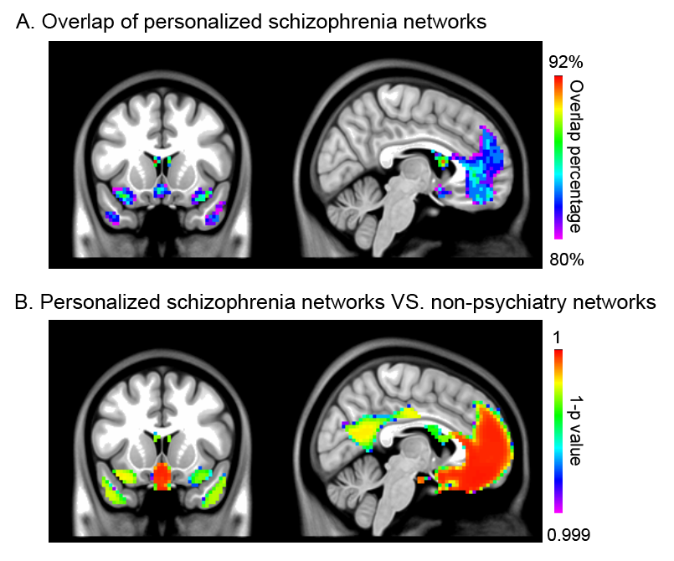
Figure S1. Specificity of the personalized atrophy networks. (A) Atrophy maps in more than 80% of patients showing common functional connectivity in nine clusters. (B) Regions showing higher functional connectivity with atrophy regions in schizophrenia patients than non-psychiatry patients (P_{FWE} < 0.001).

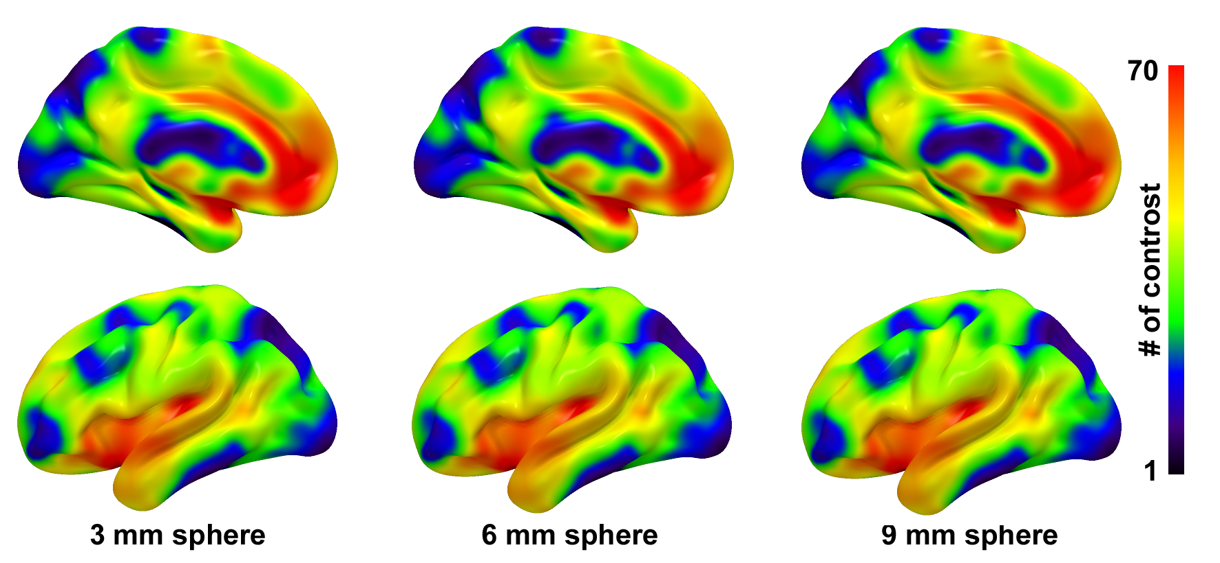
Fig. S2 The overlap patterns derived from regions-of-interest (ROI) with different sphere diameters. The ROIs are from 27 case-control contrasts. Their connectivity map on 653 normative data were binarized by t > 4.7, and then overlapped together. The overlap pattern from 3mm sphere significantly correlated with that from 6 mm (r = 0.99, P_{spin} < 0.0001) and 9 mm (r = 0.98, P_{spin} < 0.0001) across 360 regions in HCPMMP atlas.

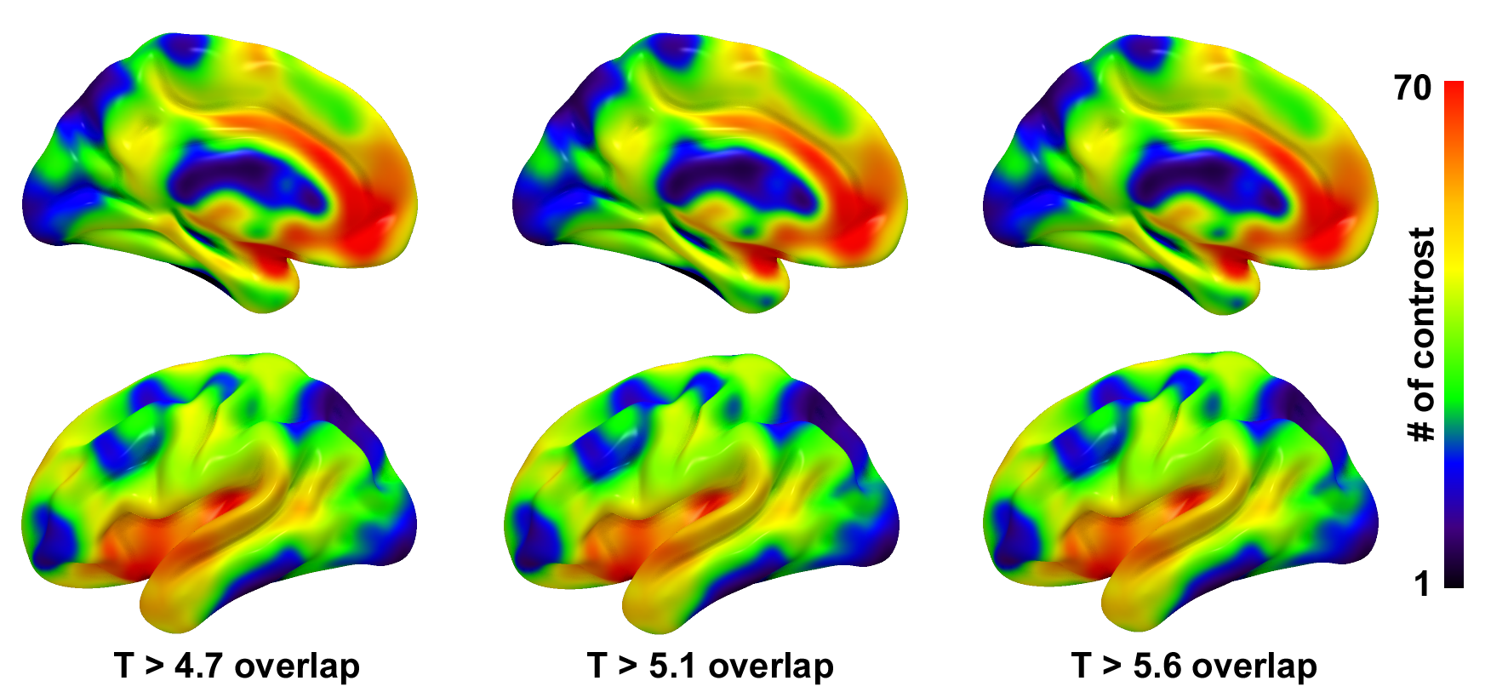
Fig. S3 The overlap patterns derived from regions-of-interest (ROI) with different t thresholds. The ROIs are from 27 case-control contrasts. Their connectivity map of sphere ROIs (3mm diameter) on 653 normative data were binarized by t value, and then overlapped together. The pattern from t > 4.7 significantly correlated with that from t > 5.1 (r = 0.99, P_{spin} < 0.0001) and t > 5.6 (r = 0.98, P_{spin} < 0.0001) across 360 regions in HCPMMP atlas.

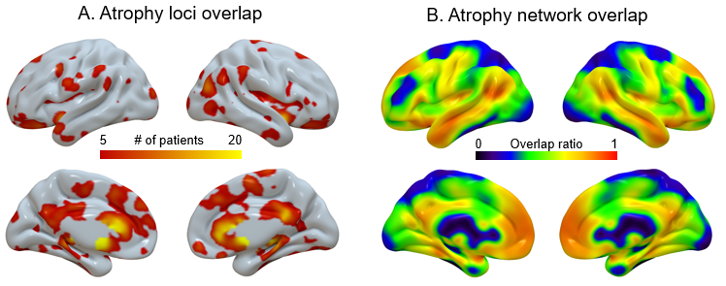
Fig. S4 The overlap map of atrophy loci (A) and network (B) across patients who received rTMS treatment, respectively.

References:

1. Zhao C, Zhu J, Liu X, Pu C, Lai Y, Chen L, Yu X, Hong N. Structural and functional brain abnormalities in schizophrenia: A cross-sectional study at different stages of the disease. Progress in neuro-psychopharmacology & biological psychiatry Apr 20 2018;83:27-32.
2. Zhang C, Wang Q, Ni P, et al. Differential Cortical Gray Matter Deficits in Adolescent- and Adult-Onset First-Episode Treatment-Naïve Patients with Schizophrenia. Sci Rep Aug 31 2017;7(1):10267.
3. Yue Y, Kong L, Wang J, Li C, Tan L, Su H, Xu Y. Regional Abnormality of Grey Matter in Schizophrenia: Effect from the Illness or Treatment? PLoS One 2016;11(1):e0147204.
4. Poletti S, Vai B, Smeraldi E, Cavallaro R, Colombo C, Benedetti F. Adverse childhood experiences influence the detrimental effect of bipolar disorder and schizophrenia on cortico-limbic grey matter volumes. J Affect Disord Jan 1 2016;189:290-297.
5. Filippi M, Canu E, Gasparotti R, et al. Patterns of brain structural changes in first-contact, antipsychotic drug-naive patients with schizophrenia. AJNR Am J Neuroradiol Jan 2014;35(1):30-37.
6. Schuster C, Schuller AM, Paulos C, Namer I, Pull C, Danion JM, Foucher JR. Gray matter volume decreases in elderly patients with schizophrenia: a voxel-based morphometry study. Schizophr Bull Jun 2012;38(4):796-802.
7. Bergé D, Carmona S, Rovira M, Bulbena A, Salgado P, Vilarroya O. Gray matter volume deficits and correlation with insight and negative symptoms in first-psychotic-episode subjects. Acta Psychiatr Scand Jun 2011;123(6):431-439.
8. Venkatasubramanian G. Neuroanatomical correlates of psychopathology in antipsychotic-naïve schizophrenia. Indian J Psychiatry Jan 2010;52(1):28-36.
9. Lui S, Deng W, Huang X, et al. Association of cerebral deficits with clinical symptoms in antipsychotic-naive first-episode schizophrenia: an optimized voxel-based morphometry and resting state functional connectivity study. Am J Psychiatry Feb 2009;166(2):196-205.
10. Meisenzahl EM, Koutsouleris N, Bottlender R, et al. Structural brain alterations at different stages of schizophrenia: a voxel-based morphometric study. Schizophr Res Sep 2008;104(1-3):44-60.
11. Bonilha L, Molnar C, Horner MD, Anderson B, Forster L, George MS, Nahas Z. Neurocognitive deficits and prefrontal cortical atrophy in patients with schizophrenia. Schizophr Res Apr 2008;101(1-3):142-151.
12. Kawasaki Y, Suzuki M, Kherif F, et al. Multivariate voxel-based morphometry successfully differentiates schizophrenia patients from healthy controls. Neuroimage Jan 1 2007;34(1):235-242.
13. Chua SE, Cheung C, Cheung V, et al. Cerebral grey, white matter and csf in never-medicated, first-episode schizophrenia. Schizophr Res Jan 2007;89(1-3):12-21.
14. Bassitt DP, Neto MR, de Castro CC, Busatto GF. Insight and regional brain volumes in schizophrenia. Eur Arch Psychiatry Clin Neurosci Feb 2007;257(1):58-62.
15. Jayakumar PN, Venkatasubramanian G, Gangadhar BN, Janakiramaiah N, Keshavan MS. Optimized voxel-based morphometry of gray matter volume in first-episode, antipsychotic-naive schizophrenia. Progress in neuro-psychopharmacology & biological psychiatry May 2005;29(4):587-591.
16. Salgado-Pineda P, Junqué C, Vendrell P, Baeza I, Bargalló N, Falcón C, Bernardo M. Decreased cerebral activation during CPT performance: structural and functional deficits in schizophrenic patients. Neuroimage Mar 2004;21(3):840-847.
17. Kawasaki Y, Suzuki M, Nohara S, et al. Structural brain differences in patients with schizophrenia and schizotypal disorder demonstrated by voxel-based morphometry. Eur Arch Psychiatry Clin Neurosci Dec 2004;254(6):406-414.
18. Salgado-Pineda P, Baeza I, Pérez-Gómez M, Vendrell P, Junqué C, Bargalló N, Bernardo M. Sustained attention impairment correlates to gray matter decreases in first episode neuroleptic-naive schizophrenic patients. Neuroimage Jun 2003;19(2 Pt 1):365-375.
19. Job DE, Whalley HC, McConnell S, Glabus M, Johnstone EC, Lawrie SM. Structural gray matter differences between first-episode schizophrenics and normal controls using voxel-based morphometry. Neuroimage Oct 2002;17(2):880-889.
20. Sigmundsson T, Suckling J, Maier M, et al. Structural abnormalities in frontal, temporal, and limbic regions and interconnecting white matter tracts in schizophrenic patients with prominent negative symptoms. Am J Psychiatry Feb 2001;158(2):234-243.
21. Paillère-Martinot M, Caclin A, Artiges E, et al. Cerebral gray and white matter reductions and clinical correlates in patients with early onset schizophrenia. Schizophr Res May 30 2001;50(1-2):19-26.
22. Baron JC, Chetelat G, Desgranges B, Perchey G, Landeau B, de la Sayette V, Eustache F. In vivo mapping of gray matter loss with voxel-based morphometry in mild Alzheimer's disease. NeuroImage Aug 2001;14(2):298-309.
23. Boxer AL, Kramer JH, Du AT, Schuff N, Weiner MW, Miller BL, Rosen HJ. Focal right inferotemporal atrophy in AD with disproportionate visual constructive impairment. Neurology Dec 9 2003;61(11):1485-1491.
24. Boxer AL, Rankin KP, Miller BL, Schuff N, Weiner M, Gorno-Tempini ML, Rosen HJ. Cinguloparietal atrophy distinguishes Alzheimer disease from semantic dementia. Archives of neurology Jul 2003;60(7):949-956.
25. Bozzali M, Filippi M, Magnani G, et al. The contribution of voxel-based morphometry in staging patients with mild cognitive impairment. Neurology Aug 8 2006;67(3):453-460.
26. Grossman M, McMillan C, Moore P, Ding L, Glosser G, Work M, Gee J. What's in a name: voxel-based morphometric analyses of MRI and naming difficulty in Alzheimer's disease, frontotemporal dementia and corticobasal degeneration. Brain : a journal of neurology Mar 2004;127(Pt 3):628-649.
27. Ohnishi T, Matsuda H, Tabira T, Asada T, Uno M. Changes in brain morphology in Alzheimer disease and normal aging: is Alzheimer disease an exaggerated aging process? AJNR American journal of neuroradiology Oct 2001;22(9):1680-1685.
28. Irish M, Hodges JR, Piguet O. Episodic future thinking is impaired in the behavioural variant of frontotemporal dementia. Cortex; a journal devoted to the study of the nervous system and behavior Oct 2013;49(9):2377-2388.
29. Zahn R, Buechert M, Overmans J, et al. Mapping of temporal and parietal cortex in progressive nonfluent aphasia and Alzheimer's disease using chemical shift imaging, voxel-based morphometry and positron emission tomography. Psychiatry research Nov 30 2005;140(2):115-131.
30. Amanzio M, D'Agata F, Palermo S, et al. Neural correlates of reduced awareness in instrumental activities of daily living in frontotemporal dementia. Exp Gerontol Oct 2016;83:158-164.
31. Baez S, Kanske P, Matallana D, et al. Integration of Intention and Outcome for Moral Judgment in Frontotemporal Dementia: Brain Structural Signatures. Neurodegener Dis 2016;16(3-4):206-217.
32. Baez S, Morales JP, Slachevsky A, Torralva T, Matus C, Manes F, Ibanez A. Orbitofrontal and limbic signatures of empathic concern and intentional harm in the behavioral variant frontotemporal dementia. Cortex; a journal devoted to the study of the nervous system and behavior Feb 2016;75:20-32.
33. Boccardi M, Sabattoli F, Laakso MP, Testa C, Rossi R, Beltramello A, Soininen H, Frisoni GB. Frontotemporal dementia as a neural system disease. Neurobiology of aging Jan 2005;26(1):37-44.
34. Dermody N, Hornberger M, Piguet O, Hodges JR, Irish M. Prospective Memory Impairments in Alzheimer's Disease and Behavioral Variant Frontotemporal Dementia: Clinical and Neural Correlates. J Alzheimers Dis 2016;50(2):425-441.
35. Flanagan EC, Wong S, Dutt A, et al. False Recognition in Behavioral Variant Frontotemporal Dementia and Alzheimer's Disease-Disinhibition or Amnesia? Frontiers in aging neuroscience 2016;8:177.
36. Irish M, Hornberger M, El Wahsh S, et al. Grey and white matter correlates of recent and remote autobiographical memory retrieval--insights from the dementias. PloS one 2014;9(11):e113081.
37. Irish M, Eyre N, Dermody N, O'Callaghan C, Hodges JR, Hornberger M, Piguet O. Neural Substrates of Semantic Prospection - Evidence from the Dementias. Front Behav Neurosci 2016;10:96.
38. Kanda T, Ishii K, Uemura T, Miyamoto N, Yoshikawa T, Kono AK, Mori E. Comparison of grey matter and metabolic reductions in frontotemporal dementia using FDG-PET and voxel-based morphometric MR studies. Eur J Nucl Med Mol Imaging Dec 2008;35(12):2227-2234.
39. Kipps CM, Nestor PJ, Acosta-Cabronero J, Arnold R, Hodges JR. Understanding social dysfunction in the behavioural variant of frontotemporal dementia: the role of emotion and sarcasm processing. Brain : a journal of neurology Mar 2009;132(Pt 3):592-603.
40. Luis E, Ortiz A, Eudave L, et al. Neuroimaging Correlates of Frontotemporal Dementia Associated with SQSTM1 Mutations. J Alzheimers Dis May 7 2016;53(1):303-313.
41. Mandelli ML, Vitali P, Santos M, et al. Two insular regions are differentially involved in behavioral variant FTD and nonfluent/agrammatic variant PPA. Cortex; a journal devoted to the study of the nervous system and behavior Jan 2016;74:149-157.
42. Massimo L, Libon DJ, Chandrasekaran K, Dreyfuss M, McMillan CT, Rascovsky K, Boller A, Grossman M. Self-appraisal in behavioural variant frontotemporal degeneration. Journal of neurology, neurosurgery, and psychiatry Feb 2013;84(2):148-153.
43. Ossenkoppele R, Pijnenburg YA, Perry DC, et al. The behavioural/dysexecutive variant of Alzheimer's disease: clinical, neuroimaging and pathological features. Brain : a journal of neurology Sep 2015;138(Pt 9):2732-2749.
44. Pardini M, Huey ED, Cavanagh AL, Grafman J. Olfactory function in corticobasal syndrome and frontotemporal dementia. Archives of neurology Jan 2009;66(1):92-96.
45. Tu S, Wong S, Hodges JR, Irish M, Piguet O, Hornberger M. Lost in spatial translation - A novel tool to objectively assess spatial disorientation in Alzheimer's disease and frontotemporal dementia. Cortex; a journal devoted to the study of the nervous system and behavior Jun 2015;67:83-94.
46. Whitwell JL, Jack CR, Jr., Przybelski SA, et al. Temporoparietal atrophy: a marker of AD pathology independent of clinical diagnosis. Neurobiology of aging Sep 2011;32(9):1531-1541.
47. Wong S, Bertoux M, Savage G, Hodges JR, Piguet O, Hornberger M. Comparison of Prefrontal Atrophy and Episodic Memory Performance in Dysexecutive Alzheimer's Disease and Behavioral-Variant Frontotemporal Dementia. J Alzheimers Dis 2016;51(3):889-903.
48. Zamboni G, Huey ED, Krueger F, Nichelli PF, Grafman J. Apathy and disinhibition in frontotemporal dementia: Insights into their neural correlates. Neurology Sep 2 2008;71(10):736-742.
49. Boxer AL, Geschwind MD, Belfor N, Gorno-Tempini ML, Schauer GF, Miller BL, Weiner MW, Rosen HJ. Patterns of brain atrophy that differentiate corticobasal degeneration syndrome from progressive supranuclear palsy. Archives of neurology Jan 2006;63(1):81-86.
50. Garraux G, Salmon E, Peigneux P, Kreisler A, Degueldre C, Lemaire C, Destee A, Franck G. Voxel-based distribution of metabolic impairment in corticobasal degeneration. Movement disorders : official journal of the Movement Disorder Society Sep 2000;15(5):894-904.
51. Gross RG, Ash S, McMillan CT, et al. Impaired information integration contributes to communication difficulty in corticobasal syndrome. Cogn Behav Neurol Mar 2010;23(1):1-7.
52. Huey ED, Goveia EN, Paviol S, et al. Executive dysfunction in frontotemporal dementia and corticobasal syndrome. Neurology Feb 3 2009;72(5):453-459.
53. Hosaka K, Ishii K, Sakamoto S, Mori T, Sasaki M, Hirono N, Mori E. Voxel-based comparison of regional cerebral glucose metabolism between PSP and corticobasal degeneration. Journal of the neurological sciences Jul 15 2002;199(1-2):67-71.
54. Juh R, Pae CU, Kim TS, Lee CU, Choe B, Suh T. Cerebral glucose metabolism in corticobasal degeneration comparison with progressive supranuclear palsy using statistical mapping analysis. Neuroscience letters Jul 22-29 2005;383(1-2):22-27.
55. Lee SE, Rabinovici GD, Mayo MC, et al. Clinicopathological correlations in corticobasal degeneration. Annals of neurology Aug 2011;70(2):327-340.
56. McMillan CT, Boyd C, Gross RG, et al. Multimodal imaging evidence of pathology-mediated disease distribution in corticobasal syndrome. Neurology Sep 20 2016;87(12):1227-1234.
57. Morgan B, Gross RG, Clark R, et al. Some is not enough: quantifier comprehension in corticobasal syndrome and behavioral variant frontotemporal dementia. Neuropsychologia Nov 2011;49(13):3532-3541.
58. Wolpe N, Moore JW, Rae CL, Rittman T, Altena E, Haggard P, Rowe JB. The medial frontal-prefrontal network for altered awareness and control of action in corticobasal syndrome. Brain : a journal of neurology Jan 2014;137(Pt 1):208-220.
59. Gorno-Tempini ML, Dronkers NF, Rankin KP, et al. Cognition and anatomy in three variants of primary progressive aphasia. Annals of neurology Mar 2004;55(3):335-346.
60. Gorno-Tempini ML, Ogar JM, Brambati SM, Wang P, Jeong JH, Rankin KP, Dronkers NF, Miller BL. Anatomical correlates of early mutism in progressive nonfluent aphasia. Neurology Nov 28 2006;67(10):1849-1851.
61. Hu WT, McMillan C, Libon D, Leight S, Forman M, Lee VM, Trojanowski JQ, Grossman M. Multimodal predictors for Alzheimer disease in nonfluent primary progressive aphasia. Neurology Aug 17 2010;75(7):595-602.

