SkyDrop System Design
  - Software Development Processes Lab 3
Yuning Yao 2065

Scope and continuity with Labs 1 and 2
I propose a responsive web portal and a small depot application connected to one modular cloud application. A relational database stores operational records, while private object storage holds delivery photographs. This design supports the Manchester pilot without creating a separate system for every stakeholder.
Lab 1 established the wider stakeholder context. The streamlined Lab 2 retained eight core groups: recipients, warehouse and fulfilment, COO and operations, maintenance and recovery, customer support, the retailer, the drone manufacturer, and regulatory and aviation bodies. Their requirements remain the basis of this design. The CEO and other peripheral groups do not receive separate components or workflows.
The baseline remains 19 Must, 3 Should and 1 provisional Won’t Have requirements. The responsive website supports mobile and desktop users; a separate native customer app remains deferred under R23, subject to the COO’s clarification. Proposed protocols and database structures below are design choices, not confirmed manufacturer specifications.

Task 1 Identifying system components
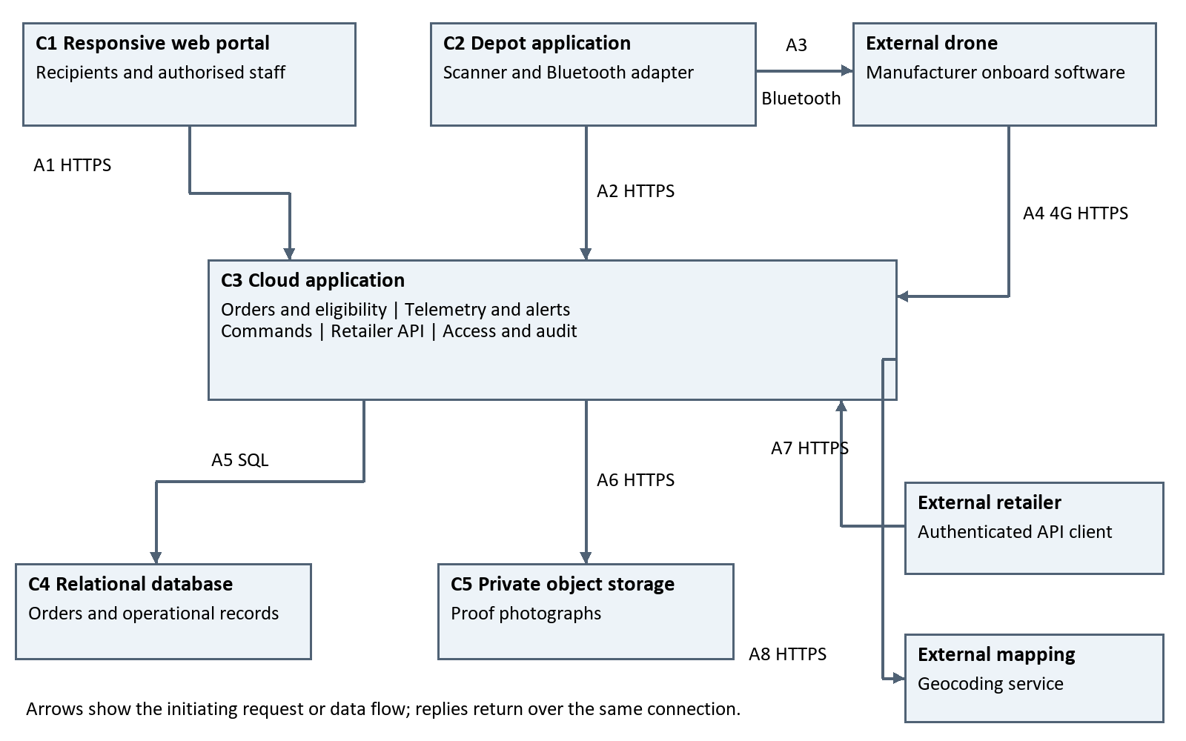
Figure 1 Proposed architecture. C1 to C5 are SkyDrop components. Aircraft navigation and flight control remain within the manufacturer’s onboard software.

Component responsibilities and requirements
Component | Responsibility and data location | Lab 2 IDs
C1 Web portal | Recipient location selection, tracking and photos; role based staff monitoring, history and emergency controls. No permanent operational database in the browser. | R01–R04  R09–R13  R16–R18
C2 Depot application | Read parcel scans, request a drone assignment, program approved coordinates through Bluetooth and report the acknowledgement. Cloud approval is required before dispatch. | R05–R08  R17
C3 Cloud application | Authoritative order workflow, eligibility checks, telemetry processing, fault alerts, emergency queue, retailer API, authorisation and audit. Modules use internal method calls. | R02–R22
C4 Relational database | Accounts, parcels, flights, telemetry, commands, events and versioned service policies. Transactions prevent conflicting assignments. | R03 R05–R18  R20 R22
C5 Private object storage | Photograph files. The database keeps the matching flight identifier and object key; access is checked by C3. | R04 R12  R14 R15 R18

Operational boundaries
The manufacturer implements autonomous routing, obstacle avoidance, altitude control and flight safety. C3 checks whether a delivery is eligible; it does not calculate or fly the aircraft’s route. C2 is a depot tool, not the separate customer mobile app discussed in R23.
R19 is supported by cloud hosting and a battery laptop accessing C1 through independent 4G when depot power or wired networking fails. This does not restore a failed aircraft radio link. Staff must see stale telemetry and unacknowledged commands explicitly.
For R20, the initial workload is 175 drones and 2,500 deliveries per day. Index telemetry by drone and observation time, paginate history, and store photographs outside the database. Capacity tests must use agreed telemetry frequency, photo sizes, peak traffic and response and alert limits; these limits are still open.

Development and integration
The design allows work on the web portal, depot integration, and cloud and data modules to proceed against shared interfaces. A manufacturer simulator and versioned message contracts support R21 before aircraft arrive in month six. The remaining three months support aircraft integration, fault exercises and field acceptance for the nine-month pilot.

Task 2 Communication and coordination
Arrow | Operation and example data
A1 Web to cloud | HTTPS JSON requests, for example PUT /v1/parcels/{id}/drop-point with latitude, longitude and locationVersion; GET /v1/parcels/{id}. C3 checks both role and order ownership.
A2 Depot to cloud | HTTPS JSON: POST /v1/scans with eventId, parcelId, direction and scannedAt; POST /v1/flights with parcelId, droneId and locationVersion. Reused event IDs do not repeat an action.
A3 Depot to drone | Bluetooth request writeDropPoint(flightId, latitude, longitude), followed by an acknowledgement for that same flight. Encoding and acknowledgement details require manufacturer agreement.
A4 Drone to cloud | Authenticated HTTPS telemetry and delivery-event requests over 4G. Pending emergency commands are returned in the response to the drone’s next status update. Photos are uploaded as binary image files linked to a flight.
A5 Cloud to database | Parameterized SQL reads and transactions. Example: reserve parcel and drone, create a flight and write an audit event atomically.
A6 Cloud to storage | Private HTTPS object upload and retrieval. C3 validates the flight and image metadata, then records the object key only after successful storage.
A7 Retailer to cloud | Authenticated GET /v1/retailer/parcels/{id} and /proof. Return only the retailer’s orders, with an explicit pending state when the photograph is unavailable.
A8 Cloud to mapping | HTTPS geocoding request with an address; return candidate latitude and longitude. C1 displays licensed map and satellite imagery through the mapping integration. Ambiguous results require recipient clarification.

Internal coordination
Within C3, DispatchService calls EligibilityService.check(parcelId, droneId, policyVersion, nowUtc). The result includes allowed, reasonCodes and estimatedReturnAt. A rejected or uncertain result holds dispatch. Status and reason codes are shared by the web portal, depot application and retailer API to keep R16 messages consistent.
All external requests use authenticated identities and validated identifiers. Proposed JSON APIs use ISO 8601 UTC timestamps, degrees for coordinates and heading, metres for altitude and metres per second for airspeed. Contract versions define health codes, retries, size limits and error responses.

Message example and delivery storyboard

Telemetry and emergency command example
The following illustrative payloads use shortened identifiers for readability. The manufacturer must agree the protocol, frequency and acknowledgement behaviour before integration.
POST /v1/drones/D17/telemetry
{"messageId":"m104", "flightId":"F82",
"observedAt":"2026-06-01T12:00:00Z",
"latitude":53.38, "longitude":-2.28,
"headingDeg":90, "altitudeM":60, "airspeedMps":8,
"batteryPct":72, "healthCode":"OK"}
Response
{"accepted":true, "command":{"id":"C9",
"type":"RETURN_TO_BASE", "expiresAt":"2026-06-01T12:01:00Z"}}
A command progresses from QUEUED to SENT and then ACKNOWLEDGED when the aircraft confirms receipt. Acknowledgement does not prove that landing or return has completed. Expiry or missing acknowledgement produces a failed or timed-out state and an operations alert. Retries preserve the command ID; the aircraft must deduplicate it. A new Land Immediately request supersedes a pending Return to Base request under an agreed manufacturer rule.

Storyboard from warehouse staff to delivery evidence
1. A warehouse employee scans a parcel in C2. C2 sends a uniquely identified entry event to C3, which records it in C4 and returns the parcel and its selected drop point.
2. The employee selects an available drone and requests dispatch preparation. C3 checks the approved ground-level point, service radius, restricted-zone data, weather and daylight against the current policy. The round-trip estimate must account for the manufacturer’s route, with an approved return margin.
3. C3 reserves the parcel and drone together and stores the flight’s coordinate snapshot and policy version in C4. A competing reservation is rejected. C2 receives the flight ID and approved coordinates.
4. C2 writes those coordinates to that drone over Bluetooth. A matching acknowledgement returns to C2 and is recorded by C3. A failed or uncertain write blocks dispatch and requires reconciliation before the reservation is released or reused.
5. The employee scans the parcel out. C3 rechecks time-sensitive eligibility and the successful programming state, then authorises dispatch. A changed drop point or expired check requires preparation again. The aircraft begins its autonomous flight.
6. The aircraft sends telemetry through A4. C3 stores samples and updates C1. Duplicate samples are ignored; older samples can enter history without replacing newer current readings. Serious faults create a maintenance alert with the last known coordinates and their time.
7. The aircraft submits the delivery outcome and a photograph tied to the flight. C3 stores the image in C5 and its key in C4. C1 and A7 expose the correct outcome and proof only to authorised users. A delayed image remains pending; a failed delivery never appears as delivered.

Task 3 Data design
The relational schema below uses UUID identifiers, TEXT, BOOLEAN, INTEGER, DECIMAL, JSON and TIMESTAMPTZ. PK means primary key; FK means foreign key; ? means nullable. All unmarked fields are required. Enumerated values are constrained text fields. Photographs remain binary objects in C5.
Entity | Fields and types
Account | id UUID PK; auth_subject TEXT UNIQUE; role ENUM (RECIPIENT, WAREHOUSE, OPERATIONS, MAINTENANCE, SUPPORT, RETAILER); active BOOLEAN. Credentials are handled by the authentication mechanism, not stored as plain text.
Parcel | id UUID PK; retailer_id UUID FK Account; retailer_ref TEXT; recipient_id UUID FK Account; address TEXT; latitude DECIMAL(9,6)?; longitude DECIMAL(9,6)?; location_version INTEGER; ground_status ENUM (PENDING, APPROVED, REJECTED); status ENUM; created_at TIMESTAMPTZ.
Drone | id UUID PK; serial TEXT UNIQUE; operational_status ENUM (AVAILABLE, RESERVED, FLYING, MAINTENANCE). Current position and health come from the latest valid Telemetry sample.
Flight | id UUID PK; parcel_id UUID FK Parcel; drone_id UUID FK Drone; policy_id UUID FK ServicePolicy; location_version INTEGER; latitude DECIMAL(9,6); longitude DECIMAL(9,6); status ENUM; programmed_at TIMESTAMPTZ?; departed_at TIMESTAMPTZ?; completed_at TIMESTAMPTZ?; proof_key TEXT?; proof_received_at TIMESTAMPTZ?.
Telemetry | id UUID PK; drone_id UUID FK Drone; flight_id UUID FK Flight?; message_id TEXT; observed_at TIMESTAMPTZ; received_at TIMESTAMPTZ; latitude DECIMAL(9,6); longitude DECIMAL(9,6); heading_deg DECIMAL; altitude_m DECIMAL; airspeed_mps DECIMAL; battery_pct DECIMAL; health_code TEXT; health_detail JSON?.
EmergencyCommand | id UUID PK; drone_id UUID FK Drone; requested_by UUID FK Account; type ENUM (RETURN_TO_BASE, LAND_IMMEDIATELY); status ENUM (QUEUED, SENT, ACKNOWLEDGED, FAILED, EXPIRED, SUPERSEDED); requested_at TIMESTAMPTZ; expires_at TIMESTAMPTZ; acknowledged_at TIMESTAMPTZ?.
Event | id UUID PK; source TEXT; message_id TEXT; parcel_id UUID FK Parcel?; flight_id UUID FK Flight?; drone_id UUID FK Drone?; actor_id UUID FK Account?; type ENUM (SCAN_IN, SCAN_OUT, DELIVERY, FAULT_ALERT, AUDIT); occurred_at TIMESTAMPTZ; received_at TIMESTAMPTZ; result TEXT; detail JSON?; acknowledged_by UUID FK Account?; acknowledged_at TIMESTAMPTZ?.
ServicePolicy | id UUID PK; version INTEGER UNIQUE; active BOOLEAN; approved_by UUID FK Account; effective_at TIMESTAMPTZ; range_mode ENUM; normal_radius_miles DECIMAL; windy_radius_miles DECIMAL; wind_threshold_mph DECIMAL; restricted_zone JSON; return_margin_sec INTEGER; settings JSON.

Relationships and data integrity
Relationship | Cardinality and meaning
Account to Parcel | One recipient has many parcels; one retailer has many parcels. Each parcel belongs to exactly one of each. Account roles must match the relationship.
Parcel and Drone to Flight | Each flight belongs to one parcel and one drone. Both may have many historical flights, but each may have only one active reservation or flight at a time.
ServicePolicy to Flight | One policy version governs many flights. Each flight keeps the version used at preparation; dispatch revalidation records any change before departure.
Drone and Flight to Telemetry | A drone has many samples. A sample may reference one flight, or none while on the ground; its flight must belong to the same drone.
Account and Drone to Command | An authorised operator requests many commands. Each command targets exactly one drone and has a unique ID for safe retries.
Operational entities to Event | A parcel, flight, drone or account can have many events. Applicable FKs link each scan, outcome, alert or audit action to its target; system events may have no human actor.

Validation and consistency rules
Enforce uniqueness on (retailer_id, retailer_ref), (drone_id, message_id) for telemetry and (source, message_id) for events. Latitude must be between −90 and 90, longitude between −180 and 180, and battery percentage between 0 and 100. Validate message timestamps and identity before accepting data.
A database transaction reserves both parcel and drone. Only permitted workflow transitions update parcel and flight status. Flight coordinates are immutable after programming; a recipient edit invalidates preparation. Bluetooth success and database success are separate steps, so an uncertain acknowledgement must be reconciled rather than assumed successful.
Each flight has at most one accepted proof image in the MVP. Upload retries must not attach an image to another flight. An unsuccessful object upload leaves proof_key empty; a cleanup job removes abandoned objects. Store fault severity, last known location and its observation time in the fault event so a recovery alert remains meaningful even when fresh telemetry is unavailable.

Access and retention
C3 checks recipient ownership, retailer ownership and staff role for every read or action. Support may inspect authorised journeys but cannot issue emergency commands. Object storage is private; photo retrieval passes through C3 after authorisation. Audit events record the actor, time, target and result, including denied critical actions.
Retention periods and approved exceptions remain decisions under R18. A scheduled process deletes expired images and eligible personal records together, while retaining only justified operational or audit data. Anonymisation must also remove personal information from event details. Database backup and restore procedures must respect the approved retention policy.

Task 4 Design review and class discussion

Design rationale
A single modular cloud application is sufficient for the pilot and keeps order, assignment and command state consistent. The depot application handles the local scanner and Bluetooth hardware, while the web portal supports customer and staff access from different devices. Separate photo storage prevents large image files from dominating operational queries.
The main trade-off is dependence on cloud connectivity for approved dispatch. Holding new dispatches during an outage is preferable to authorising flights against stale policy or conflicting assignments. The independent 4G laptop supports emergency access, subject to the aircraft maintaining its own connection.

Decisions required before the design baseline
Decision | Owner and required outcome
Range and ground verification  R07 R22 | COO with retailer and aviation input: approve fixed three-mile or weather-dependent coverage, weather freshness and missing-data behaviour, and the method of confirming ground-level points. A map click alone is insufficient.
Daylight and flight estimates  R08 | Operations and manufacturer: agree an estimate that includes route detours and return, the dusk source and safety margin. Missing or uncertain inputs hold dispatch.
Aircraft integration  R06 R09 R11 R13 R21 | Manufacturer and development team: agree Bluetooth and 4G contracts, telemetry frequency, health codes, alert limits, acknowledgement, command expiry, precedence and retry behaviour.
Data and capacity  R18 R20 | COO with responsible data and technical staff: approve retention and exceptions, image sizes, peak workload, response targets and recovery expectations.
Customer app scope  R23 | COO: confirm responsive web for launch or promote the separate app to Must and revise the plan.

The case describes normal coverage of about four miles, reduced to three miles in winds of at least 15 mph. These values inform configuration, but the unresolved commercial choice must not be treated as an approved operating policy. ServicePolicy versions preserve the chosen rules and support controlled rollback under R22.

Questions for classroom comparison
Compare whether other designs use a separate depot component, where they store photographs, how they prevent two assignments to one drone, and how emergency commands reach an aircraft. Check whether alternative designs preserve the manufacturer’s flight-control responsibility and the same privacy and safety constraints.
Record actual peer feedback, the affected component or requirement, the decision and its reason after discussion. No peer agreement is assumed. Retain Figure 1 as the architecture baseline and revise its version only when an agreed change affects components or communication.

