# Machine Learning and Artificial Intelligence

Overview

Exploring AI, ML, DL, and their applications

* - Artificial Intelligence (AI) involves creating systems that simulate human intelligence.
* - Machine Learning (ML) is a subset of AI that enables systems to learn from data without explicit programming.
* - Deep Learning (DL) is a specialized form of ML using neural networks to analyze complex data patterns.

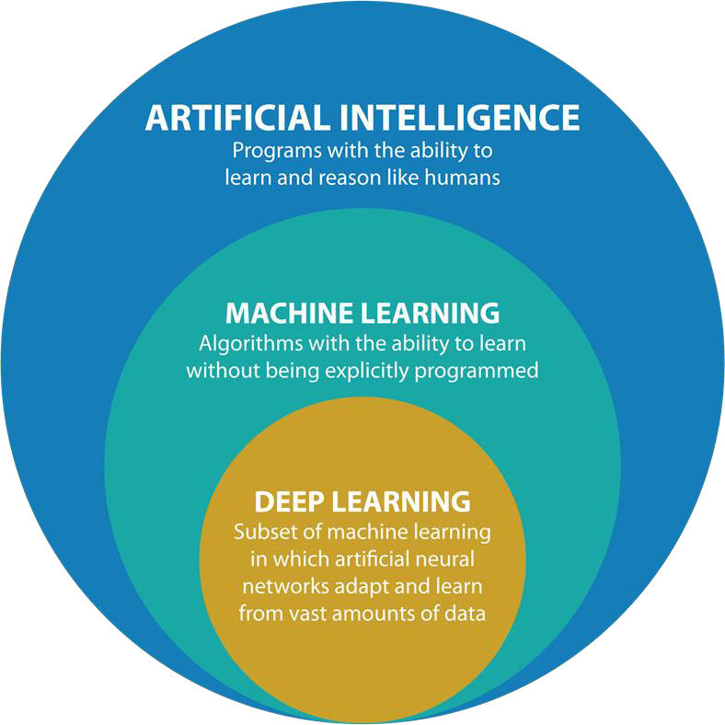

* - Strong AI refers to systems with generalized human-like intelligence, capable of reasoning and problem-solving.
* - Weak AI is designed for specific tasks, like virtual assistants or recommendation systems.
* - Examples: Strong AI (Theoretical), Weak AI (Chatbots, Voice Assistants).

# Need of Machine Learning for AI

* - Machine Learning enhances AI by enabling systems to learn, adapt, and improve over time.
* - It automates decision-making processes by analyzing large datasets.
* - Used in predictive analytics, autonomous vehicles, fraud detection, and more.

## Types of Problems Solved by Machine Learning

* - **Classification**: Identify categories
* - **Regression**: Predict continuous values (e.g., House Price Prediction).
* - **Clustering**: Group similar data points (e.g., Customer Segmentation).
* - **Recommendation**: Suggest items (e.g., Movie Recommendations).

# Classification

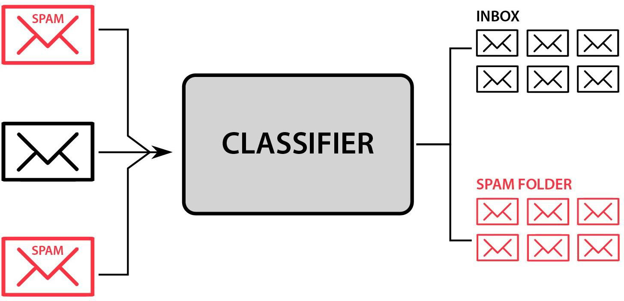

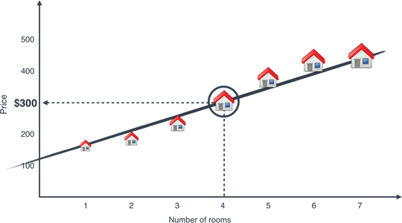

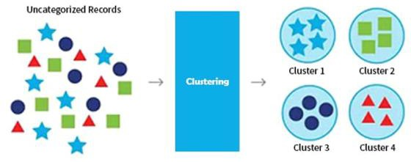

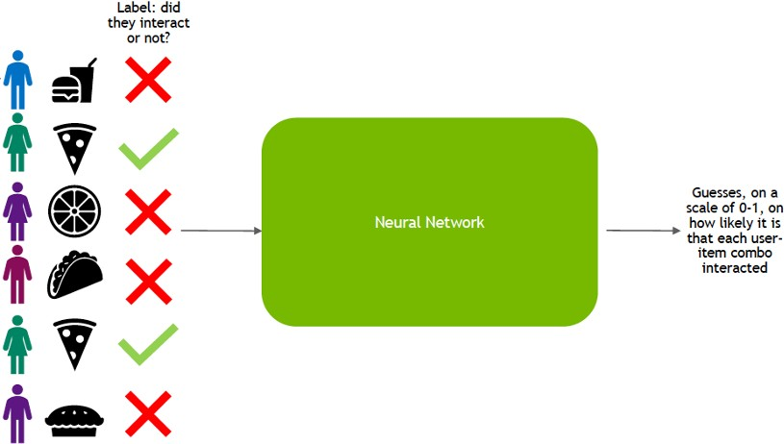

Recommendation

* - **Supervised Learning:** Uses labeled data for training. (e.g., Email Spam Detection).
* - **Unsupervised Learning:** Uses unlabeled data to find hidden patterns. (e.g., Customer Segmentation).
* - **Reinforcement Learning**: Uses data from real-time feedback system to make guided decisions or actions

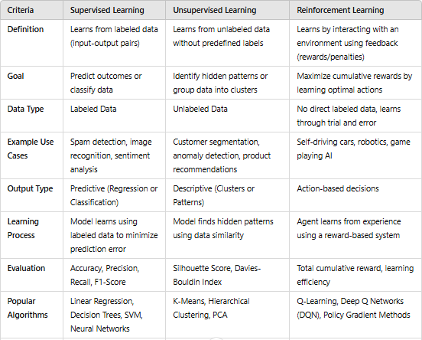

# Machine Learning Lifecycle

Trai

Data

-Set

Tneinstgi

Eval

uati

ng

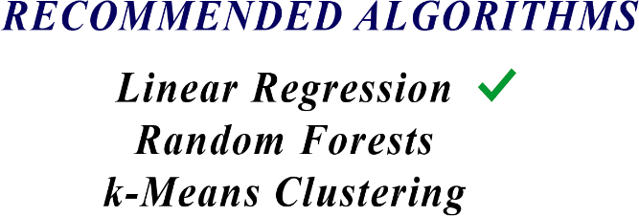

**DIVISION OF DATA**



**DATA**

**PRE-PROCESSING**



**DATA COLLECTION**



**SELECTING THE ALGORITHM**

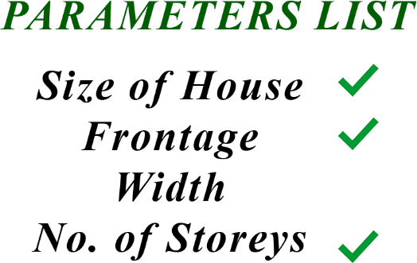

**DEFINING PARAMETERS**

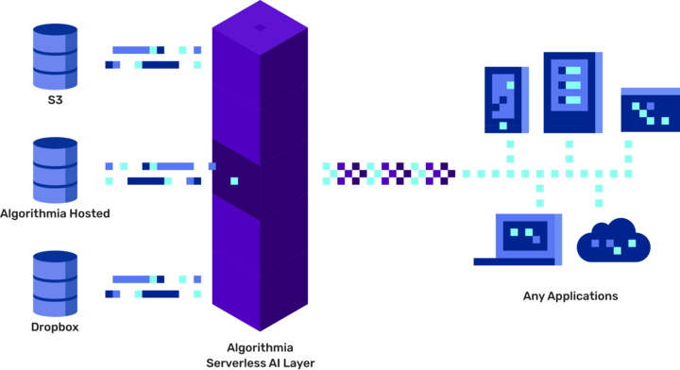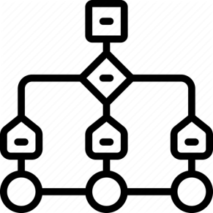

**REDEFINING THE MODEL TESTING THE MODEL**



**TRAINING MODEL WITH TRAINING DATASET**



**HOSTING THE MODEL ON ANY PLATFORM**