Using MTOM with non-WCF service

1. Don’t use “Input Attachment” UI here because if we use it, MTOM WCF will be failed (UFT cannot combine 2 features here):

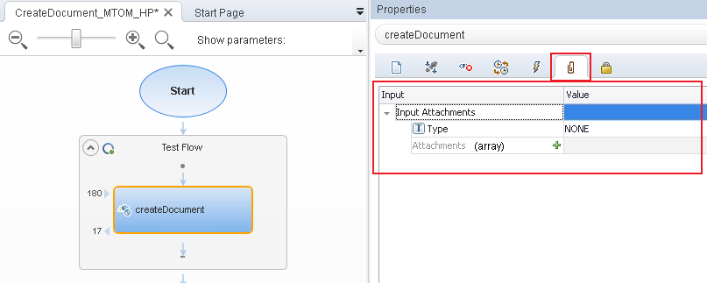

1. Attachment file will be included in **<content>** tag with **base64Binary** format:

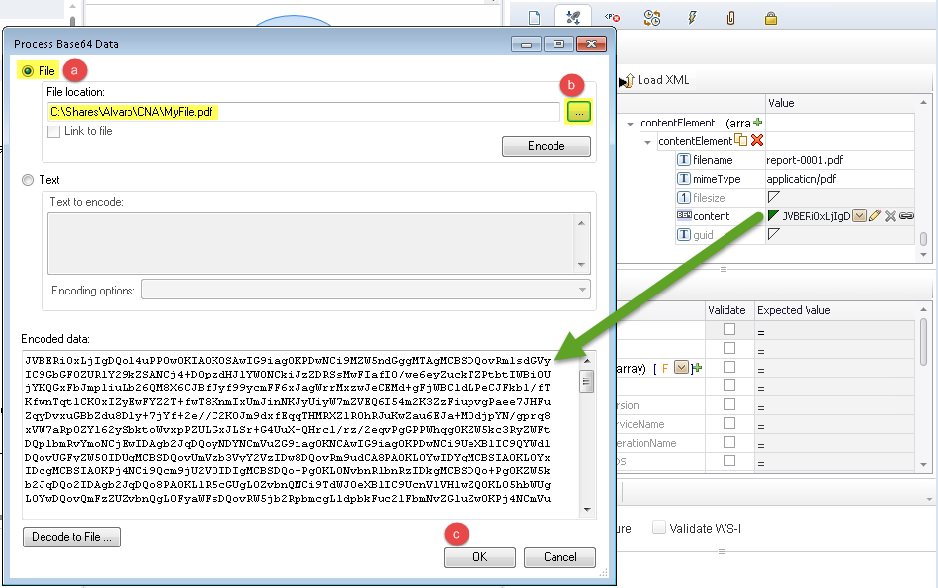

1. From WCF Custom Binding:

3.1 Choose Encoding with MTOM

3.2 From Advance - > choose *WS-Addressing version* to “**None**” (Your WS server does not use WS-Addressing, if we set it, it will be failed with error “headers: [{http://www.w3.org/2005/08/addressing}Action, {http://www.w3.org/2005/08/addressing}To] are not understood”)

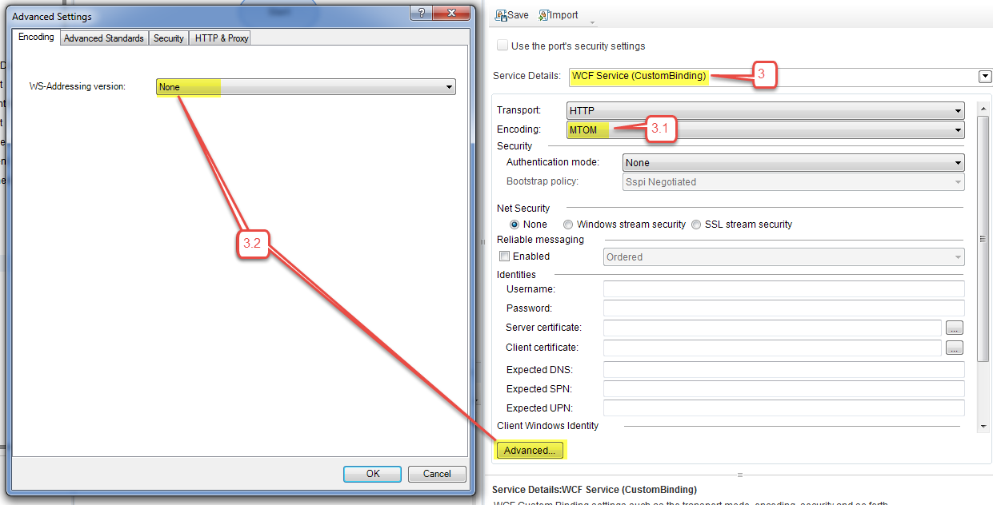

Results:

Using [Fiddler](http://www.telerik.com/download/fiddler) to capture the packet from UFT, we are able to confirm that UFT sends the attachment using MTOM encoding. See text view below:

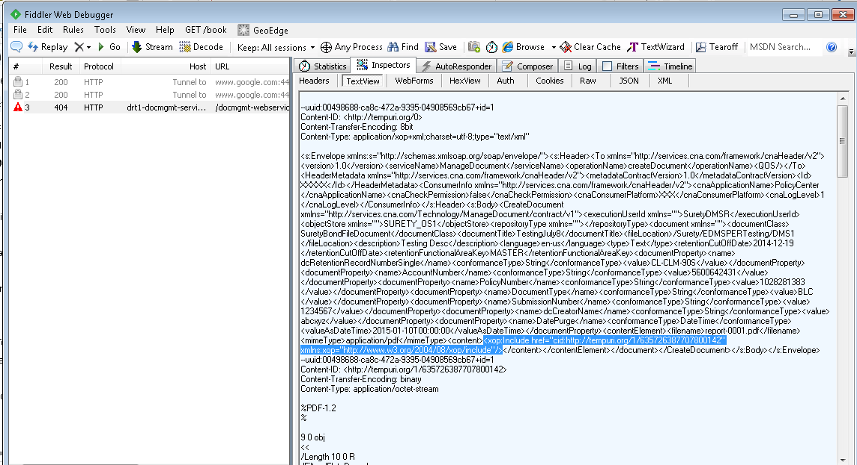

**Raw** message:

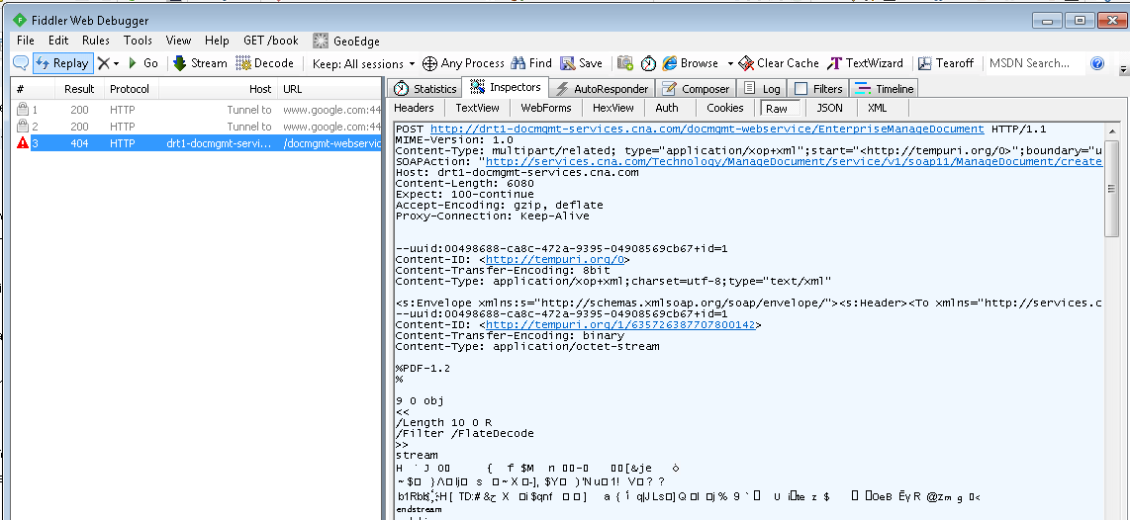

What happens we use **Text** encoding instead of **MTOM** encoding? (this is equivalent to check “*Use the port’s security settings*” checkbox in default configuration)

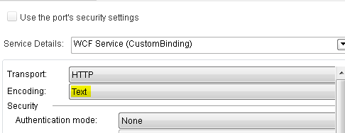

UFT will send the data as base64Binary instead of using MTOM encoding:

