class04.R

iuliarusu

2024-01-19

x <-1:50  
  
plot(x,sin(x))

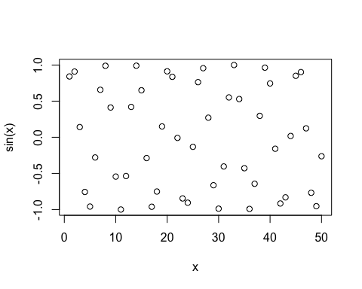

plot(x,sin(x), typ="l", col="blue")

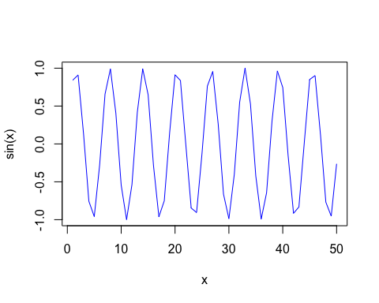

plot(x,sin(x), typ="l", col="blue", lwd=2, xlab="hello")

