Software Design

Assignment 1

Documentation

Chereji Iulia

30434

1. Use Case Diagram

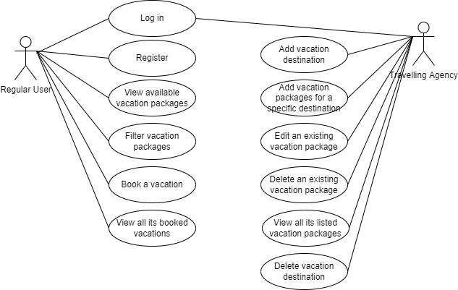

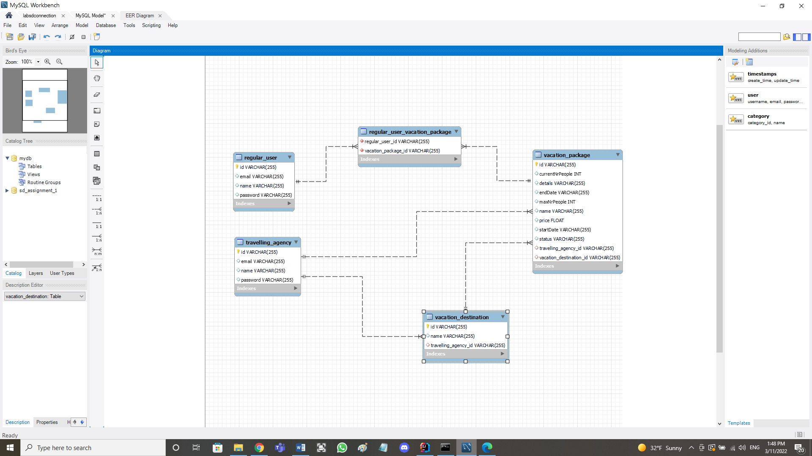2. Database Diagram

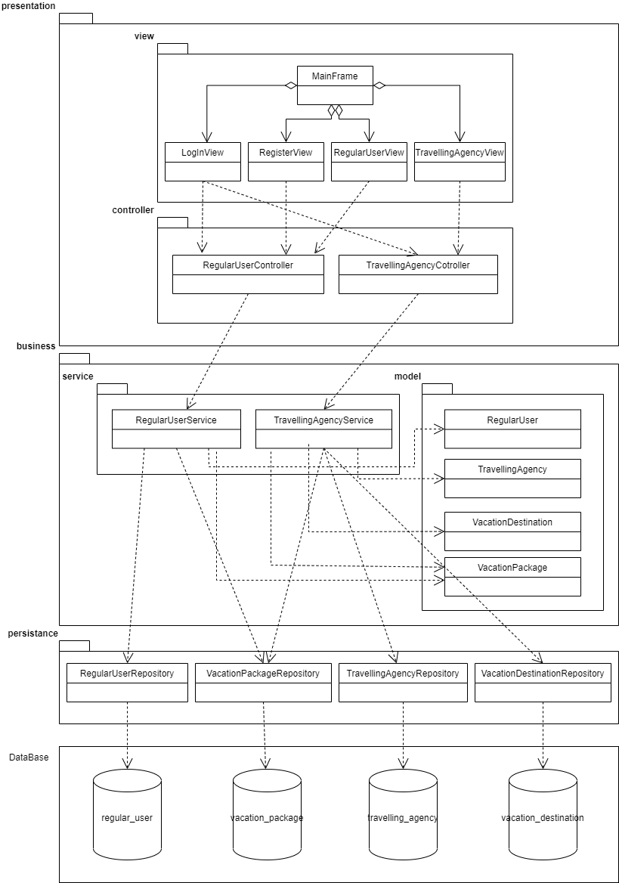3. Class Diagram