Software Design

Assignment 2

Documentation

Chereji Iulia

30434

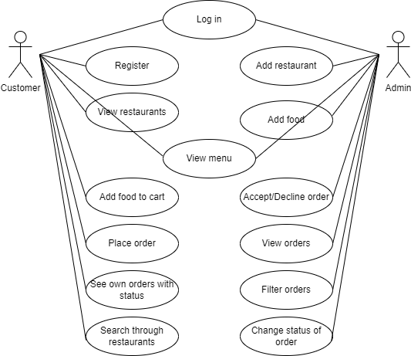1. Use Case Diagram

2. Database Diagram

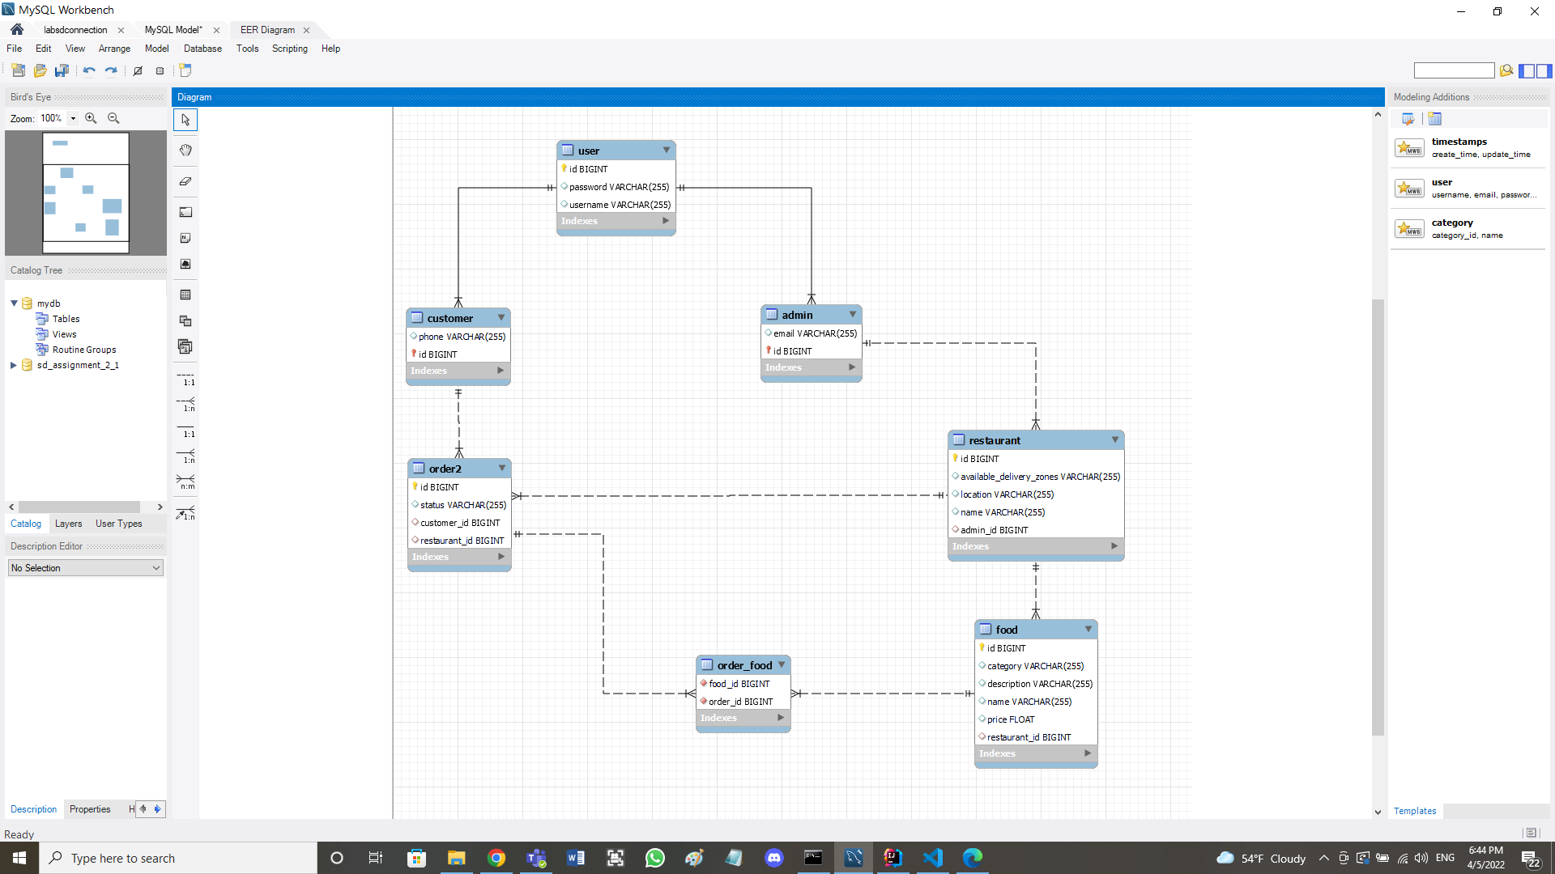

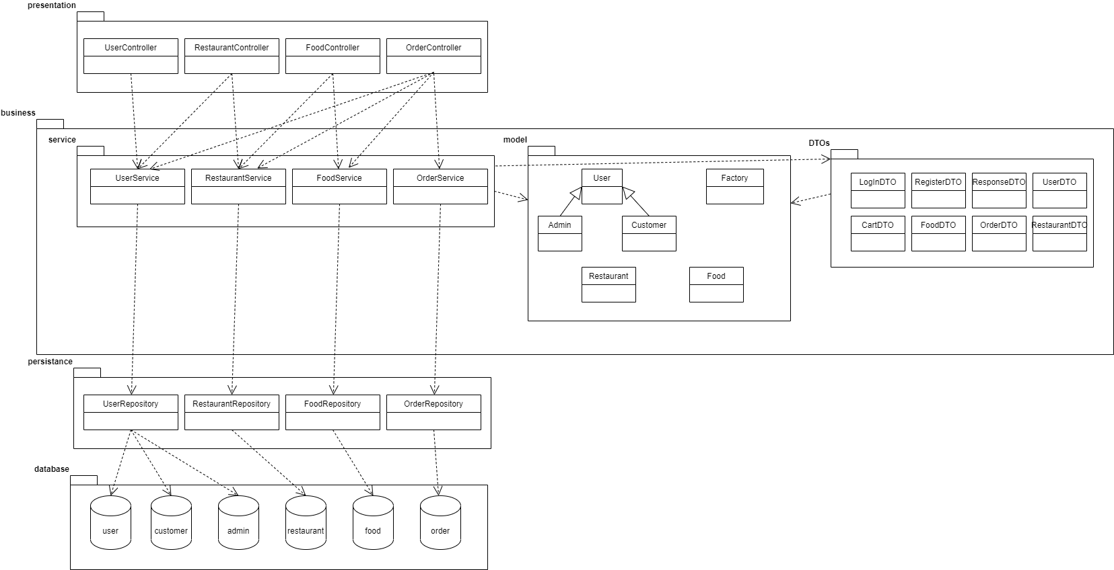3. Class Diagram