Avr_UART_TXD
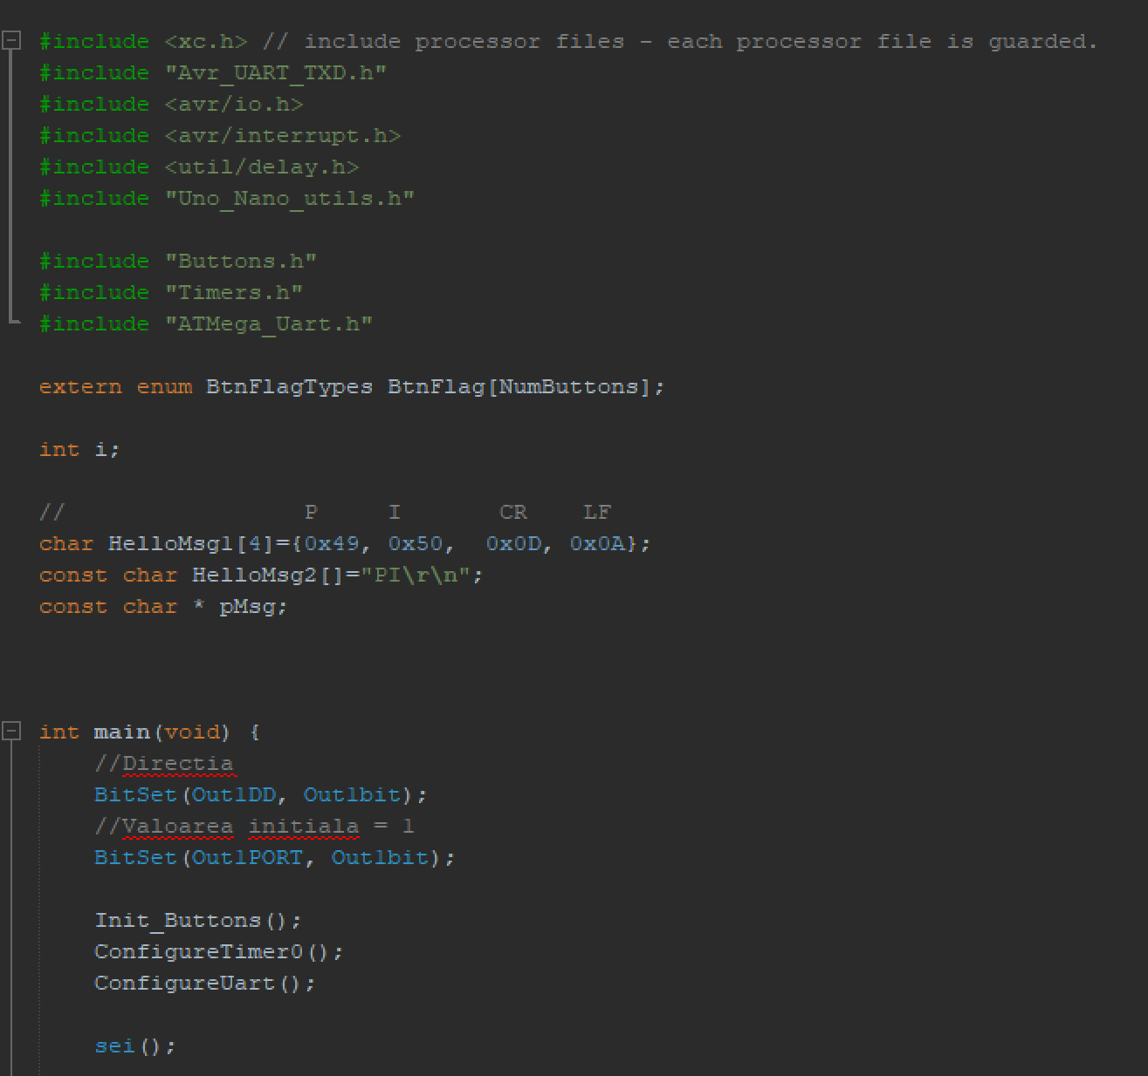
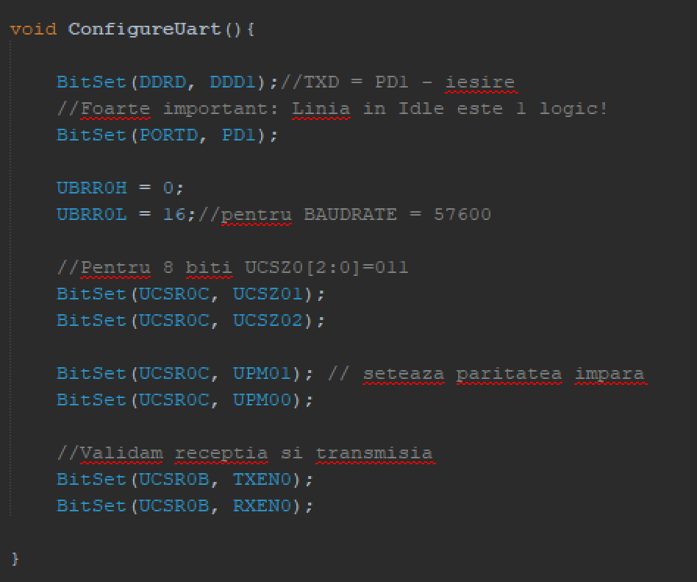
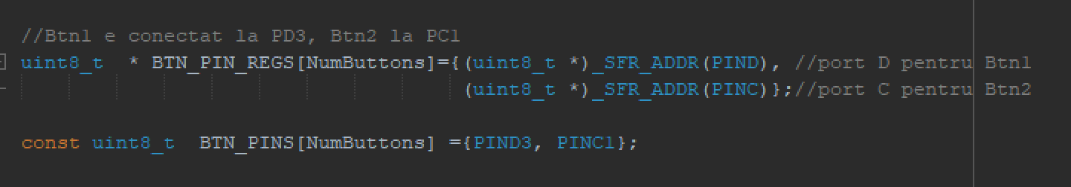
AVR_shift_TXD
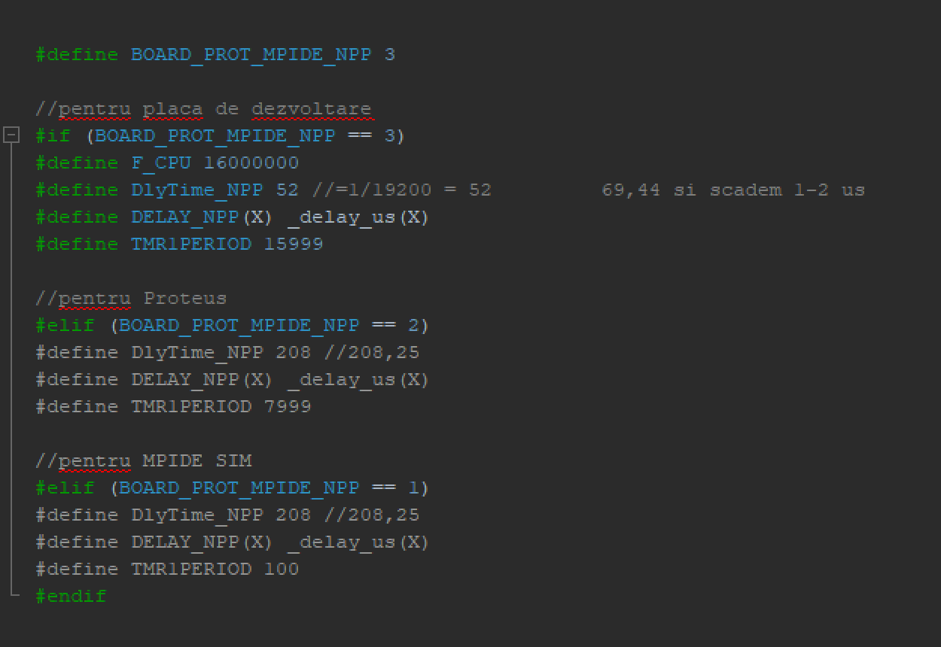
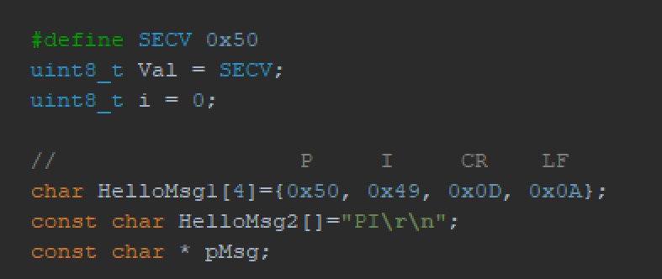
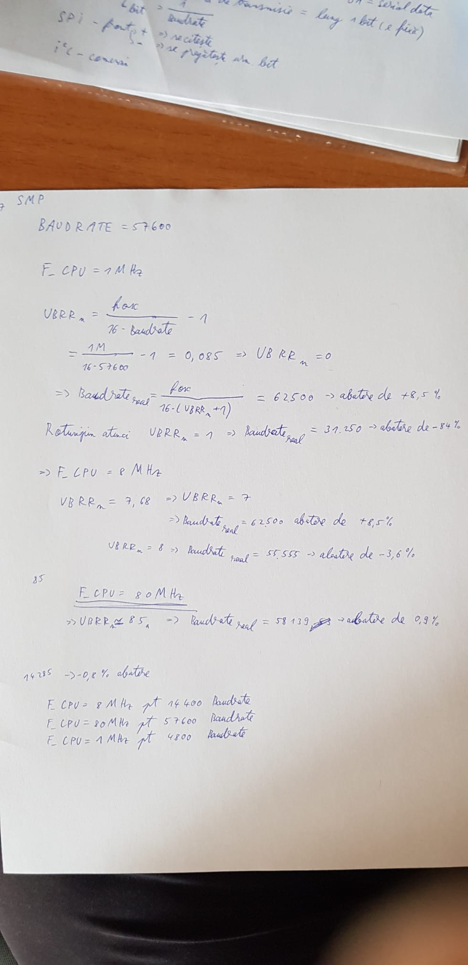
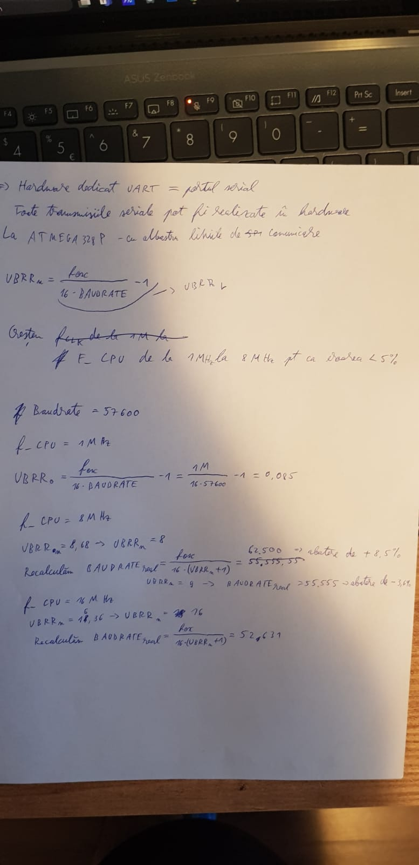

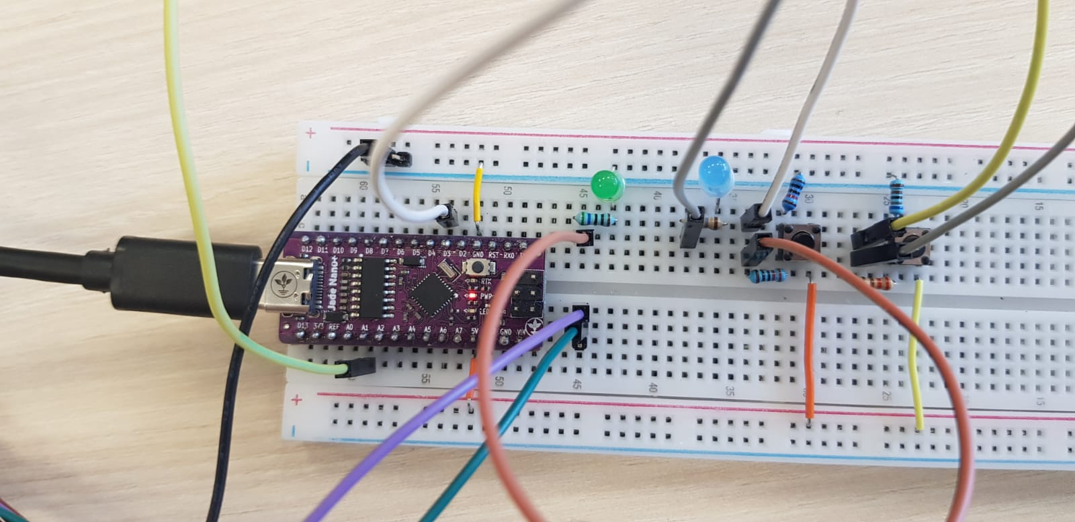
Adalm2000
AVR_Shift_TXD
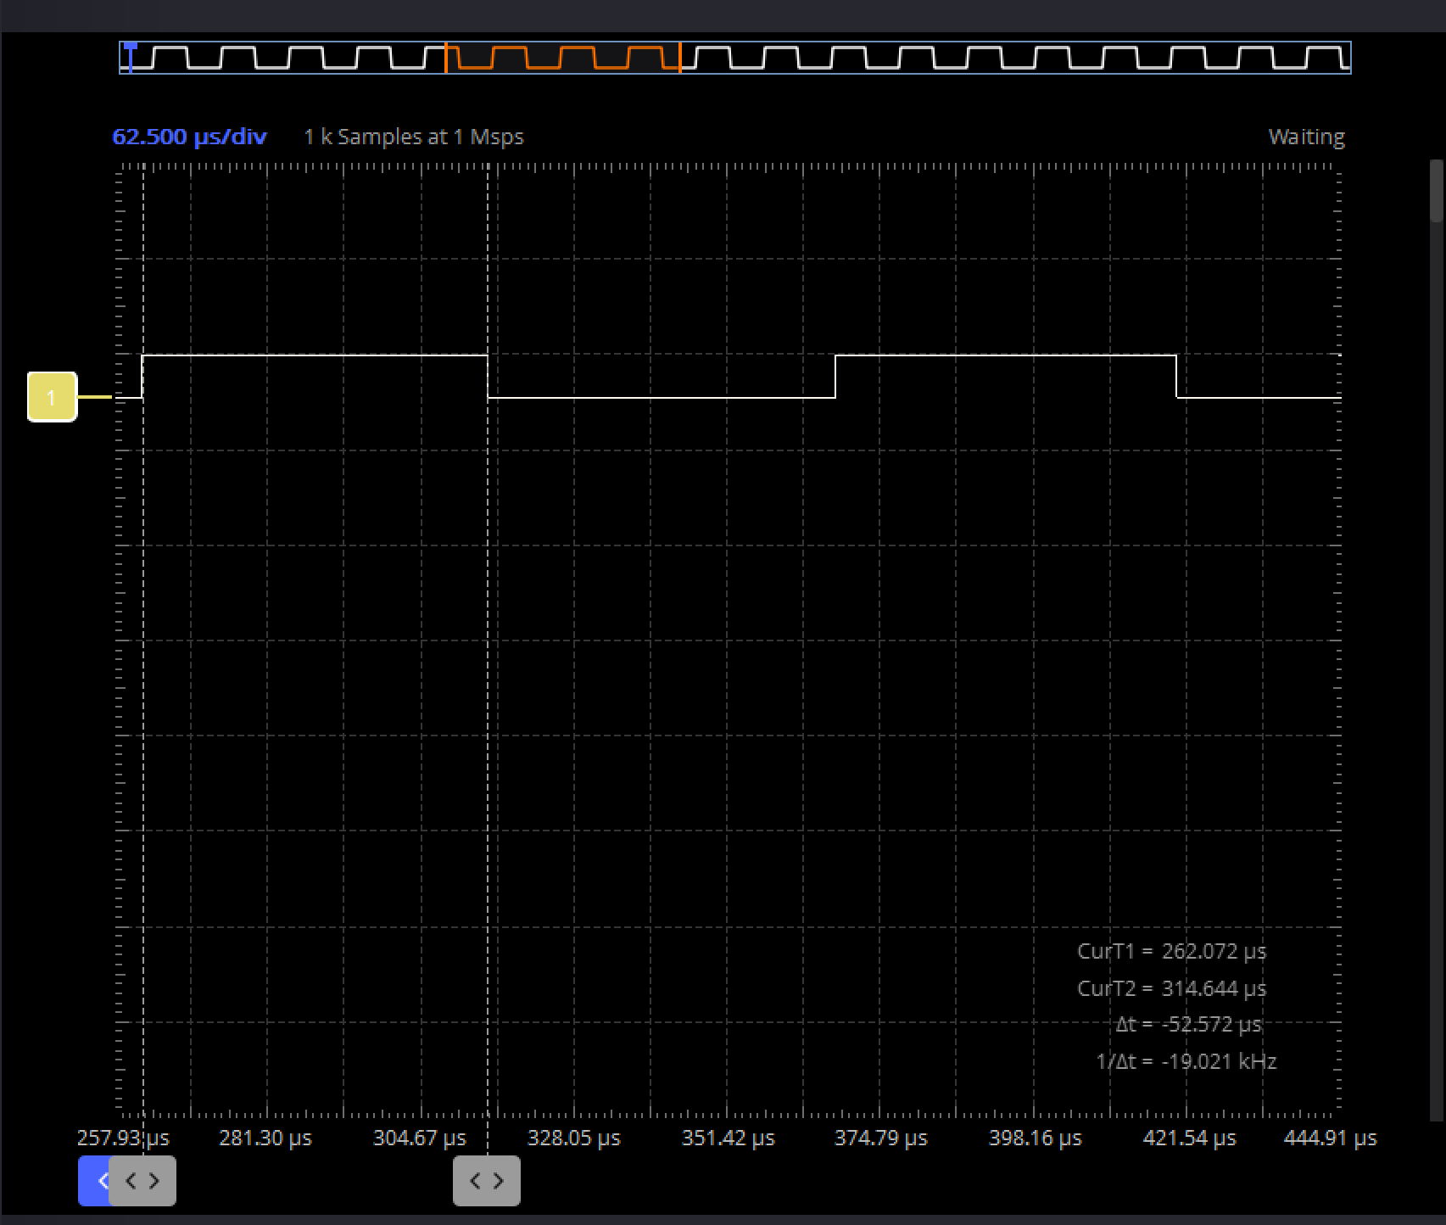
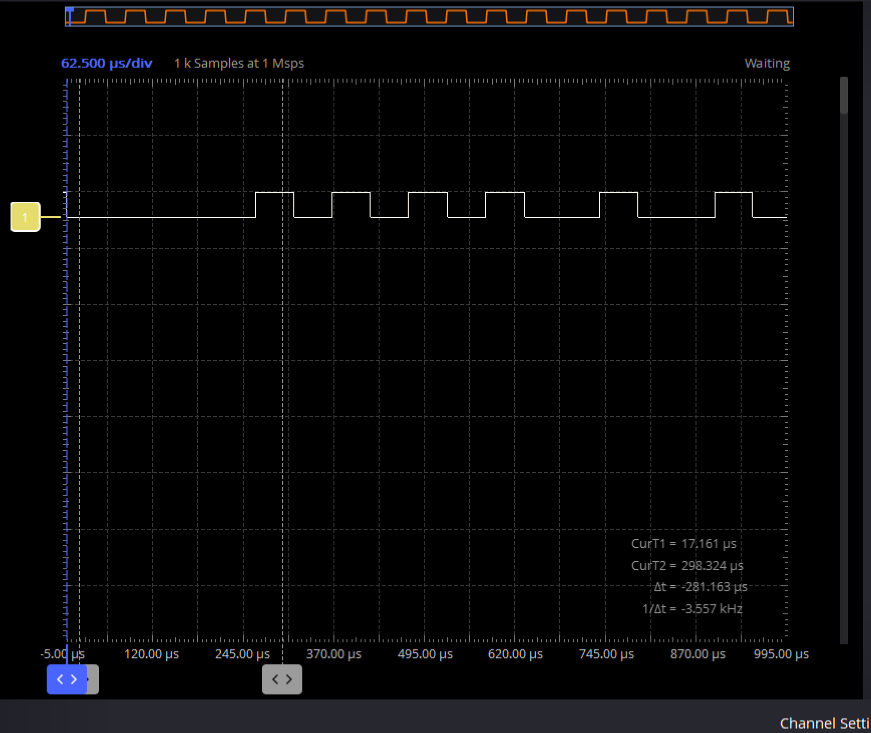
start 0000_1010 stop start 1010_0100 10 stop
0101_0000 = 50 h = “P” in Ascii
0010_0101 = 25 h …
Corectat :
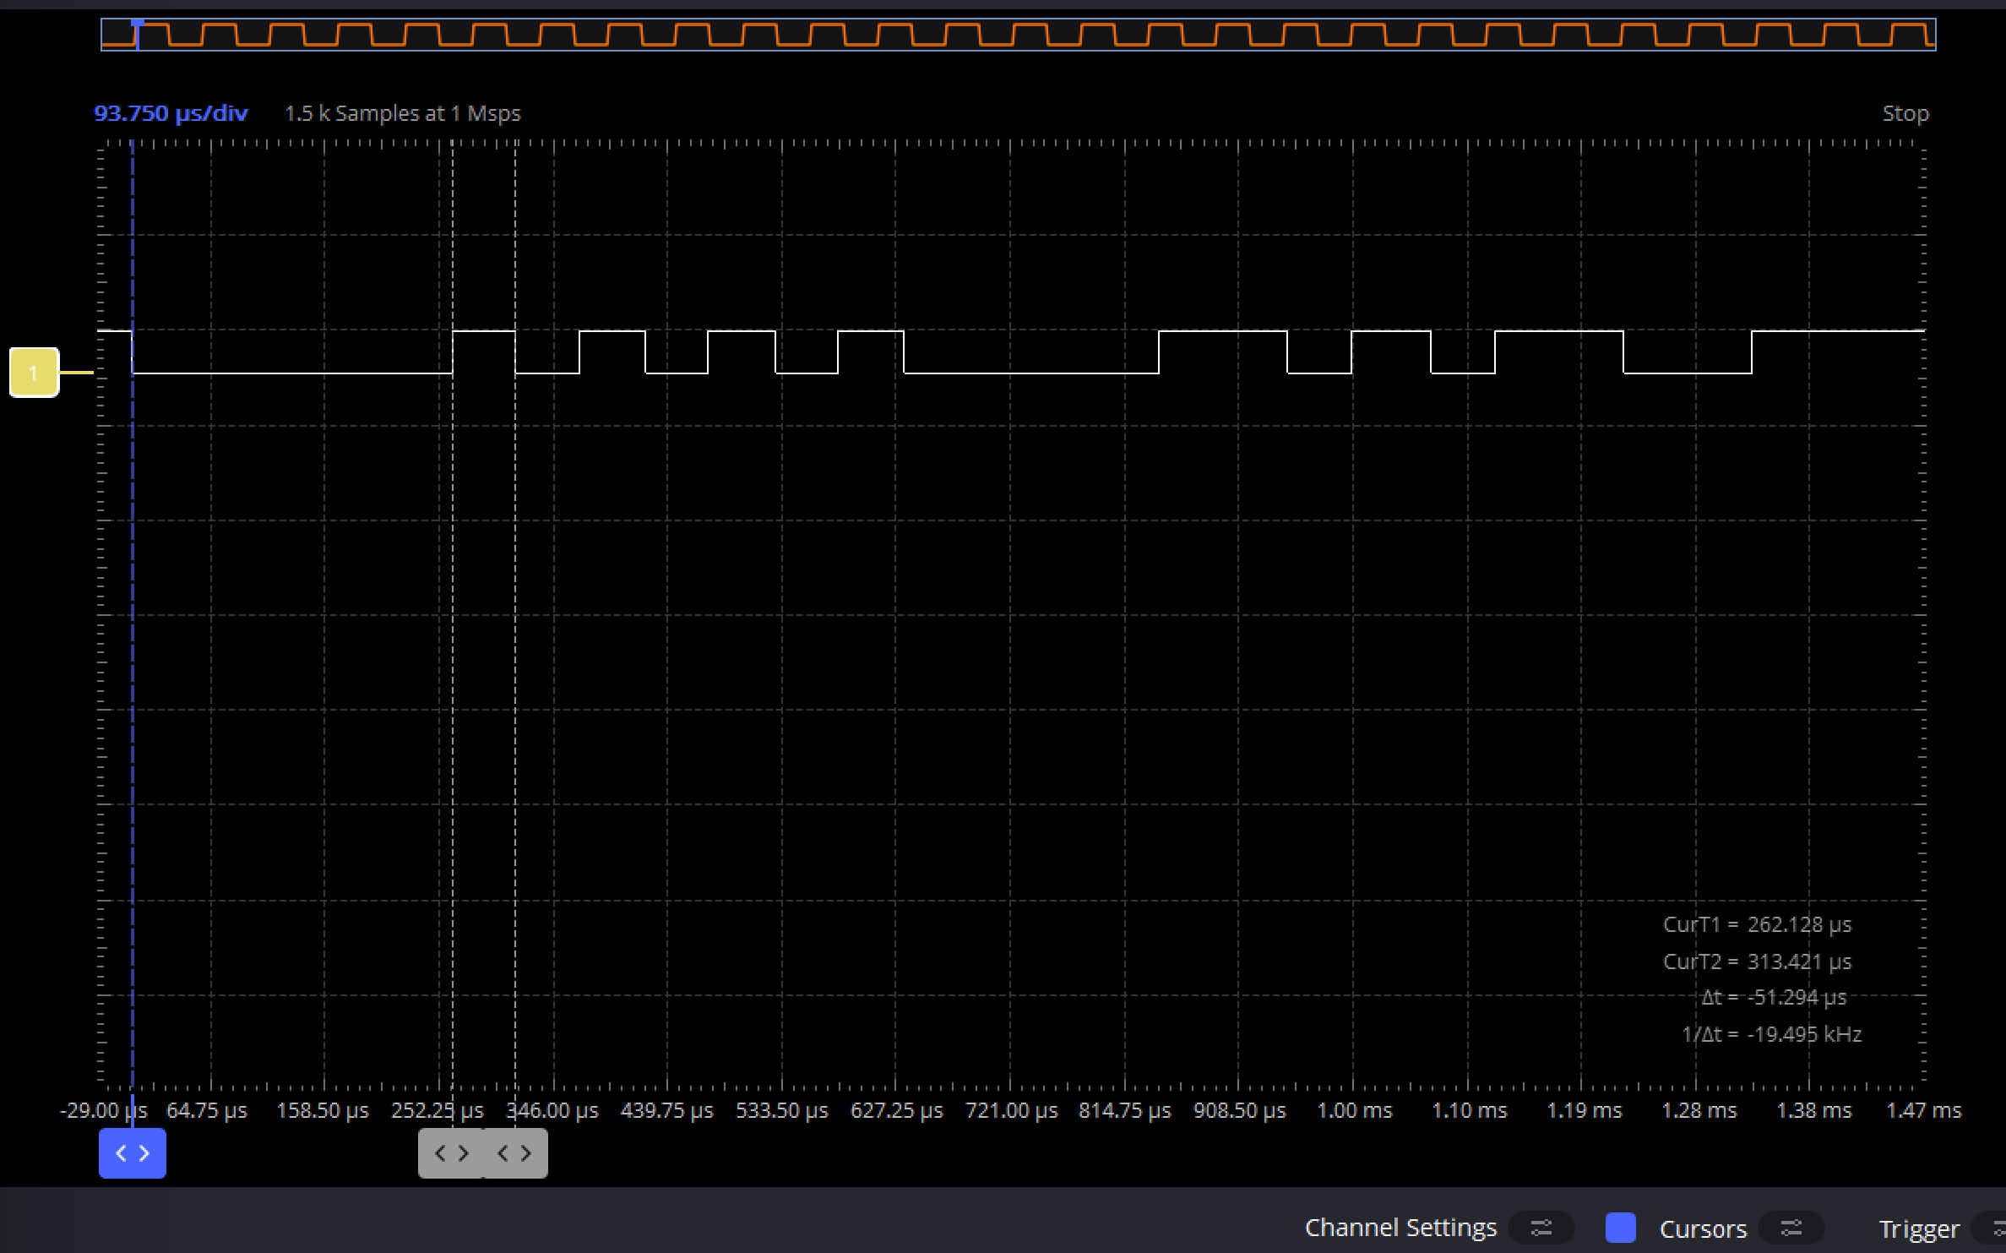
0 0000_1010 1 0 1000_0110 1 01100
0101_0000 = 50h = “P” in Ascii
0110_0001 = 61h = “a” in Ascii
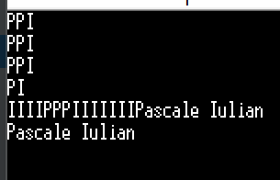
Avr_UART_TxD

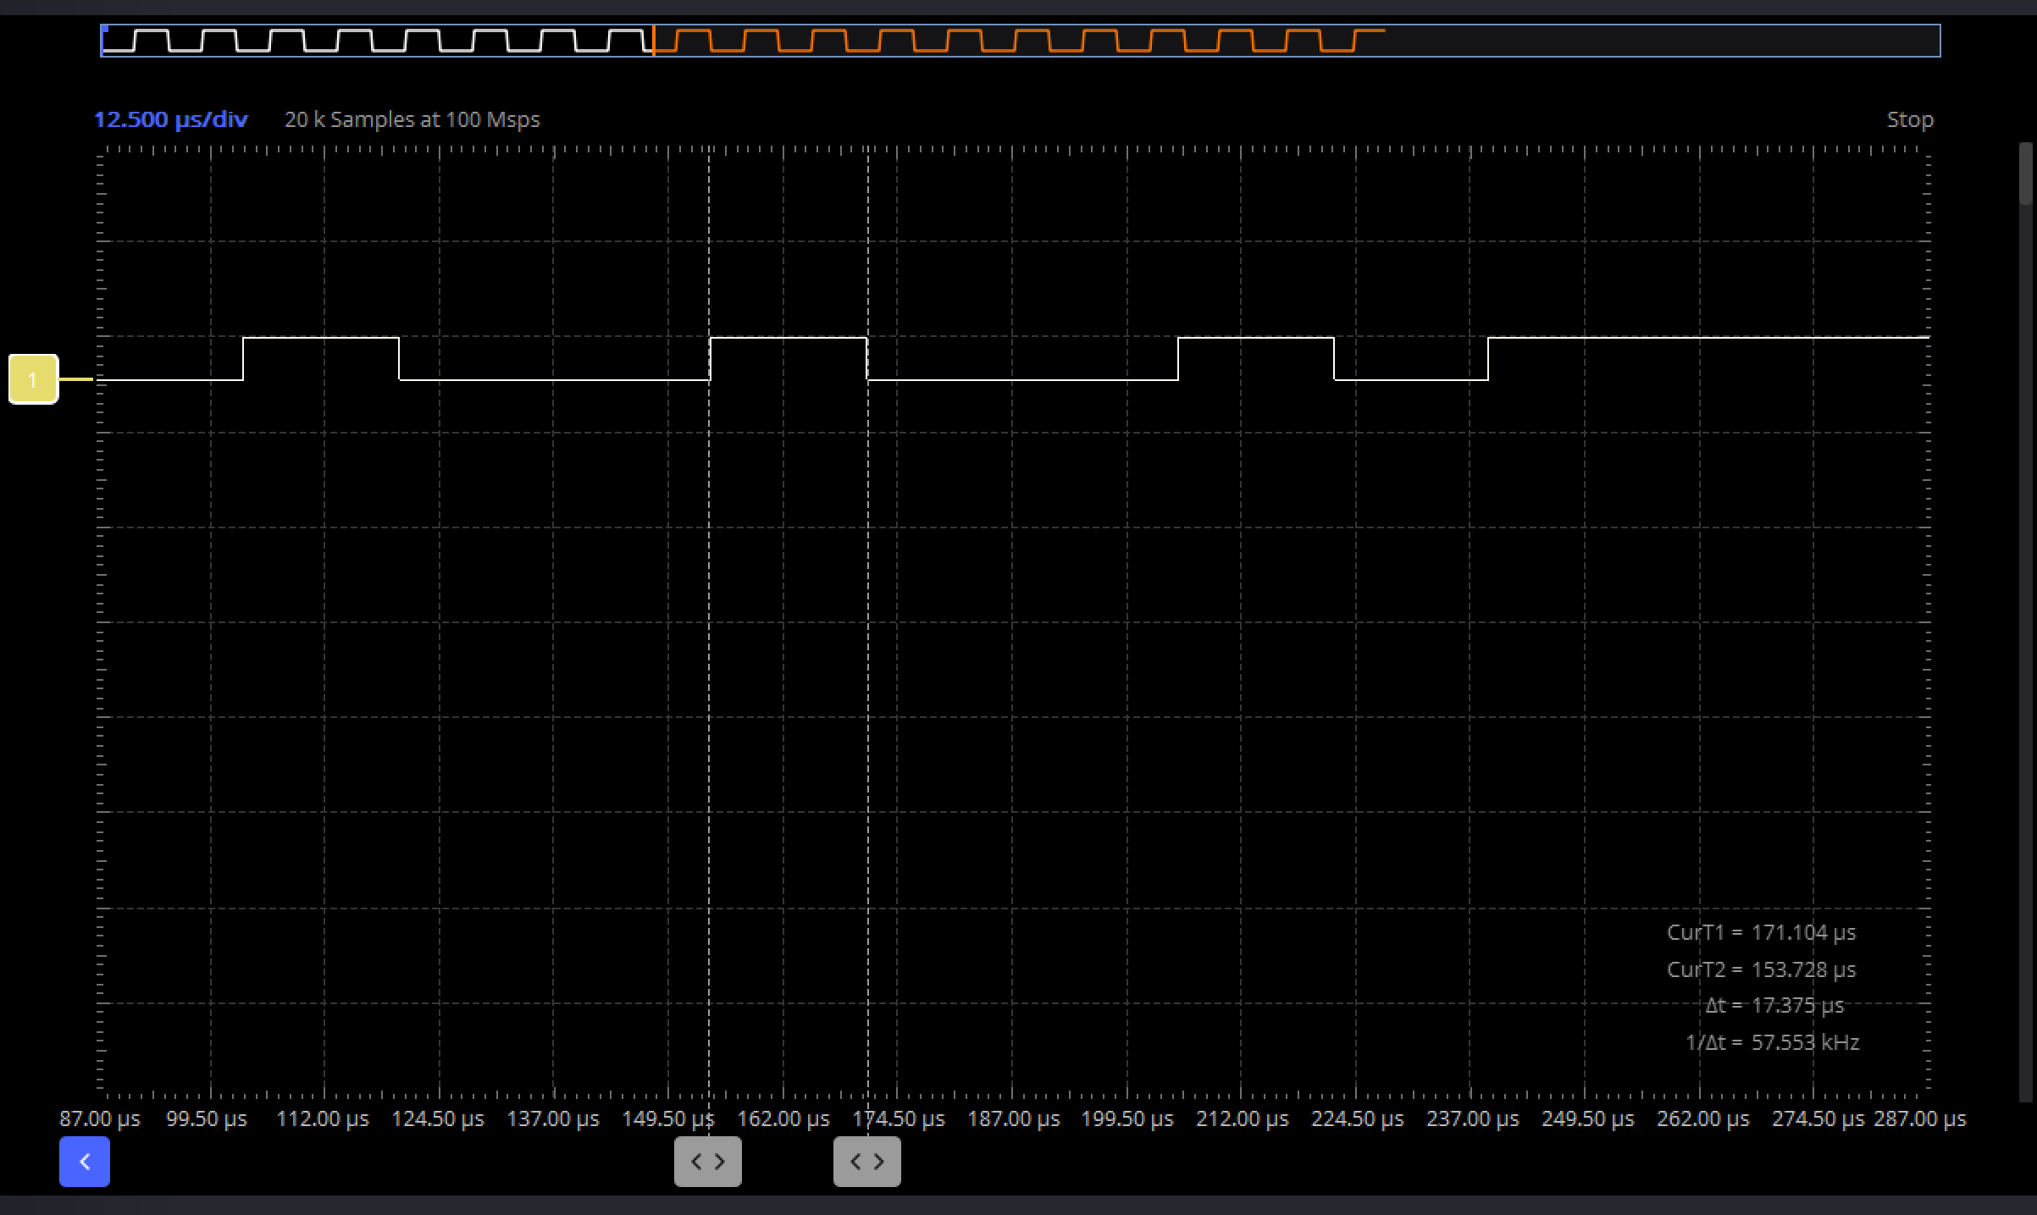
0 1001_0010 1

