PYTHON NOTES – W1

* Types of programming languages:

1. **Procedural:** procedures like if/then,while,switch,function(flow of program)[example- C,Java], Disadvantage- data hiding is not available.
2. **OOP** -- can divide program in blocks, concept of classes

[Example - C++, **Java,Python(**both are hybrid language**)**],

Principal of OOPs

* Inheritance
* Abstraction
* Encapsulation
* Polymorphism

1. **Functional** programming: **functions are treated as 1st class citizens**

[Example - Python].

* **First-class functions** when functions in that language are treated like any other variable. For example, in such a language, a function can be passed as an argument to other functions, can be returned by another function and can be assigned as a value to a variable.
* **Primitives:** int,bool,float,char. **All primitives in Python are objects, no such concept of primitives.**
* **Class** is a combination (bundle) of Properties **(variables) + Methods (functions),** instance of class is called **Object.**
* **Object** is a global class, and every other class inherits the object class.
* **Dynamic vs Static Language**: if int is provided it will keep it as it is in Java, while in Python type of variable is determined during runtime. During compilation, type_check is performed.

int a = 10; // LHS happens at compile time whereas RHS happens at runtime

* Types of memory in any programming language:

1. **Stack memory**:

* reference variable is saved

1. **Heap memory**

* Object is saved
* Actual object value is saved somewhere in RAM

a = 10 // a is a reference which resides in stack memory whereas 10 is an object residing in heap memory.

* More than one reference can point to an object, but a single reference variable cannot point to 2 objects simultaneously.

Garbage collection eats up unreferenced object from memory

* **== Compares values whereas “is” compares references**.

-6 to 256 are reserved by python, i.e.

|  |
| --- |
| a=10 b=10 print(a is b) → true (same object(same reference)) a= 4555 b= 4555 print(a is b) → false(coz, -6 to 256 is reserved, and numbers beyond this range will have different objects(different reference), even for same values). |

* Size of integer in Python: RAM in the computer
* Python converts all int to float before performing division.
* Python is a strongly typed language as it **does type check** of all variables during runtime, loosely typed language(e.g. - C).
* // gives floor division(integer value)
* NameError(if interpreter doesn’t recognize something; sees a variable which was never defined) & SyntaxError(if there is something wrong in the way a program should be written) are 2 errors in Python.
* Data types: **Mutable(can change value) & Non-Mutable(cannot be changed)**
* Array is homogeneous (elements having the same type of data type) whereas list is heterogeneous.
* List is built either using [] or using list function. ( list()).
* Tuple is immutable---value of object cannot be changed, use () for making tuple.
* Set (unique collection of values) is unordered, non-duplicate values
* Dictionary-- key value pair, key should be unique.
* Reverse a list a[-1::-1]
* Dictionary is a key-value pair database.

1. dict() is the constructor used for manually making a dictionary.
2. Dictionaries have no order.
3. The get() method returns the value of the item with the specified key.
4. *dictionary*.get(*keyname, value*)
5. Using the “for” loop, it loops on keys not on values.

* Mutable -- list[], set, dict{key:value}
* Immutable -- tuple(), string
* Tuples are immutable.

1. Tuples are comparable

* Zero(0) stands for false and any other number stands true, empty list [] is also false.

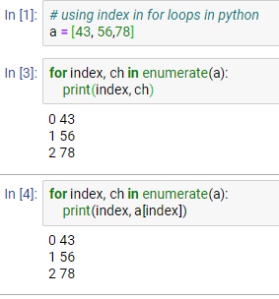

* List comprehension

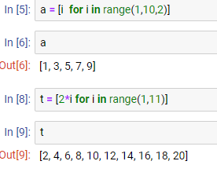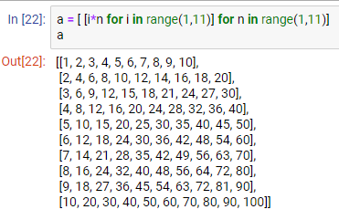

* **Functions**

1. If function has no return types, then function would return **None**
2. Functions are also Objects!
3. If your function body is small use **inline/lambda** function

|  |
| --- |
| lambda argument : function body |

|  |
| --- |
| def **add**(a, b):  return a + b OR add = lambda a,b: a + b add(3,4) 7 |

1. **map()** function returns a map object(which is an iterator) of the results after applying the given function to each item of a given iterable (list, tuple etc.)

map(fun, iter)

Map? Shows help on functions provided before ? (valid in jupyter notebook)

|  |
| --- |
| a = [1,2,3,4,5] list(map(lambda x: x ** 2, a)) [1, 4, 9, 16, 25] |

1. **filter()** method filters the given sequence with the help of a function that tests each element in the sequence to be **true or not**.

filter(function, sequence)

Returns: an iterator that is already filtered.It is normally used with [Lambda functions](https://www.geeksforgeeks.org/python-lambda-anonymous-functions-filter-map-reduce/) to separate list, tuple, or sets.

a = [1,2,3,4,5,6,7,8,9,10]  
list(filter(isEven, a))  
[2, 4, 6, 8, 10]

1. In python, there is only 1 way to give comments i.e #

multiline strings : """ """ or ''' ''', they are not comments

|  |
| --- |
| def **fun**():  """  this is a comment(really?)  """  def **fun**():  *# this is actually a comment*  File "<ipython-input-88-522eb4d9fa79>", line 2  *# this is actually a comment*  ^ SyntaxError: unexpected EOF while parsing |

1. isinstance(obj, class_or_tuple, /)

Return whether an object is an instance of a class or of a subclass thereof.

***Classes are also object!***

|  |
| --- |
| def **multiply**(x): *# x here is each element of a, not whole a!*  return 2 * x isinstance(multiply, object) True |

* input() functions take everything as a string irrespective of the type you provide.
* The value between the parentheses when we call the function is referred to as an argument of the function call.(value passed while calling a function)
* **Positional arguments** because their assignments depend on their positions in the function call, **Keyword arguments**, where we explicitly refer to what each argument is assigned to in the function call.
* “**break**” keyword takes the cursor out of the while loop to the end whereas “**continue**” keyword skips the present iteration and goes to next iteration statement.