Project plans:

1 — Auto-RL (Automated Reinforcement Learning)

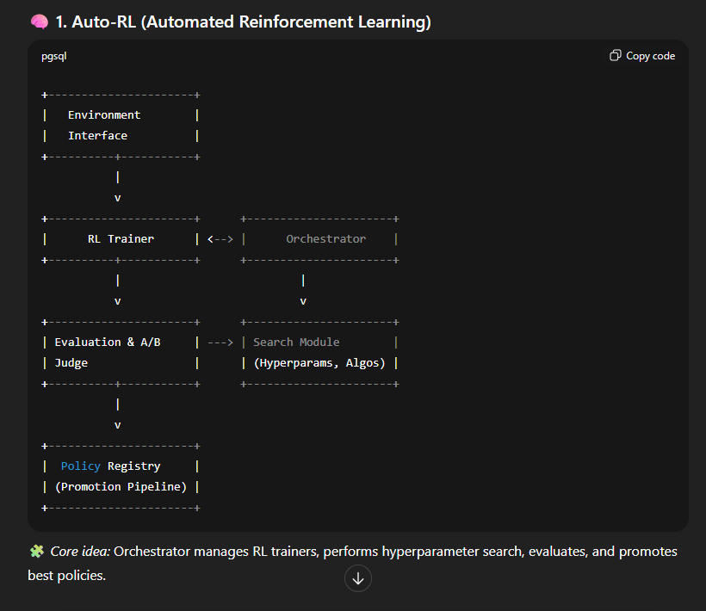

1.1 Architecture (high level)
- Orchestrator (controller): schedules experiments, monitors metrics, coordinates search (hyperparams, algorithm, reward shaping).
- Search Module / AutoML layer: uses Bayesian optimization / population based / evolutionary search to pick RL hyperparameters & architectures.
- RL Trainer Pool: multiple RL workers running different algorithms (PPO, SAC, DQN, etc) — distributed using Ray/RLlib (scalable) or custom Kubernetes jobs. docs.ray.io+1
- Simulator / Environment Interface: Gym/ACE/Custom env wrappers; environment adapters for real or simulated tasks.
- Evaluation & A/B judge: offline validation and LLM-based judge for policy behavior (optional).
- Data & Replay Store: shared log/replay buffers, metrics DB (Prometheus / Influx), and artifact store (model checkpoints, logs).
- Policy Registry & Promotion Pipeline: validated policies promoted to staging / production, with automatic safety checks.

1.2 Functional Spec (FSD — essentials)
- Input: env spec (Gym/Custom), reward signals, constraints, performance goals (reward threshold, sample budget).
- Outputs: best policy checkpoint(s), hyperparameter report, evaluation metrics, policy promotion package (serving container).
- Constraints: sample budget, compute budget, safety constraints (e.g., reward clipping, safe action masks).
- SLOs: discover a policy reaching X reward within budget Y, automated reproducible experiments.
- Monitoring: training curves, anomaly alerts, early stopping rules.

1.4 2-Month Plan (Nov 2025 — Dec 2025) — parallelizable
Assumption: Team of 5 (1 lead, 2 infra/devops, 2 RL engineers)

Week 1 (Nov 1–7)
- Kickoff, finalize envs, define success metrics & budgets. Select core libraries (Ray RLlib + AutoRL survey methods). arXiv+1

Week 2 (Nov 8–14)
- Implement orchestrator skeleton; integrate RLlib examples; set up artifact & metrics store.

Week 3 (Nov 15–21)
- Implement search connector (Bayes / population search) and run first small experiments.

Week 4 (Nov 22–30)
- Parallel: implement safety checks & evaluation scripts; begin longer runs.

Week 5 (Dec 1–7)
- Scale experiments (multi-worker), collect results, add early stopping and resource manager.

Week 6 (Dec 8–14)
- Add policy promotion pipeline (containerization, reproducible checkpoints).

Week 7 (Dec 15–21)
- Finalize judge and human/eval reporting, tune search heuristics.

Week 8 (Dec 22–31)
- Run validation on held-out tasks, finalize docs, deliver model registry and a demo.

1.5 Open-source tools & notes (recommended)
- Ray / RLlib — production-grade, scalable RL engine (algorithms, examples). Good for distributed experiments. docs.ray.io+1
- ARLO / AutoRL frameworks — research frameworks / papers for AutoRL patterns; use for algorithmic ideas and baseline methods. ScienceDirect+1
- Optuna / Ax — hyperparameter search backends (Bayesian).
- MLFlow / Weights & Biases — experiment tracking.
Recommendation: prototype with Ray+RLlib + Optuna; follow AutoRL literature for search strategies.

2 — Dynamic Context Engineering (dynamic RAG / Mem management)
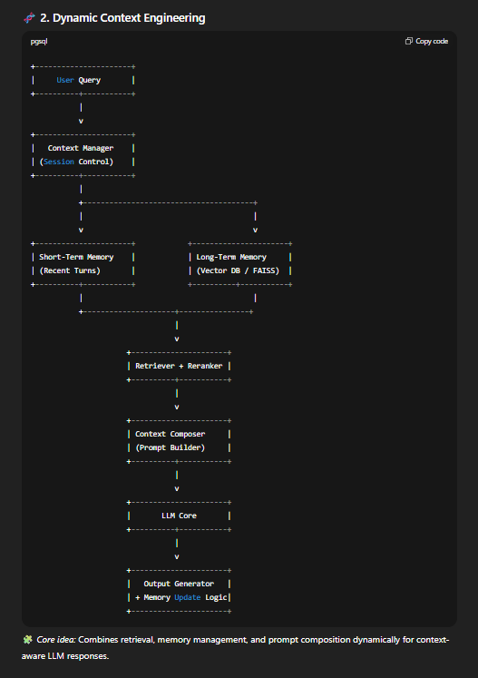

2.1 Architecture (high level)
- User/Agent Interface → request → Context Manager.
- Context Manager:
  - Short-term memory (current conversation window)
  - Long-term memory tier (vector DB index + metadata) — e.g., Weaviate, Milvus, Pinecone.
  - Memory Policy Engine — rules to decide what to store, compress, evict, summarize. (MemGPT concepts.) GitHub+1
  - Retriever — dense retriever (FAISS, Milvus) + sparse filters.
  - Context Composer — builds the final prompt: system prompt + retrieved shards + condensed summary + recent turns.
- Reranker / Safety Filter — de-dupe, redact PII, apply policy.
- LLM / Generator — receives composed context; returns output; agent logs feedback for self-learning.
- Sleep time compute (optional)

2.2 Functional Spec (FSD)
- Input: user query, session id, privacy policy.
- Outputs: composed context delivered to model; stored mem updates; retrieval logs.
- Memory policies: TTL, importance scoring, user preference, privacy labels.
- SLOs: context assembly < 150 ms (target), retrieval precision > X% on domain eval.
- Data store: vector DB + metadata store; document store for raw artifacts.

2.4 2-Month Plan (Nov–Dec 2025)
Team: 1 architect, 2 backend engineers, 2 ML engineer

Week 1
- Finalize memory tiers, choose vector DB (Milvus/Weaviate/Pinecone), select retriever (FAISS/Embeddings provider). LangChain+1

Week 2
- Implement simple RAG pipeline: ingestion → embedding → retrieval; basic context composer.

Week 3
- Implement memory policy engine (importance scores + eviction). Integrate MemGPT ideas. GitHub+1

Week 4
- Add reranker, PII redaction, and safety filter; benchmark latency.

Week 5
- Integrate with LLMs (OpenAI / local SLM); iterate prompt templates.

Week 6
- Add summarization/compaction module; policy experiments for store vs. forget.

Week 7
- Robustness testing: hallucination checks, user personalization tests.

Week 8
- Documentation, demo, and handover.

2.5 Open-source tools & notes
- MemGPT (implementations / repos) — strategies for hierarchical memory management. GitHub+1
- LangChain — orchestration/vocab for RAG and prompt chains; good for prototyping. LangChain
- Vector DBs: Milvus, Weaviate, Pinecone — choose by latency and cost.
- FAISS for on-prem dense retrieval.
Recommendation: Prototype with LangChain + Milvus/FAISS + MemGPT patterns; tune memory policy offline.

3 — Auto-Fine-Tuning (automated, continuous model specialization)
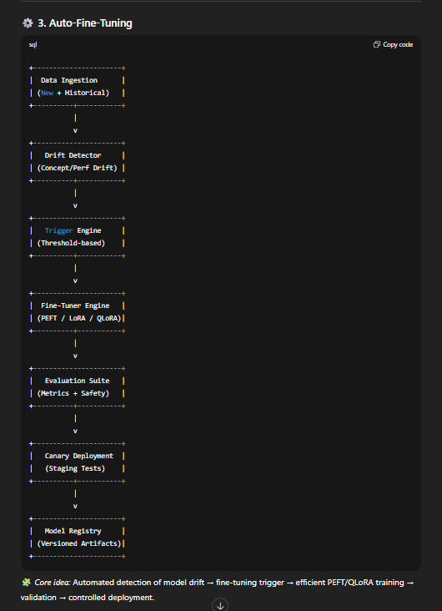

3.1 Architecture (high level)
- Data Ingest / Drift Detector: streams new labeled/unlabeled data and flags drift or new concepts.
- Trigger Engine: when performance or drift thresholds are hit, trigger fine-tune job.
- Fine-Tuner: uses PEFT/LoRA/QLoRA pipelines, integrates DeepSpeed/bitsandbytes for efficiency. GitHub+1
- Validation & Canary: run evaluation, human in the loop (if needed); deploy to canary.
- Model Registry & Rollback: versioned artifacts, auto rollback on regressions.

3.2 Functional Spec (FSD)
- Input: incremental data, performance thresholds, domain constraints.
- Output: new model artifact (LoRA adapter or full weights), eval report, deployment package.
- Safety: data sanitization, PII removal, evaluation against holdout.
- SLOs: end-to-end fine-tune pipeline under fixed compute budget; no more than X% performance regression.

3.4 2-Month Plan (Nov–Dec 2025)
Team: 3 ML engineer, 1 data engineer, 1 infra

Week 1
- Define drift detectors & metrics; choose base model(s); set fine-tune policies.

Week 2
- Build data pipeline for incremental ingestion; sandbox tuning with PEFT/LoRA. Hugging Face+1

Week 3
- Integrate bitsandbytes + DeepSpeed configs for QLoRA experiments. Hugging Face+1

Week 4
- Automate validation & canary deploy; add rollback logic.

Week 5–6
- Run live fine-tune jobs on historical drift scenarios; measure cost and time.

Week 7
- Hardening: security (key management), logging, monitoring.

Week 8
- Docs, runbook, handover.

3.5 Open-source tools & notes
- PEFT / LoRA — low-cost adapters to fine-tune large models. Good default. GitHub+1
- QLoRA (bitsandbytes + 4-bit quantization + LoRA) — very memory efficient for large models; recommended if GPU memory is tight. Hugging Face
- DeepSpeed — large scale training optimizations + ZeRO for memory reduction.

4 — Auto-Quantization (automated model compression & distillation)
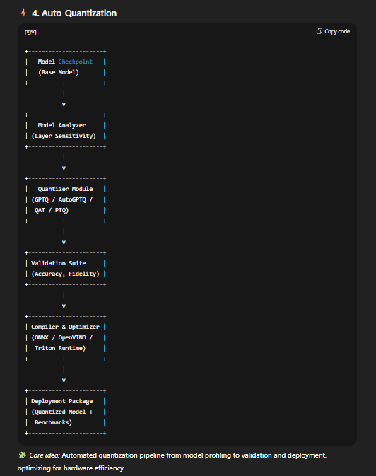

4.1 Architecture (high level)
- Model Fetch & Analyzer: collects model, estimates sensitivity per layer.
- Quantizer Module:
  - Post-training quantization (e.g., GPTQ / AutoGPTQ) for int4/int8 weight quantization. GitHub+1
  - Optional distillation/knowledge transfer pipelines to create distilled SLMs.
- Validation Suite: fidelity checks, accuracy vs. size tradeoff.
- Compiler / Inference Optimizer: compile for target (CPU: ONNX/OpenVINO; GPU: Triton / vLLM).
- Rollback & Monitoring: keep both original and compressed model endpoints for A/B.

4.2 Functional Spec (FSD)
- Input: checkpoint, target hardware profile, acceptable accuracy drop (e.g., ≤2%).
- Output: quantized artifact, inference container, benchmark report.
- Constraints: quantization must preserve safety properties and not reveal private info.

4.4 2-Month Plan (Nov–Dec 2025)
Team: 3 model engineer, 2 infra

Week 1
- Baseline: benchmark FP16/FP32 model on target hardware; choose target accuracy budget.

Week 2
- Prototype GPTQ / AutoGPTQ quantization on small models. GitHub+1

Week 3
- Integrate quantization into CI; run systematic layer-wise ablations.

Week 4
- Add inference compilers (ONNX/Triton/Intel OpenVINO) and latency tests.

Week 5–6
- Run production-grade quantization on primary models; tune scheme to meet SLAs.

Week 7
- Integrate with Auto-Fine-Tuning pipeline so newly fine-tuned models go through quantization.

Week 8
- Finalize artifacts, docs, deploy stable quantized models for field testing.

4.5 Open-source tools & notes
- AutoGPTQ / GPTQModel / GPT-Q tooling — for post-training quantization (int4). Good starting point. GitHub+1
- bitsandbytes — supports 4-bit ops and efficient training; used in QLoRA pipelines. Hugging Face
- ONNX / OpenVINO / Triton — inference runtimes / compilers for production.
Recommendation: Use AutoGPTQ or GPTQModel for aggressive int4 quantization and validate using your evaluation suite

Final tentative fusion:
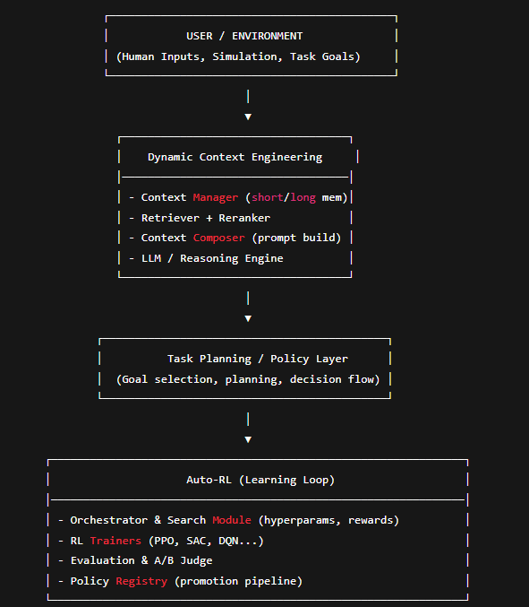

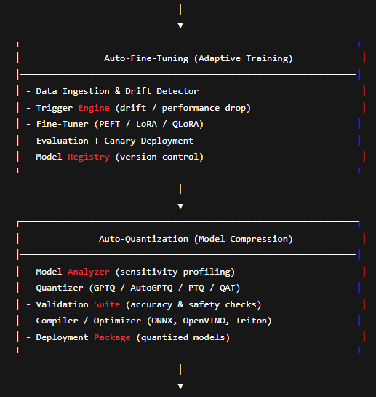
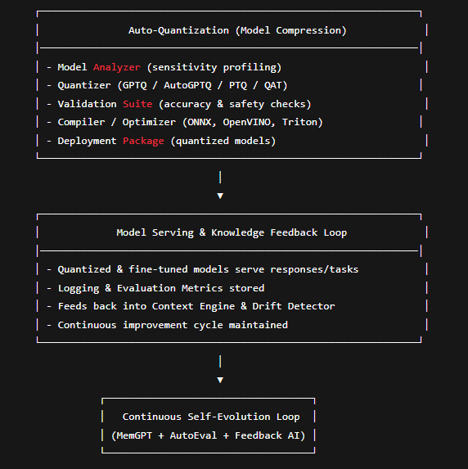

Flow | Description
User → Dynamic Context Engineering | Inputs processed into semantically rich prompts via memory & retrieval.
Context → Auto-RL | Reinforcement learning policies improve task execution and adapt to environment feedback.
Auto-RL → Auto-Fine-Tuning | New behavior data and improved policy checkpoints trigger fine-tuning for generalization.
Auto-Fine-Tuning → Auto-Quantization | Models optimized for size and speed for real-world deployment.
Auto-Quantization → Deployment | Compressed models deployed into production or simulation environments.
Deployment → Context Engine | Observations, user feedback, and performance metrics re-enter the memory for context refinement.
Loop | Enables continuous evolution — models adapt, compress, redeploy, and improve autonomously.

