**Лабораторная работа №12**

**Пакет 1: Работа с отделами (dept_pkg)**

**Спецификация пакета**  
CREATE OR REPLACE PACKAGE dept_pkg AS

-- Исключения

e_dept_exists EXCEPTION;

e_dept_not_found EXCEPTION;

-- Процедуры и функции

PROCEDURE new_dept(p_name IN DEPT.d_name%TYPE, p_loc IN DEPT.location%TYPE);

FUNCTION count_emp_in_dept(p_name IN DEPT.d_name%TYPE) RETURN NUMBER;

PROCEDURE count_all_emp_per_dept;

PROCEDURE rename_dept(p_old_name IN DEPT.d_name%TYPE, p_new_name IN DEPT.d_name%TYPE);

PROCEDURE relocate_dept(p_name IN DEPT.d_name%TYPE, p_new_loc IN DEPT.location%TYPE);

END dept_pkg;

**Тело пакета**  
  
CREATE OR REPLACE PACKAGE BODY dept_pkg AS

PROCEDURE new_dept(p_name IN DEPT.d_name%TYPE, p_loc IN DEPT.location%TYPE) IS

v_count NUMBER;

v_new_id DEPT.d_no%TYPE;

BEGIN

SELECT COUNT(*) INTO v_count FROM DEPT WHERE d_name = p_name;

IF v_count > 0 THEN

RAISE e_dept_exists;

END IF;

SELECT NVL(MAX(d_no), 0) + 1 INTO v_new_id FROM DEPT;

INSERT INTO DEPT(d_no, d_name, location) VALUES (v_new_id, p_name, p_loc);

EXCEPTION

WHEN e_dept_exists THEN

RAISE_APPLICATION_ERROR(-20001, 'Такой отдел уже существует');

END;

FUNCTION count_emp_in_dept(p_name IN DEPT.d_name%TYPE) RETURN NUMBER IS

v_count NUMBER;

BEGIN

SELECT COUNT(*) INTO v_count

FROM EMP

WHERE d_no = (SELECT d_no FROM DEPT WHERE d_name = p_name);

RETURN v_count;

EXCEPTION

WHEN NO_DATA_FOUND THEN

RAISE_APPLICATION_ERROR(-20002, 'Отдел не найден');

END;

PROCEDURE count_all_emp_per_dept IS

CURSOR c_depts IS SELECT d_name FROM DEPT;

v_name DEPT.d_name%TYPE;

v_count NUMBER;

BEGIN

FOR rec IN c_depts LOOP

v_name := rec.d_name;

SELECT COUNT(*) INTO v_count

FROM EMP

WHERE d_no = (SELECT d_no FROM DEPT WHERE d_name = v_name);

DBMS_OUTPUT.PUT_LINE('Отдел: ' || v_name || ' — сотрудников: ' || v_count);

END LOOP;

END;

PROCEDURE rename_dept(p_old_name IN DEPT.d_name%TYPE, p_new_name IN DEPT.d_name%TYPE) IS

v_count NUMBER;

BEGIN

SELECT COUNT(*) INTO v_count FROM DEPT WHERE d_name = p_old_name;

IF v_count = 0 THEN

RAISE e_dept_not_found;

END IF;

UPDATE DEPT SET d_name = p_new_name WHERE d_name = p_old_name;

EXCEPTION

WHEN e_dept_not_found THEN

RAISE_APPLICATION_ERROR(-20003, 'Указанный отдел не найден');

END;

PROCEDURE relocate_dept(p_name IN DEPT.d_name%TYPE, p_new_loc IN DEPT.location%TYPE) IS

v_count NUMBER;

BEGIN

SELECT COUNT(*) INTO v_count FROM DEPT WHERE d_name = p_name;

IF v_count = 0 THEN

RAISE e_dept_not_found;

END IF;

UPDATE DEPT SET location = p_new_loc WHERE d_name = p_name;

EXCEPTION

WHEN e_dept_not_found THEN

RAISE_APPLICATION_ERROR(-20004, 'Указанный отдел не найден');

END;

END dept_pkg;  
  
  
**Тесты для dept_pkg**

**1. Создание нового отдела new_dept (p_name, p_loc)**

**Пример:** Добавим отдел IT в Chicago

BEGIN

dept_pkg.new_dept('IT', 'Chicago');

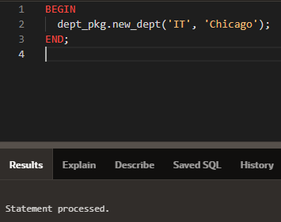END;

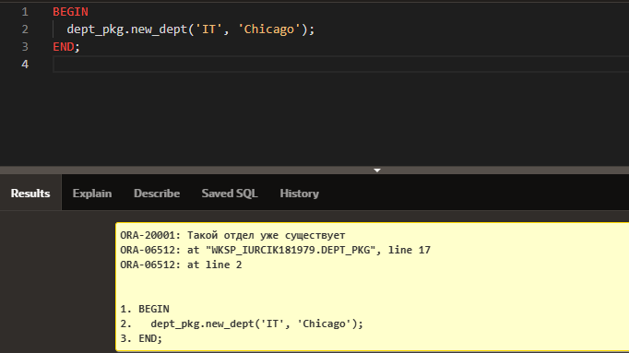  
 - Повторив вызов — будет ошибка ORA-20001: Такой отдел уже существует.

**Проверка:**

SELECT * FROM DEPT WHERE d_name = 'IT' AND location = 'Chicago';

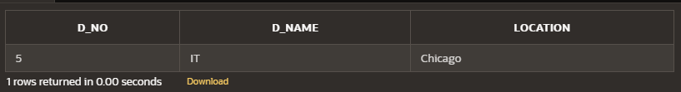

**2. Подсчет количества сотрудников в указанном отделе count_emp_in_dept (p_name)**

**Пример:** Узнать сколько сотрудников в отделе 'Soft'

DECLARE

v_count NUMBER;

BEGIN

v_count := dept_pkg.count_emp_in_dept('Soft');

DBMS_OUTPUT.PUT_LINE('Сотрудников в Soft: ' || v_count);

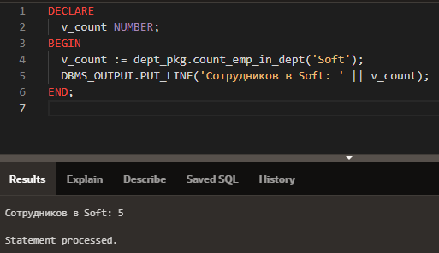END;

**3. Подсчет количества сотрудников в каждом отделе (count_all_emp_per_dept)**

BEGIN

dept_pkg.count_all_emp_per_dept;

END;

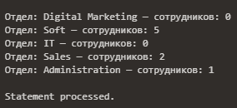

**4. Изменение названия указанного отдела на новое rename_dept (p_old_name, p_new_name)**

**Пример:** Переименуем 'Marketing' в 'Digital Marketing'

BEGIN

dept_pkg.rename_dept('Marketing', 'Digital Marketing');

END;

Затем:

SELECT * FROM DEPT WHERE d_name = 'Digital Marketing';

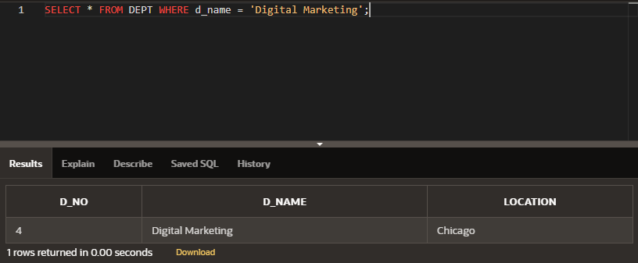

### 5. Перевод указанного отдела в новый город relocate_dept (p_name, p_new_loc)

**Пример:** Переносим 'Sales' в 'Chicago'

BEGIN

dept_pkg.relocate_dept('Sales', 'Chicago');

END;

**Проверка:**

SELECT * FROM DEPT WHERE d_name = 'Sales';

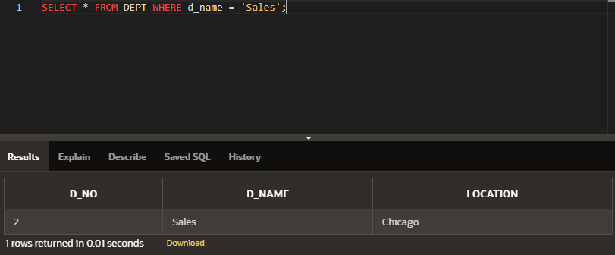

**Пакет 2: Работа с сотрудниками (emp_pkg)**

**Спецификация пакета**

CREATE OR REPLACE PACKAGE emp_pkg AS

-- Исключения

e_emp_exists EXCEPTION;

e_emp_not_found EXCEPTION;

e_dept_not_found EXCEPTION;

-- Подпрограммы

PROCEDURE add_emp(p_name IN EMP.e_name%TYPE, p_date IN EMP.date_hire%TYPE,

p_salary IN EMP.salary%TYPE, p_address IN EMP.address%TYPE,

p_dept_name IN DEPT.d_name%TYPE);

PROCEDURE update_salary(p_name IN EMP.e_name%TYPE, p_new_salary IN EMP.salary%TYPE);

FUNCTION yearly_salary(p_name IN EMP.e_name%TYPE) RETURN NUMBER;

FUNCTION dept_salary_total(p_dept_name IN DEPT.d_name%TYPE) RETURN NUMBER;

PROCEDURE move_emp(p_name IN EMP.e_name%TYPE, p_new_dept IN DEPT.d_name%TYPE);

END emp_pkg;

**Тело пакета**

CREATE OR REPLACE PACKAGE BODY emp_pkg AS

PROCEDURE add_emp(p_name IN EMP.e_name%TYPE, p_date IN EMP.date_hire%TYPE,

p_salary IN EMP.salary%TYPE, p_address IN EMP.address%TYPE,

p_dept_name IN DEPT.d_name%TYPE) IS

v_exists NUMBER;

v_dept_id DEPT.d_no%TYPE;

v_new_id EMP.e_no%TYPE;

BEGIN

SELECT COUNT(*) INTO v_exists FROM EMP WHERE e_name = p_name;

IF v_exists > 0 THEN

RAISE e_emp_exists;

END IF;

SELECT d_no INTO v_dept_id FROM DEPT WHERE d_name = p_dept_name;

SELECT NVL(MAX(e_no), 100099) + 1 INTO v_new_id FROM EMP;

INSERT INTO EMP(e_no, e_name, date_hire, salary, address, d_no)

VALUES (v_new_id, p_name, p_date, p_salary, p_address, v_dept_id);

EXCEPTION

WHEN e_emp_exists THEN

RAISE_APPLICATION_ERROR(-20010, 'Сотрудник уже существует');

WHEN NO_DATA_FOUND THEN

RAISE_APPLICATION_ERROR(-20011, 'Отдел не найден');

END;

PROCEDURE update_salary(p_name IN EMP.e_name%TYPE, p_new_salary IN EMP.salary%TYPE) IS

v_count NUMBER;

BEGIN

SELECT COUNT(*) INTO v_count FROM EMP WHERE e_name = p_name;

IF v_count = 0 THEN

RAISE e_emp_not_found;

END IF;

UPDATE EMP SET salary = p_new_salary WHERE e_name = p_name;

EXCEPTION

WHEN e_emp_not_found THEN

RAISE_APPLICATION_ERROR(-20012, 'Сотрудник не найден');

END;

FUNCTION yearly_salary(p_name IN EMP.e_name%TYPE) RETURN NUMBER IS

v_salary EMP.salary%TYPE;

BEGIN

SELECT salary INTO v_salary FROM EMP WHERE e_name = p_name;

RETURN v_salary * 12;

EXCEPTION

WHEN NO_DATA_FOUND THEN

RAISE_APPLICATION_ERROR(-20013, 'Сотрудник не найден');

END;

FUNCTION dept_salary_total(p_dept_name IN DEPT.d_name%TYPE) RETURN NUMBER IS

v_total NUMBER;

BEGIN

SELECT SUM(salary * 12) INTO v_total

FROM EMP

WHERE d_no = (SELECT d_no FROM DEPT WHERE d_name = p_dept_name);

RETURN NVL(v_total, 0);

EXCEPTION

WHEN NO_DATA_FOUND THEN

RAISE_APPLICATION_ERROR(-20014, 'Отдел не найден');

END;

PROCEDURE move_emp(p_name IN EMP.e_name%TYPE, p_new_dept IN DEPT.d_name%TYPE) IS

v_emp_count NUMBER;

v_dept_id DEPT.d_no%TYPE;

BEGIN

SELECT COUNT(*) INTO v_emp_count FROM EMP WHERE e_name = p_name;

IF v_emp_count = 0 THEN

RAISE e_emp_not_found;

END IF;

SELECT d_no INTO v_dept_id FROM DEPT WHERE d_name = p_new_dept;

UPDATE EMP SET d_no = v_dept_id WHERE e_name = p_name;

EXCEPTION

WHEN e_emp_not_found THEN

RAISE_APPLICATION_ERROR(-20015, 'Сотрудник не найден');

WHEN NO_DATA_FOUND THEN

RAISE_APPLICATION_ERROR(-20016, 'Отдел не найден');

END;

END emp_pkg;

**Тесты для emp_pkg**

1. **Зачисление нового сотрудника add_emp (p_name, p_date, p_salary, p_address, p_dept_name)**

**Пример:** Добавим нового сотрудника 'Ivanov' в отдел 'Soft'

BEGIN

emp_pkg.add_emp('Ivanov', TO_DATE('01.04.2024', 'DD.MM.YYYY'), 1700, 'CH', 'Soft');

END;

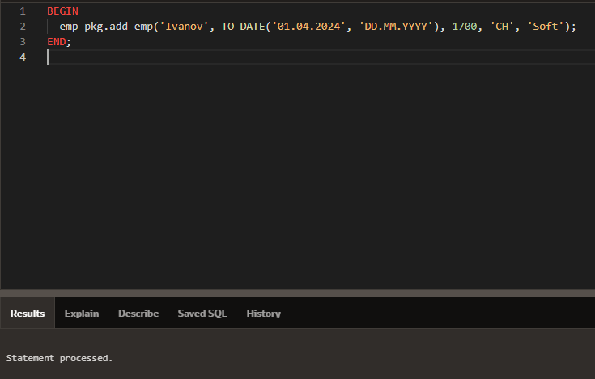

**Проверка:**

SELECT * FROM EMP WHERE e_name = 'Ivanov';

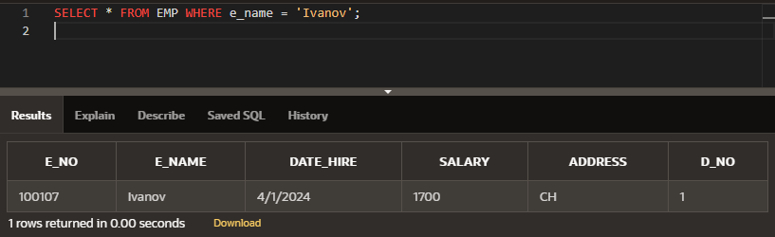

Если повторно — выдаст ошибку:

ORA-20010: Сотрудник уже существует

1. **Изменение зарплаты указанного сотрудника на заданную величину update_salary (p_name, p_new_salary)**

**Пример:** Изменим зарплату Smirnov на 1800

BEGIN

emp_pkg.update_salary ('Smirnov', 1800);

END;  
  
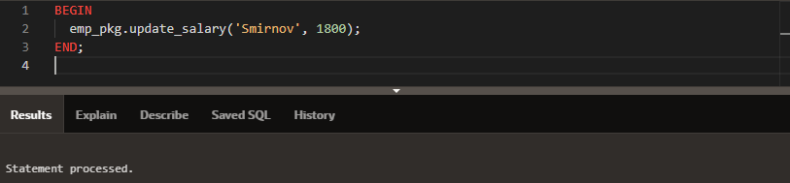

**Проверка:**

SELECT salary FROM EMP WHERE e_name = 'Smirnov';   
  
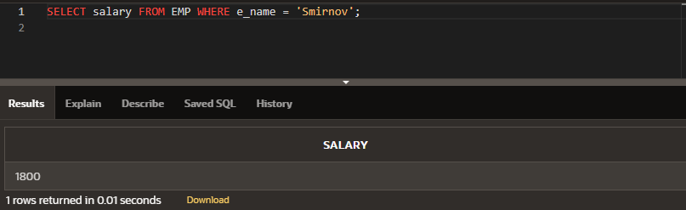

1. **Расчет ежегодного объема зарплаты для указанного сотрудника yearly_salary (p_name) RETURN NUMBER**

**Пример:** Получим годовую зарплату Clark

DECLARE

v_annual NUMBER;

BEGIN

v_annual := emp_pkg.yearly_salary('Clark');

DBMS_OUTPUT.PUT_LINE('Годовая зп Clark: ' || v_annual);

END

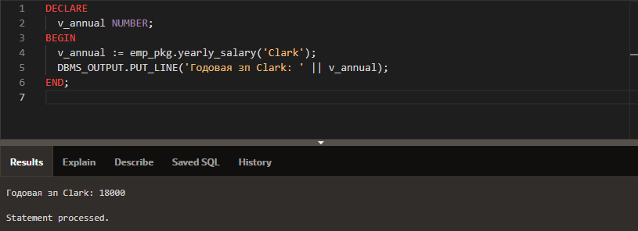

1. **Расчет ежегодного объема зарплаты сотрудников в указанном отделе. dept_salary_total (p_dept_name) RETURN NUMBER**

**Пример:** Годовая зарплата всех сотрудников в 'Sales'

DECLARE

v_total NUMBER;

BEGIN

v_total := emp_pkg.dept_salary_total('Sales');

DBMS_OUTPUT.PUT_LINE('Фонд зарплаты отдела Sales: ' || v_total);

END;

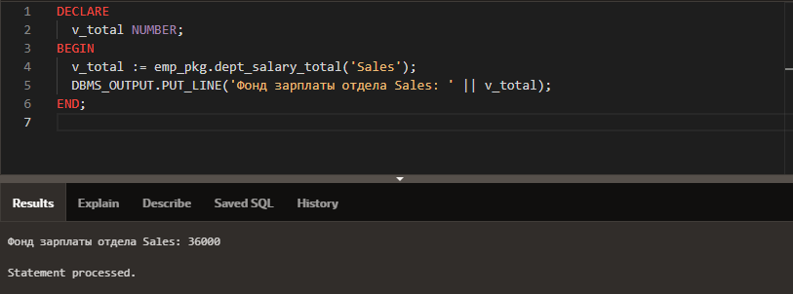

1. **Перевод сотрудника в указанный отдел. move_emp (p_name, p_new_dept)**

**Пример:** Переводим Gordon из 'Administration' в 'Soft'

BEGIN

emp_pkg.move_emp('Gordon', 'Soft');

END;

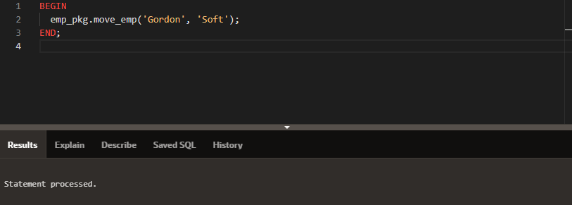

**Проверка:**

SELECT e_name, d_no FROM EMP WHERE e_name = 'Gordon';

