Referências

Lógica e sintaxe.

Ciência e Engenharia.

etc

https://github.com/CAChemE/Python-Chemical-Engineers
"Introduction to Python for Chemical Engineers (crash course with additional resources)"

http://kitchingroup.cheme.cmu.edu/pycse/pycse.pdf
Prof. Kitchin blog and free book (399pp)

https://github.com/CAChemE/learn
"Education resources for Chemical and Process Engineering written in Python"
"We want to reproduce this work (learnChemE.com) with this technology (Nature and Ipython)"

http://jckantor.github.io/CBE20255/
"Introduction to Chemical Engineering Analysis introduces the use of mass and energy balances to analyze chemical processes and products."

https://github.com/mgaitan/curso-python-cientifico
"Un curso de Python orientado a estudiantes, investigadores y profesionales de ingeniería y ciencias."

http://nbviewer.jupyter.org/github/iurisegtovich/PyTherm-applied-thermodynamics/blob/master/index.ipynb
"open source interactive computational course materials for students of Applied Thermodynamics"

* https://github.com/fangohr/introduction-to-python-for-computational-science-and-engineering
* https://www.southampton.ac.uk/~fangohr/training/python/pdfs/Python-for-Computational-Science-and-Engineering.pdf
"Introduction to Python for Computational Science and Engineering (A beginner’s guide)", book developed by Hans Fangohr, free download.
* in portuguese at: https://github.com/gcpeixoto/lecture-ipynb

https://www.udemy.com/python-programacao-para-ciencia-e-engenharia/
Programação em Python, do básico ao avançado, com orientação para computação científica e engenharia. (#seems legit)

https://medium.com/@margaretmz/running-jupyter-notebook-with-colab-f4a29a9c7156
"I recently discovered Colaboratory (short for Colab), a tool for machine learning education and research, created as a Google research project. Creating and running Jupyter Notebook on Colab is super easy and it’s free. You can save your notebook to Google Drive or GitHub and even train your deep learning on GPU. It feels almost too good to be true…"

https://www.cheatography.com/weidadeyue/cheat-sheets/jupyter-notebook/pdf_bw/
"Jupyter Notebook Keyboard Shortcuts by weidadeyue via cheatography.com/"

https://colab.research.google.com/
"%pylab
%matplotlib inline
plt.plot(np.random.rand(10))"

http://www.im.ufrj.br/bernardofpc/blog/Computa%C3%A7%C3%A3o%20Cient%C3%ADfica.php
Aqui, uma contribuição significativa do Python para o programador é disponibilizar uma documentação de altíssima qualidade das suas funções, não apenas com a definição dos argumentos e seu papel, mas muitas vezes com exemplos claros e diversos.
Com o notebook do iPython, é ainda mais conveniente acessar esta informação de forma não-intrusiva, pois esta aparece como um pop-up, com vários níveis de detalhe. Isto é extremamente conveniente tanto durante o aprendizado ("qual era mesmo a ordem destes argumentos?") quanto durante o uso posterior (_"será que eu posso passar um parâmetro extra para esta função?").
O esforço de documentação também se reflete na internet: o próprio site do python tem
- um tutorial muito completo,
- a documentação da linguagem, e
- a definição do interpretador (para os detalhes técnicos de implementação, se você precisar saber deles)
em locais separados.

Open-source e Free software
Além de o código inteiro do Python (e do iPython) estarem disponíveis, também a maior parte das bibliotecas são de código aberto, e muitas vezes, livre.
No caso do iPython, é possível usar o operador ?? para, além da documentação de uma função, acessar o código correspondente que a implementa, de dentro do interpretador. Com isso, podemos copiar, usar como inspiração, corrigir, ... o código com grande facilidade.

http://www.im.ufrj.br/bernardofpc/cursos/CientificaI.php

http://lightbot.com/flash.html
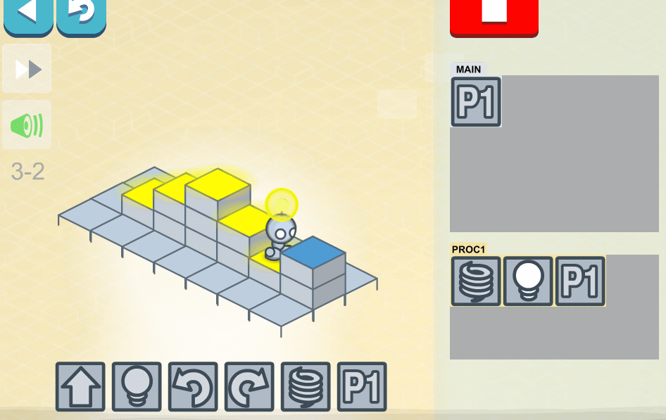

Tutoriais

https://www.tutorialspoint.com/python/index.htm
pure python tutorial

https://docs.scipy.org/doc/numpy/user/quickstart.html
numpy quickstart tutorial

https://www.scipy.org/getting-started.html
scipy getting started

https://matplotlib.org/tutorials/index.html
matplotlib tutorials

https://matplotlib.org/gallery/index.html
matplotlib learning by examples

Under the hood
https://indianpythonista.wordpress.com/2018/01/04/how-python-runs/
Compiler compiles your source code (the statements in your file) into a format known as byte code....As soon as source code gets converted to byte code, it is fed into PVM (Python Virtual Machine)

Comparison
https://www.slant.co/versus/110/127/~python_vs_c

Versions
https://www.dataquest.io/blog/python-2-or-3/
Today, there are very few libraries that do not support Python 3. … many packages are announcing the end of support for 2.x ... many of the main (scientific) libraries are committing to stop supporting 2.x in 2020 or sooner.

https://wiki.python.org/moin/Python2orPython3
Short version: Python 2.x is legacy, Python 3.x is the present and future of the language

Best of stack overflow
https://stackoverflow.com/questions/20699736/why-should-i-refer-to-names-and-binding-in-python-instead-of-variables-and
In C and C++, a variable is a named memory location. The value of the variable is the value stored in that location. Assign to the variable and you modify that value. So the variable is the memory location, not the name for it. In Python, a variable is a name used to refer to an object. The value of the variable is that object. So far sounds like the same thing. But assign to the variable and you don't modify the object itself, rather you alter which object the variable refers to. So the variable is the name, not the object.

