Anexos

Reid Prausnitz & Poling, 1987, pp 42, 43
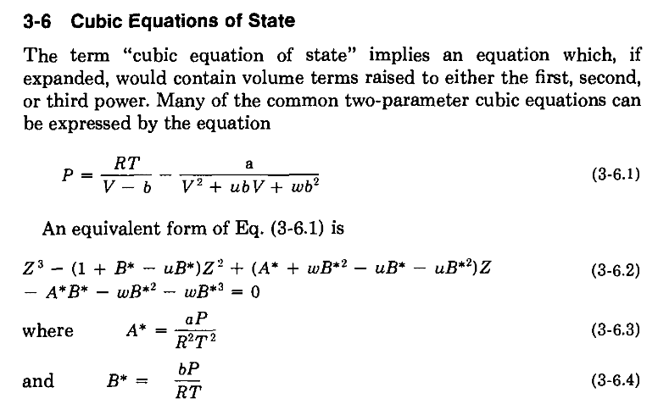
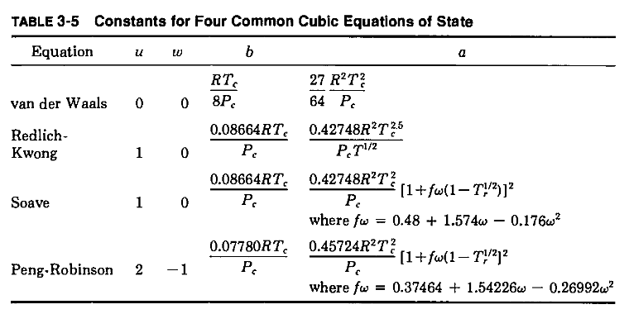

Reid Prausnitz & Poling, 1987, pp 82
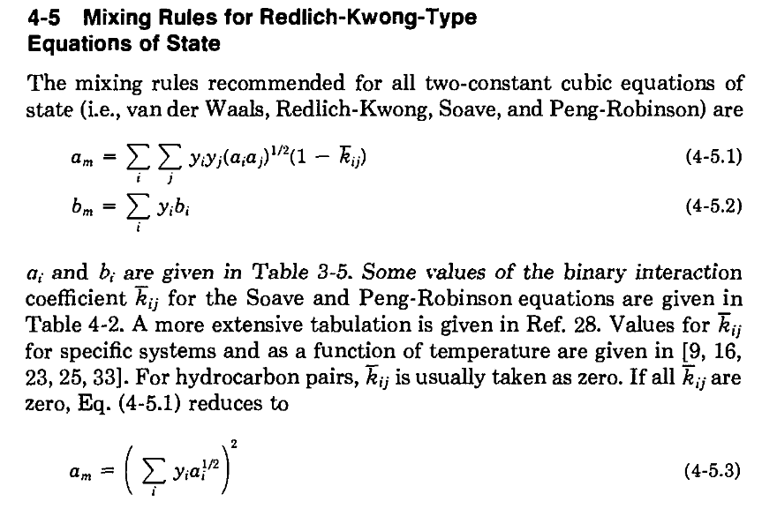

Reid Prausnitz & Poling, 1987, pp 102
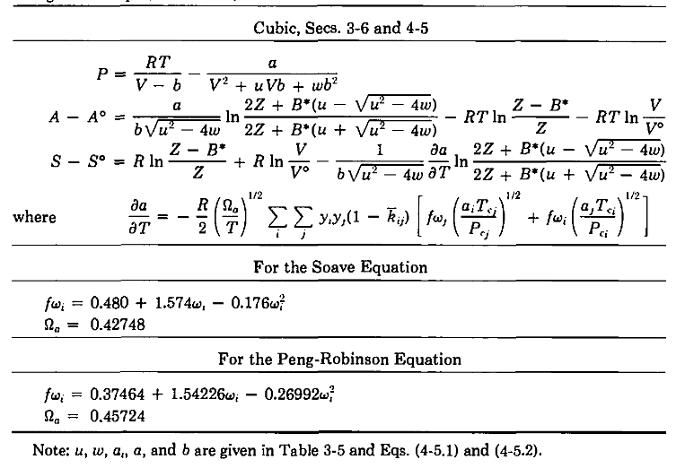

Reid Prausnitz & Poling, 1987, pp 144, 145
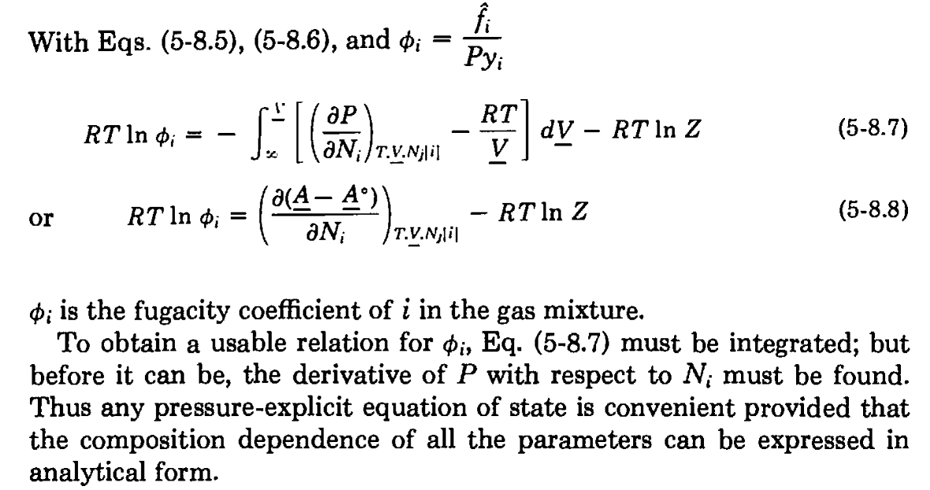
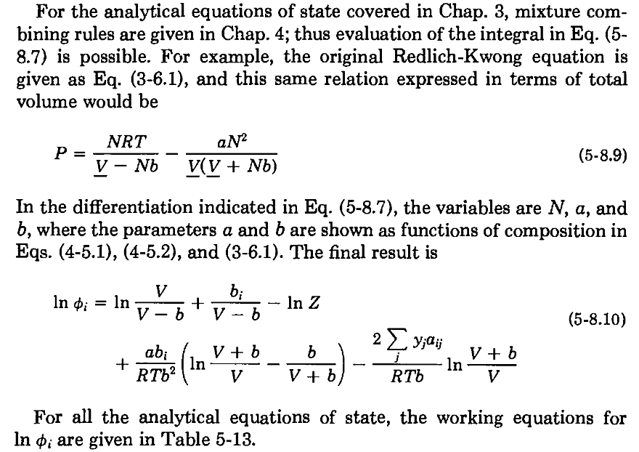
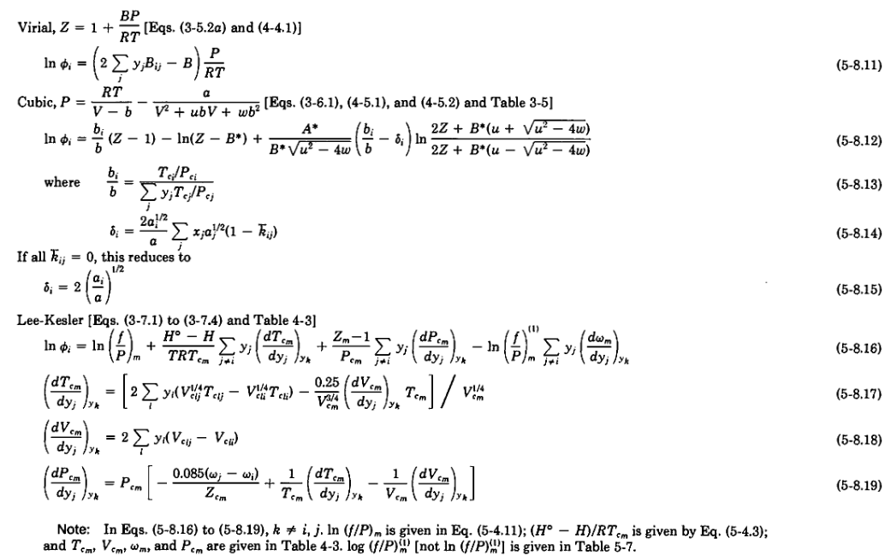

Smith, van Ness & Abbott, 2007, pp 67
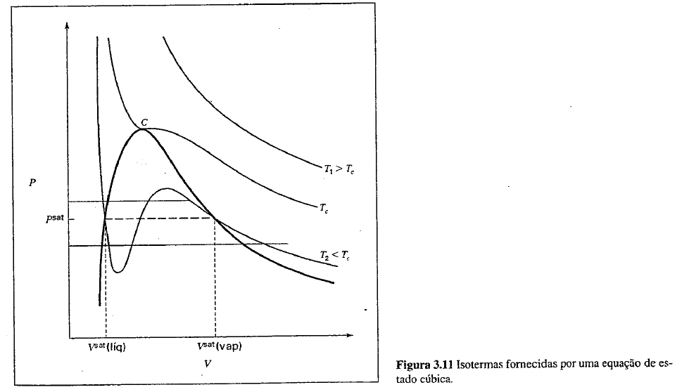

Smith, van Ness & Abbott, 2007, pp 168
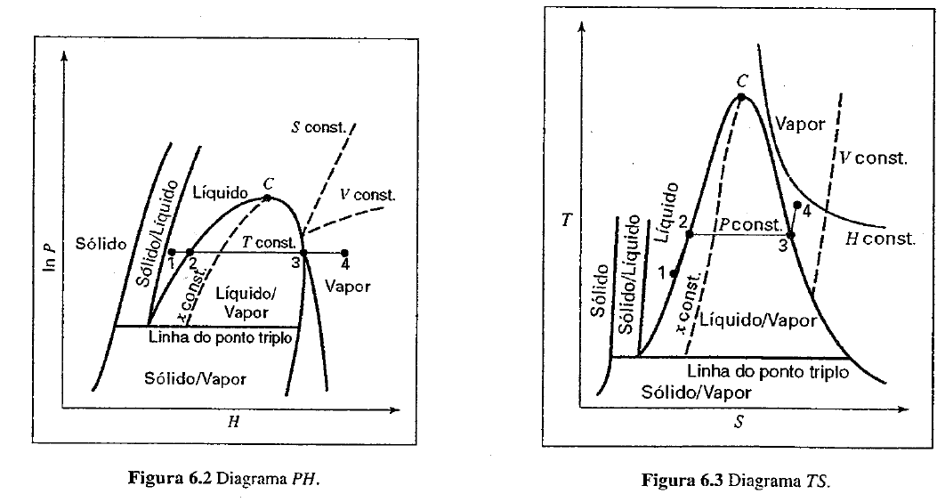

Smith, van Ness & Abbott, 2007, pp 510
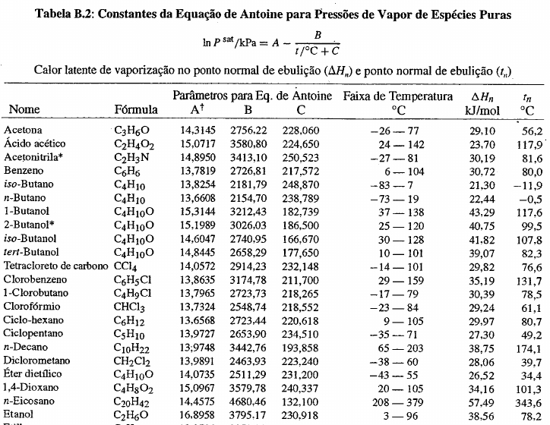
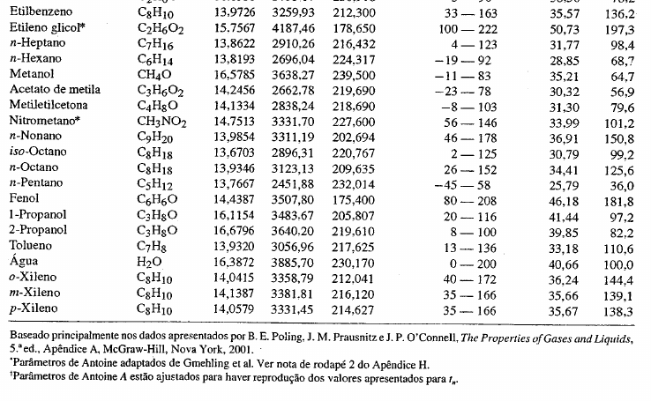

Smith, van Ness & Abbott, 2007, pp 507, 508, 509
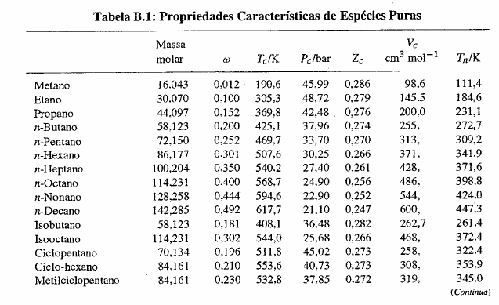
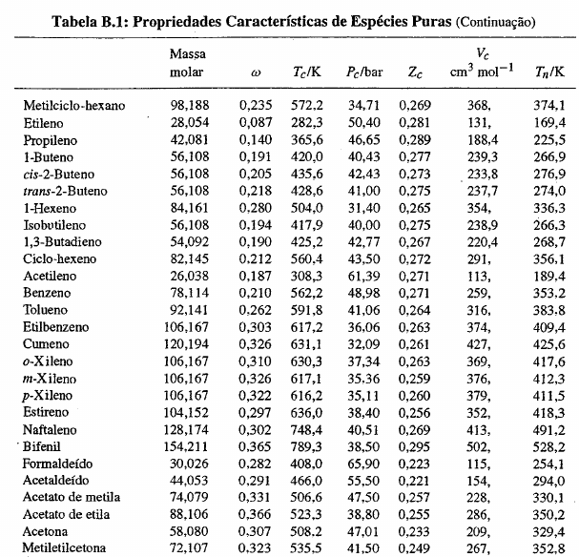
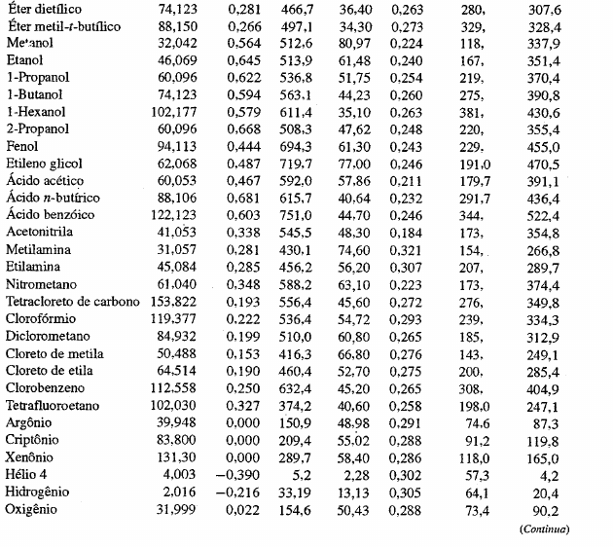

Sandler, 2006, 561, 562
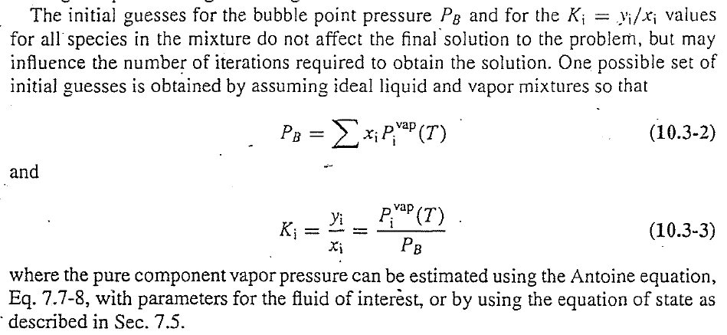
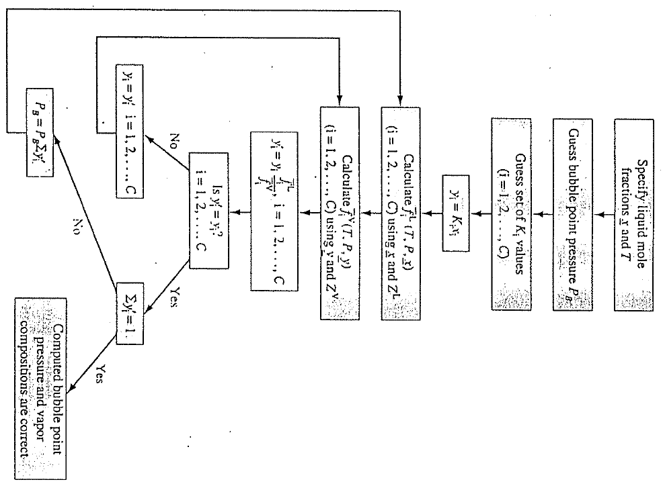

Smith, van Ness & Abbott, 2007, pp 48
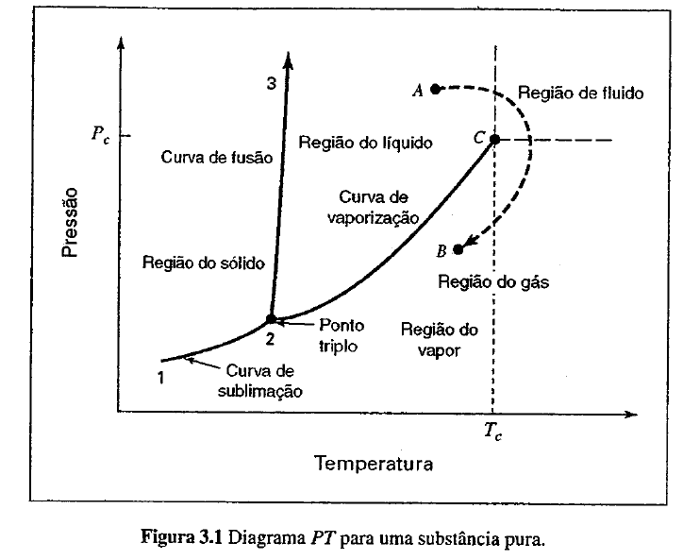

Smith, van Ness & Abbott, 2007, pp 260
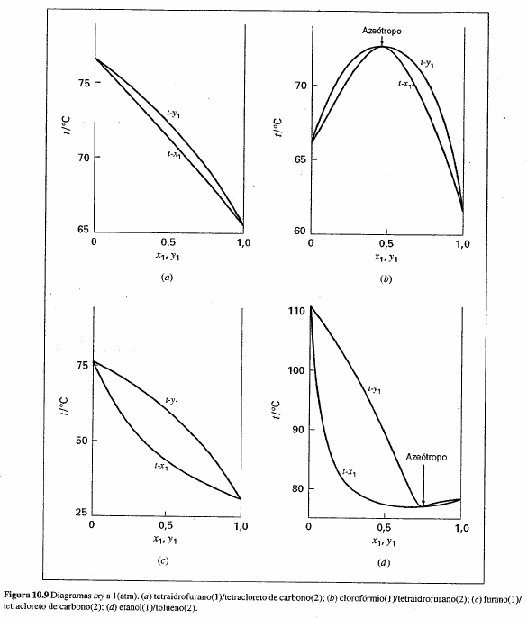

Smith, van Ness & Abbott, 2007, pp 119
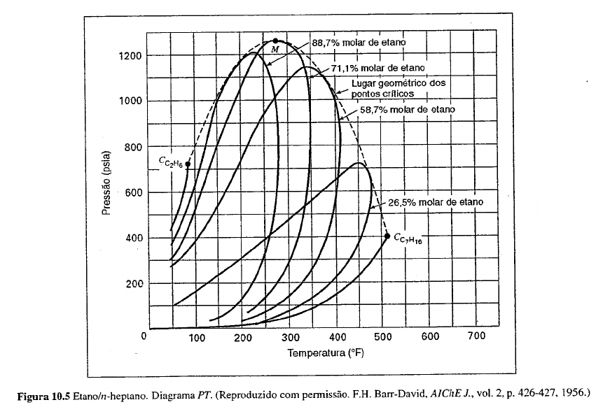

Smith, van Ness & Abbott, 2007, pp 512
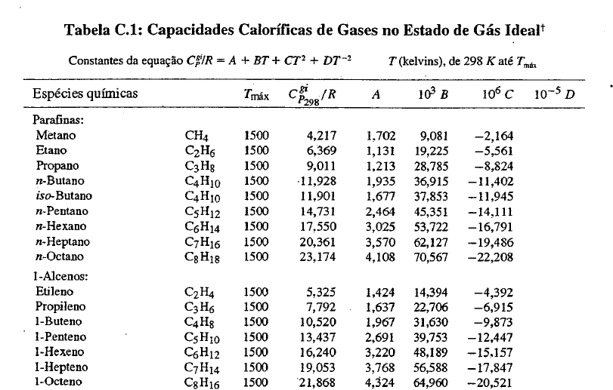
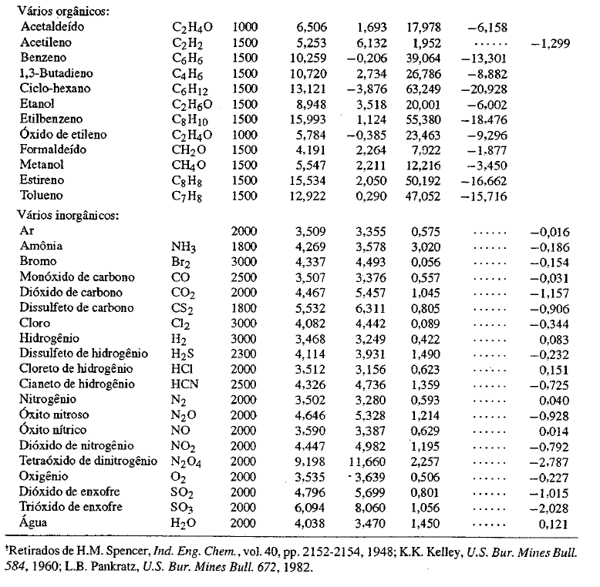

Referências recomendadas
- Reid, R. C., Prausnitz, J. M. and Poling, B. E., 1987. The Properties of Gases and Liquids. 4th ed., McGraw-Hill. [ISBN: 0070517991, 9780070517998](https://books.google.com.br/books?id=AcRTAAAAMAAJ)
- Smith, J. M., van Ness, H. C. and Abbott, M. M., 2007. Introdução a termodinâmica da engenharia química. 7a ed., LTC. [ISBN: 8521615531, 9788521615538](https://books.google.com.br/books?id=TzeQPgAACAAJ)
- Sandler S., 2006, Chemical, Biochemical, and Engineering Thermodynamics, 4th ed. John Wiley & Sons [ISSN: 0471661740, 9780471661740](https://books.google.com.br/books?id=4MXDAgAAQBAJ)

