on the origin of citations

Iuri

September 15, 2015

# Load the data

counts_raw=read.delim("data/counts-raw.txt.gz")  
counts_norm=read.delim("data/counts-norm.txt.gz")

# Data exploration

What is the distribution of authors in all the articles in the data?

hist(counts_raw$authorsCount, main="Authors per paper", xlab="# authors")

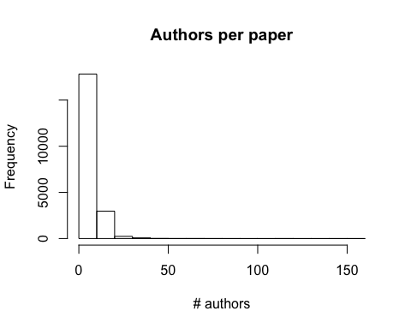

Papers on Facebook! 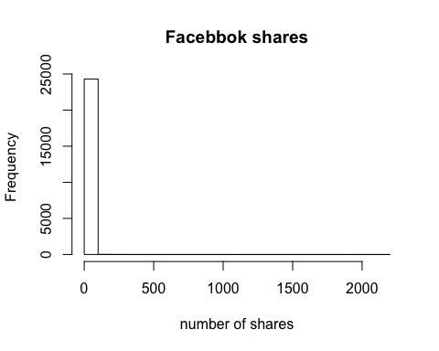 The average number of Facebook shares per paper is 0.6524187