Manage categories

1 – Brief description

A recipe belongs to one or more categories. The goal is to give simple information about the recipe (for example, the recipe is a "vegetarian" "dish"), but also to be able to apply filters on the recipe search.
The different categories can be created, modified and deleted only by administrators connected to their account.

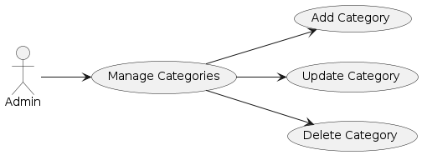

2 – Flow of events
- The system requests that the Administrator specify the function he/she would like to perform (either Add a Category, Update a Category, or Delete a Category)
Cf Figure 1
- Once the Administrator provides the requested information, one of the sub flow is executed.
If the Administrator selected “Add a Category“, the Add a Category sub flow is executed.
If the Administrator selected “Update a Category“, the Update a Category sub flow is executed.
If the Administrator selected “Delete a Category“, the Delete a Category sub flow is executed.

Add a Category:
The system request that the administrator enter new information. This include the name’s category.
Cf Figure 4
After that, the system generate a id number for the new category, register it in the database, the category is available for recipes and the administrator is informed that the creation worked with the message “The category has been created”.
Cf Figure 2.

Update a Category:
The administrator select a category from the list of categories (obtained from the system). The administrator can only change the name’s category.
Cf Figure 4
The system update the category’s name in the database. The administrator is informed that the update worked with the message “The category has been updated”.
Cf Figure 2

Delete a category:
The administrator select a category from the list of category (obtained from the system). The administrator can delete the chosen category and need to confirm to delete.
Cf Figure 5
The system update the database therefore delete the category. The administrator is informed that the delete has worked with the message “The category has been deleting”.
Cf Figure 2

Alternative Flows

Add Category or Update category (with an existing name):
The administrator can’t create a category or update a category with an existing name. In this case, the state will not change and the administrator is notified that he is not allowed to do the change/creation with a message “This name is already use”.
Cf Figure 3

Deletion Canceled or Update Canceled:
If in the Delete a Category sub-flow or Update category sub-flow, and the Administrator decides to cancel, then the action abort and the system is unchanged.

3 - Special Requirements
None.

4 - Preconditions
The Administrator must be logged onto the system before this use case begins.

5 - Postconditions
If the use case was successful, the category information is added, updated, or deleted from the system. Otherwise, the system state is unchanged.

6 - Extension Points
None.

Manage adverts

1 – Brief description

We have advertisements in the application, to suggest to buy some ingredients with a promotion with our partners. So we need to manage the ads : create an ad, update an ad and delete an ad.
The different adverts can be created, modified and deleted only by administrators connected to their account.

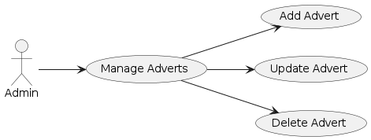

2 – Flow of events
- The system requests that the Administrator specify the function he/she would like to perform (either Add an Advert, Update an Advert, or Delete an Advert)
Cf Figure 1
- Once the Administrator provides the requested information, one of the sub flows is executed.
If the Administrator selected “Add an Advert“, the Add an Advert sub flow is executed.
If the Administrator selected “Update a Category“, the Update an Advert sub flow is executed.
If the Administrator selected “Delete a Category“, the Delete an Advert sub flow is executed.

Add an advert:
The system request that the administrator enter the new information. This include the partner, the product, the promotion, the price.
Cf Figure 4
After that, the system generate a id number for the new advert, register it in the database and the ad is available for the ingredient. The administrator is informed the creation has working with the message “The advert has been creating”.
Cf Figure 2

Update an advert:
The administrator select in the list of advert (obtain by the system) an ad. The administrator can change the partner, the product, the promotion, the price.
Cf Figure 4
The system update changes in the database and the administrator is informed the update has working with the message “The advert has been updating”.
Cf Figure 2

Delete an advert:
The administrator select in the list of advert (obtain by the system) an ad. The administrator can delete the advert choose and need to confirm to delete.
Cf Figure 5
The system update the database therefore delete the ad. The administrator is informed the delete has working with the message “The advert has been deleting”.
Cf Figure 2

Alternative Flows

Deletion Canceled or Update Canceled:
If in the Delete an Advert sub flow or Update an Advert sub-flow, the Administrator decides not to delete the ad, the delete is canceled and the system is unchanged.

3 – Special requirement
None

4 – Pre-conditions
The Administrator must be logged onto the system before this use case begins.

5 – Post-conditions
If the use case was successful, the advertising information is added, updated, or deleted from the system. Otherwise, the system state is unchanged.

6 – Entension Points
None

Manage suggestions

1 – Brief description

When the customer use the application, sometimes he can be disappointed because he can’t find a recipe or an ingredient or want to propose a new feature for the application.
The manage suggestions is the CRUD to this. The users will create suggestions and the admins will read,update and/or delete the suggestion (and if he wants, he can implement the suggestion.)

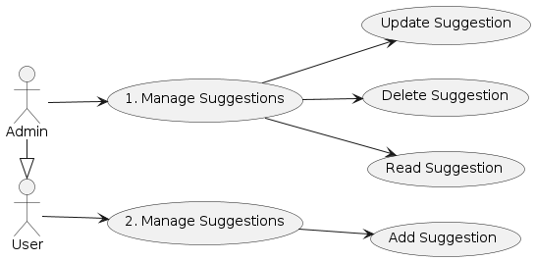

2 – Flow of events
The functionality is available through a button placed in different places in the application. The button to access the proposal form page is visible in the drop down menu and when searching for an ingredient or recipe the button to access the form is directly available on the page if no results match the user's search.
Cf Figure 6
- If the Payroll User selected “Propose a Suggestion“, the Add a Suggestion sub flow is executed.
If the Administrator selected “Update a Suggestion“, the Update a Suggestion sub flow is executed.
If the Administrator selected “Delete a Suggestion“, the Delete a Suggestion sub flow is executed.

Add a Suggestion:
The customer enters the information into the system. This includes the category of the suggestion (ingredient, recipe, feature) and a text field to detail the request (the name of the ingredient or the new feature required, etc).
Cf Figure 4
After that, the system generate a id number for the new suggestion, register it in the database and the suggestion is available for admin. The customer is informed the creation has working with the message “The suggestion has been sending”.
Cf Figure 2

Update a Suggestion:
The administrator select in the list of suggestion (obtain by the system) a suggestion. The admin can change the suggestion, that is change the text field and also change the category of the suggestion if the customer is mistaken. The system updates changes in the database. The administrator is informed the update has working with the message “The suggestion has been updating”.
Cf Figure 2

Delete an advert:
The administrator select in the list of suggestion (obtain by the system) a suggestion. The administrator can delete the suggestion choose and need to confirm to delete.
Cf Figure 5
The system update the database therefore delete the suggestion. The administrator is informed the deletion has working with the message “The suggestion has been deleting”.
Cf Figure 2

Alternative Flows

Deletion Canceled or Update Canceled:
If in the Delete a Suggestion sub flow or Update a Suggestion sub flow, the Administrator decides not to delete the suggestion, the delete or update is canceled and the system is unchanged.

3 – Special requirement
None

4 – Pre-conditions
None

5 – Post-conditions
If the use case was successful, the suggestion is added, updated, or deleted from the system. Otherwise, the system state is unchanged.

6 – Entension Points
None

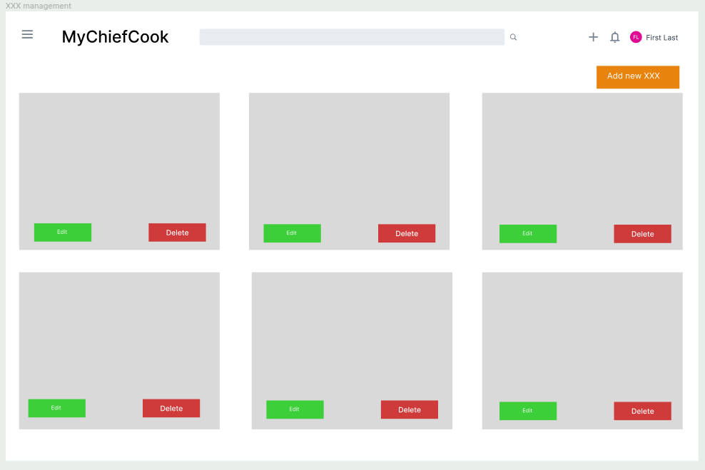
Figure 1: Interface for the Management Category, Management Recipe, Management Ingredient, Management advert

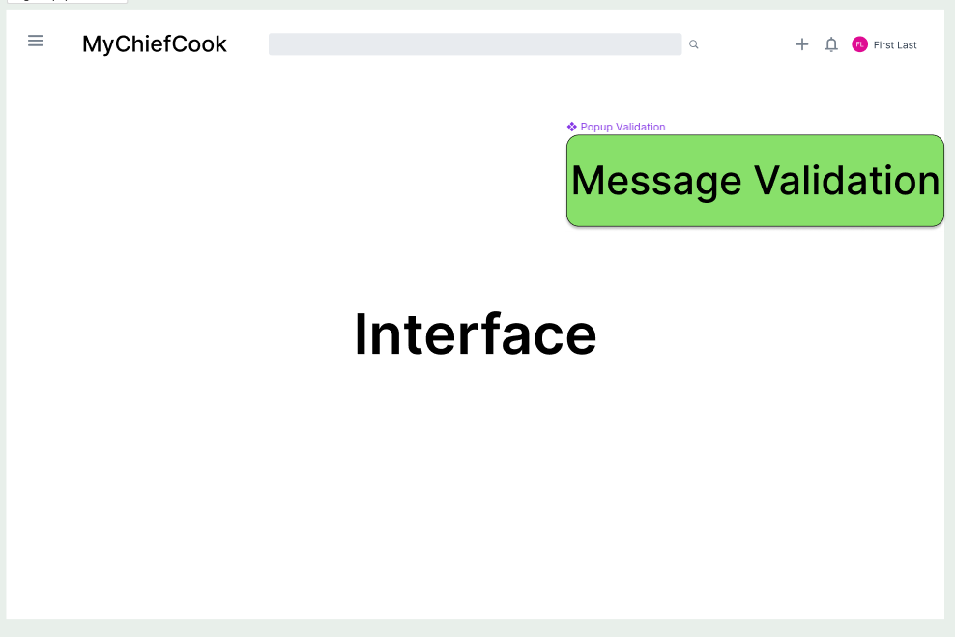
Figure 2: Popup message validation
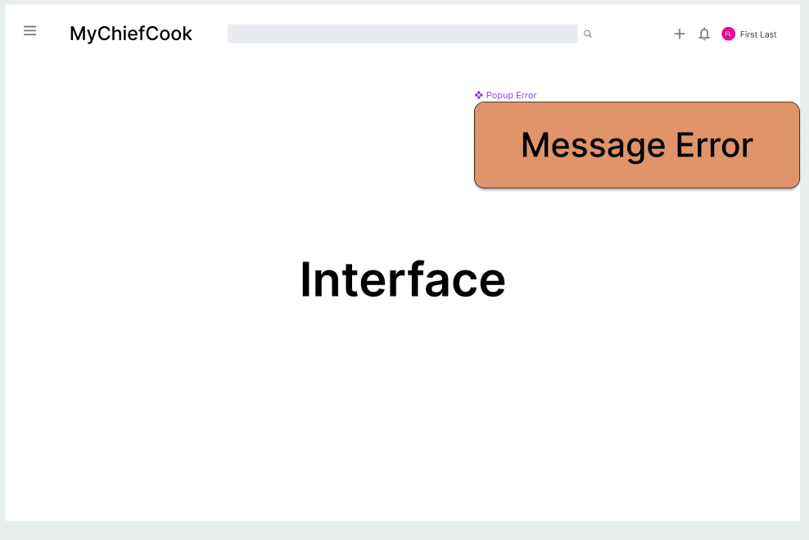
Figure 3: Popum message error

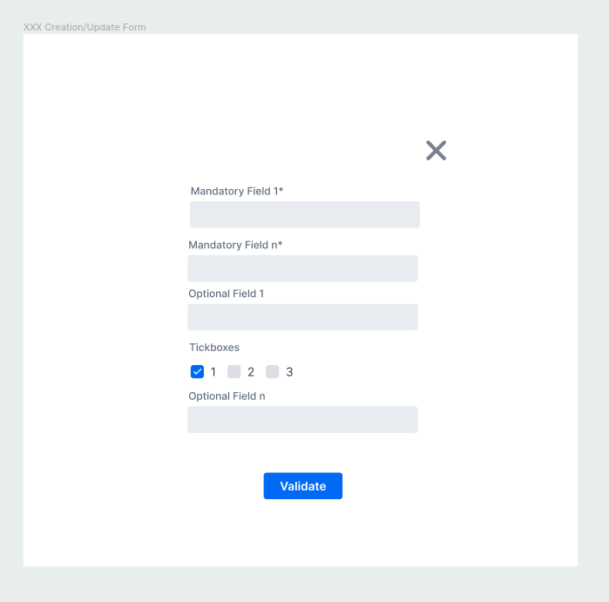
Figure 4: Form to add or update

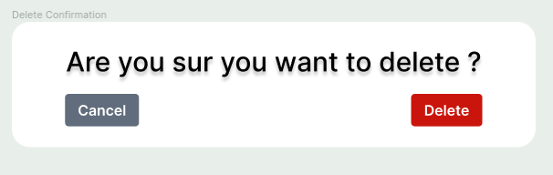
Figure 5: Delete Confirmation

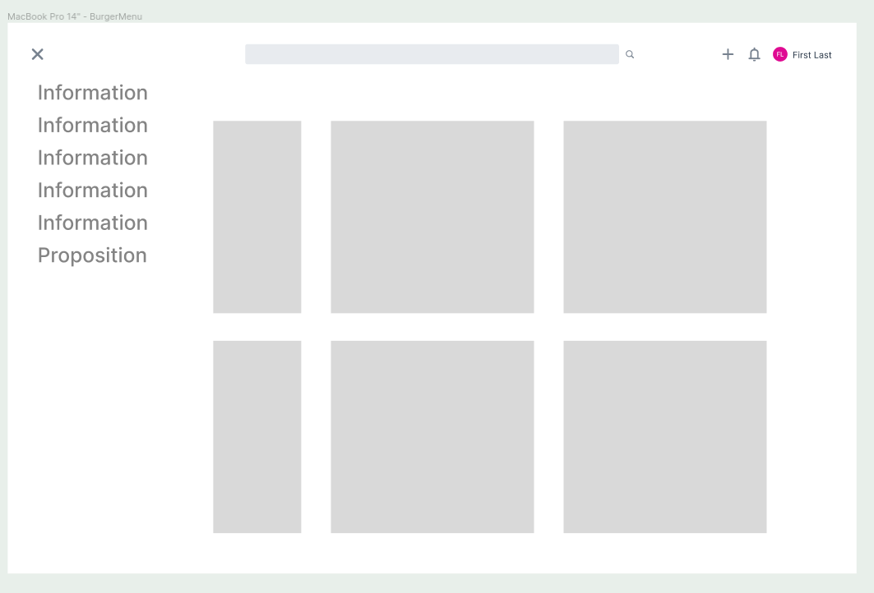
Figure 6: Burger Menu

