Manage profile

1 - Brief description
This use case :
- Describes how a user (administrator or not) logs into the system.
- Describes how a user (administrator or not) logs out the system.
- Describes how a user register in the system.
- Allows the user to maintain user information. This includes changing and reading user information from the system. If the user wants to delete his account, he can make a request to the administrator.
- Allows the administrator to maintain user information. This includes reading, changing, and deleting user information from the system.

- Log in
  - Flow of events
    - Basic flow
This starts when a user wishes to log into the application.
If the user selected “Sign in” the Sign in sub flow is executed.
If the user selected “Sign up “, the Register sub flow is executed.

Sign in :
The system requests that the user enter the login information. This includes :
- Email
- Password
If the user provides the requested information, the system validates the entered information and logs the user into the system.
If the user selects “forgot password” the system will ask the secret question and if the system validates the user is login and he can modify his password else, he is redirect to the log in page.
If the user selects “Register”, the user will be redirect to the Register flow.

    - Alternative flow
Invalid email/password :
If in the Have an account flow, the user enters an invalid email and/or password, the system displays an error message. The user can choose to either return to the beginning of the Have an account flow or cancel the login, at which point the use case ends.

Login canceled :
If in the sign in subflow the user decides not to login himself, the sign in is canceled and the user is redirect to the log in subflow.
  - Special requirements
  - Preconditions
  - Postconditions
If the log in was successful, the user is now logged into the system. If not, the system state is unchanged.
  - Extensional points
  - Mock-up
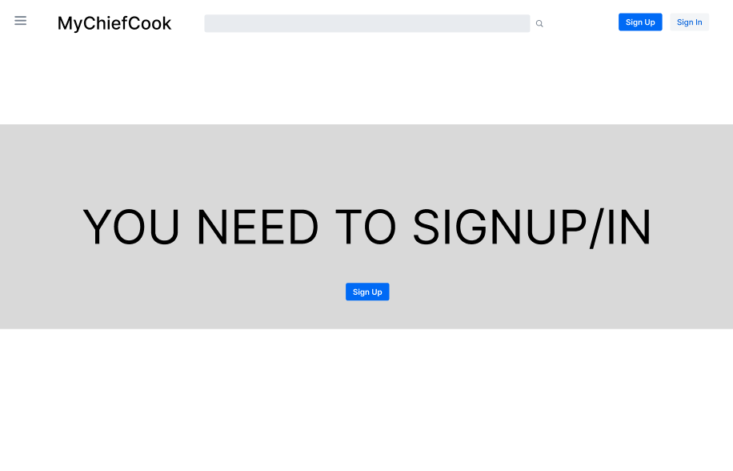
Basic flow – home page
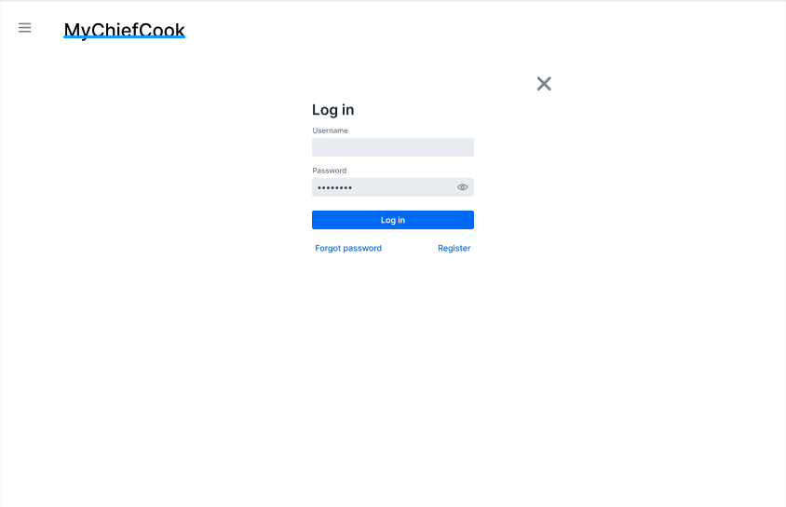
Basic flow – sign in

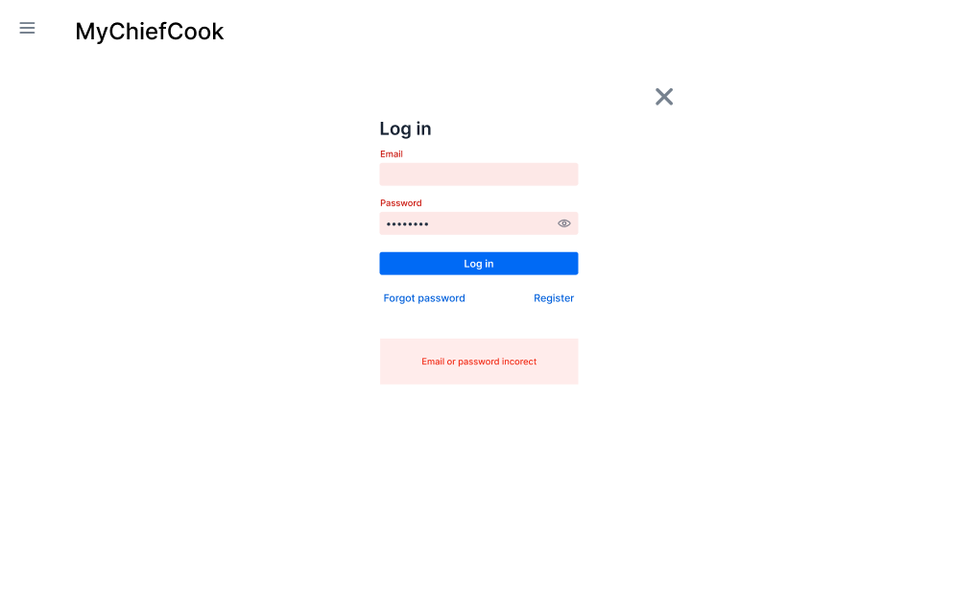
Invalid email/password :

- Log out
  - Flow of events
    - Basic flow
This starts when a user wishes to log out the application.
If the user selected “Disconnect “, the Disconnect sub flow is executed.

Disconnect:
The system logs out the user from the system.
    - Alternative flow
  - Special requirements
  - Preconditions
User must be logged in to log out.
  - Postconditions
If the log out was successful, the user is now disconnected from the system and he will be redirected to the login page. If not, the system state is unchanged.
  - Extensional points
  - Mock-up

Basic flow

- Register
  - Flow of events
    - Basic flow
This starts when a user wishes to register into the application.

Register :
The system requests that the user enter the register information. This includes :
- Name
- Birthdate
- Phone
- Email
- Password
- Secret question
Once the user provides the requested information, the system validates the entered information the system generates and assigns a unique user id number to the user. The user is added to the system and logs into the system.
    - Alternative flow
Form problem :
If the user enters an email already used or if another field of the form is wrong, the system displays an error message (“Something goes wrong”).

Register canceled :
If in the Register subflow the user decides not to register himself, the register is canceled and the user is redirect to the login subflow.

  - Special requirements
  - Preconditions
User shouldn’t already have an account.
  - Postconditions
If the register was successful, the user is redirect to the home page.
  - Extensional points
  - Mock – up
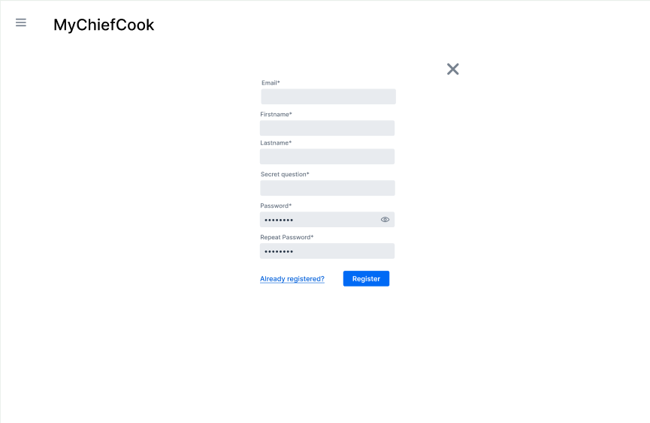
Basic flow
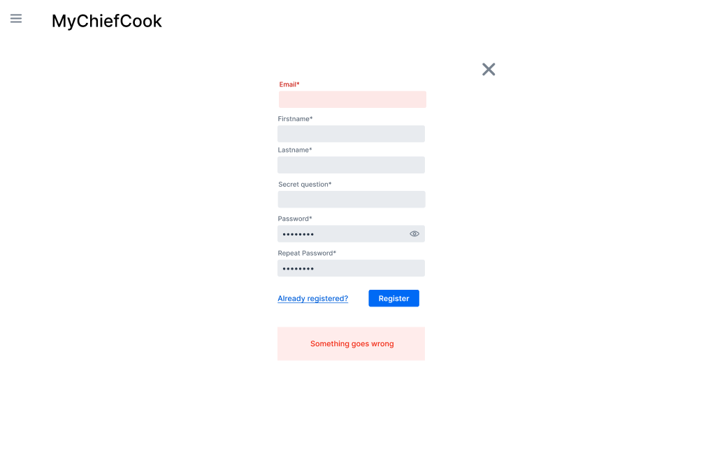
Alternative flow – problem with the form

- User
  - Flow of events
    - Basic flow
This use case allows the user to maintain his personal information. This includes changing user information from the system. He can also ask for deleting his account.
The system requests that the user specify the function he/she would like to perform (either modify personal information or ask for deleting).
Once the user provides the requested information, one of the sub flows is executed.
If the user selected “modify personal information“, the modify personal information subflow is executed.
If the user selected “Ask for deleting“, the Ask for deleting subflow is executed.

Modify personal information :
The system retrieves his personal information and displays the user information. The user makes the desired changes to his information. This includes any of the information specified in the Register sub-flow. Once the user updates the necessary information, the system updates the user record with the updated information.

Ask for deleting :
The system sends a notification to the administrator. This notification informs that the user x wants to delete his account. After, the administrator can decide if he delete it or not.
    - Alternative flow
Modify personal information canceled :
If in the modify personal information sub flow the user decides not to modify his information, the modification is canceled and the user is redirect to the user page.

Ask for deleting canceled :
If in the ask for deleting sub flow the user decides not to delete his account, the demand is canceled and the user is redirect to the user page.

  - Special requirements
  - Preconditions
User must be logged in.
  - Postconditions
If the use case was successful, the user information is updated from the system. Otherwise, the system state is unchanged.
  - Extensional points
  - Mock-up
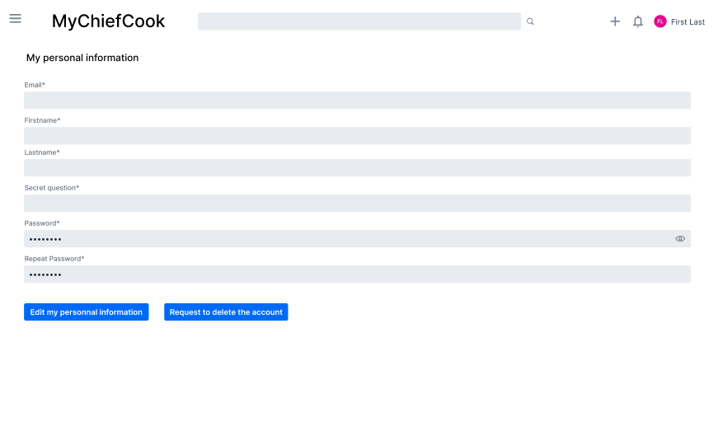
Basic flow
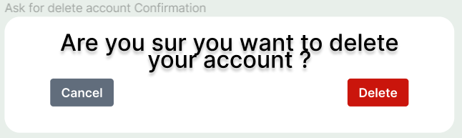
Alternative flow

- Administrator
  - Flow of events
    - Basic flow
This use case allows the administrator to maintain his personal information and maintain users. This includes changing his personal information from the system. He can also view the list of users and delete user account.
The system requests that the administrator specify the function he/she would like to perform (either modify personal information or deleting).
Once the administrator provides the requested information, one of the sub flows is executed.
If the administrator selected “modify personal information“, the modify personal information subflow is executed.
If the administrator selected “view all users“, the view user subflow is executed.
If the administrator selected “Delete a user “, the Delete a user subflow is executed.
Modify personal information :
The system retrieves his personal information and displays the administrator information. The administrator makes the desired changes to his information. This includes any of the information specified in the Register sub-flow. Once the administrator updates the necessary information, the system updates the user record with the updated information.
View user :
The system retrieves the list of all users and displays it. The administrator has the list of all users. He can click and see all the information of a user.

Delete a user :
The administrator will get a notification that a user wants to delete his account. He can decide to delete the account permanently or not. If he decides to delete the account, an email will be sent to the user and the system updates the user record.
    - Alternative flow
Modify personal information canceled :
If in the modify personal information sub flow the administrator decides not to modify his information, the modification is canceled and the administrator is redirect to the user page.

  - Special requirements
  - Preconditions
The administrator must be logged in.
  - Postconditions
If the use case was successful, the administrator information is updated from the system and the user information is updated or deleted from the system. Otherwise, the system state is unchanged.

  - Extensional points
  - Mock-up
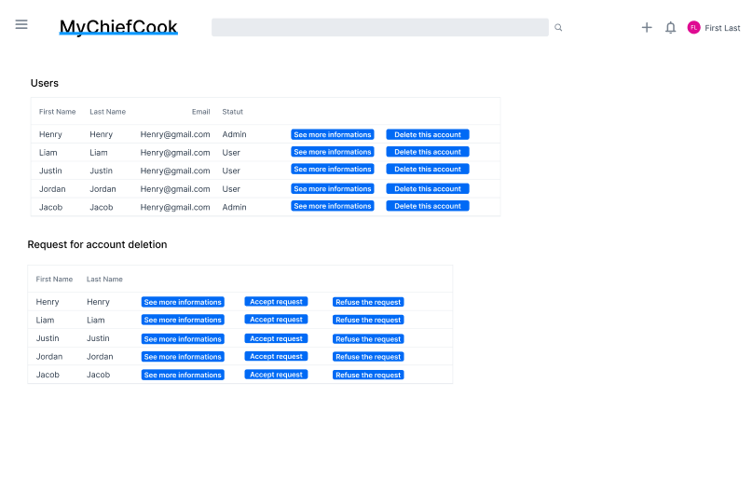
Basic flow – user management
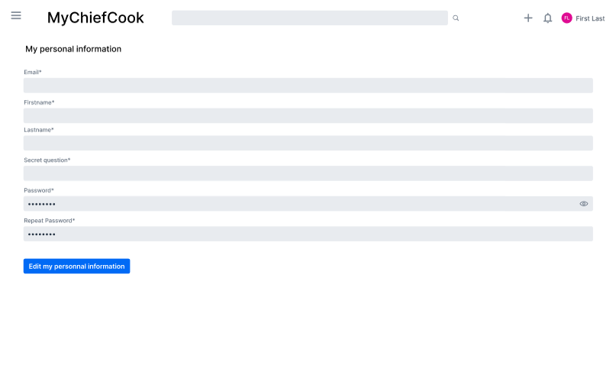
Basic flow – admin management
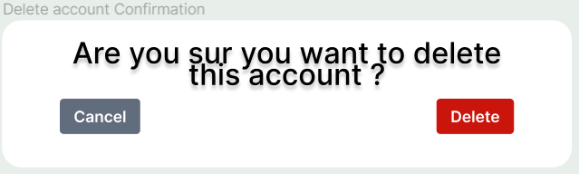
Alternative flow

Diagrammes :

Manage news

1 - Brief description
The news will show the user what is new (change in the application, new recipes, new partner). It can be modified (created, updated) by administrators only. They will be able to specify a title, a description, and a picture if they want. They also will be able to display or not the news to the users.

2 - Flow of events
This use case starts when the administrator wishes to add, change, and/or display a news from the system.
- The system requests that the administrator specify the function he/she would like to perform (either add a news, update a news or display a news)
- Once the administrator provides the requested information, one of the sub flows is executed.
If the administrator selected “Add a news“, the Add a news sub flow is executed. He can add a news item only if it does not exist yet. If the news already exists, he can only modify it.
If the administrator selected “Update a news“, the Update a news sub flow is executed.
If the administrator selected “Display a news“, the Display a news sub flow is executed.

Add a news :
The system requests that the administrator enter the news information. This includes :
- Title
- Description
- Pictures (only if the administrator wants)
Once the administrator provides the requested information, the system generates and assigns a unique news id number to the news. The news is added to the system and the news display is set to "not displayed" by default.

Update a news :
The system requests that the administrator makes the desired changes to the news information. This includes any of the information specified in the Add a news sub-flow. Once the administrator updates the necessary information, the system updates the news record with the updated information.

Display a news :
The system requests that the administrator selects the option he wants. He can display the news to the users or hide it.

3 - Special requirements

Must be thread-safe in case multiple administrators are modifying the news.

4 - Pre-conditions

The administrator must be logged onto the system before this use case begins.

5 - Post-conditions

If it’s successful, the news will be added/updated from the database and display if the administrator wishes. Otherwise, the state remains unchanged.

6 - Extension points
None

7- Mock up
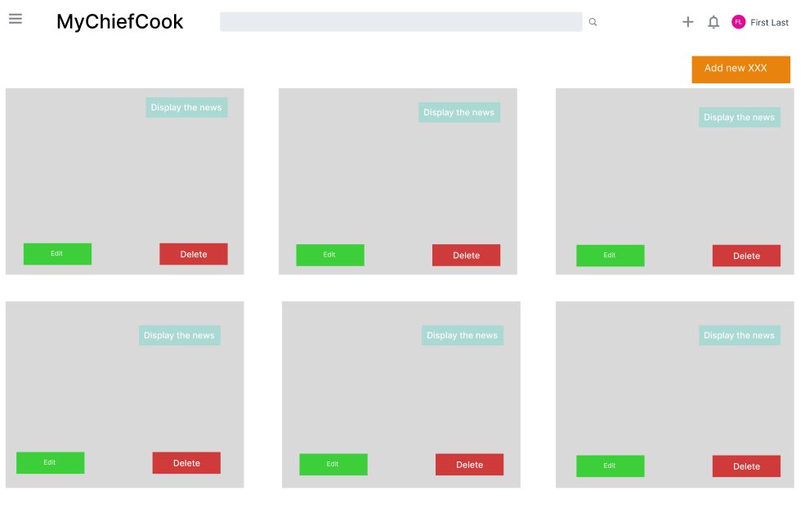
Basic flow – list of news
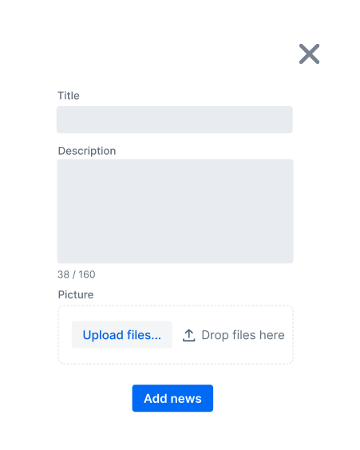
Basic flow – add a news

Diagrammes :

