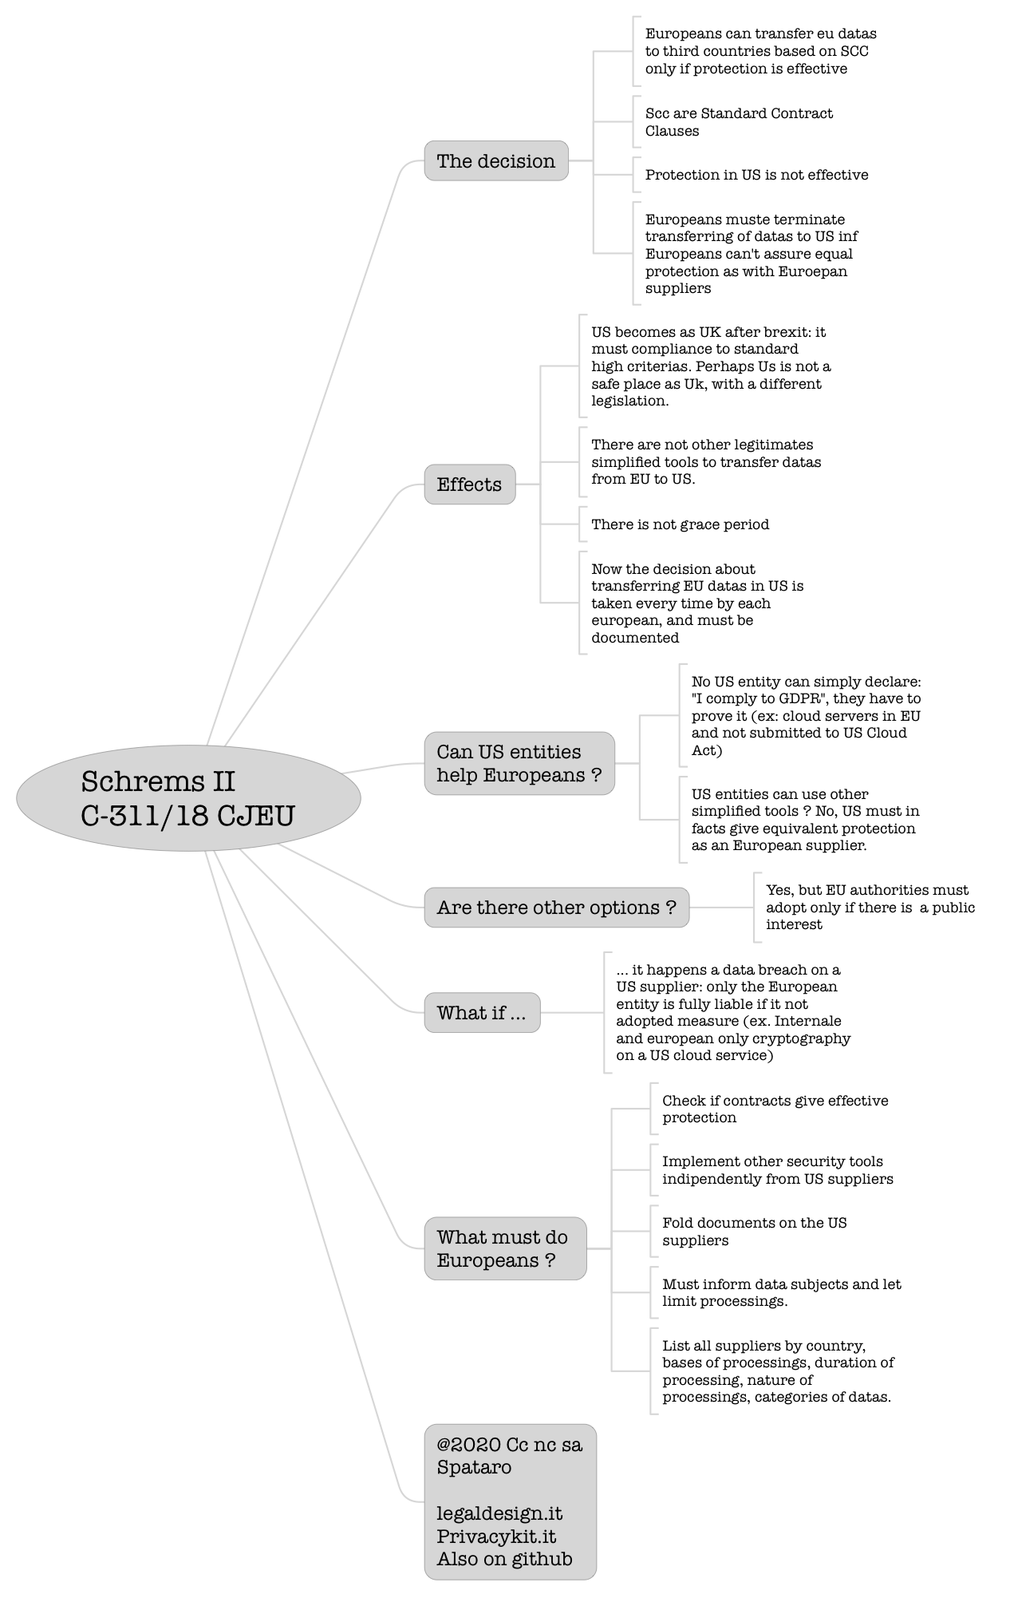

# Schrems II C-311/18 CJEU

## The decision

### Europeans can transfer eu datas to third countries based on SCC only if protection is effective

### Scc are Standard Contract Clauses

### Protection in US is not effective

### Europeans muste terminate transferring of datas to US inf Europeans can't assure equal protection as with Euroepan suppliers

## Effects

### US becomes as UK after brexit: it must compliance to standard high criterias. Perhaps Us is not a safe place as Uk, with a different legislation.

### There are not other legitimates simplified tools to transfer datas from EU to US.

### There is not grace period

### Now the decision about transferring EU datas in US is taken every time by each european, and must be documented

## Can US entities help Europeans ?

### No US entity can simply declare: "I comply to GDPR", they have to prove it (ex: cloud servers in EU and not submitted to US Cloud Act)

### US entities can use other simplified tools ? No, US must in facts give equivalent protection as an European supplier.

## Are there other options ?

### Yes, but EU authorities must adopt only if there is a public interest

## What if ...

### ... it happens a data breach on a US supplier: only the European entity is fully liable if it not adopted measure (ex. Internale and european only cryptography on a US cloud service)

## What must do Europeans ?

### Check if contracts give effective protection

### Implement other security tools indipendently from US suppliers

### Fold documents on the US suppliers

### Must inform data subjects and let limit processings.

### List all suppliers by country, bases of processings, duration of processing, nature of processings, categories of datas.

## @2020 Cc nc sa Spataro legaldesign.it Privacykit.it Also on github