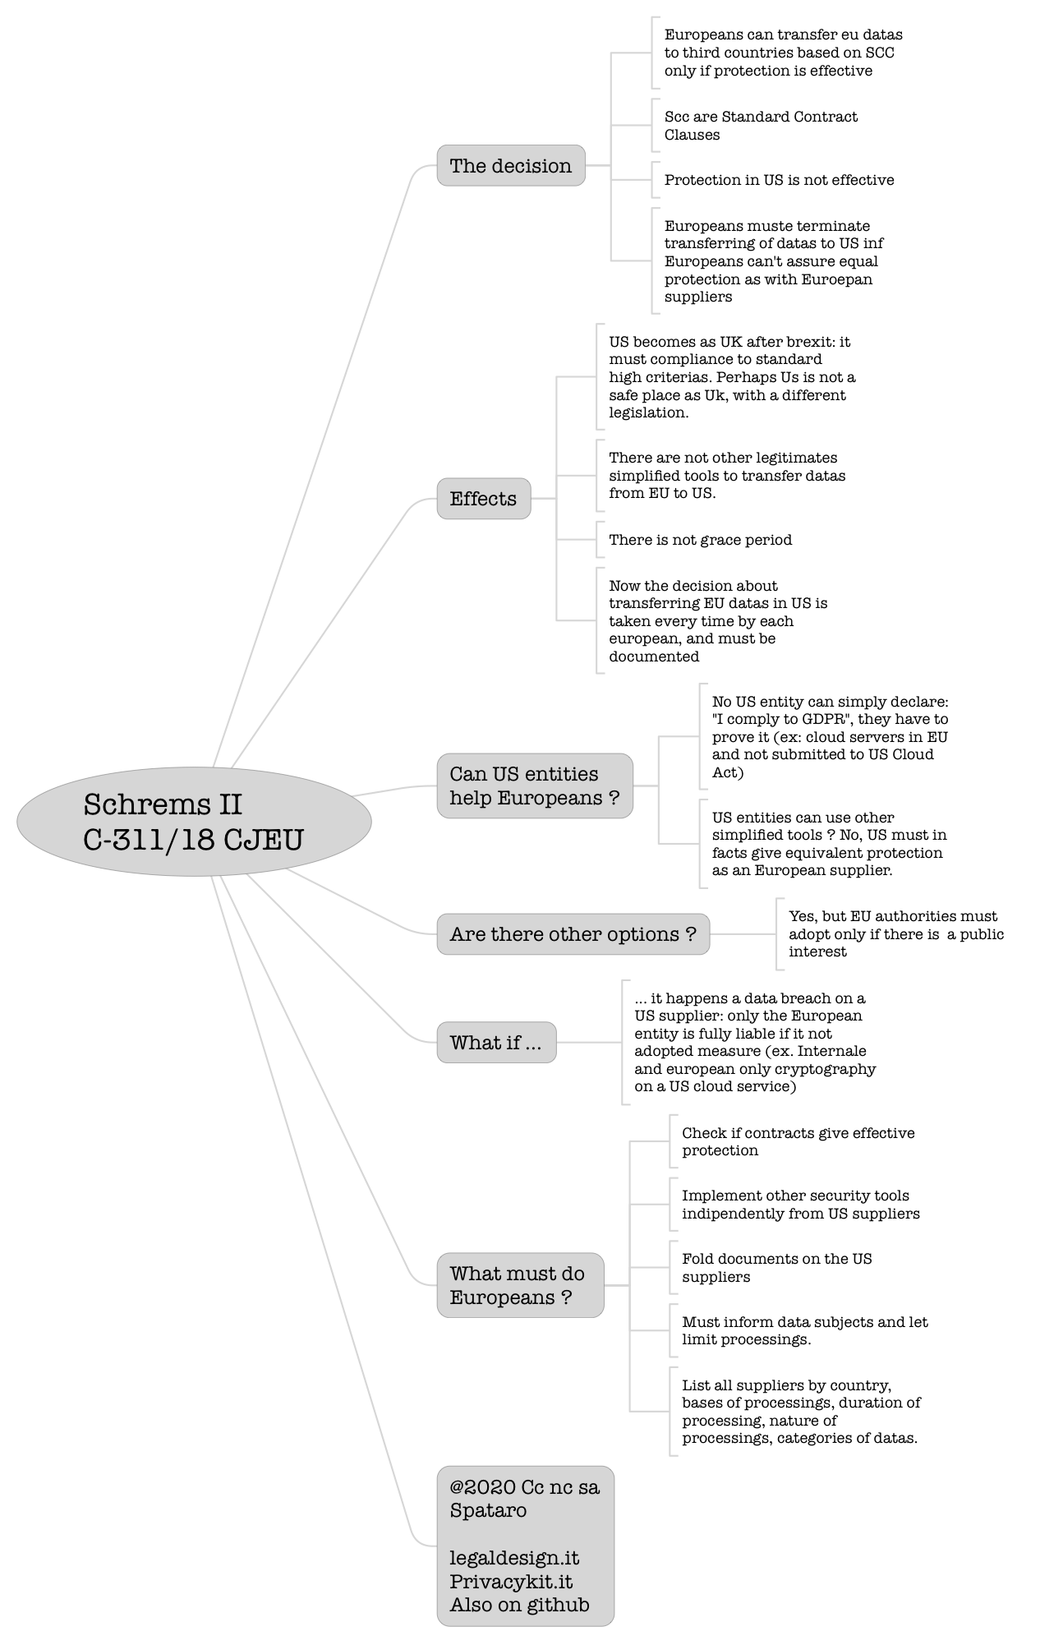

# Schrems II C-311/18 CJEU

|  |  |
| --- | --- |
| The decision | Europeans can transfer eu datas to third countries based on SCC only if protection is effective |
| Scc are Standard Contract Clauses |
| Protection in US is not effective |
| Europeans muste terminate transferring of datas to US inf Europeans can't assure equal protection as with Euroepan suppliers |
| Effects | US becomes as UK after brexit: it must compliance to standard high criterias. Perhaps Us is not a safe place as Uk, with a different legislation. |
| There are not other legitimates simplified tools to transfer datas from EU to US. |
| There is not grace period |
| Now the decision about transferring EU datas in US is taken every time by each european, and must be documented |
| Can US entities help Europeans ? | No US entity can simply declare: "I comply to GDPR", they have to prove it (ex: cloud servers in EU and not submitted to US Cloud Act) |
| US entities can use other simplified tools ? No, US must in facts give equivalent protection as an European supplier. |
| Are there other options ? | Yes, but EU authorities must adopt only if there is a public interest |
| What if ... | ... it happens a data breach on a US supplier: only the European entity is fully liable if it not adopted measure (ex. Internale and european only cryptography on a US cloud service) |
| What must do Europeans ? | Check if contracts give effective protection |
| Implement other security tools indipendently from US suppliers |
| Fold documents on the US suppliers |
| Must inform data subjects and let limit processings. |
| List all suppliers by country, bases of processings, duration of processing, nature of processings, categories of datas. |
| @2020 Cc nc sa Spataro  legaldesign.it Privacykit.it Also on github | |