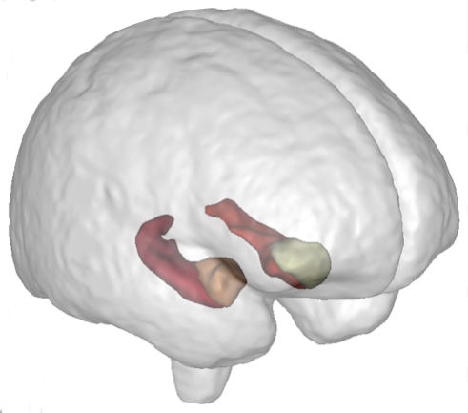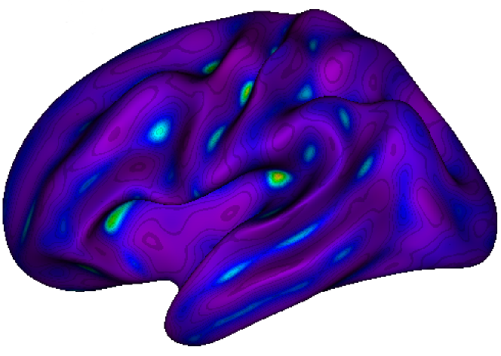

**NeuroSpin** is an outstanding research center on the **Human brain**. Part of the CEA (Atomic Energy Commission) and Paris-Saclay University, the NeuroSpin teams are leaders in very high field MRI and carry out studies in **fundamental and clinical neurosciences**. The **BrainOmics** team works in **imaging-genetics**, at the crossroad where **neuroinformatics, bioinformatics** and **machine learning** meet, and in collaboration with Gustave Roussy and ICM-La Pitié-Salpétrière.

**Deep learning for genotype-phenotype association studies**

In the BrainOmics team at Neurospin, the trainee will work on the implementation of different deep neural networks to extend the classical methods in the genotype-phenotype association studies (GWAS). We intend to use genotyping data to design neural networks that will learn the genome structure or learn regulatory pattern, while predicting a phenotype.

This work will be applied to the imaging-genetics UK Biobank cohorts (genetics for 500,000 subjects, MRI for 25,000 and WES for 50,000 subjects - ongoing access #25251). More specifically, the link between brain sulci morphometry (the phenotype) and the biological pathways/genes/SNPs will be studied.

Trainee’s Activities

* From existing helper functions, the trainee will prepare training/validation/test data at the scale of the UK Biobank cohort. He/she will quality-controls the data obtained.
* Build, train various neural networks, and study the impact of the training strategies as well as optimization functions.
* Applications in neurosciences: contributions to the study of the genetic architecture of the brain cortical folding**.**

Benefits of the training

The proposed training introduces to the research job in Data Science. The work will be applied to an exceptional world-class resource in imaging-genetics: UK-BioBank. It offers the opportunity to investigate original and new uses of deep learning for genome wide association studies.

Searched profile: Engineering School, Master in Data Science. Fluent in English.

Job-related skills

* Knowledge in optimization, statistics or applied mathematics
* Strong programming skills : Python, R, Deep learning frameworks
* Curiosity, taste for multi-disciplinary environment and for innovation.
* Good communication skills, good personal relationship skills.
* Knowledge in biomedical image analysis and/or genetics is an asset

Behavioral skills

Good team player, strong motivation, rigor, autonomy and resourcefulness.

Training duration:6 months, starting from february, 2019.

Location: NeuroSpin-CEA, Plateau de Saclay, Gif-sur-Yvette.

Please email your CV + cover letter **by november 15th, 2019** to cathy.philippe@cea.fr and

vincent.frouin@cea.fr