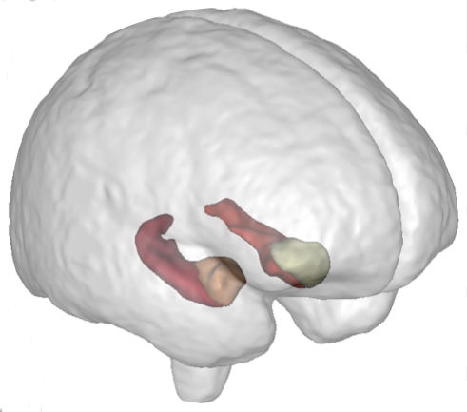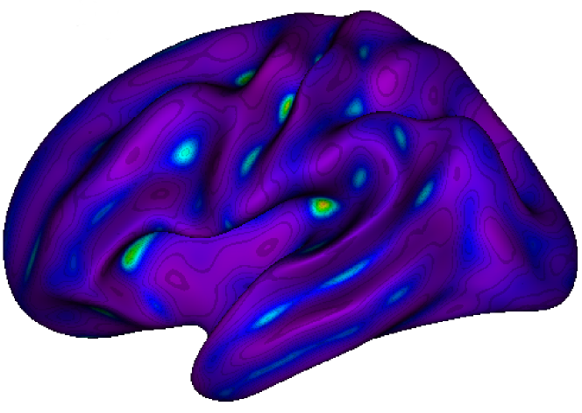

**NeuroSpin** is an outstanding research center on the **Human brain**. Part of the CEA (Atomic Energy Commission) and Paris-Saclay University, the NeuroSpin teams are leaders in very high field MRI and carry out studies in **fundamental and clinical neurosciences**. The **BrainOmics** team works in **imaging-genetics**, at the crossroad where **neuroinformatics, bioinformatics** and **machine learning** meet and in collaboration with Gustave Roussy and ICM-La Pitié-Salpétrière.

**Machine learning in imaging-genetics on UK Biobank**

In the **BrainOmics** team at Neurospin, the post-doc researcher will work on the conception of **machine learning** models incorporating multi-modal MRI and multi-omic data. Moreover, he/she will take part to the analysis in imaging-genetics of UK Biobank cohort (genetics for 500K, MRI for 25K, WES for 50K subjects) regarding the study of genes/SNPs association with the brain morphology, including in particular the sulci and the sulcal pits (ongoing project #25251).

Post-doc Activities

* Data quality control and inspection for each modality separately.
* Train **machine learning** prediction models for each modality.
* **Genotype microarray, WES, MRI data integration**.
* **Applications in neurosciences.**

Searched profile

PhD in one of the following fields : Data Science, Machine Learning, Applied Statistics, Data integration, Neuro-Imaging, Genomics. Fluent in english.

Job-related skills

* **Very good skills in statistics and applied mathematics**
* Programming : **Python**, R, Matlab
* **Curiosity, taste for multi-disciplinary environment and for innovation.**
* Knowledge in biomedical image analysis and/or genetics and/or neruoscience is an asset.

Behavioral skills

Good team player, strong motivation, rigor, autonomy and resourcefulness.

Duration**: 2 years**, starting in june 2019.

Location : NeuroSpin-CEA, Plateau de Saclay, Gif-sur-Yvette.

Please email your CV + cover letter **by July 31st, 2019** to [cathy.philippe@cea.fr](mailto:cathy.philippe@cea.fr) and [vincent.frouin@cea.fr](mailto:vincent.frouin@cea.fr)

References:

Castel *et al.* (2018) Modified penetrance of coding variants by cis-regulatory variation shapes human traits. *Nature Genetics*.

Guigui *et al.* (2019) Network Regularization in Imaging Genetics Improves Prediction Performances and Model Interpretability on Alzheimer's Disease. *ISBI 2019 Venise, Italie.*

Tenenhaus *et al.* (2014). Variable selection for generalized canonical correlation analysis. *Biostatistics*