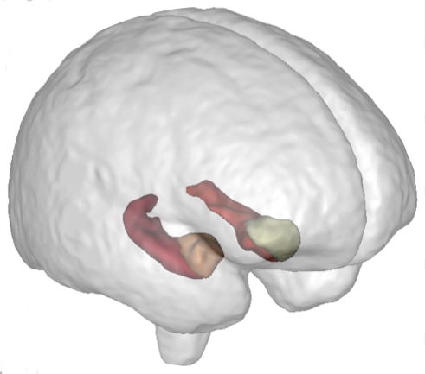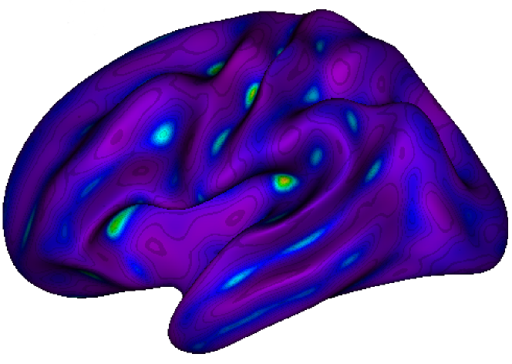

**NeuroSpin** is an outstanding research center on the **Human brain**. Part of the CEA (Atomic Energy Commission) and Paris-Saclay University, the NeuroSpin teams are leaders in very high field MRI and carry out studies in **fundamental and clinical neurosciences**. The **BrainOmics** team works in **imaging-genetics**, at the crossroad where **neuroinformatics, bioinformatics** and **machine learning** meet and in collaboration with Gustave Roussy, ICM-La Pitié-Salpétrière and CentraleSupelec.

**Machine learning in imaging-genetics on EU-AIMS**

The post-doc researcher will design **new machine learning models** incorporating **multi-modal MRI and multi-omic data for prediction and stratification purposes**, especially in ill-posed problems (very large p, small n). Then, he/she will perform the imaging-genetics analyses of the EU-AIMS cohort (aims-2-trials.eu), dedicated to Autism Spectrum Disorder (ASD).

Post-doc Activities

* Data quality control and inspection for each modality separately.
* Train **machine learning** prediction/stratification models for each modality.
* **Genotype microarray, brain anatomical and functional MRI data integration**.
* **Applications in clinical neurosciences, ASD.**

Searched profile

PhD in one of the following fields : Data Science, Machine Learning, Applied Statistics, Data integration, Neuro-Imaging, Genomics. Fluent in english.

Job-related skills

* **Very good skills in statistics and applied mathematics.**
* Programming : **Python**, R, Matlab.
* **Curiosity, taste for multi-disciplinary environment and for innovation.**
* Knowledge in biomedical image analysis and/or genetics and/or neuroscience is an asset.

Behavioral skills

Good team player, strong motivation, rigor, autonomy and resourcefulness.

Duration**: 2 years**, starting in January 2021.

Location : NeuroSpin-CEA, Plateau de Saclay, Gif-sur-Yvette.

Please email your CV + cover letter **by December 15th, 2020** to [cathy.philippe@cea.fr](mailto:cathy.philippe@cea.fr) and [vincent.frouin@cea.fr](mailto:vincent.frouin@cea.fr)

Mihailov *et al.* (2020). Cortical signatures in behaviorally clustered autistic traits subgroups: a population-based study. *Translational Psychiatry.*

Guigui *et al.* (2019) Network Regularization in Imaging Genetics Improves Prediction Performances and Model Interpretability on Alzheimer's Disease. *ISBI 2019 Venise, Italie.*

Marquand *et al.* (2016). Beyond lumping and splitting: a review of computational approaches for stratifying psychiatric disorders. *Biol Psy: CNNI*.