

*After a good dinner one can forgive anybody*

*So be Forgiving with us*

Leader: U1710017 Abdusodiqov Jamshid

U1710020 Eratbek Mamatov

U1710041 Shakarov Ulugmurod

U1710076 Fayziev Yodgor

U1710294 Khasanboev Bobur

<https://github.com/iuthub/design-project-diamond>

<https://diamondresta.000webhostapp.com/>

Diamond Restaurant

This restaurant is opened in 2019

Can reserve tables for clients in advance

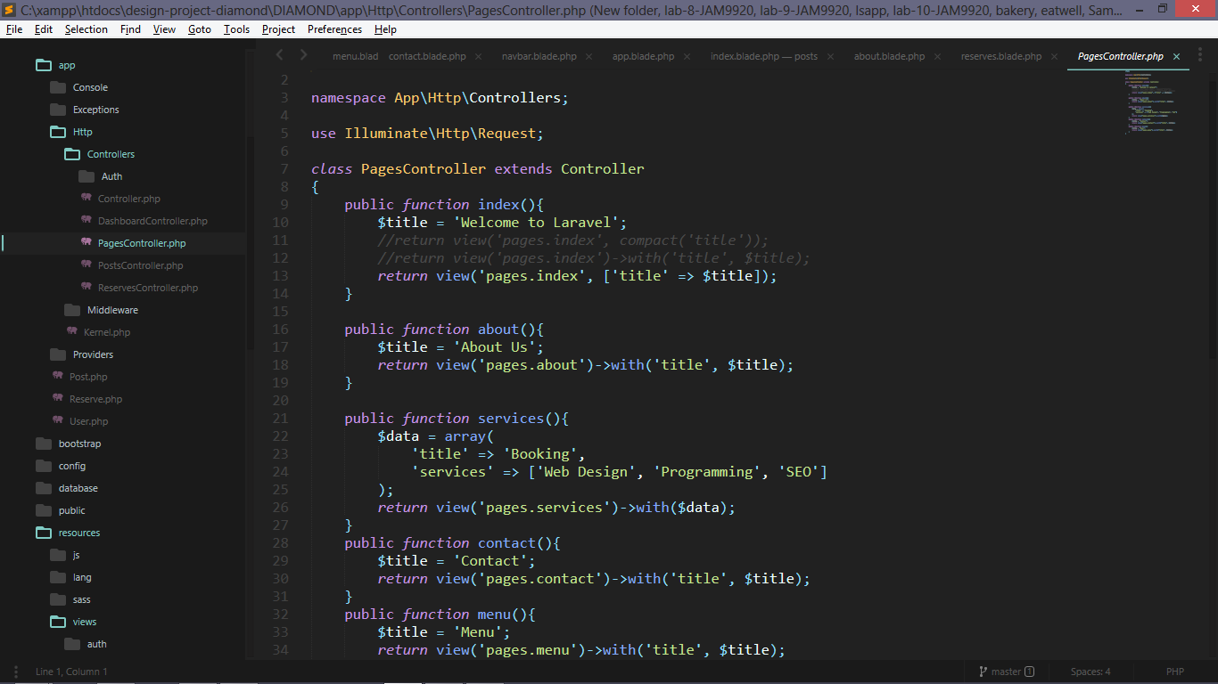

This PagesController that controls page links in this project 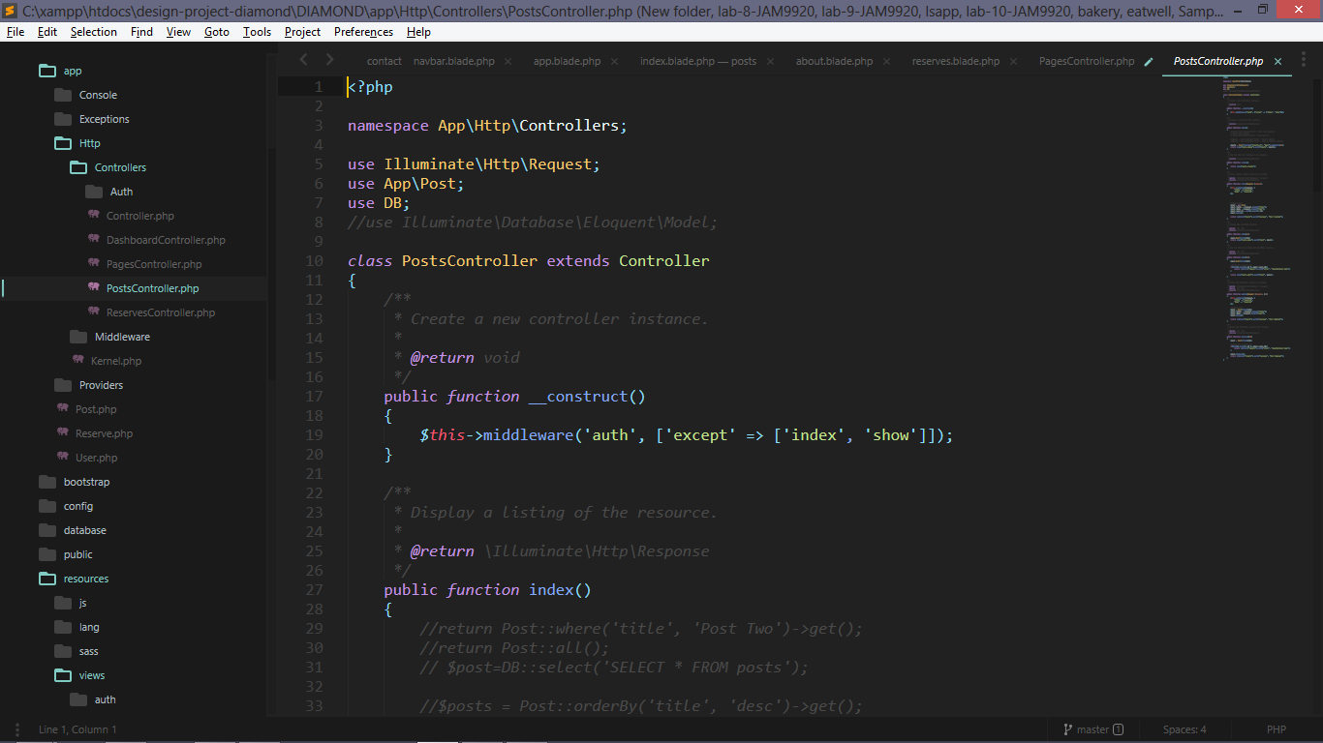

This is PostsController that saves creates deletes edits news that was posted by admin 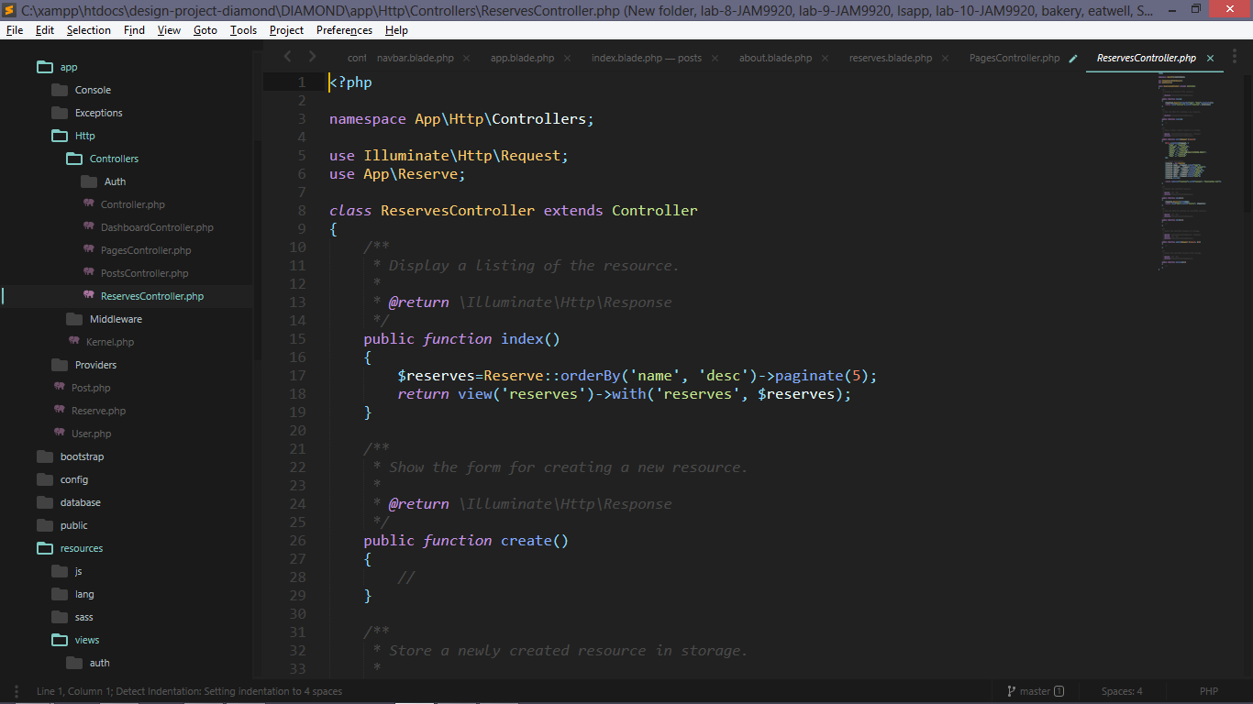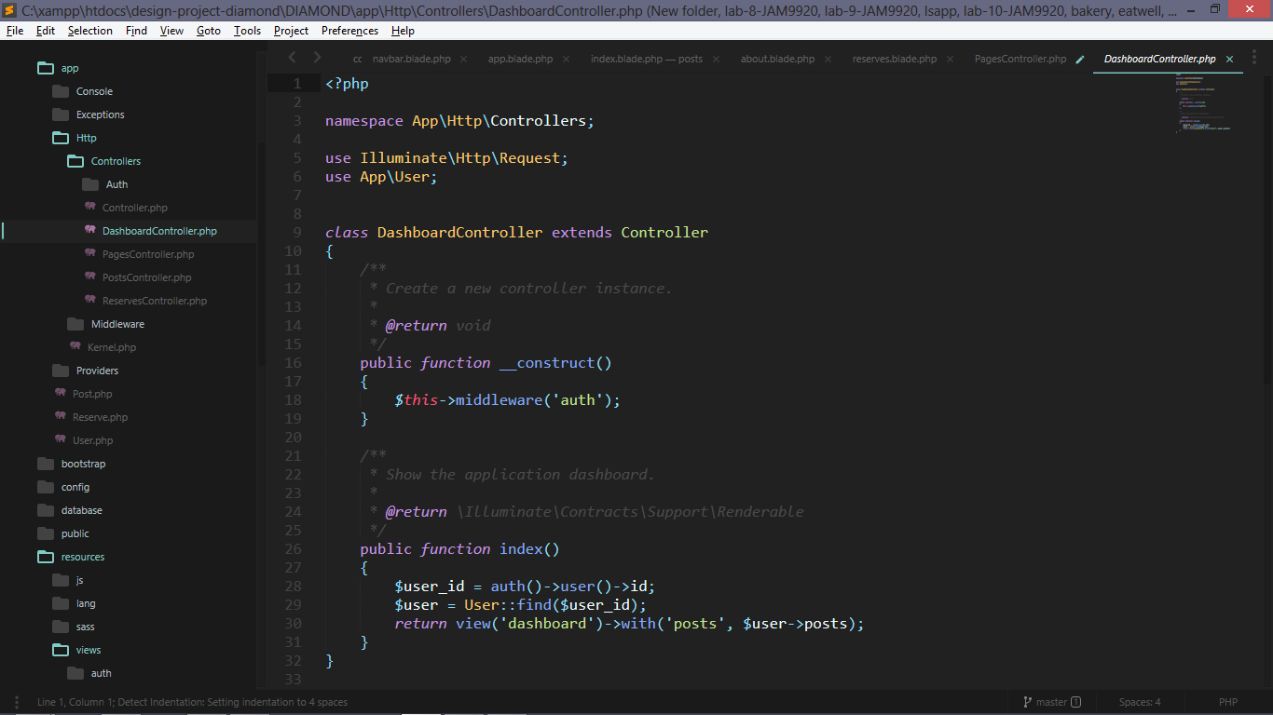This is dashboardController that accessible by admin and shows posts that was posted by this admin and allows admin to change posts or delete them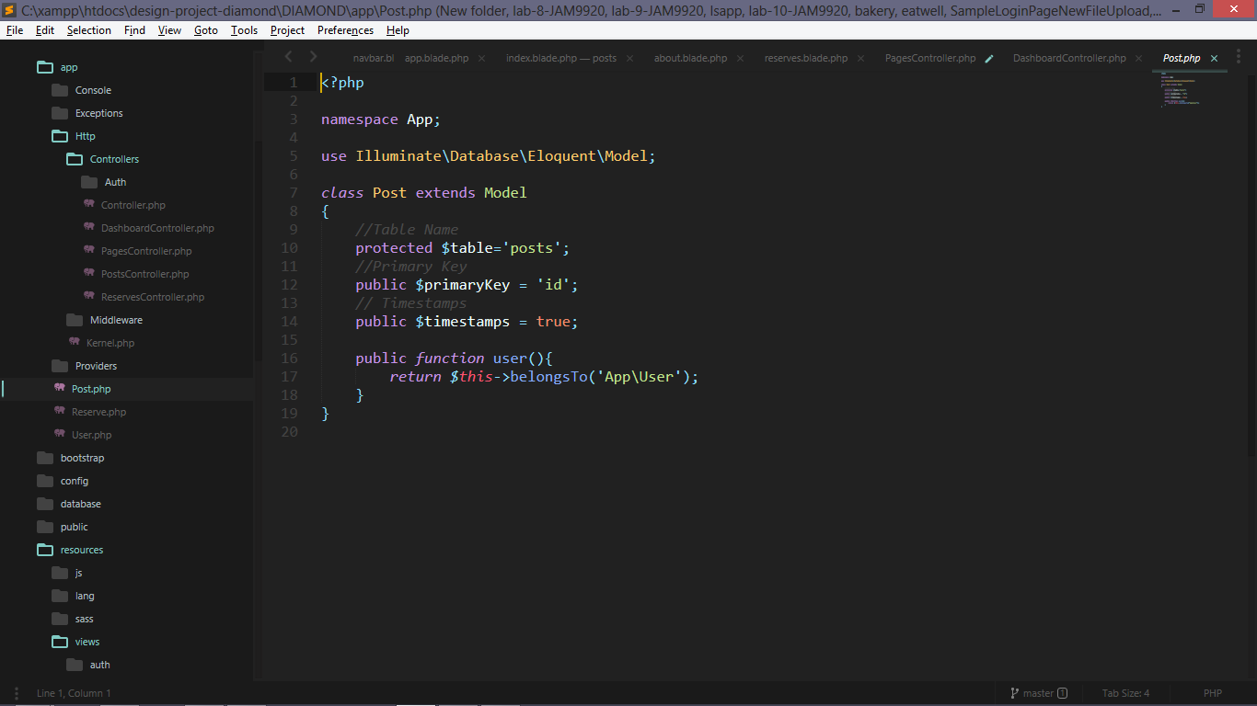this posts model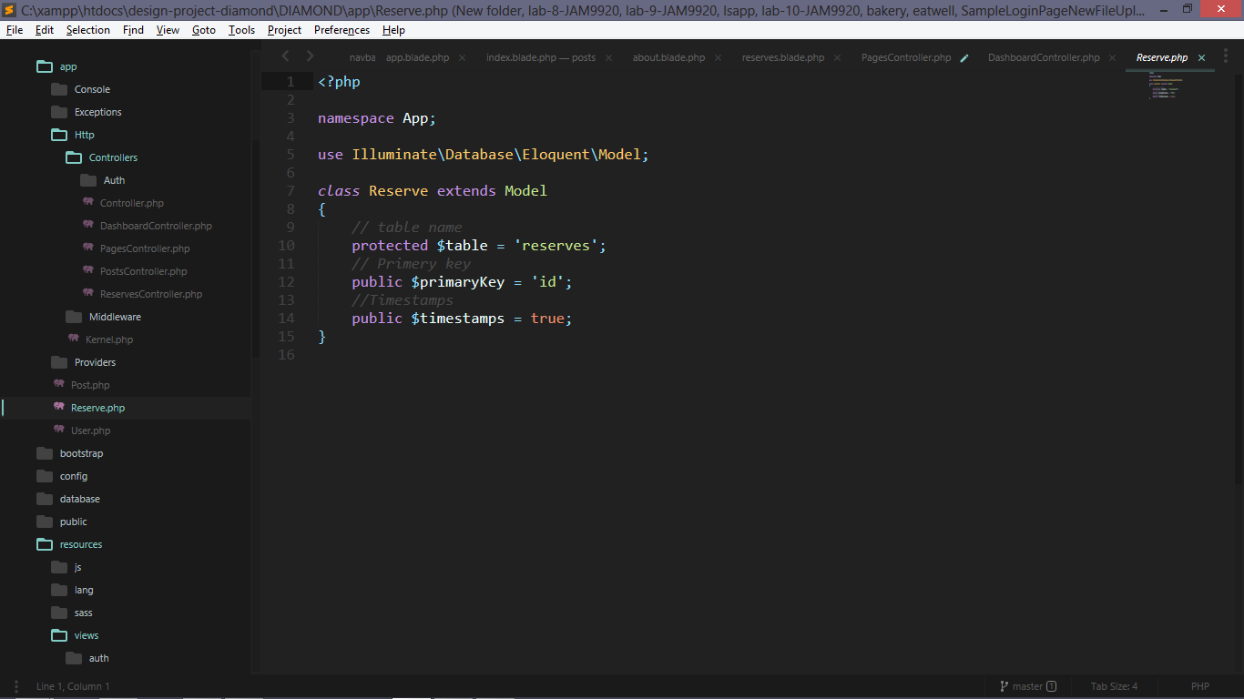this is reservation model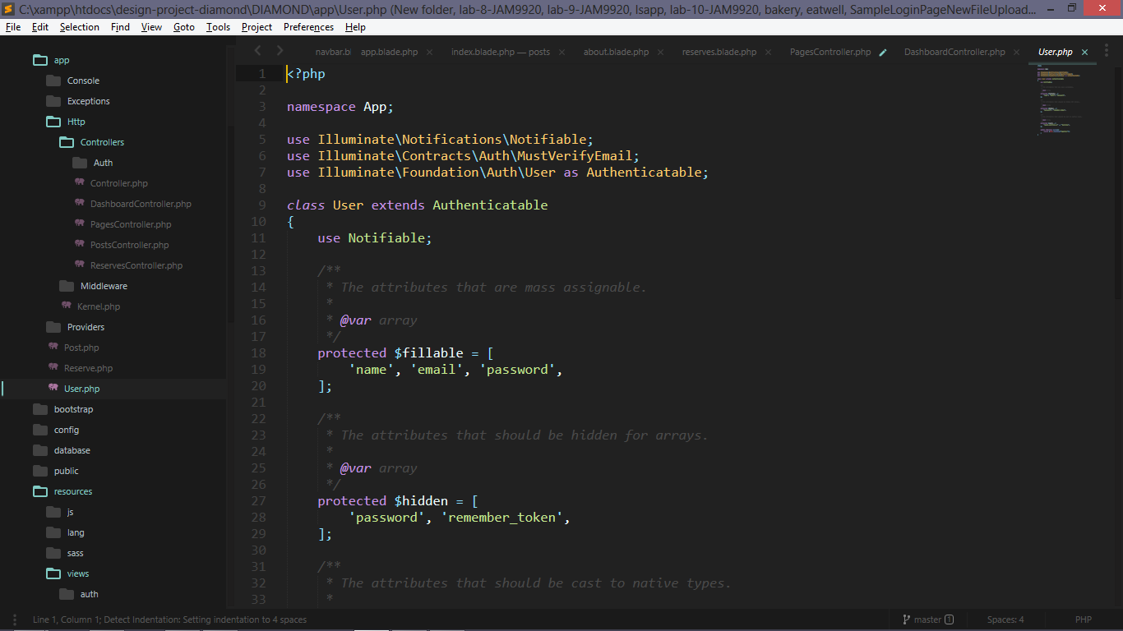this is user model 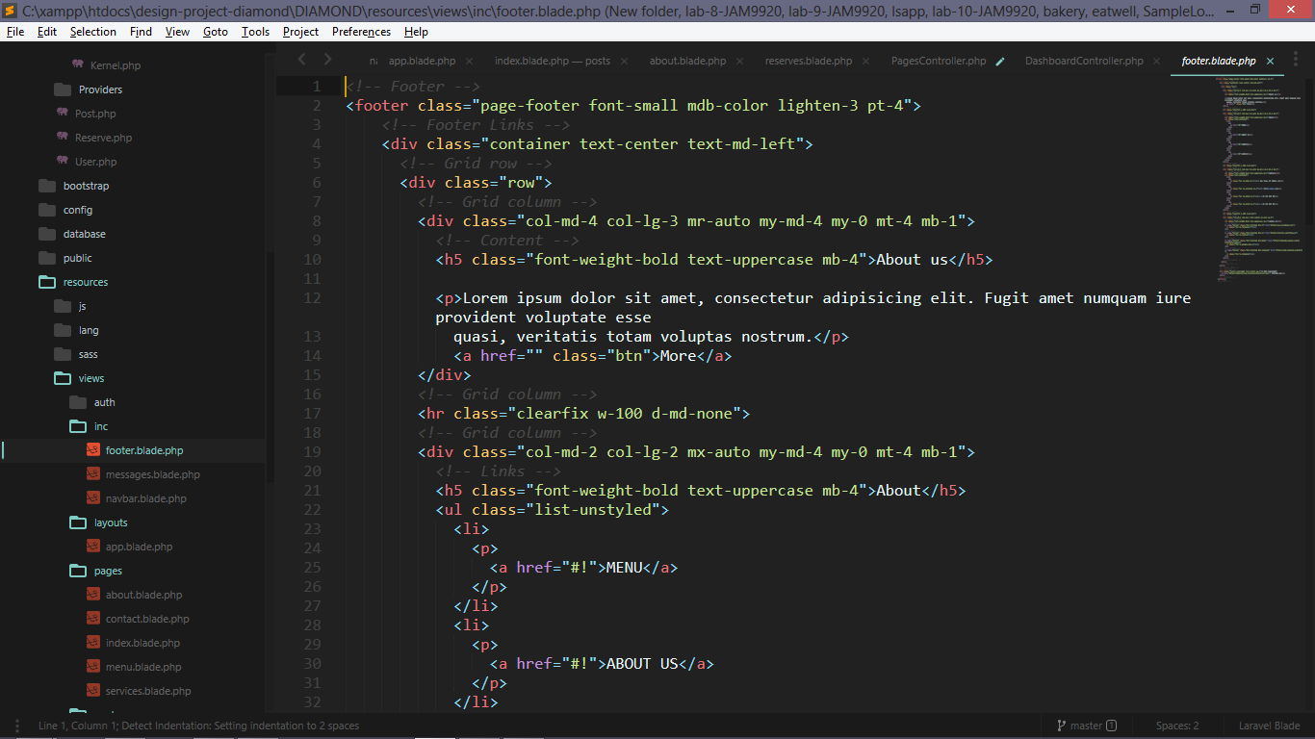this is footer content page this is shown in every page visited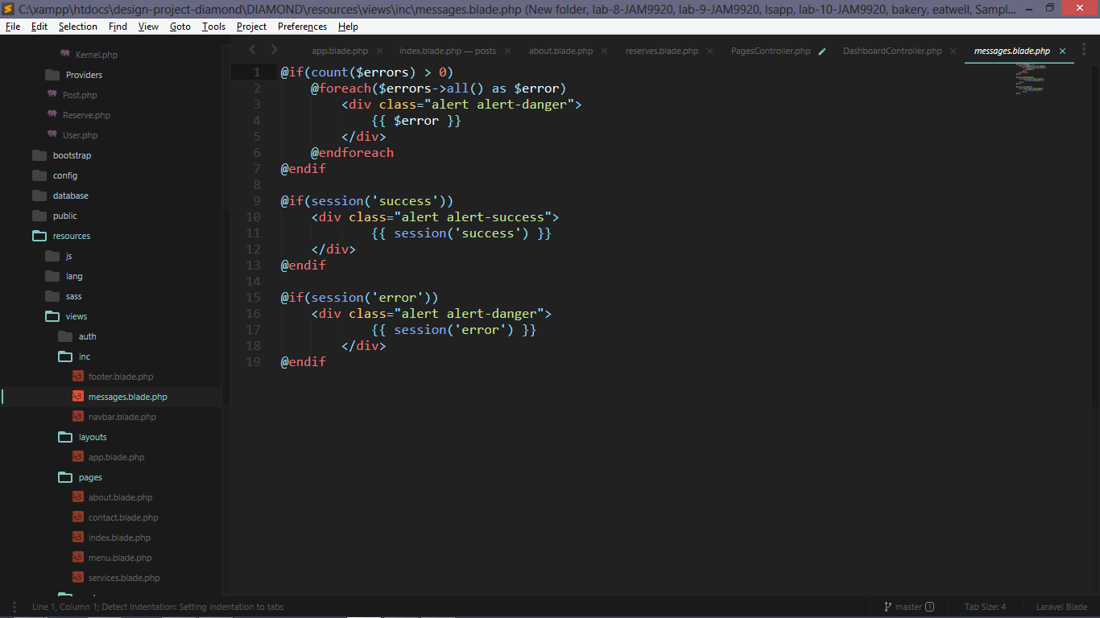this is message tab and shows if some error should be shown this is responsible for that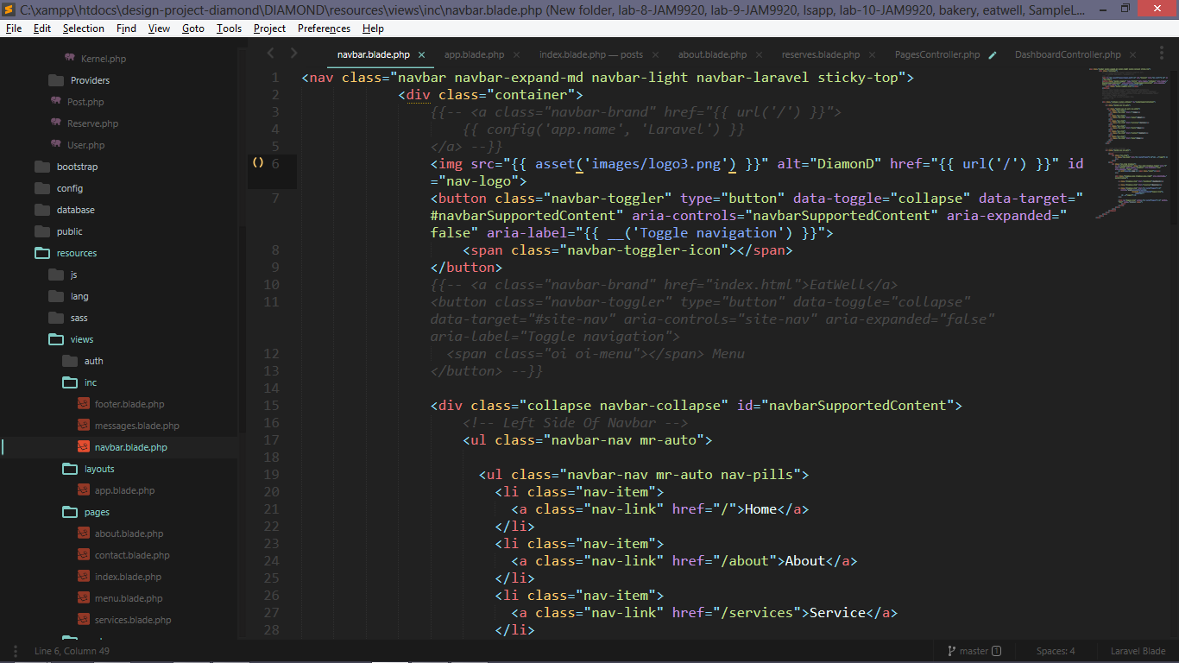this is navbar content page and contains all links if admin logins the side it is gonna show the admin name and additional pages for admin such as dashboard or reservations page that are request by users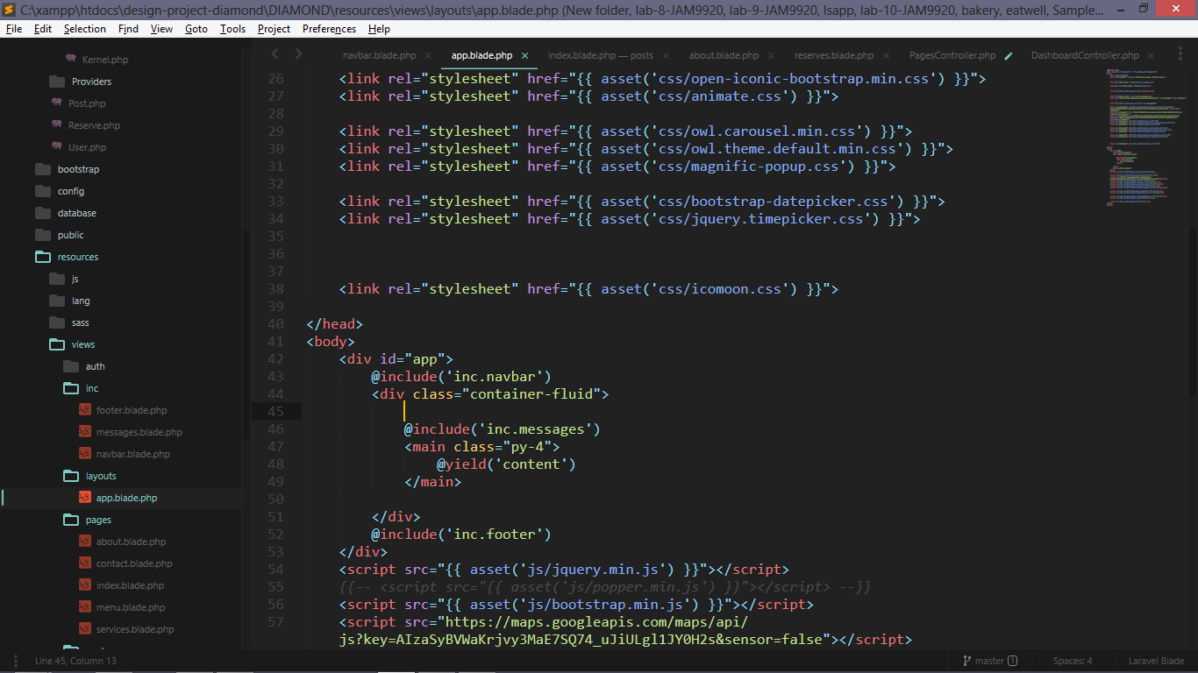this is main app page and contains all external resources links in it and it calls all pages by section name content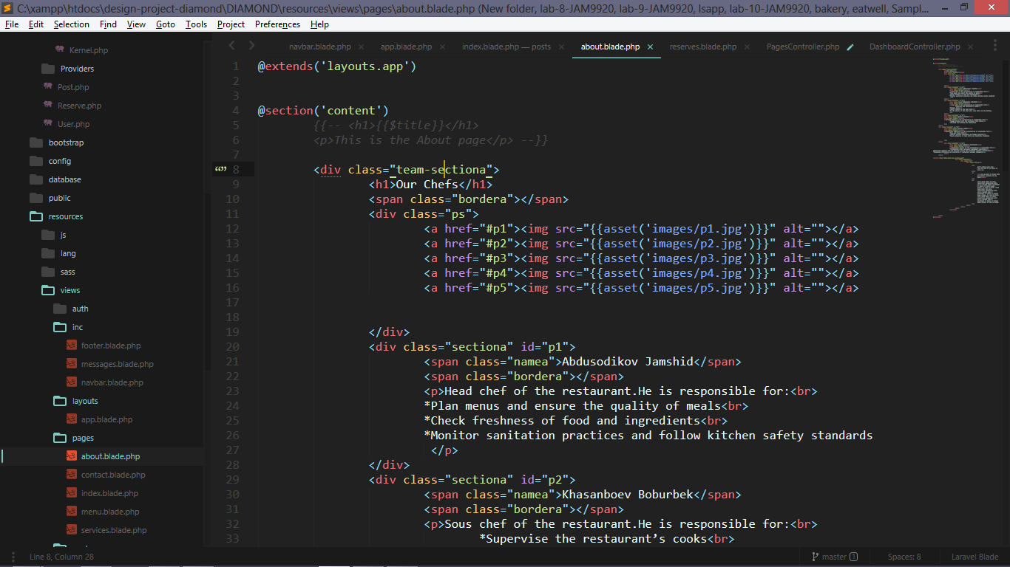this about page and contains about our restaurant and our chefs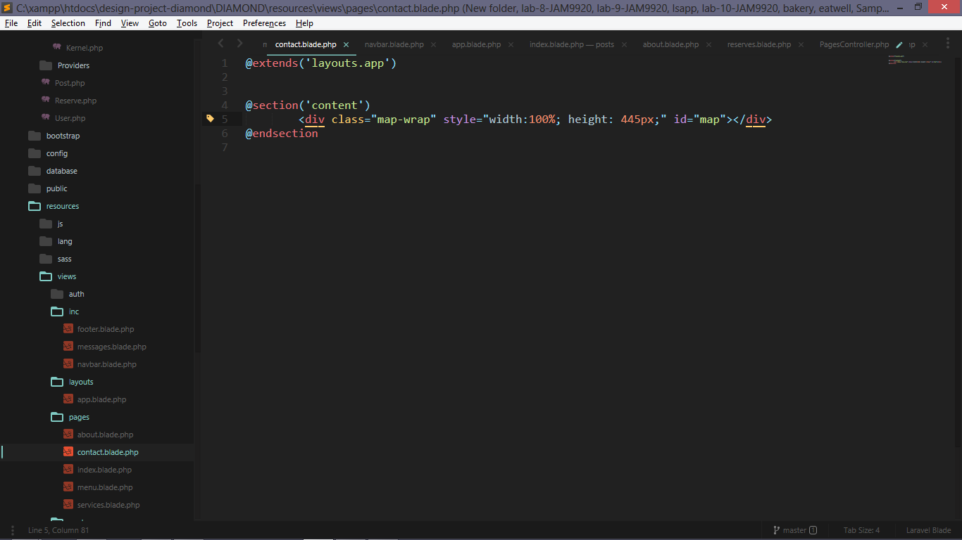this is contact page and it shows only map because in footer content we have all contact details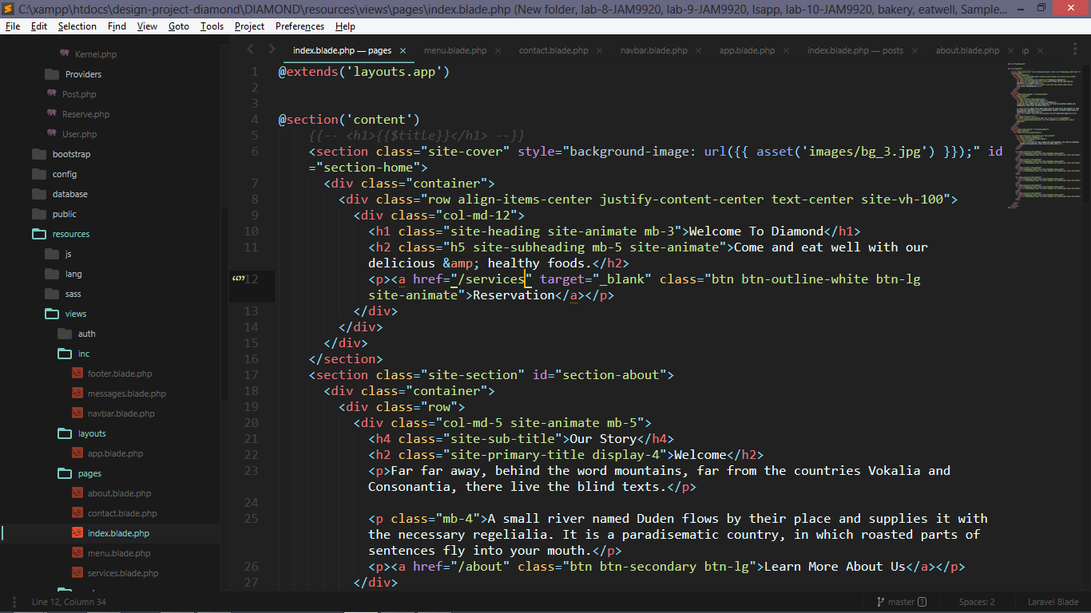this is index landing page and shows up if some is going our website 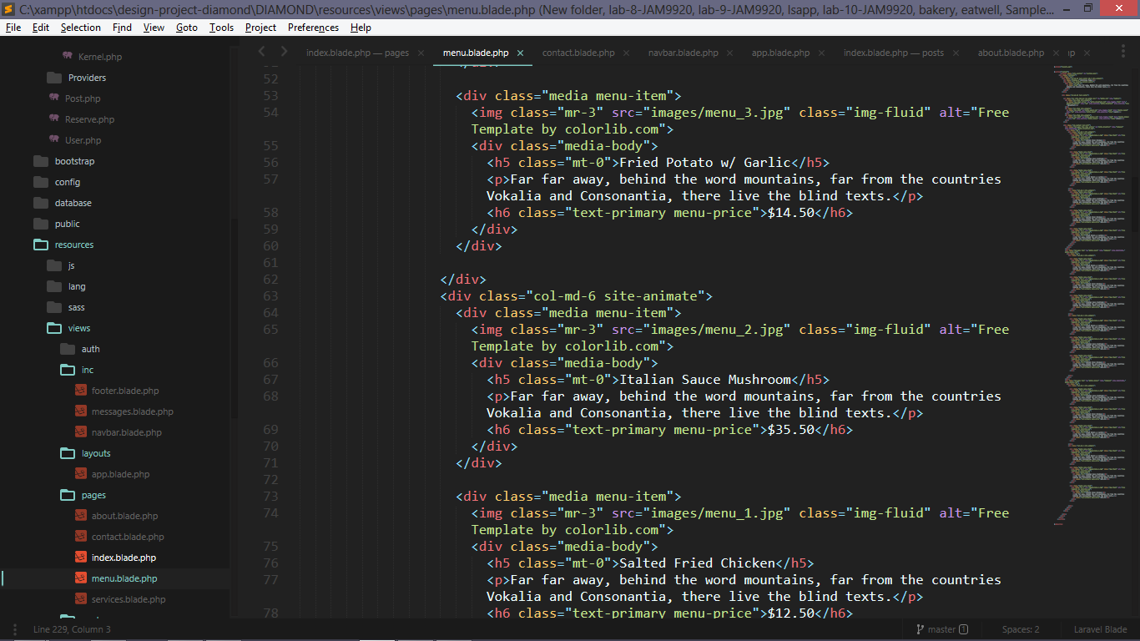this is menu page and shows our menu list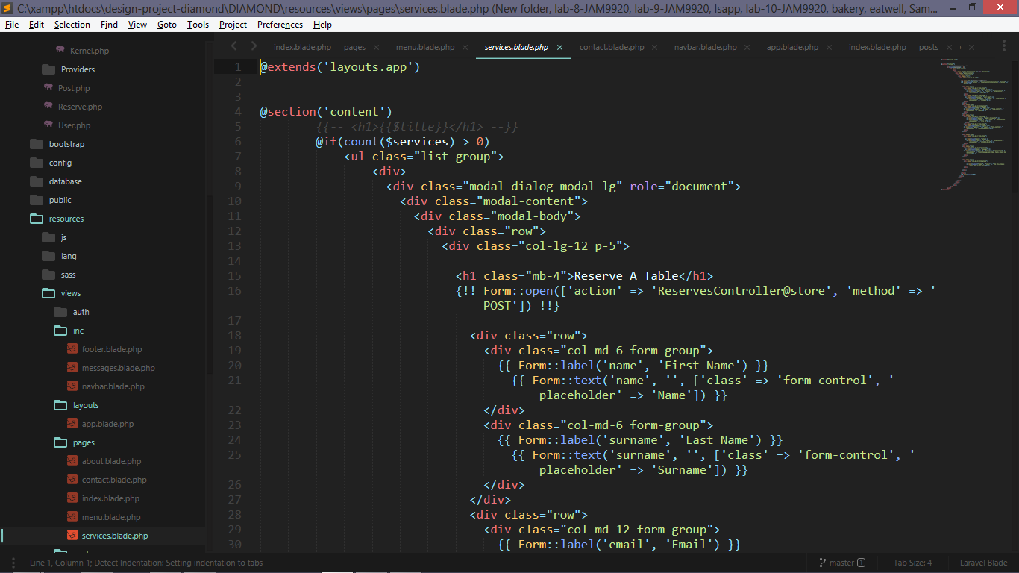this is services page and it contains reservation form requests from our clients 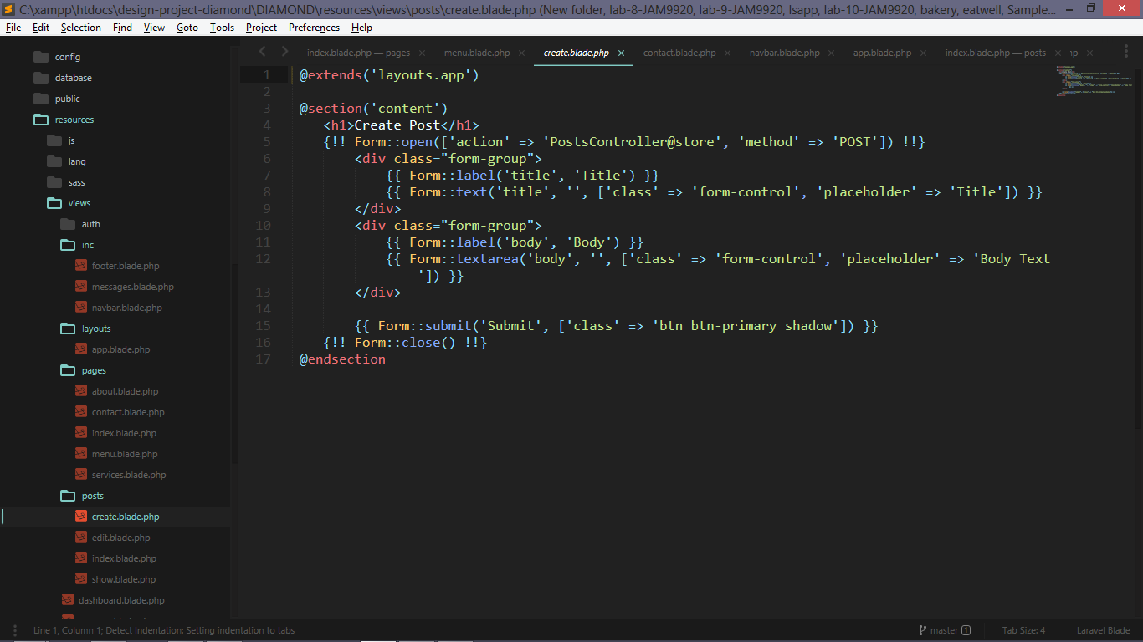this create page for admin posts 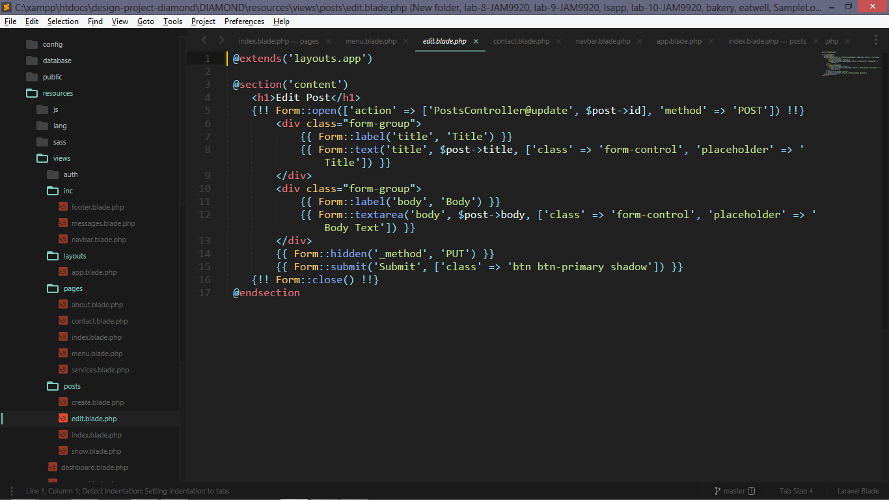this is edit page for admin can change his posts 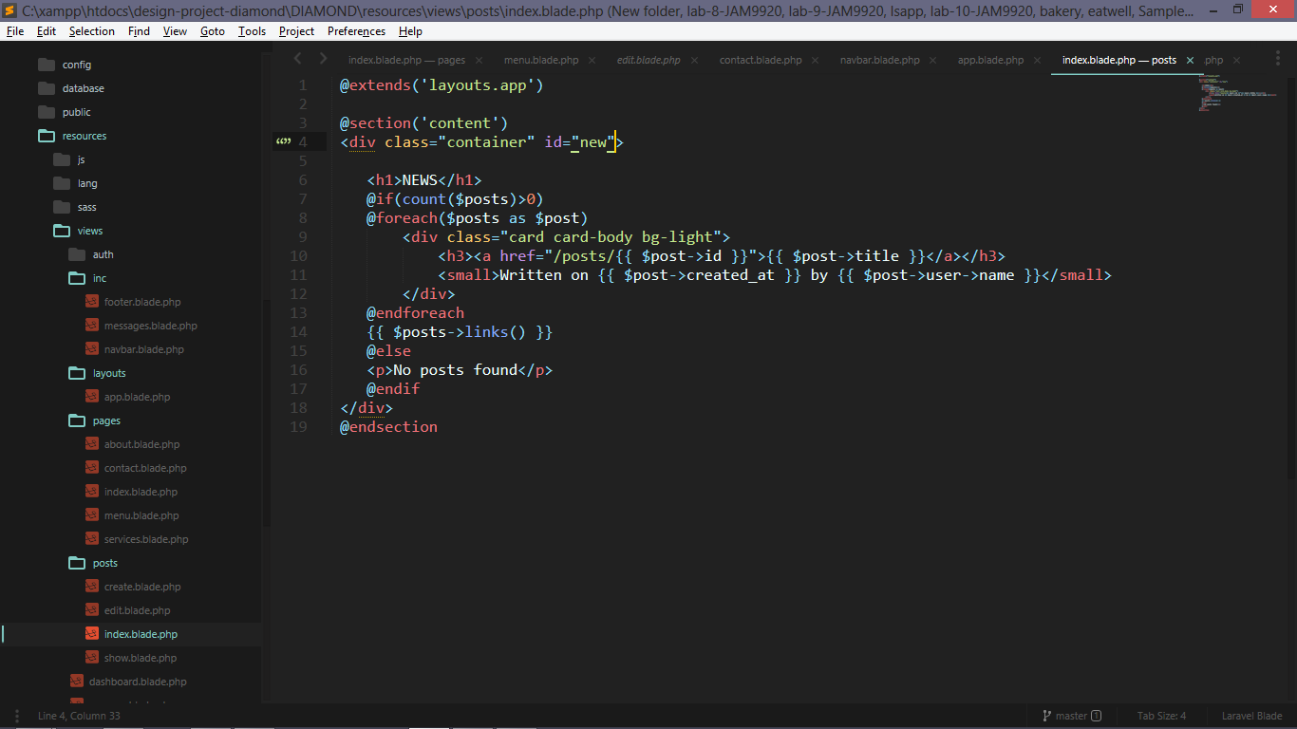this index page for posts sent by admin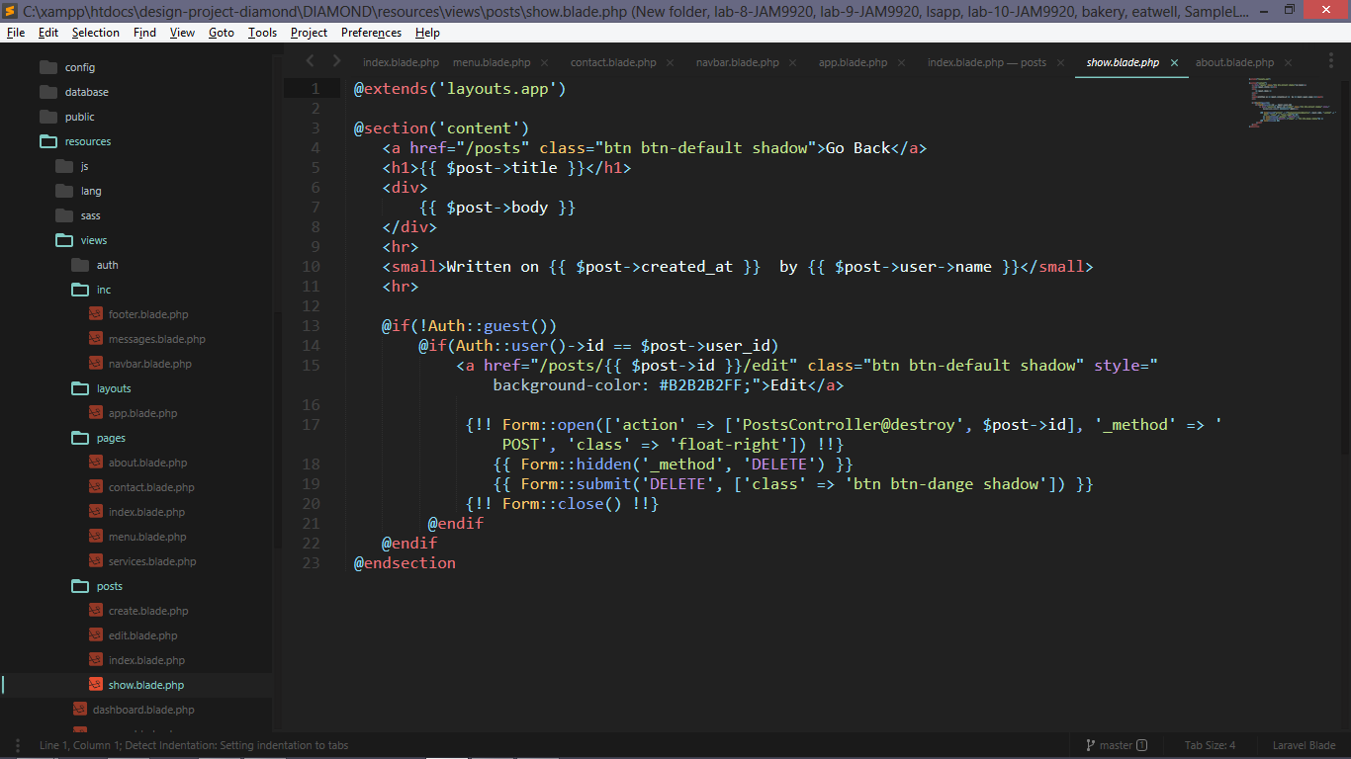this is show page and shows post details if one post is clicked 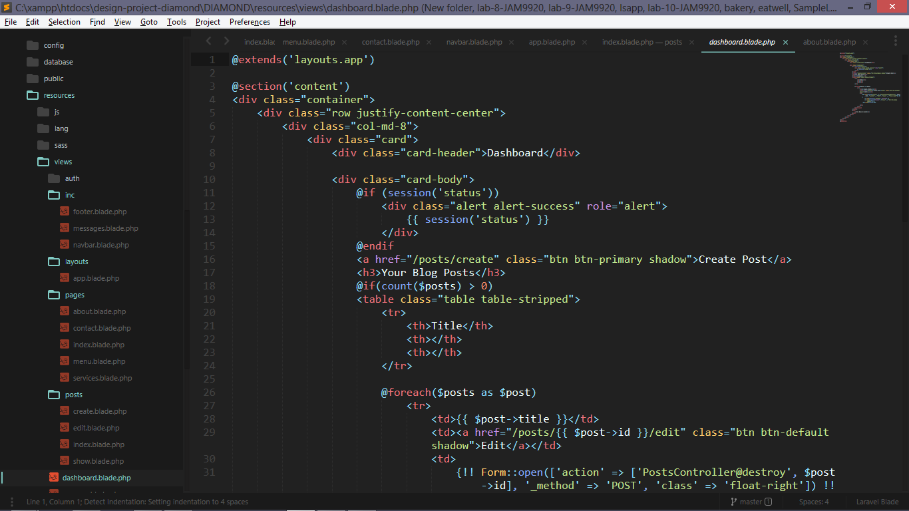this is dashboard page shows posts sent by this loged in admin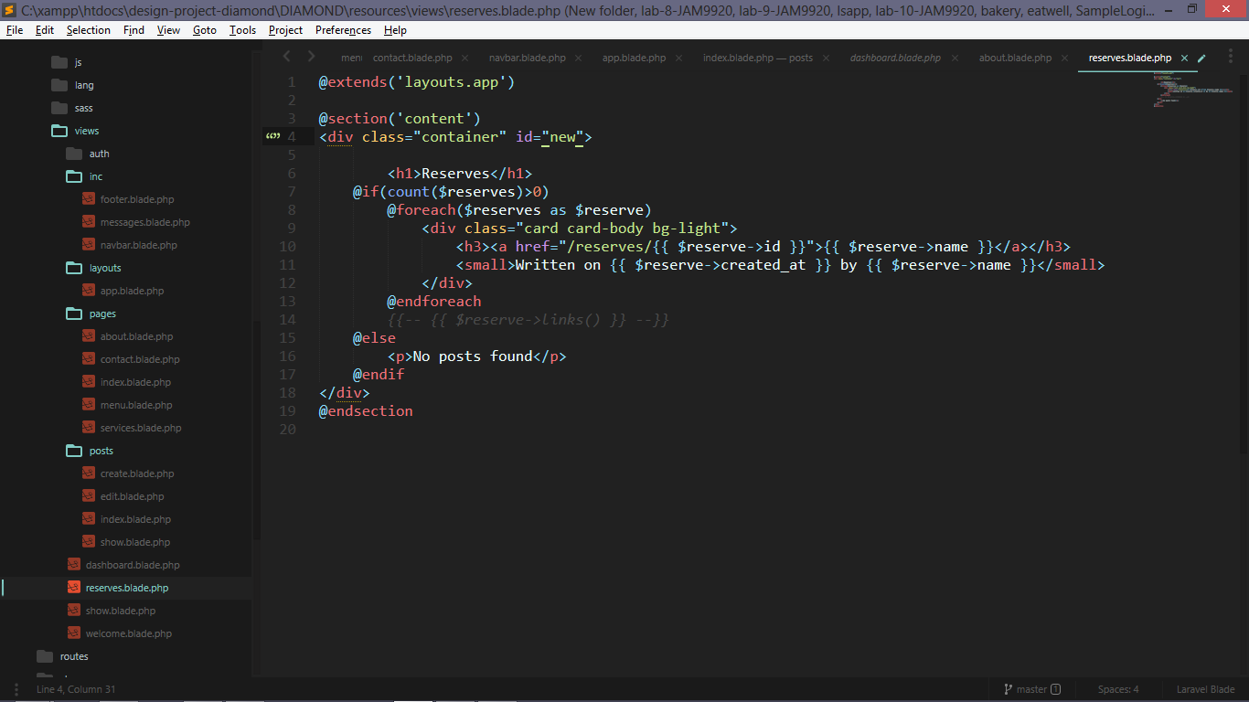this is reserves and only admin can see what reservations sent by users 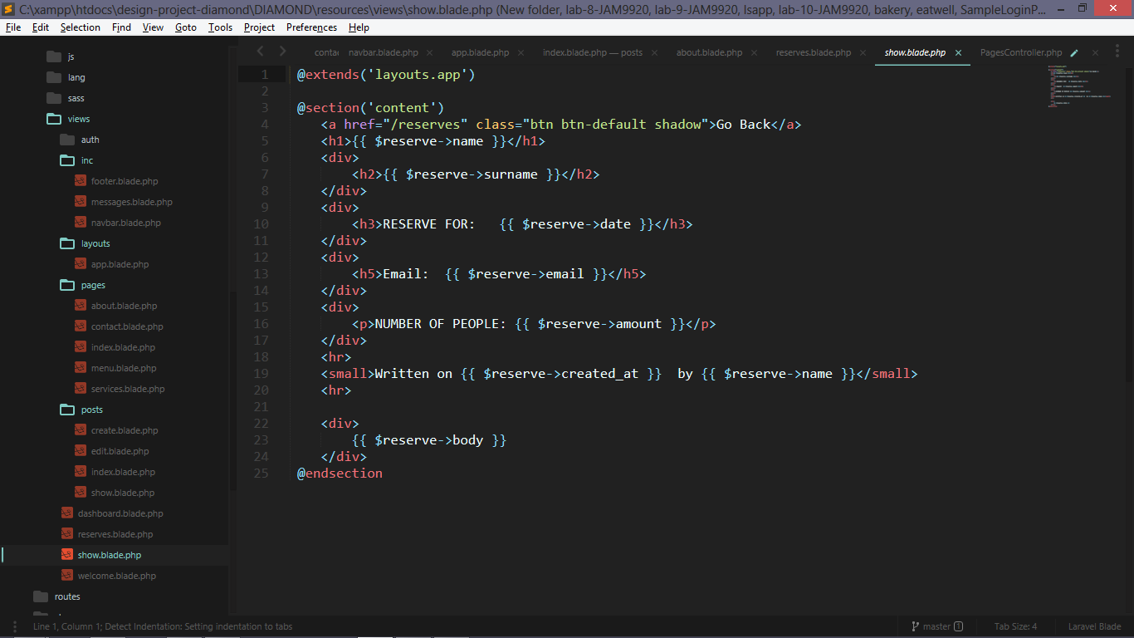this is show page and if admin clicks on 1 reservation requests , this will show reservation details 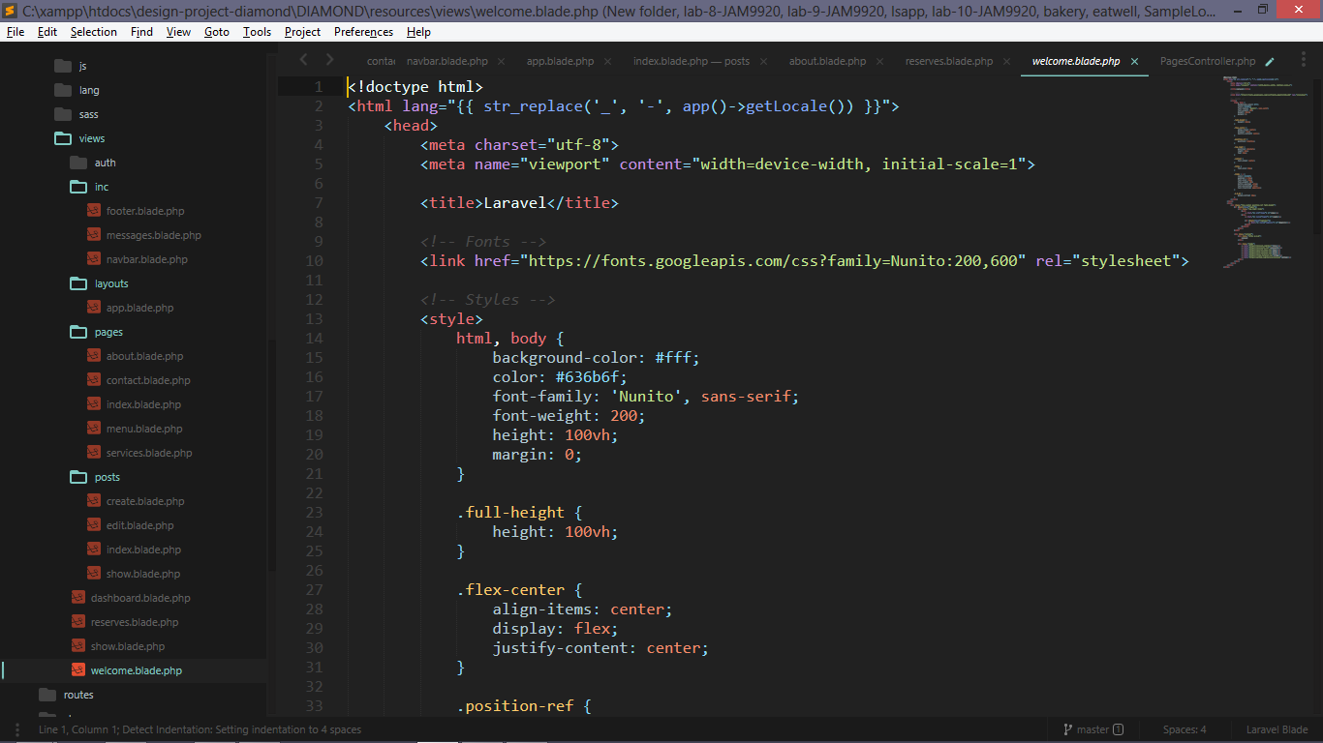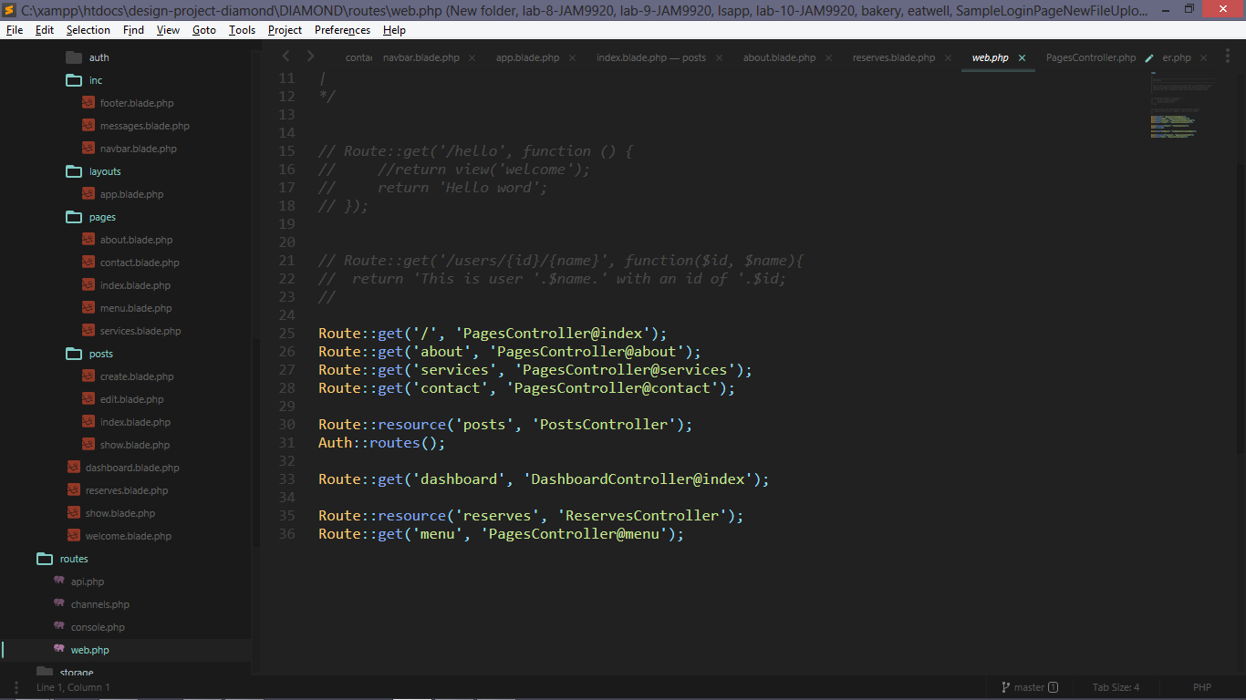this is web.php and here is given all links where there is goes and with controller it is controller

Login admin

Mail: [aaaa@mail.ru](mailto:aaaa@mail.ru)

pass: aaaaaaaa