**Name of Company: " Добрый Мастер"**

This company performs refrigerator repairs for the top refrigerator brands, makes, and models. No matter the make or model, our refrigerator repair technicians are qualified experts in fixing all major refrigerator brands.

**Made by students;**

Name: Akmalkhon Akhrolkhujaev ID# u1610018

Name: Sakhobiddin Zayniddinov ID# U1610198

**Links;**

https://github.com/iuthub/design-project-dobriymaster.git

https://dobriymasteruz.000webhostapp.com/

**" Добрый Мастер"** is your best, most-trusted option for refrigerator repairs and maintenance. With technicians that are highly skilled, vetted, and guaranteed to fix all of your refrigerator repair needs, we are your best choice for any refrigerator repair, no matter where you bought it. Rest assured that we are experts at repairing the appliances in your home.

**What types of refrigerators does " Добрый Мастер" repair?**

It repairs a broad range of refrigerator types and sizes, including:

* French door refrigerators
* Garage refrigerators
* Wine refrigerators
* Side-by-side refrigerators

Refrigerator fixes may vary by type of the refrigerator. Common problems with French door refrigerators can include leaking and malfunctioning of the water dispenser and ice makers. On the other hand, wine refrigerators need to stay at optimal temperatures and occasionally don’t have consistent temperature levels as much as they should. Refrigerators used in the garage must endure a wide range of temperatures, working extra hard to keep contents cool in the summer and running properly during cold winter months. When your garage refrigerator is giving you trouble our local repair technicians are ready to assist. Give our refrigerator repair experts a call or schedule your refrigerator repair appointment online.

**What are some common problems with refrigerators that need repair?**

Some of the most commonly repaired refrigerator problems include:

* The refrigerator is making strange noises
* The door seal or door gasket is torn
* There is a leak in the refrigerator
* The refrigerator is not making ice anymore
* There is frost buildup
* There is no water in the dispenser
* The refrigerator is using too much power
* The refrigerator compressor is not working

Of course there are other problems that can, and do, occur with refrigerators – if you’re having a problem that’s not listed here, you can always make an appointment with a highly trained, local

**" Добрый Мастер"** refrigerator specialist. Our local technicians are always near you – we come right to your house.

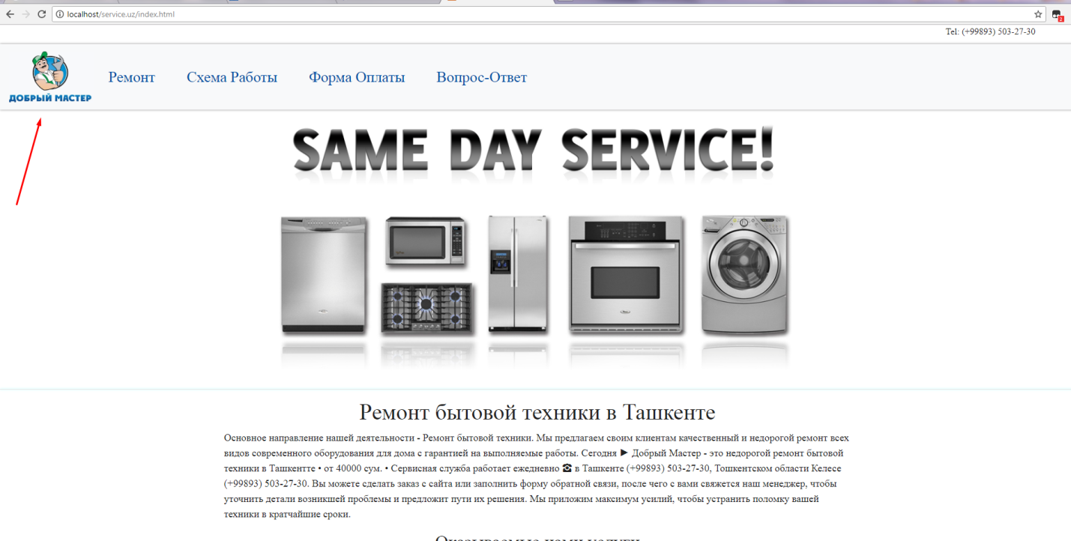

This is a index page of our web site as you can see our logotip. In the index page it clearly understands to the peoples about our service center. In all pages wer used Bootstrap 4 components like navbars, forms and others.

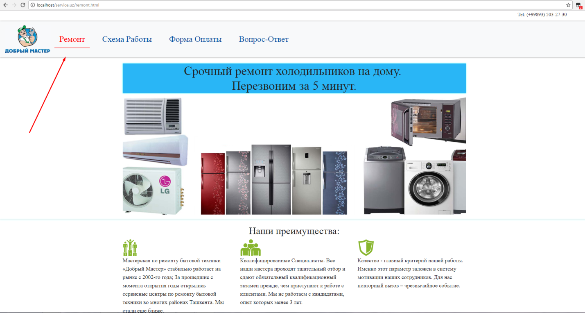

Second page of our web site is "Ремонт" page here customer call our experts at repairing.

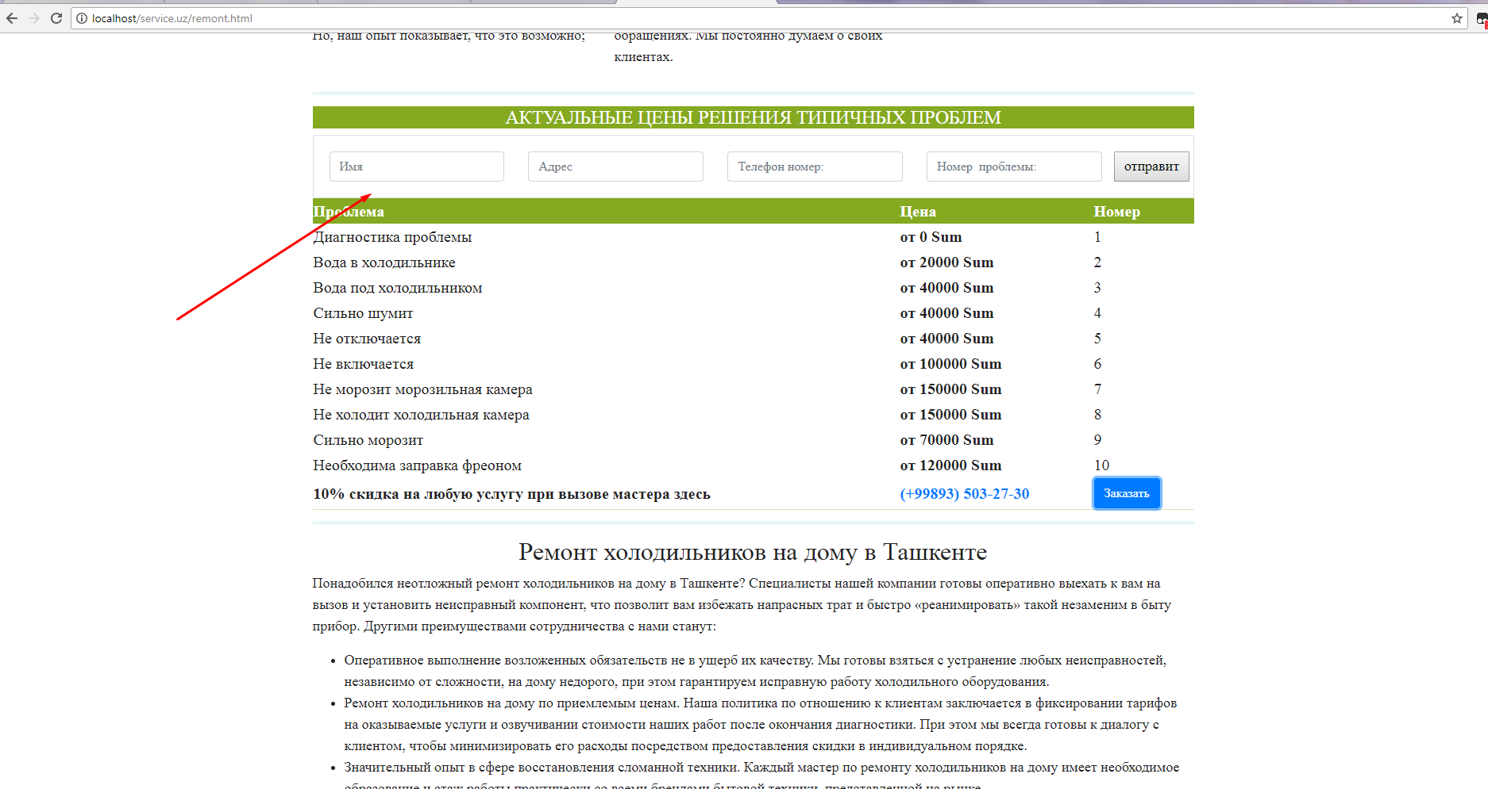

Here customer enters his name, living state, telephone number and problem number which he chose from problem table. the info will be sand to the database "name service table zakaz" and data will transferred from database to admin site. And after 5 minutes our experts recall.

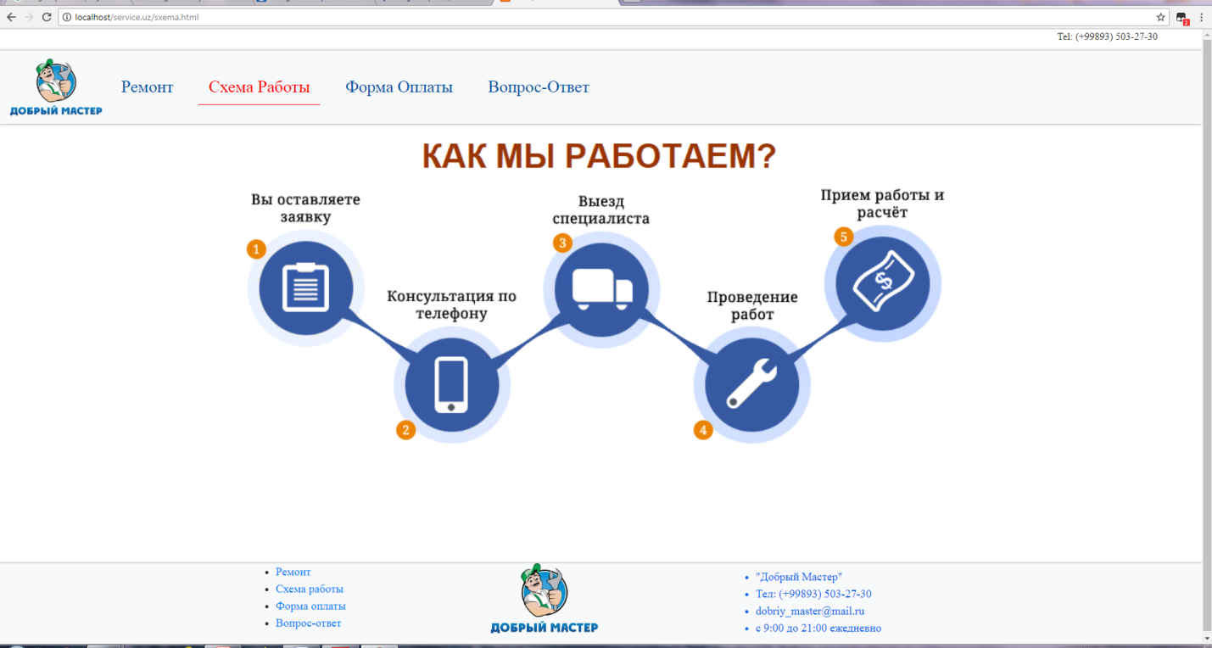

In the third page there has shown working principles;

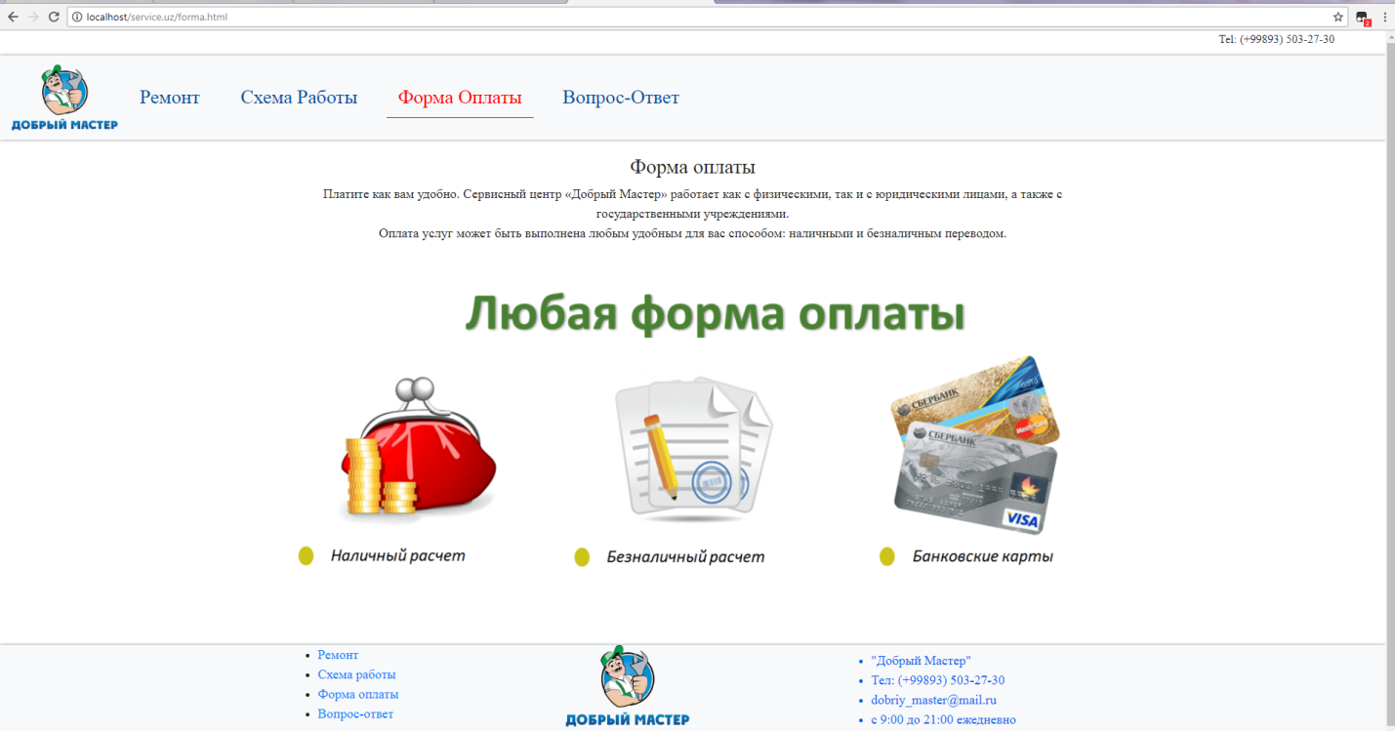

in this page gives info about payments.

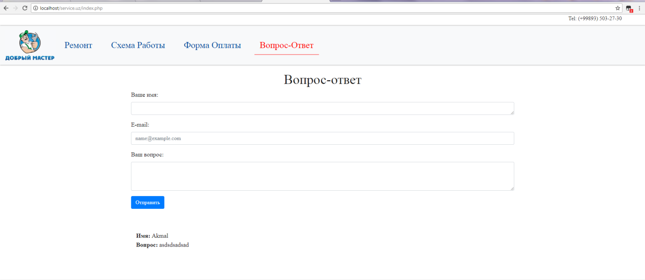

In the last page there is question/answer blog. Customer who wants to give his question first enters his name, after e-mail and last his question. This page made by using php script it sends the customers data and questions to the web server. In the style we used Bootstrap 4 (navbars, forms).

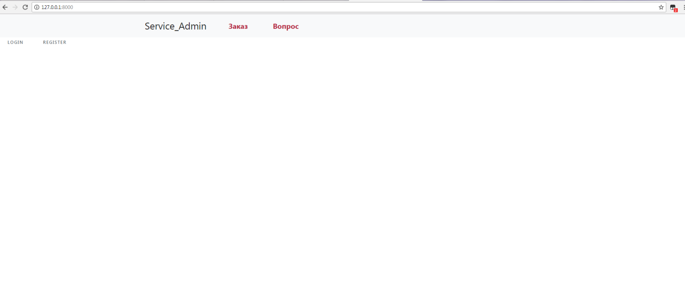

In Admin web page we built using laravel framework.

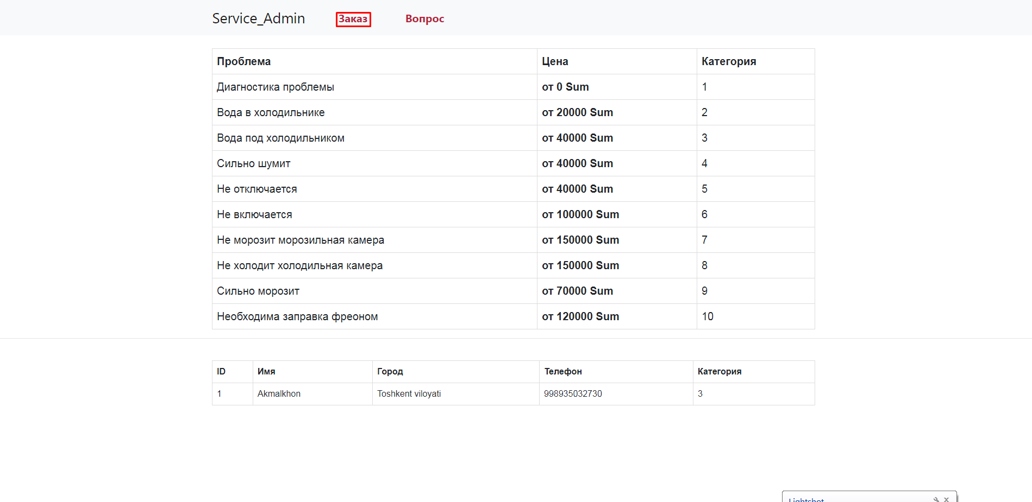

Here you can see exact table from customer calling with its categories. The information about customers get from msql database with name "service" and from table "zakaz" as you can see below

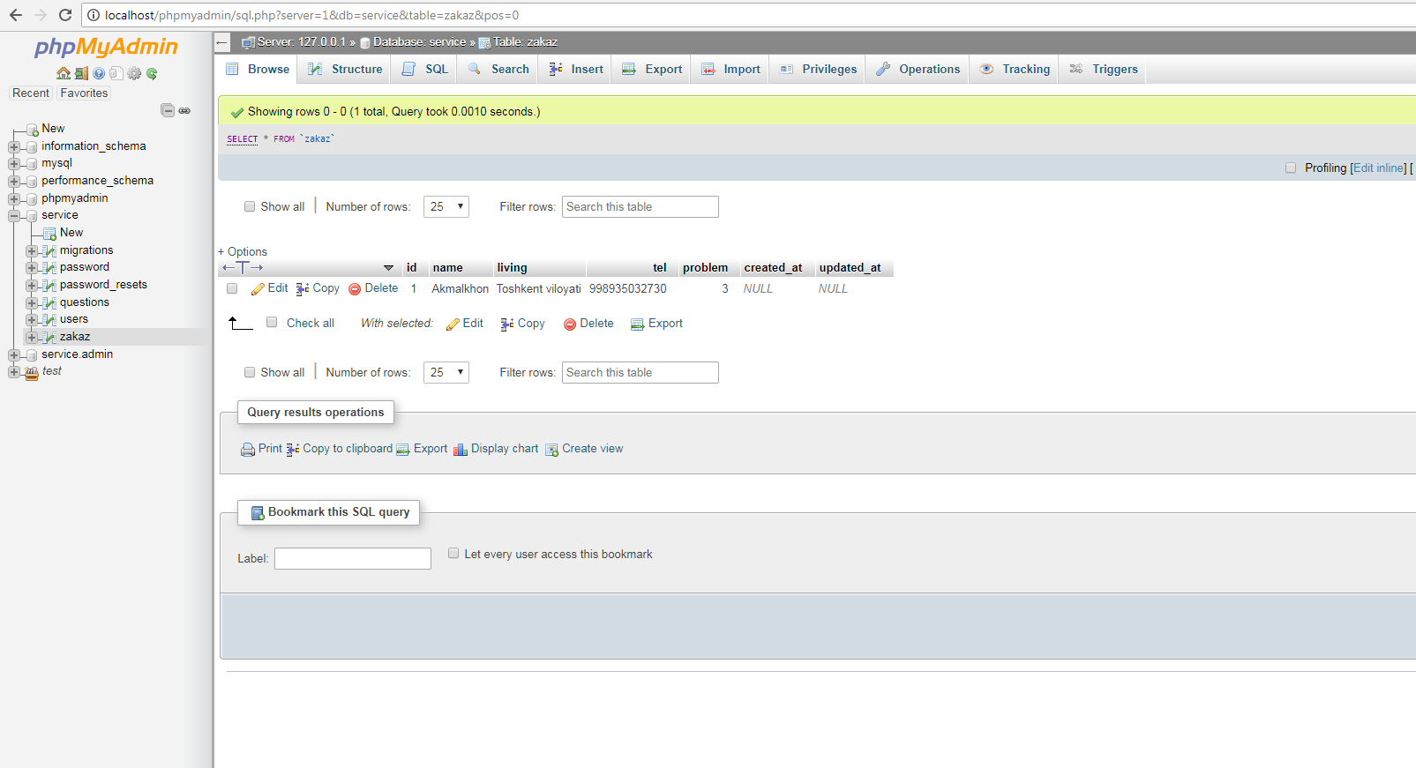

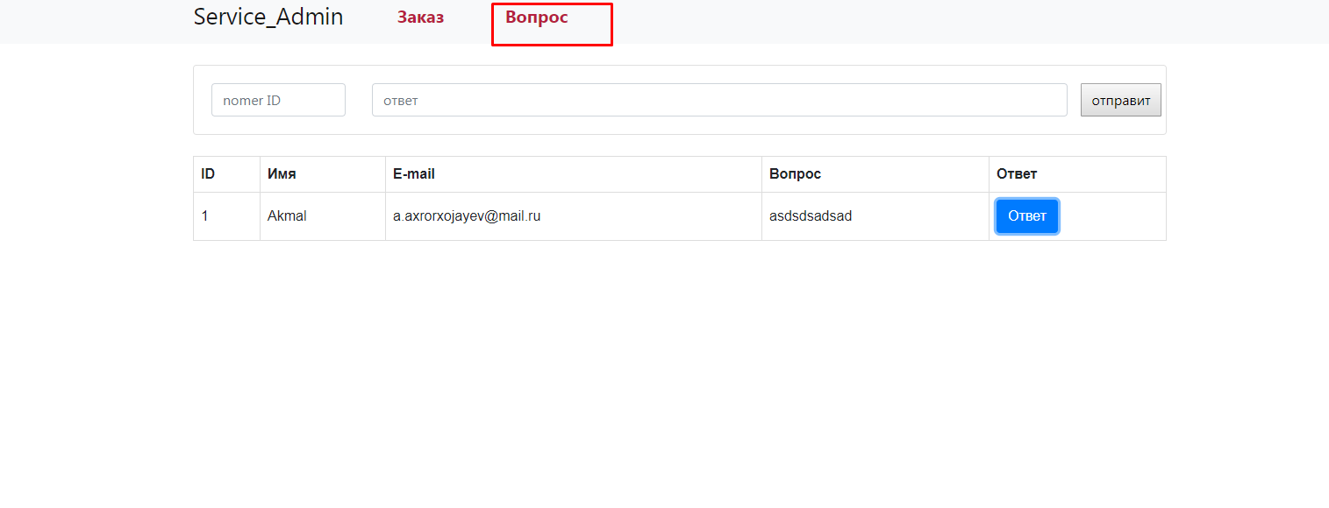

Here second admin page which gives question to our experts. There we use button answer with text areas. Admin will answer using question table and id table. In this page we have also used bootstrap 4 with components forms and navbars.

"We have bug in answer button we are able to connect to the database but not able to send data to the database. "

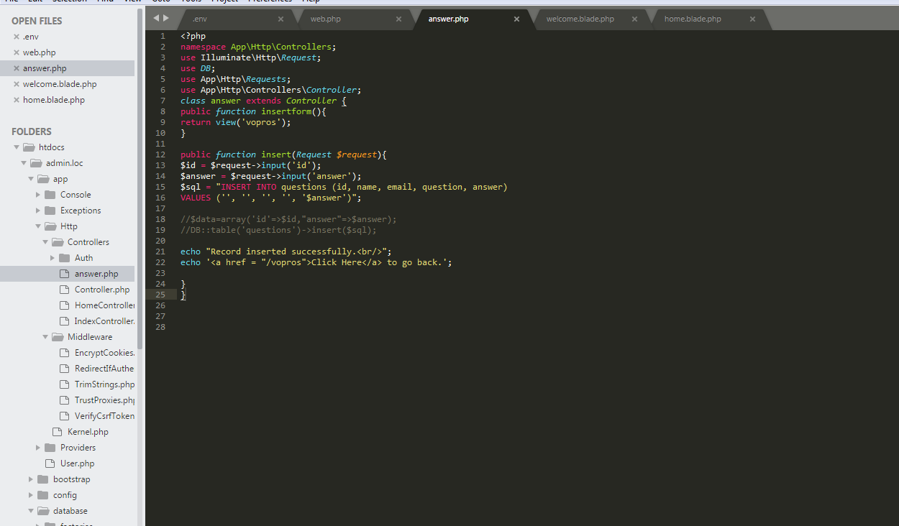

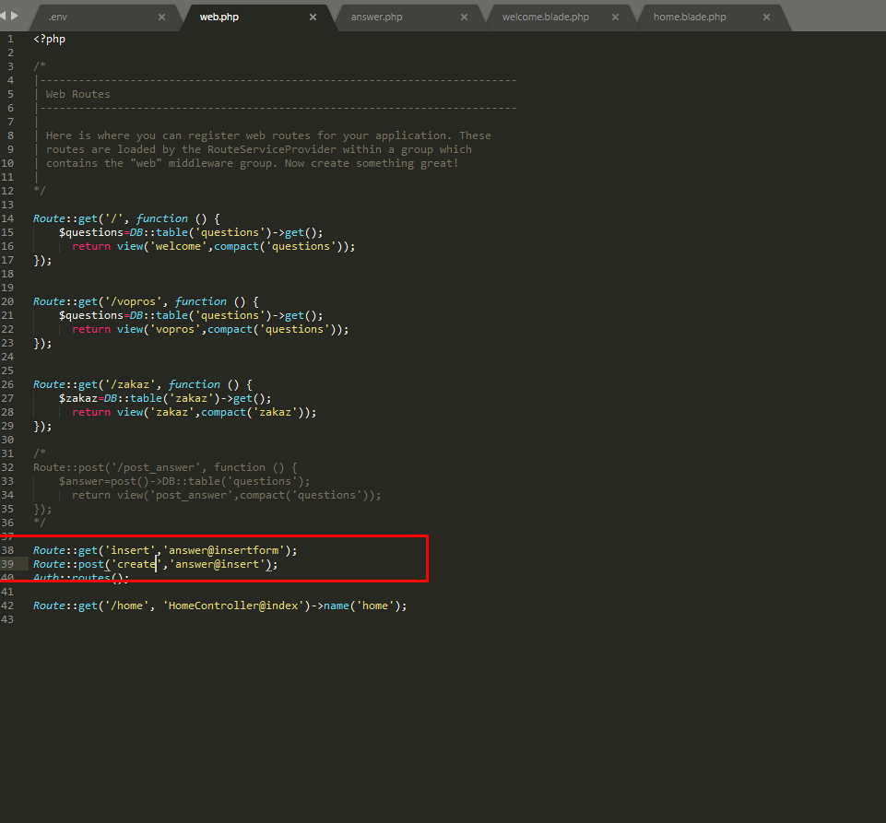

here you can see our connections and post method to the database.

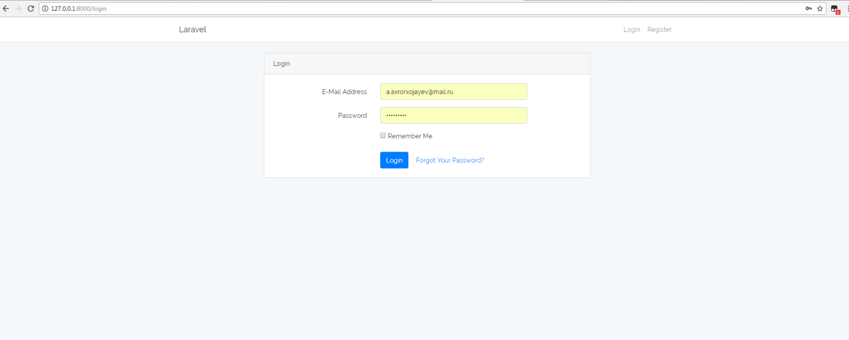

here you can see login using laravel.

We have one admin with

e-mail : a.axrorxojayev@mail.ru and parol: wolf-1996