

**Company Name:** NovaShop online shopping

**Team Members**:

**ID & Name**: U1610186 Ramazon Kushakov, U1610165 Navro’zbek Khalimov

U1610125 Lazizbek Qahhorov, U1610102 Kamoliddin Ochilov,

U1610238 Sultonbek Bokijonov, U1610221 Shamsiddin Toshmirzayev

**Problem and Our solution for that:**

Todays, there are lots of people in online web store who have difficulty in ordering products among cities or even countries like exporting...

Firstly, he will have to go to the center of his product and buy them on their own. This makes people get problem with truck-cars, finding an easier way to get there with safety and so on.

So, by the help of these problems between online store, we made the project based on shopping. Our web application project helps people ordering with clearly and cheaply rather than going there to carry by themselves, Servicing to receivers is quite solved in any possible cases. It doesn't have difficulty in recognizing the owner of product ordered. Our objective is to provide people with all kind products they ordered, among countries, region or cities.

**Requirements like that:**

To sum up all problems, we are going to specify mainly online store management system tables.

Briefly, Introduction looks like that Our online shopping databases include Office which all managers work there, Some Managers working in each office, booking who works for manager and take order from them,

Receiver who is ordering product by online and waits for booking

In overall, our **entity objects** from our projects include:

1. OFFICE {**attributes are**: officeName, address, city, phoneNum, officeWorkingTime, ContactPerson}
2. OFFICE_MANAGER {**attributes are**: OfficerName, password, address, email, phoneNum, office, registrationDate}
3. PRODUCT {**attributes are**: id, consignment_no, ship_name, phone, ship_address, rec_name, rec_phone, rec_address, product, weight, quantity, book_mode, arrivingType, PickupDate/Time,Status, servedBy, History}

By the help of these objects, we made the physical design of our project. Above the entities, we didn’t define some **sub objects** like UPDATING, DELETING, MARKING, EDITING and some.

**Briefly activity roles:**

Main-Office manages all branch offices by confirming office-Name, ….. (attributes of Office)

While Managers are dependent on branch office. They register an order with all product details and unique consignment number and hire their online shopping to get the product to the destination. Here, Consignment number makes a relationship between shoppers and receiver.

After A client (Receiver) ‘s completing all necessary details that he needs

**Screenshoots of all:**

index.php roles as a main page for all the time with different options.

In bottom side, there are some news introducing types of services related on couriering management system as well as the information about contact details and comment sections.

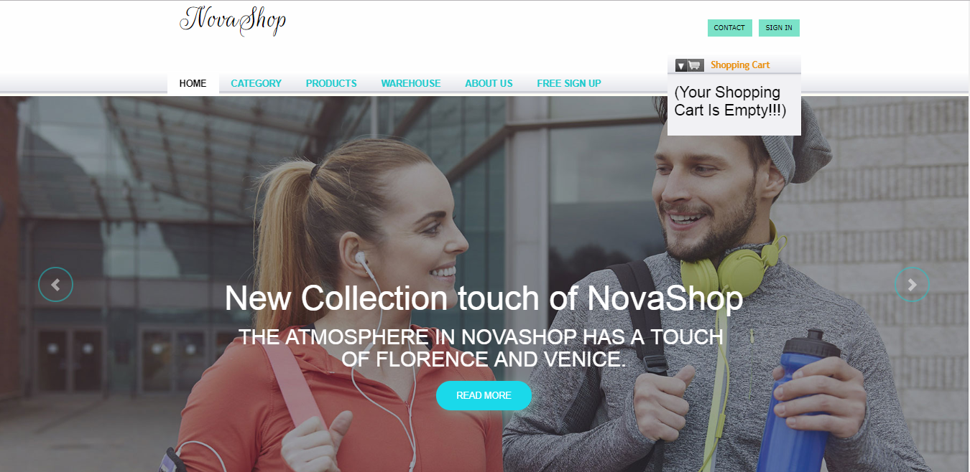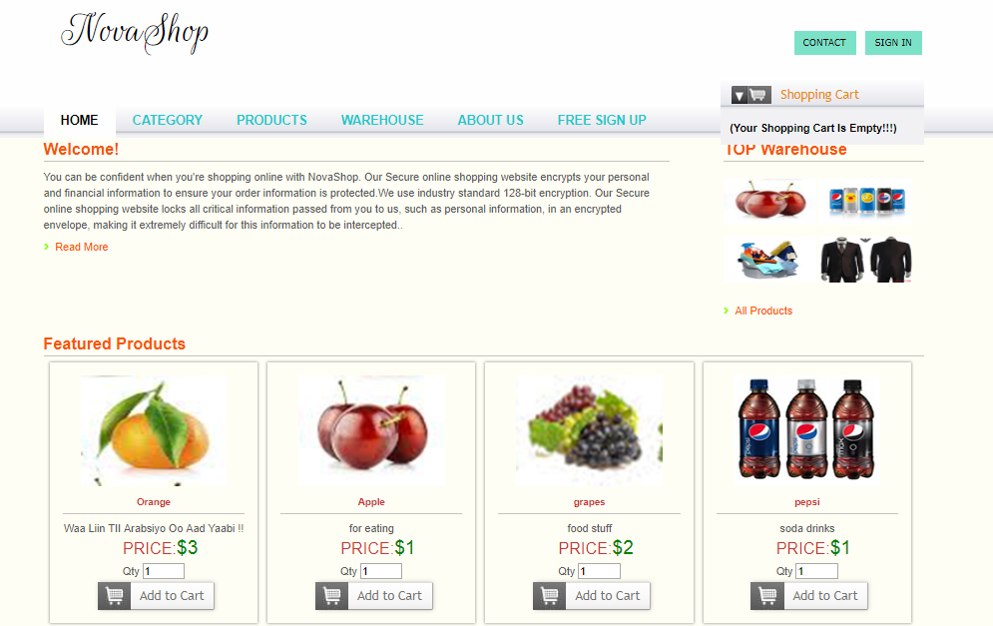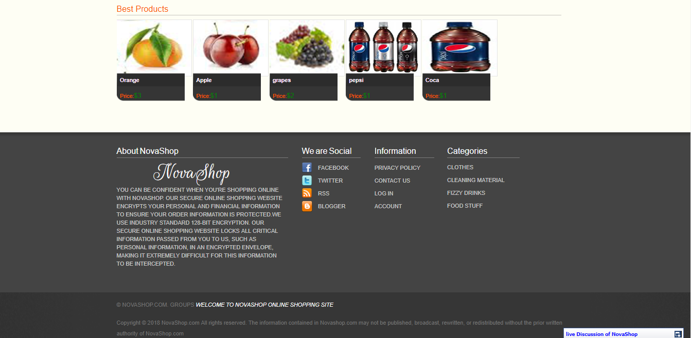

Main page is in the left corner of index.php. welcome to main page.

This is product page. On this page you can visit many options

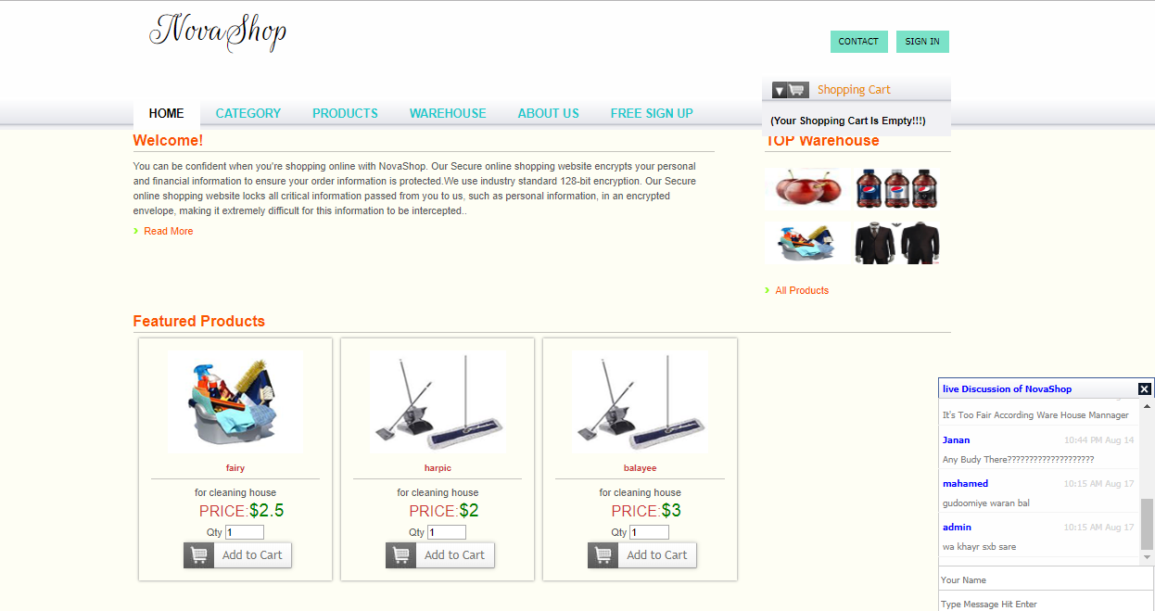

On this page we can see about page of all members,

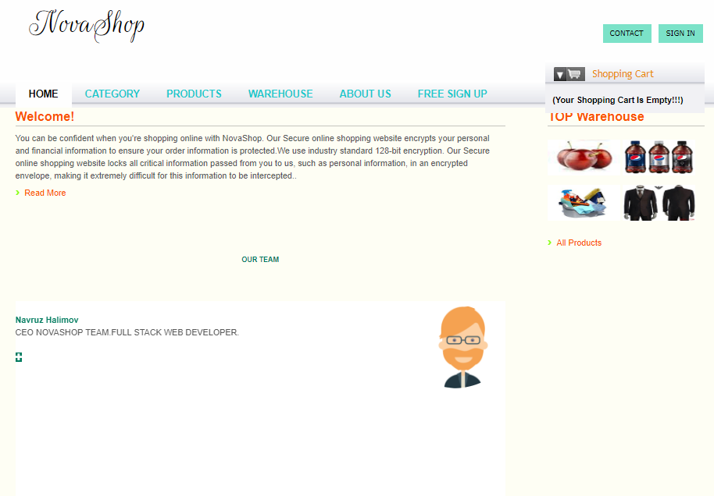

This page is registration part for all users

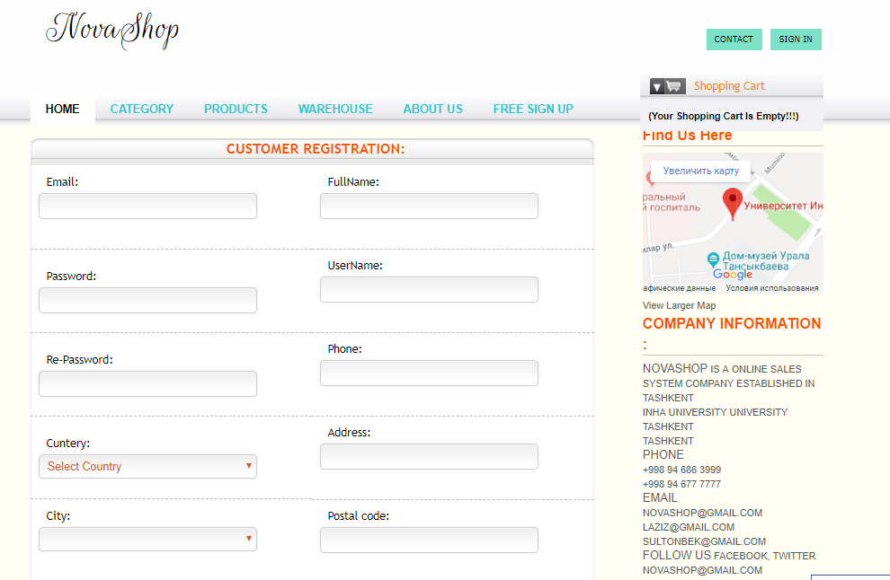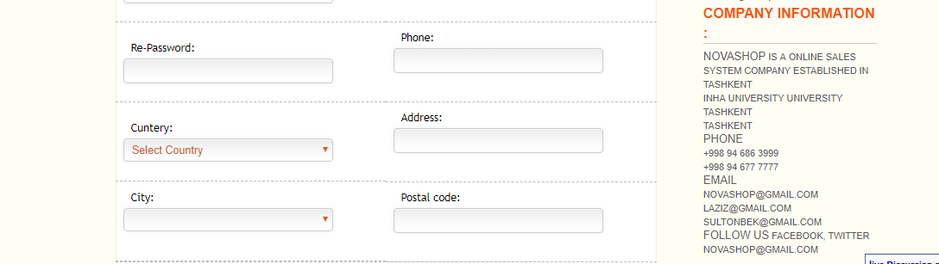

This is admin page for only admins

In this part, Admin can manage all number of branch office, can add manager for each office and give password them to access their user Menu in web application. We added some menu option like Page 1-3 in case of future requirements. As you can see, Report menu has 3 types of information. In User Panel, only 2 of them (Datewise and Delivered) are shown. But in order to improve the stack overflow, we added Deleted report. The other users just update products and delete them. So, in main office, director can take a private date which was deleted and by whom.

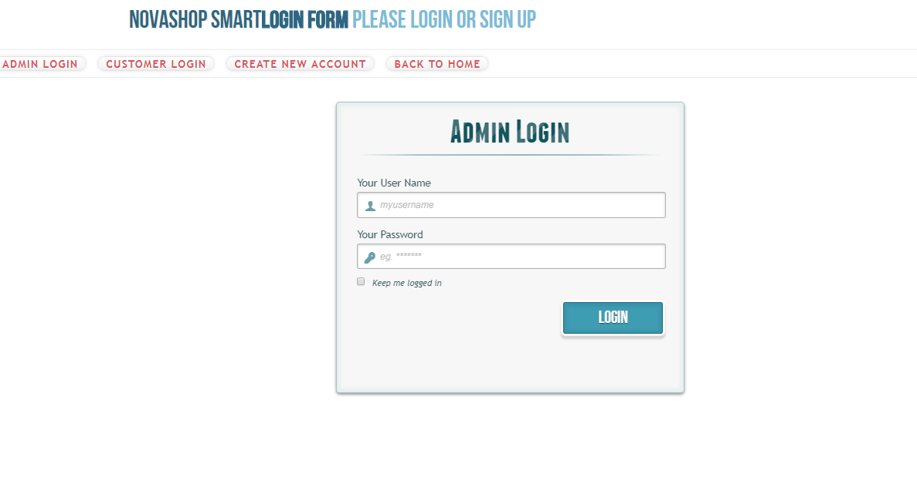

Admin adds New Office in these details order by confirming step by step.

Here, Admin can find out all Office Details that he created and also export to Excel sheet.

Like the previous one, it’s a page of adding managers for each branch office that admin created.It's having a list of all manager details in this page. When using from Reports, admin can see the all deleted product with its details and about which user (manager who works for branch office) deleted it. This can be also shown in main page and user page. The advantage of this, even a shopper can see the necessary details about his orderings and receiver’s destination according to consignment number.

After confirming consignment number, this page opens this information. As I mentioned in user panel, manager can use from this option in order to do the same thing online store does.

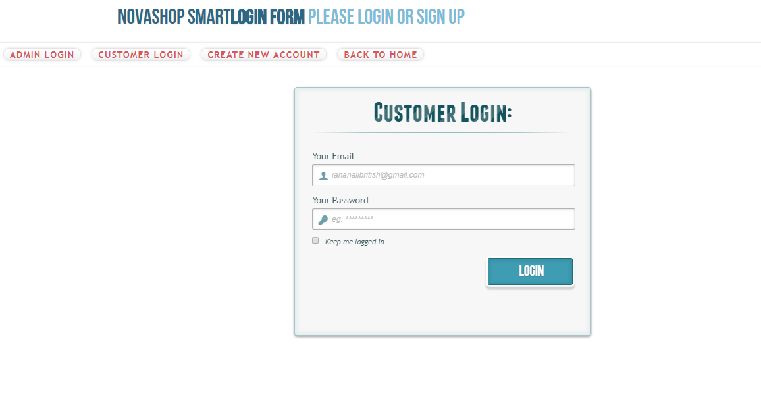

Here, It’s the view of User Panel beginning. In the bottom body, written security password, username and office-name

The brief explanation is that we are glad to create this web sites because this website helps people to buy easily on our website and receive products needs things for them

**URL** <https://NovaShop.tk>

**Admin-role**

**Username: admin Parol: admin**