**Internet**

**Programming**

**Design Project**

**Report**

**Company Name: E-Store**

**Our motto: Favourite brands and hottest trends!**

**Team members**

**Name: ID:**

**JavoxirBuvanazarov U1710046**

**AzizbekBekmurodov U1710106**

**Ozod Tagoev U1710010**

**SafarmurodMusulmonov U1710138**

**Link to Github Repository:**<https://github.com/iuthub/design-project-jaos-dev>

**Link to Web Site:**<http://arzonuz.000webhostapp.com>

**In the beginning, we made a plan to create a website of ticket booking for airports and stations, but after a while we changed our goal and we wanted to create a site for shopping that is online shopping and we reached our goal. Our project is commonly for people who want to buy the newest brands of clothes, it is clearly seen also from our motto, however we do not develop it by pushing different kinds of new fashionable clothes, because we need a sponsor for developing our project. Butwe just made the scene of clothes, and it means it will be like that, if we found sponsor for this project. So, let’s come to the tasks of our project, we just count them one by one:**

**1)**

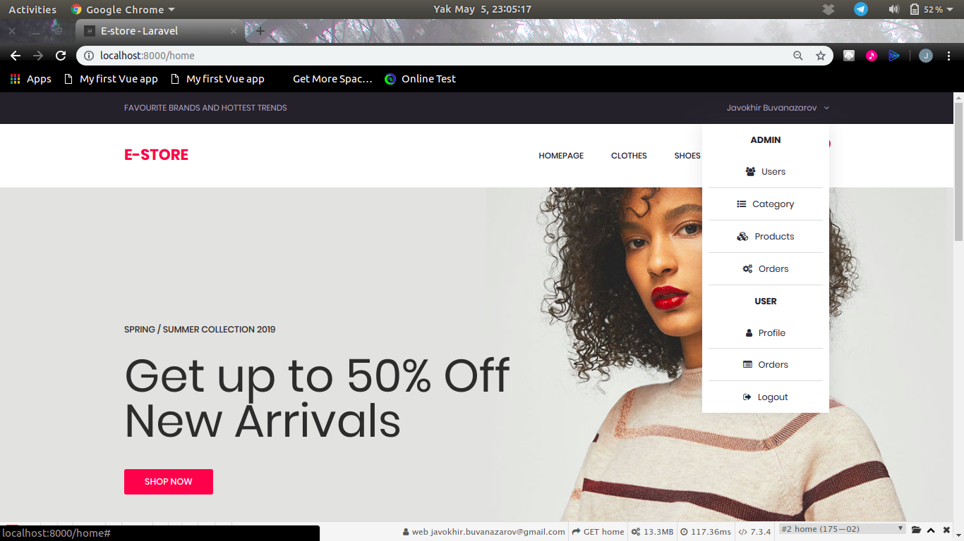

**Signing up as an admin**

**2)**

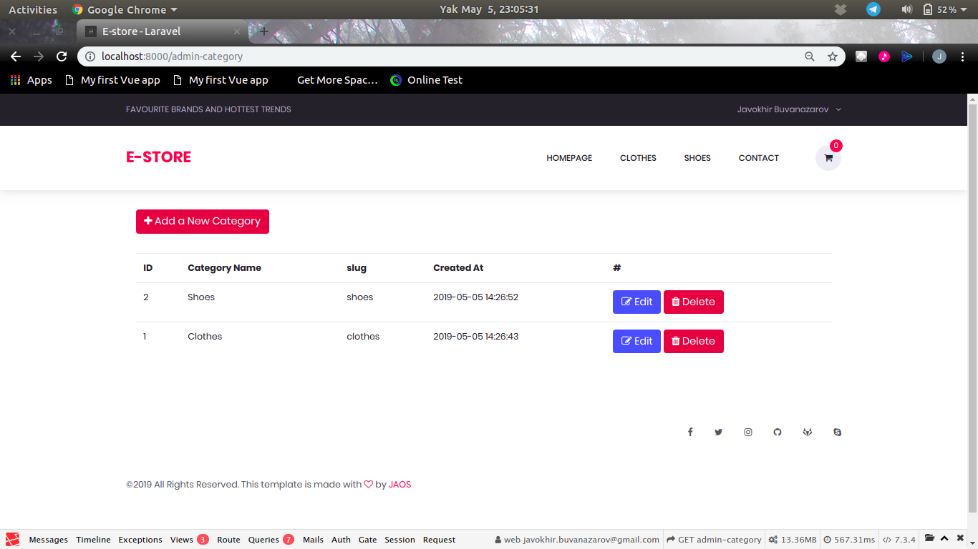

**Adding new categories to the products list**

**3)**

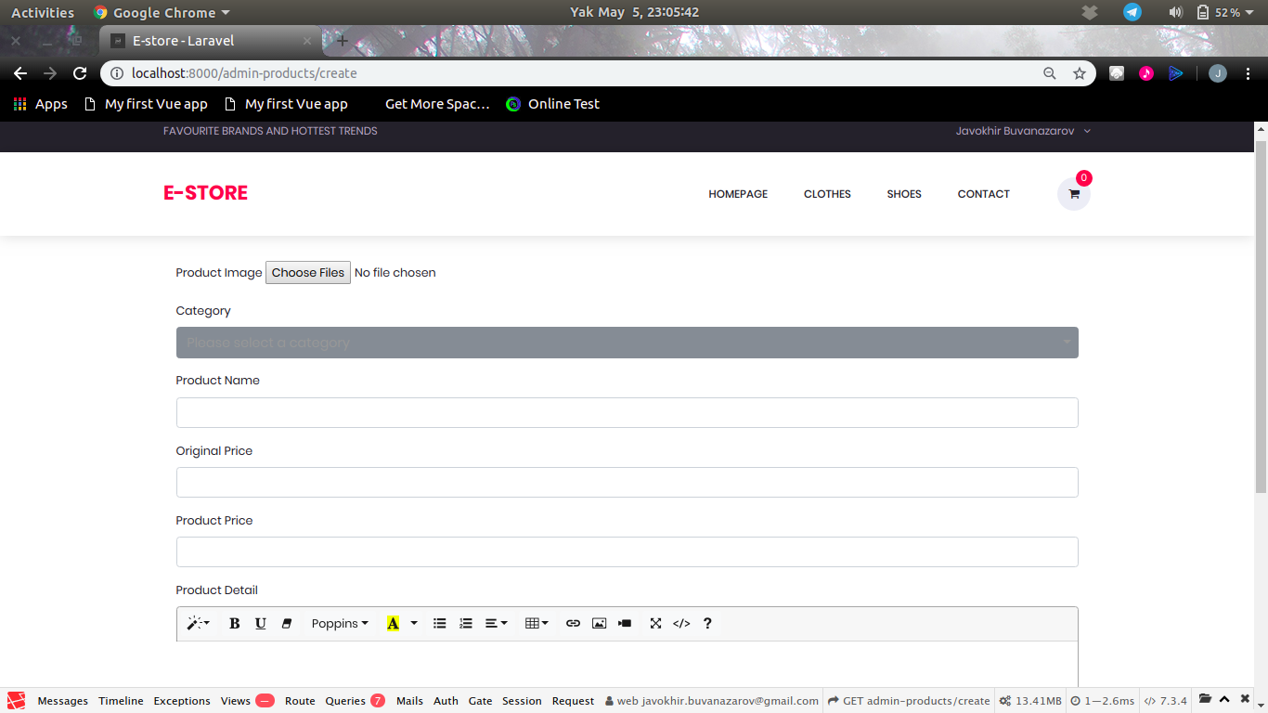

**Creating the images, prices, names of the products**

**4)**

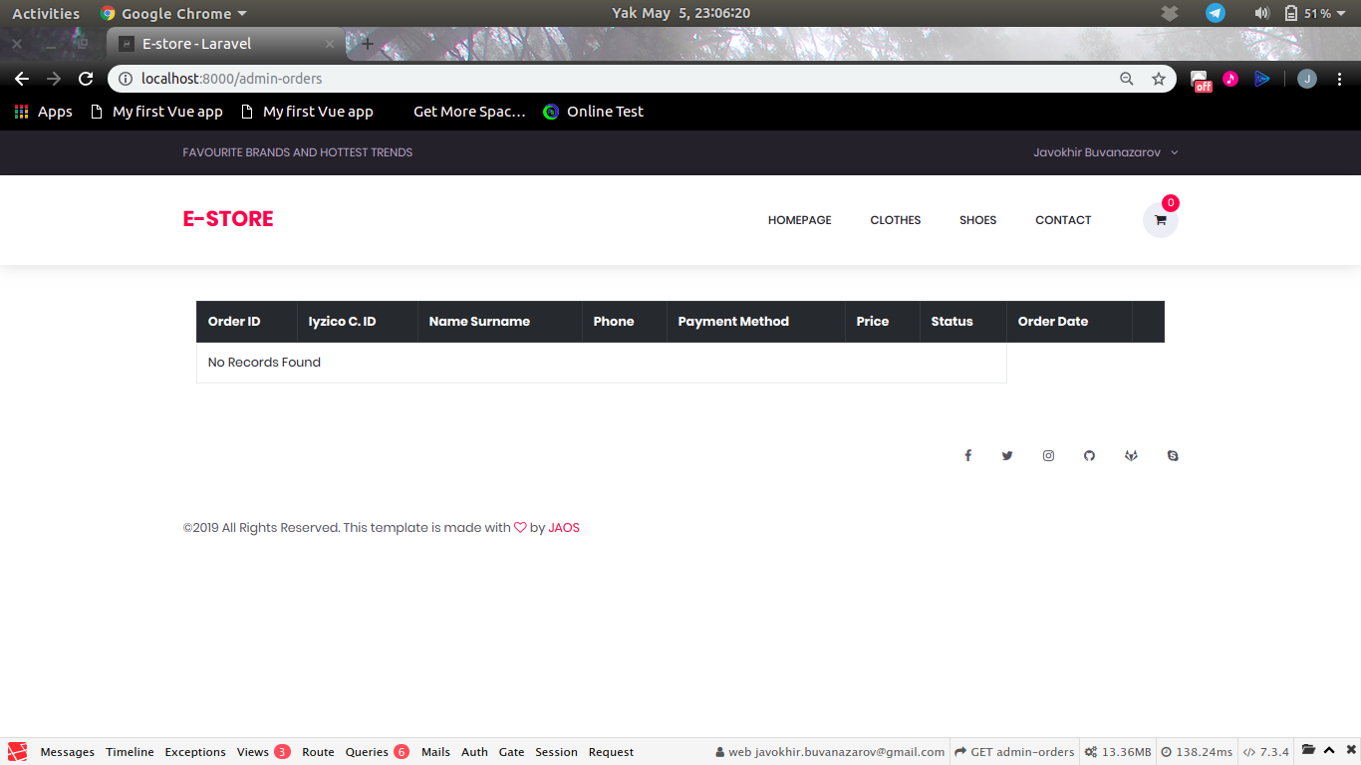

**If we order all records will appear here**

**5)**

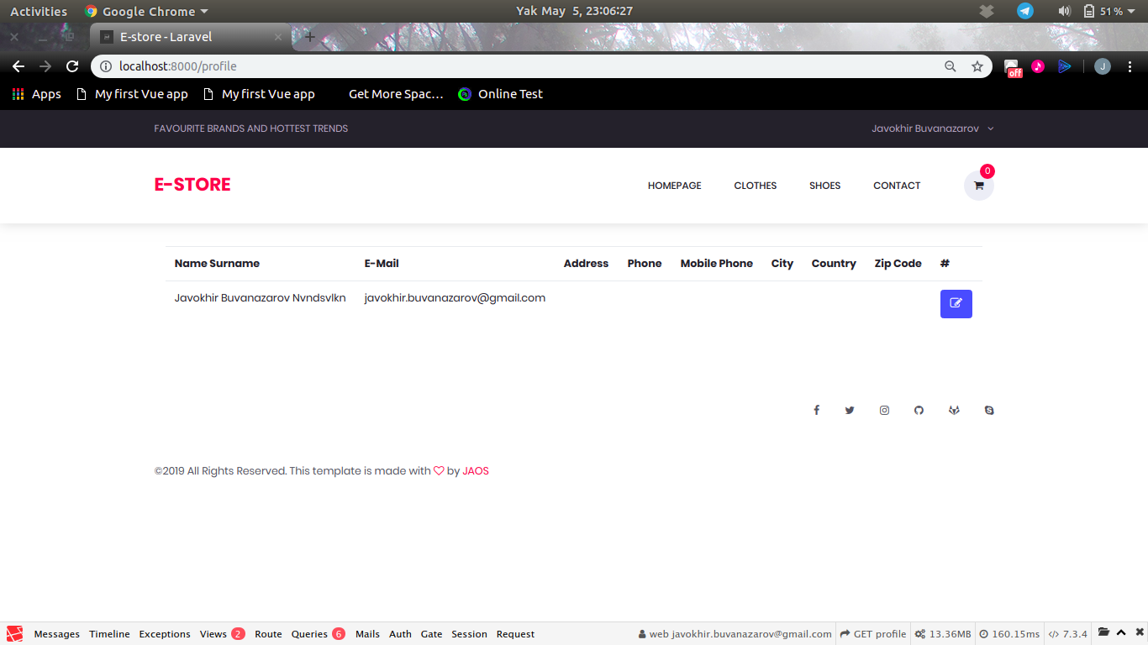

**Admin can see the list of users**

**6)**

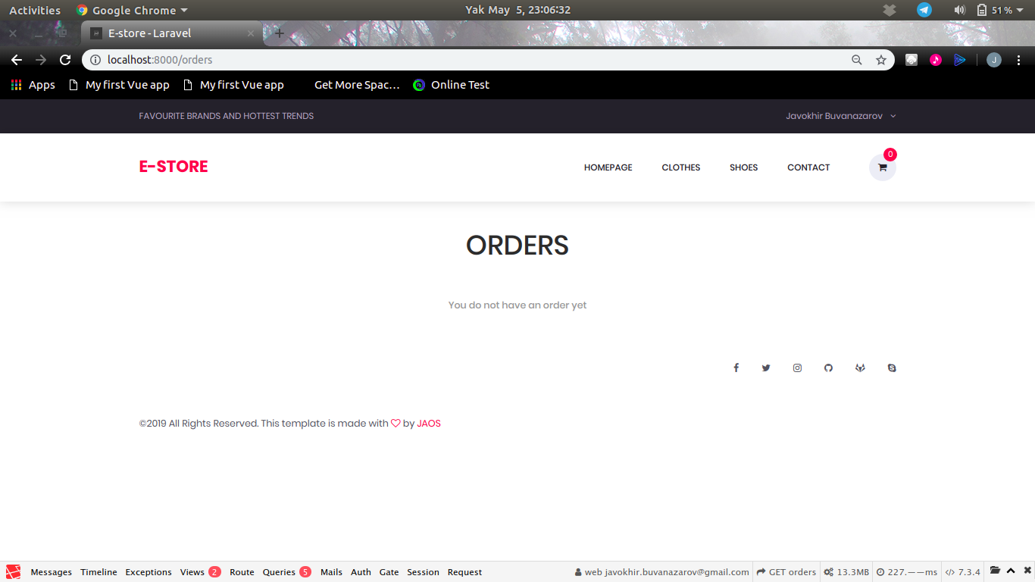

**It will show the number of orders**

**7)**

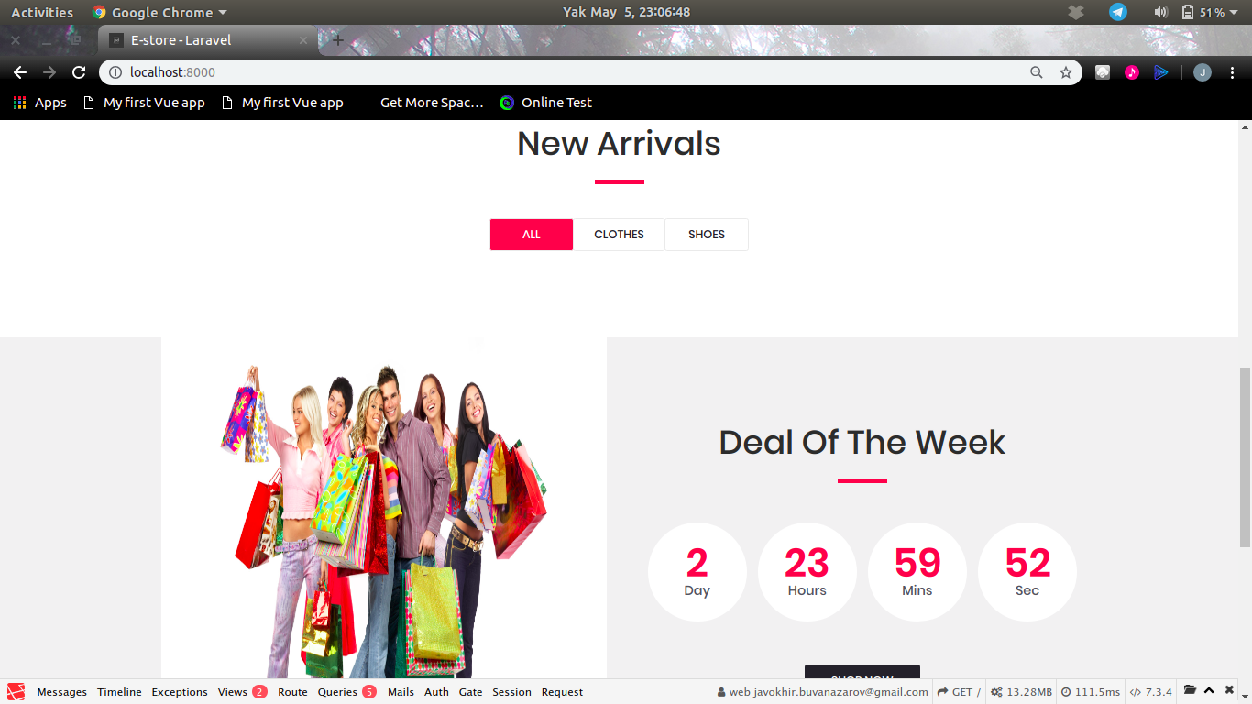

**The scene of our main page**

**If we talk about the contribution of tasks that members did like this,**

**JavoxirBuvanazarov and Tagoev Ozod: Front-end, Look and Feel, Content.**

**SafarmurodMusulmonov: Input Validation and Database**

**AzizbekBekmurodov: Back-end Framework and Hosting**

**Tagoev Ozod: Report**

**And now it is time to some logins and passwords:**

**k@mail.ru**

**12121212**