MODEST CO.

Highly curated and designed solely with men in mind!

Mukhammadyunus Tursunov u1610157

Rakhmatillo Topiboldiev u1610182

Mukhammadamin Naziraliev u1610150

Github repo link: https://github.com/iuthub/design-project-marghilan.git

Domen name: http://modest-project.000webhostapp.com

**Report**

MODEST Co. produces a variety of products for males aged 25 to 60. This company’s website is designed to provide customers with brief information about the company products and to provide the availability of online shopping.

The primary goal of this website is to promote and sell the brand apparel of MODEST CO. As, this company was established on September of 2017, it is new in the market of Uzbek Fashion. For the entry period, well-planned and effective marketing strategies are needed in order to increase popularity among target audience and gain as much as possible market share in clothing industry. Considering those facts, MODEST website was developed to attract new users and provide clear, easy to follow shopping scheme that will make users to purchase company’s products. Nowadays, only front-end mechanism of online shop is ready to present, but certain period is given to finish the project by developing back-end(server) side with payment and shipping procedures. With a help of online store company is aimed to reach stability in finance, management and to double its income for the following year.

**Functions and features**

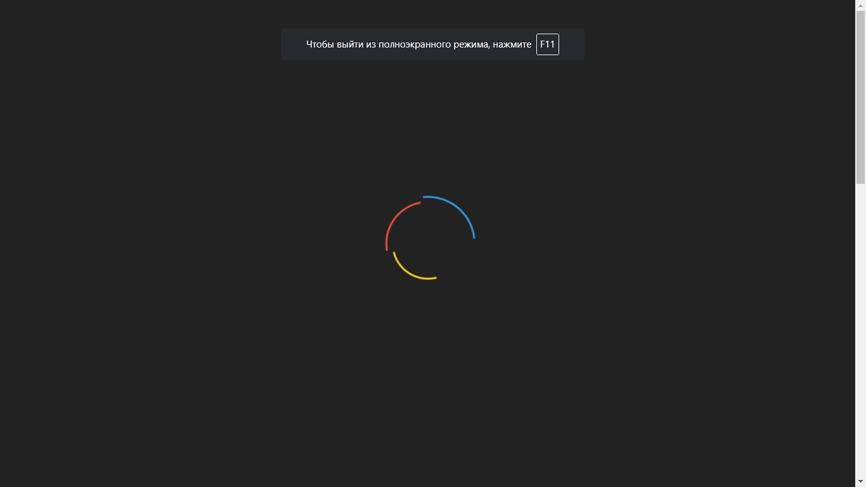

When user enters MODEST website “preloader” function will start to work. This function is created using JQuery library and CSS codes. As webpage has many interactive elements, for the browser in the beginning it may be difficult to show the page properly. That is why by giving the feeling of “beautiful” waiting it makes the website user-friendly.

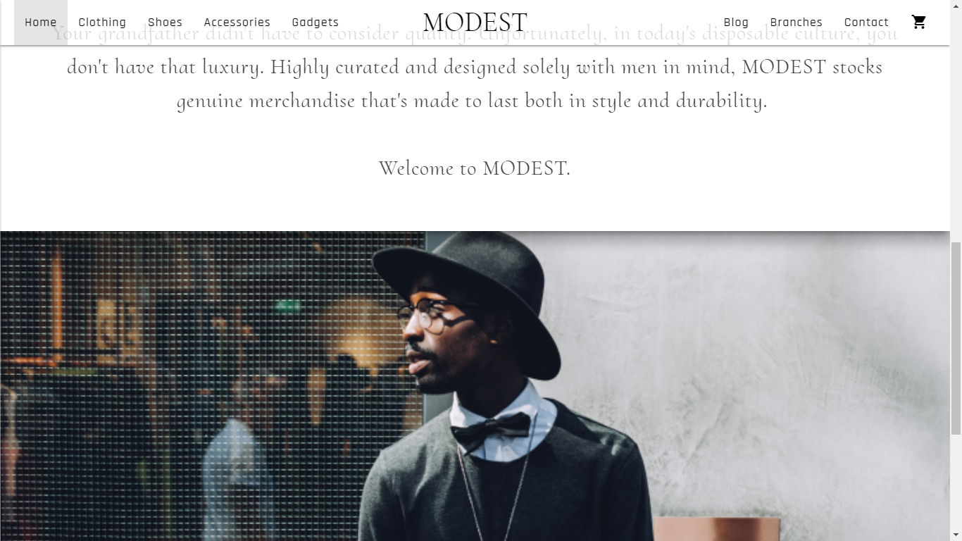

Home page has “parallax” feature which is used while scrolling to make background image and text to act in different pace. In the top right corner there is an “shopping bag” icon which enables users to check how many products they decided to buy.

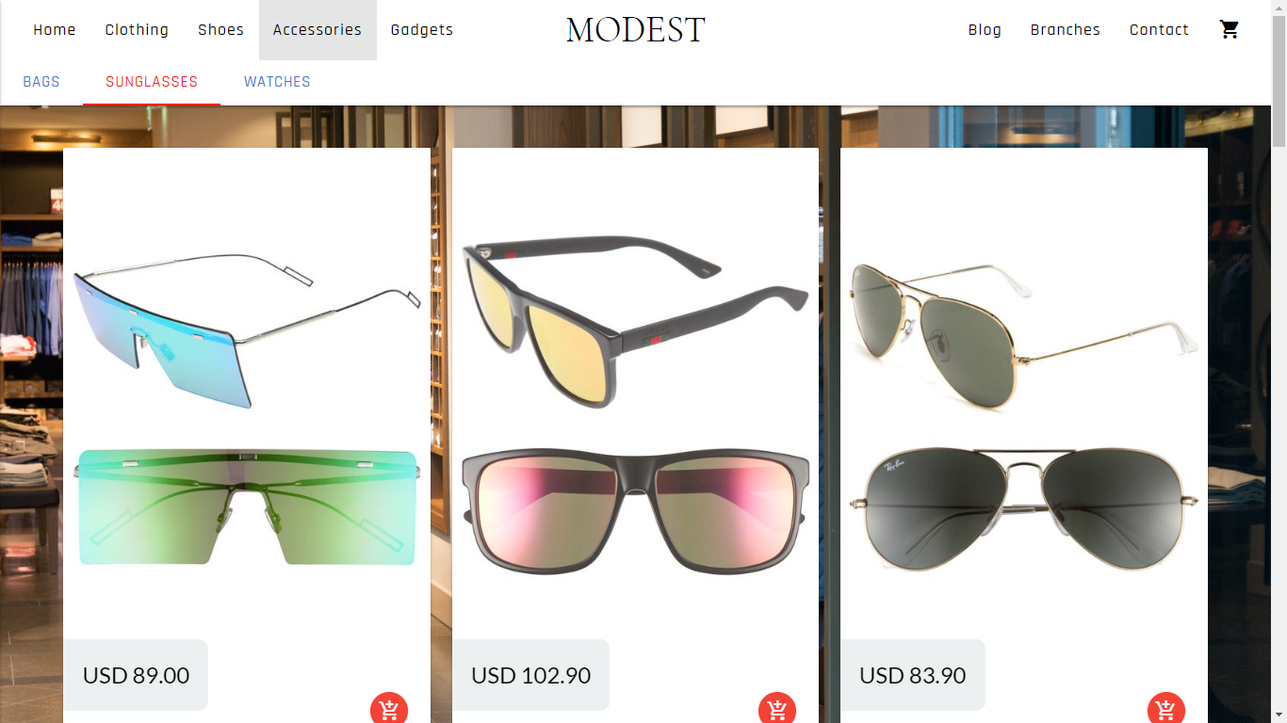

Pages that have product description are designed in similar way and follow certain style guidelines. Cards in these pages have “material-box” classes, so that when user clicks to the image of the product it covers the whole pages and all attention can be given to this product. As people use different devices to visit the website, MODEST is responsive and adaptive. Although, it has some minimal error with tablets (developer is going to fix those bugs), it can be well used in desktop and mobile phones. This feature is very important from commercial side, because nowadays online shop customers use different gadgets to purchase the product.

**Navigation**

A lot of attention is given to navigation scheme of the website. MODEST has many webpages with several sections, so in order to make the user see “the whole picture” and at the same time to make navigation system easy to understand required a lot effort. Main navigation has company name/logo at the center, home page and product pages’ link on the left and additional pages like contact, blog on the right side. This is hybrid type of navigation. While home page and additional pages are linear, product pages have dropdown links which lead to directly to that section of the page. Usability principles suggest that it is better to link company logo with home page and to make links concise. Developer tried to follow these principles and used one-word, “clear meaning” links for webpages.

Muhammadyunus designed the index page, chose color scheme, chose appropriate frameworks for building the website.

Rakhmatillo and Mukhammadamin collected necessary elements like product pictures and textual content.