**Report IP Project**

**Team name**

**MSO**

**Members**

**Otabek Nazrullayev u1610175**

**Sardorbek Abdupattoyev u1610206**

**Mirpulatjon Shukurov u1610143**

**Project name**: MSO **(Blog site)**

Used languages, technologies, frameworks:

HTML5, Javascript, JQuery, Php (Laravel), Bootstrap, laravelcollectives(for forms implementation), mailtrap.io.

**FRONTEND descriptions**

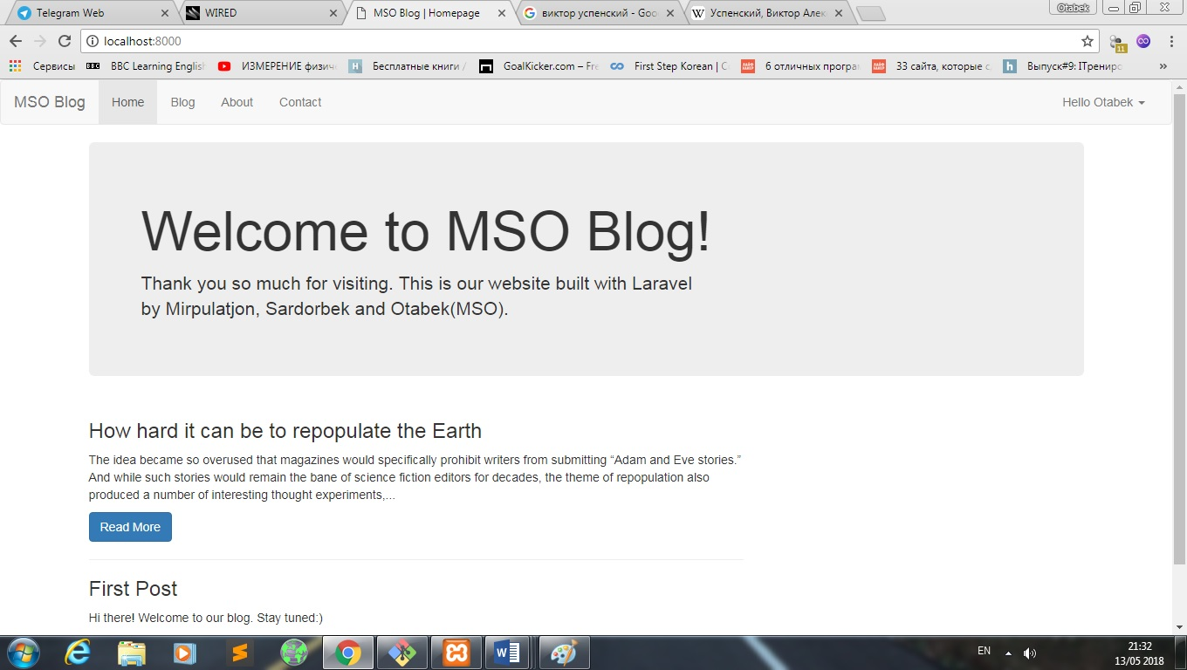

Main page shows info about our company, and also shows first three lines of posts that were posted. Read more button opens that post

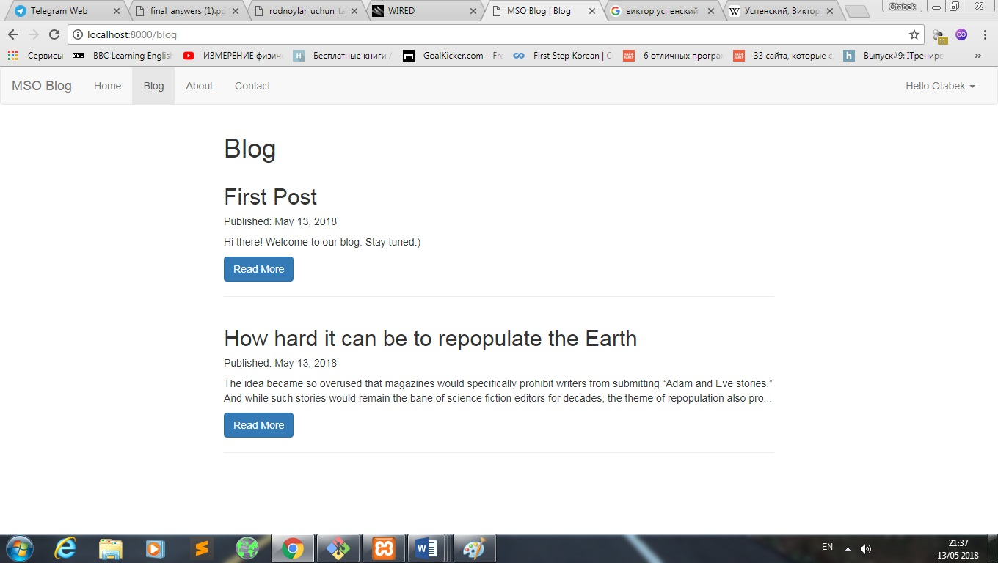

This part is made for viewers , they can see first two lines of post, they can read more information By pressing Read more

This page is about Blog

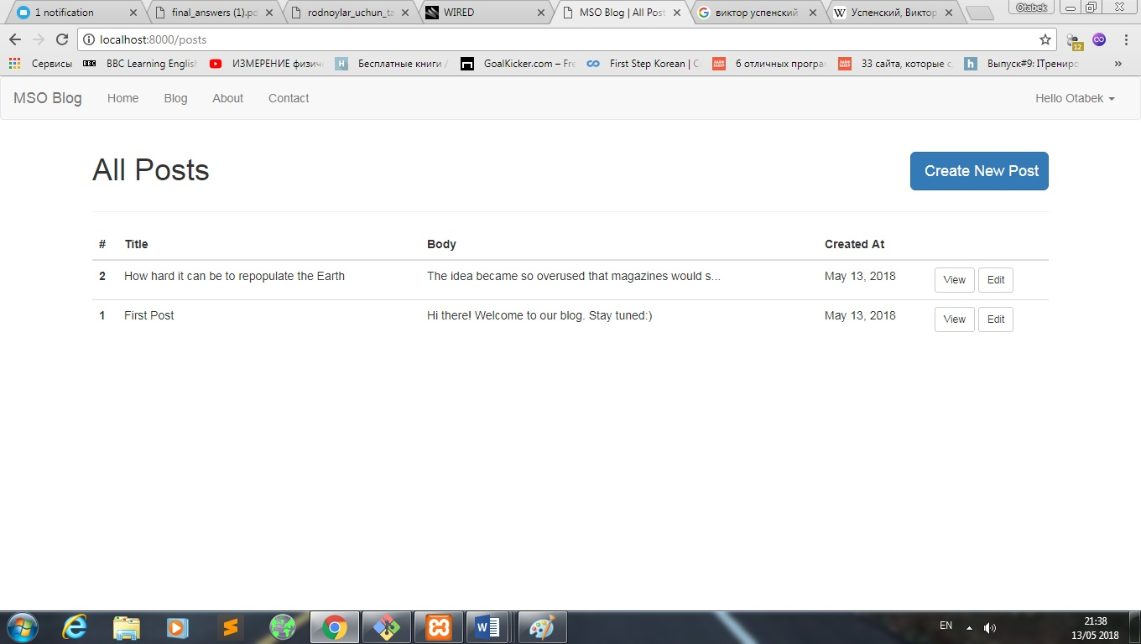

In this page you can see All posts that created or you can create a new one

You can view and edit posts that are created

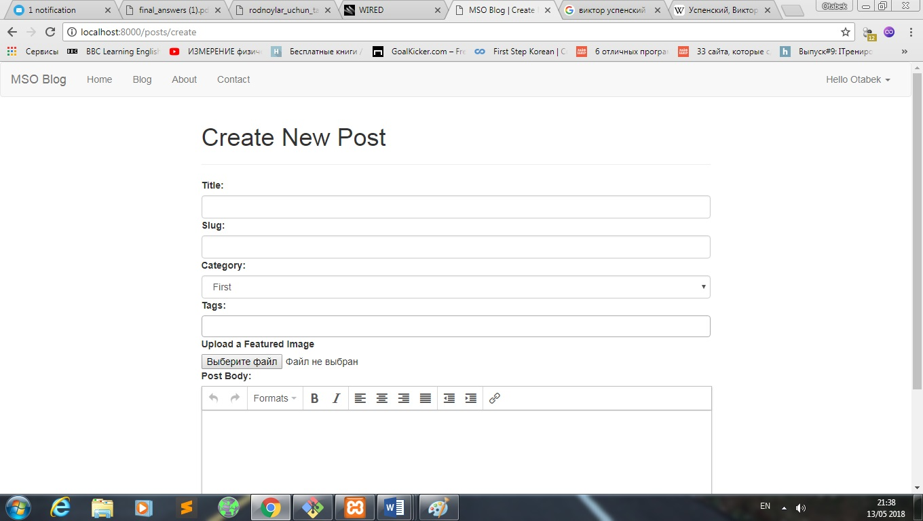

In this page you can create a new post by pressing previous page’s create new post button. Each post will have its own unique slug(that is http address extension)

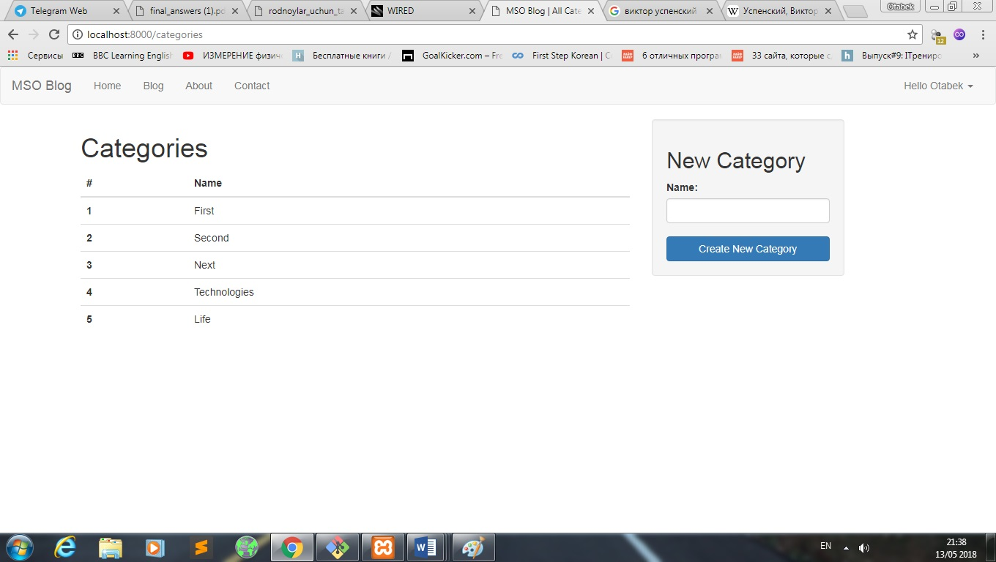

This page provides categories here you can add a new category to your blog. Each post can be found with corresponding category or tag.

Administrator can manage all posts. Edit, Delete. And also he can edit comments or delete them.

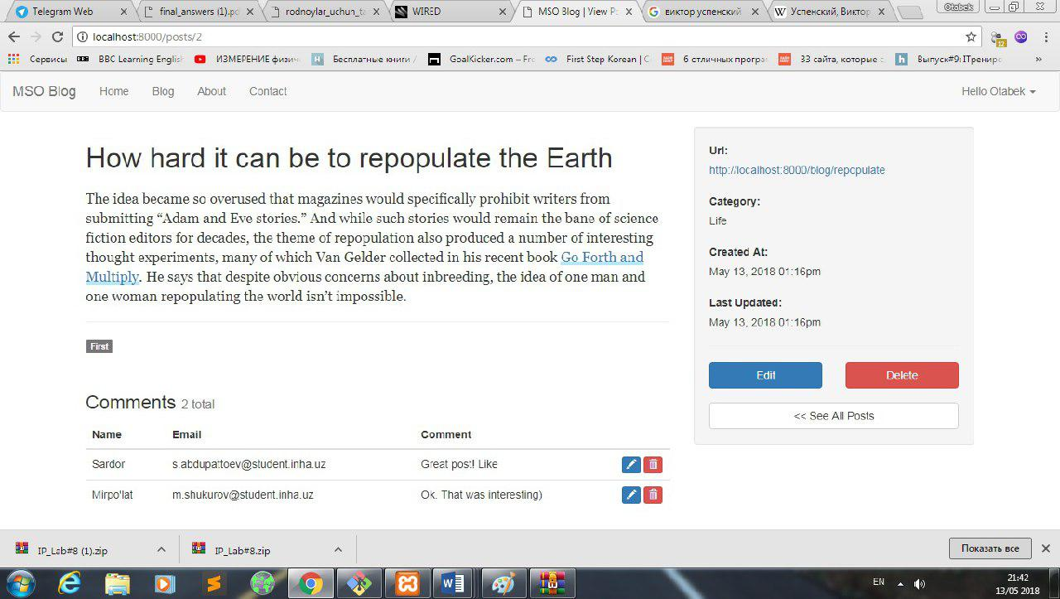

For each post any viewer can leave comment and leave his email address(there is form validation, so that each form should be filled)

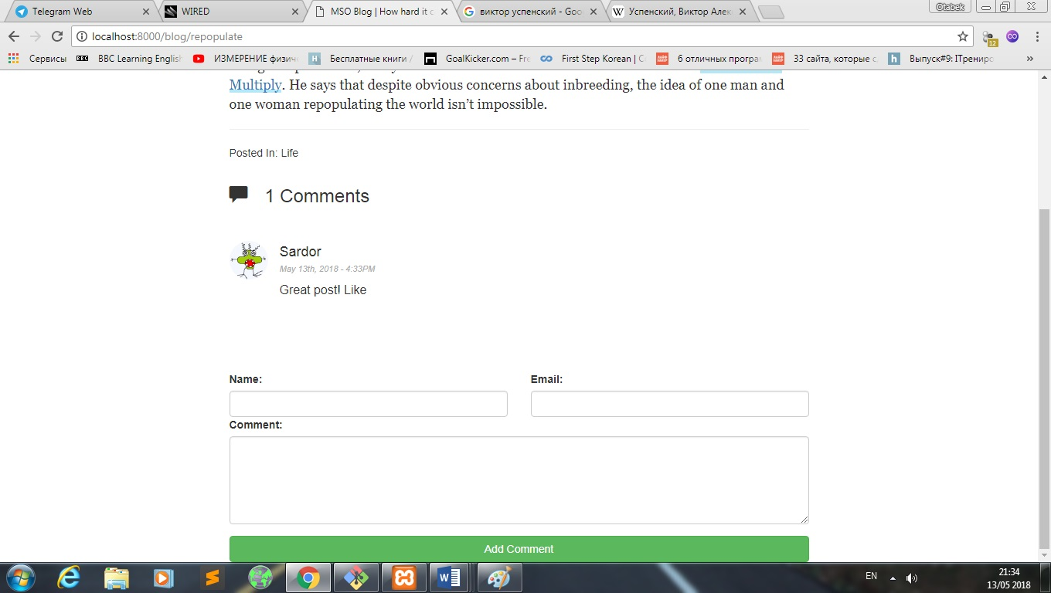

Total number of comments and their name & email also you can edit that comments

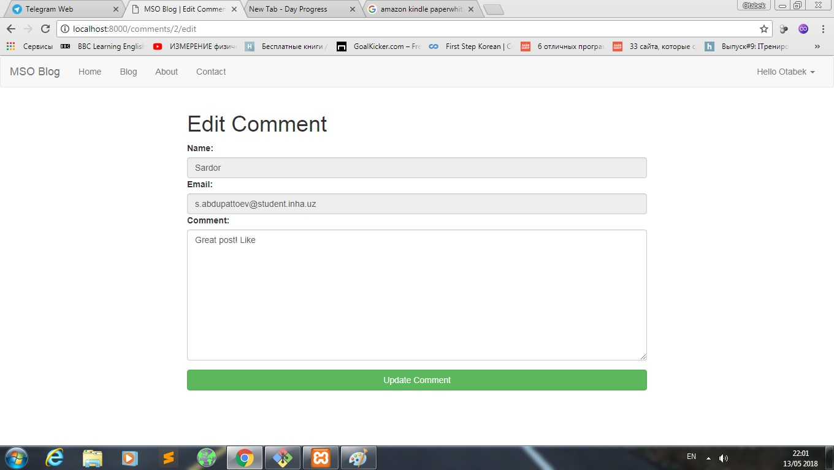

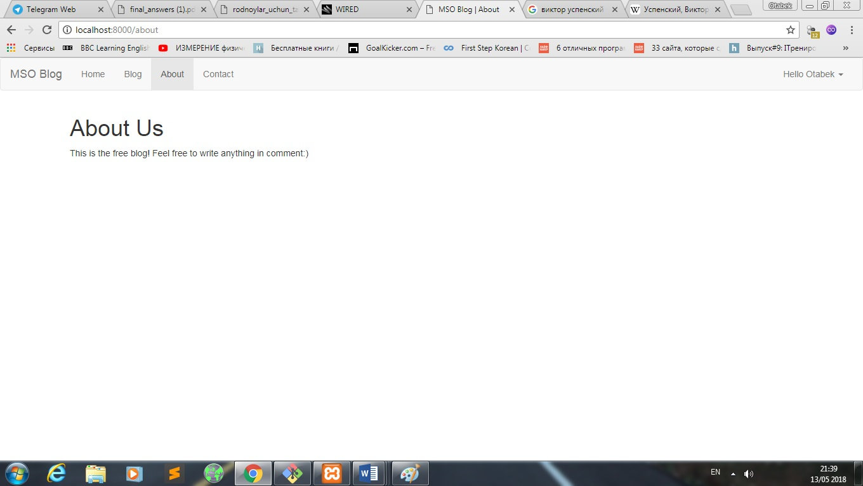

About us page appearance

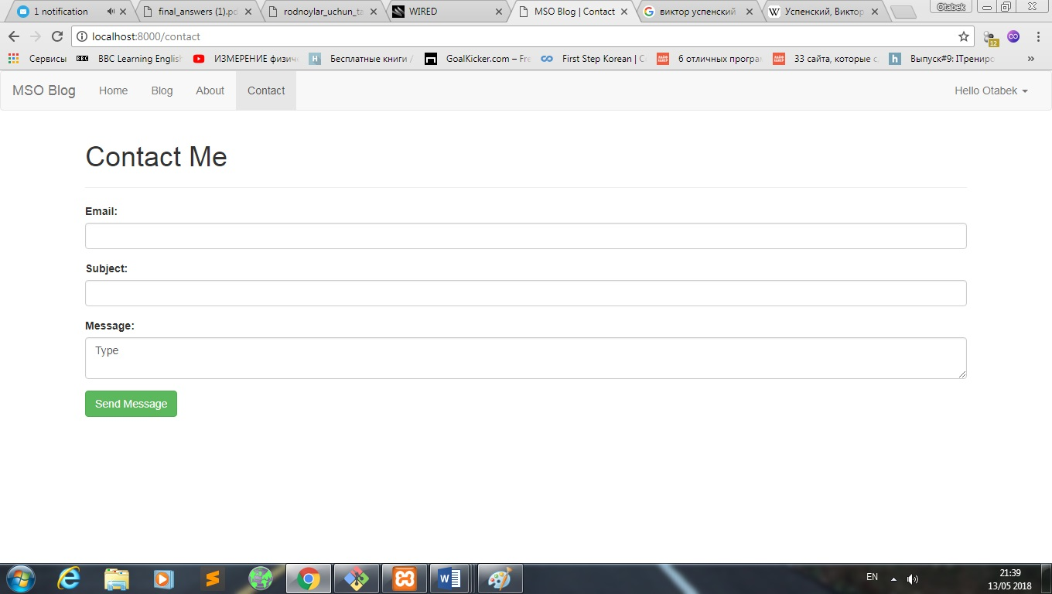

This page sends mail to [otabeknazrullaev1998@gmail.com](mailto:otabeknazrullaev1998@gmail.com) adress using mailtrap.io

For correct running:

1)create database named: blog

2)use command php artisan migrate (in some cases you might have to give to root all privileges)