**Group name: USHA Project name: Worklance**

Team members

Kholmurodov Dilshodjon u1910232

Naimov Fayyoz u1910071

Komiljonov Boburjon u1910275

Abdullokh Khojiakbarov u1910170

Sharifov Abdulaziz u1910075

Rustamov Sunatillo u1910136

Git hub repository: <https://github.com/iuthub/group-project-usha>

Project link web: worklance-usha.cg

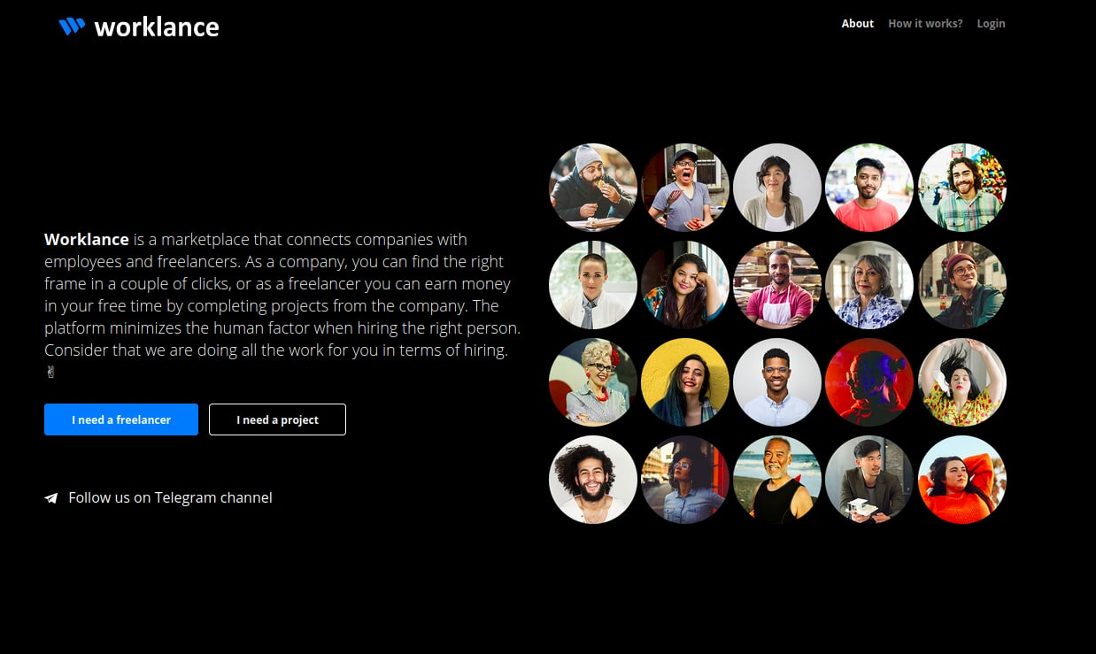

**Worklance**

Our community connects companies with employees and freelancers. As a Company you may find the correct employee for your project or as a freelancer you may find opportunities to find projects to complete on your free time! We will create every available opportunity for you to shine!

In Welcome page you can see welcoming to our website and your own profile. Furthermore there is an option to check your notifications.

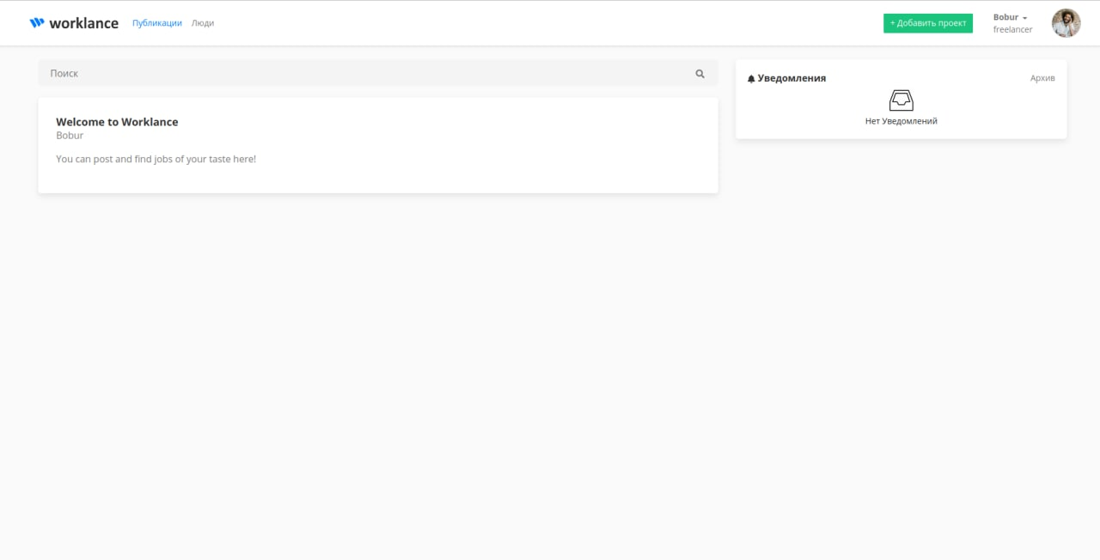

In this page a new member can join to our platform by indicating name and filling required fields

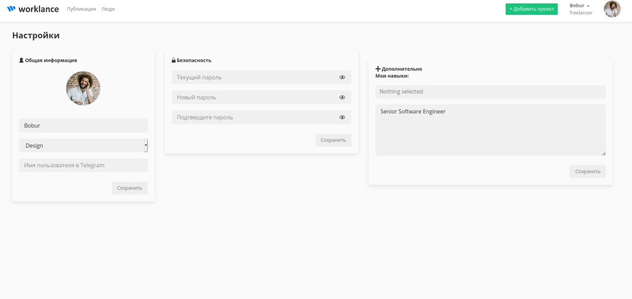

Here you can see user’s ready profile

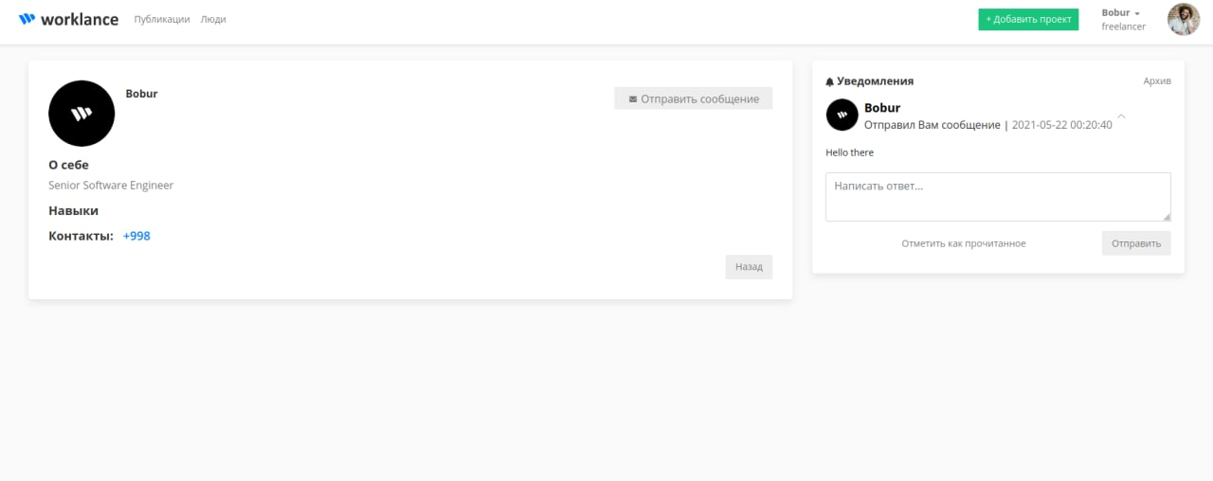

You can search users by this page

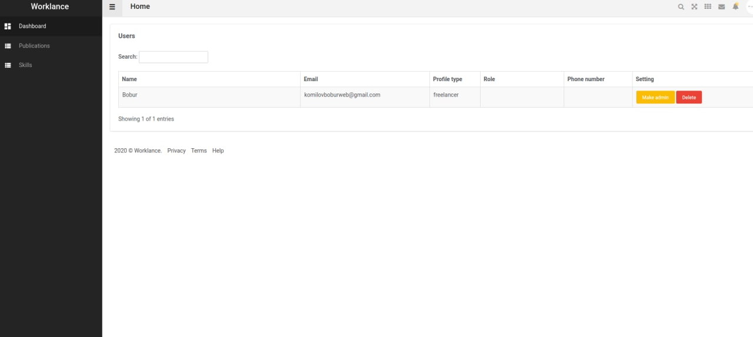

Another remarkable feature on the website is you can send messages to users

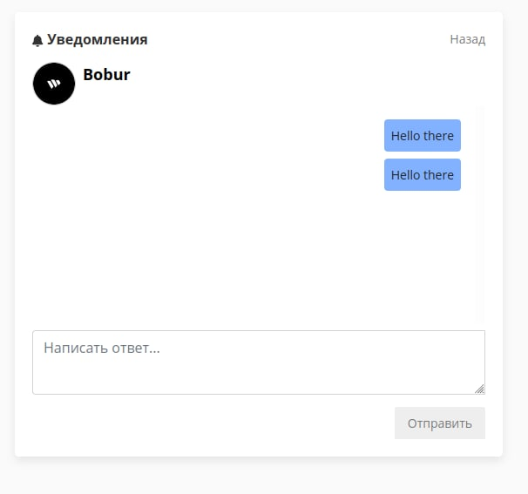

Admin page – Fayyoz Naimov (front and back)

Welcome page – Sunnatillo Rustamov

Backend (full) – Komiljonov Boburjon

CSS, Style design (extra features) – Kholmurodov Dilshodjon, Khojiakbarov Abdullokh, Sharifov Abdulaziz