IP project

Report

**Group members:**

Jaloliddin Gulomov U1610090 001

Mirzayev Akobir U1710288 001

Saidazimkhon Jasurbekov U1610195 001

Link github repo: <https://github.com/iuthub/ip-group-project-2ptr.git>

Link to website: <https://2ptr-sales.000webhostapp.com/>

Well, we wanted to create a project that would help people make their purchases or sales. Therefore, we began to think about the problems or disadvantages of our sales, as well as the difficulties that we encountered. And we counted the difficulties, there was something simple, we all experienced it.

For example, we consume everything in food, clothing, technology and the market for our own needs, we want to buy products as cheaply as possible. For this, it is always necessary to sell to us at any discount, from companies or stores. Even with our friends, when we want to make a purchase, we are looking for a certain website of the store company or android application and look at the best-selling new products.

After that, came the idea of creating a website, in which all products with sales> = 10% of all companies are united, here you can see, search for products with sales of any company. You do not need to go to all the sites of the company and find the tokens that will be sold.

The main purpose of the website is that big companies can sell their products online, and at the same time, consumers can easily and conveniently buy the products they need

Now we provide screenshots step by step, how companies signup and post products

(*Unfortunately pictures are not available because of some problems of localhost we will fix this soon)

It is a Login page, where Users can register

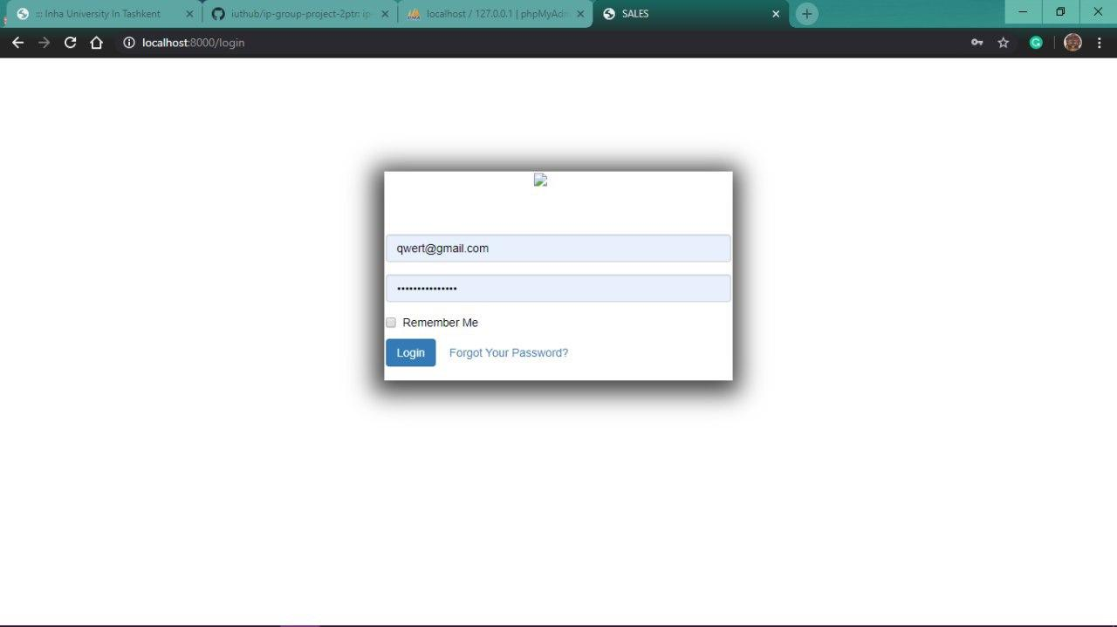

This is dashboard screen and here redirects to private page of the store, where the user have not posted any product yet

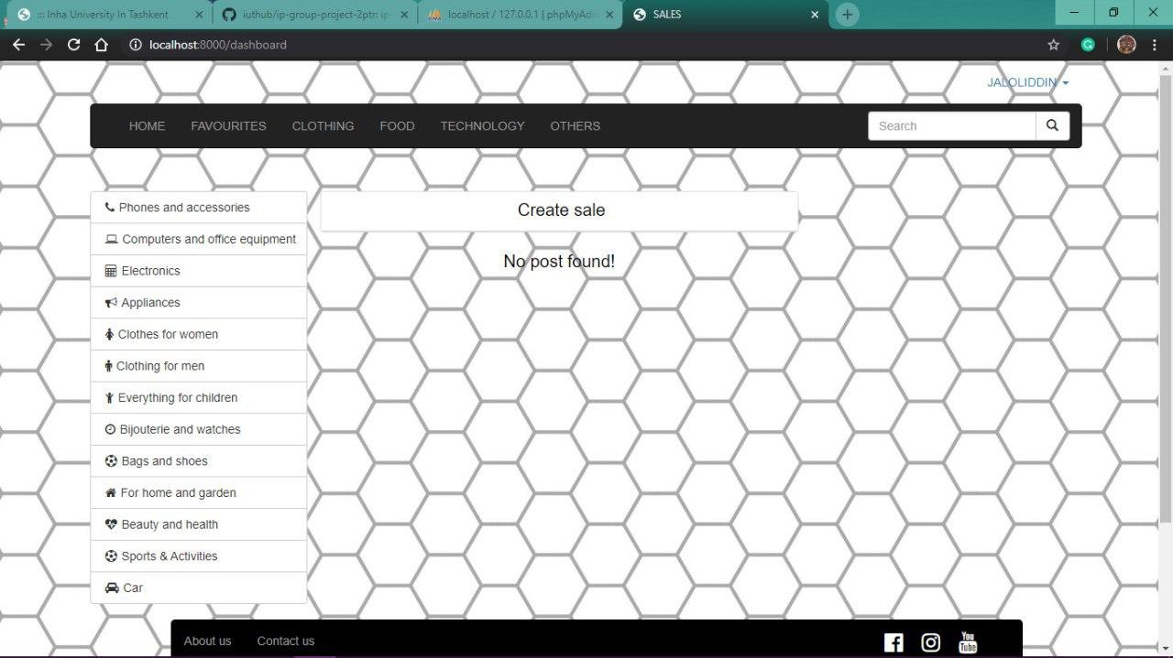

After clicking create sale button, it shows this page. Where the company should enter, title of the product, category, sale amount, and message about the product, if possible provide photo of the product, and post.

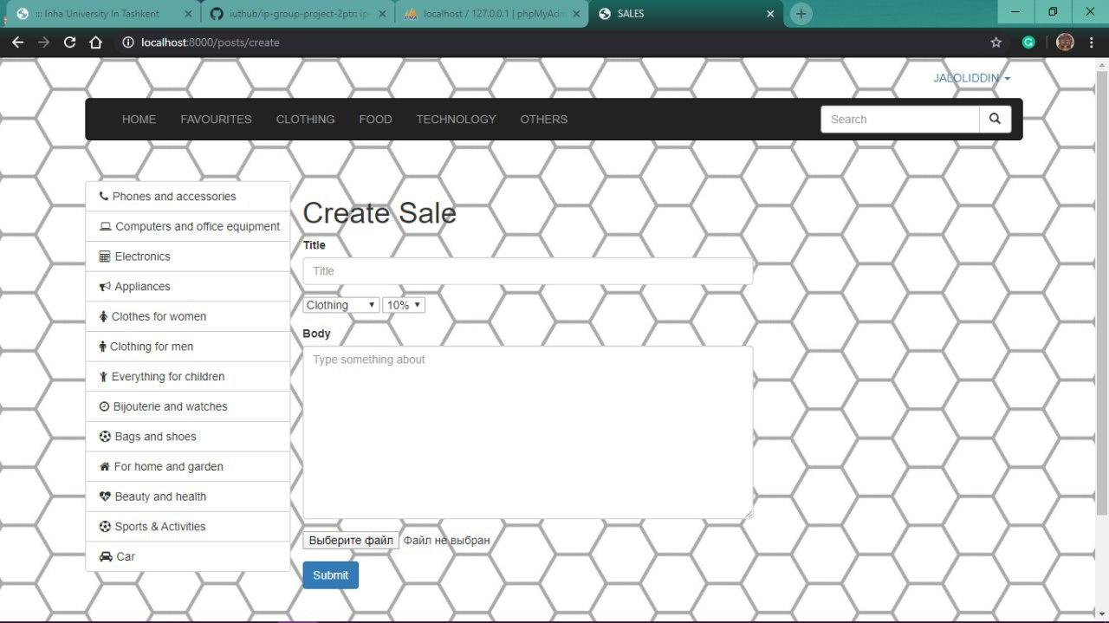

and after entering all the necessary information , user will create a new post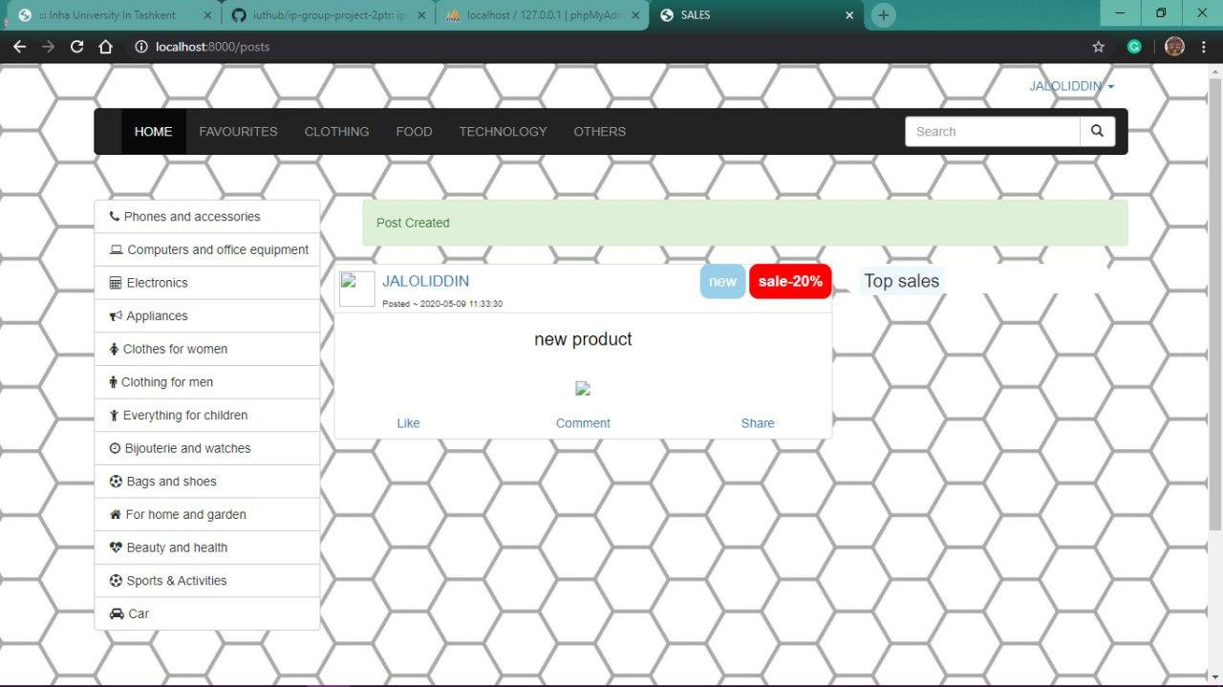

in the next window you can see all the products entered by a user:Jaloliddin

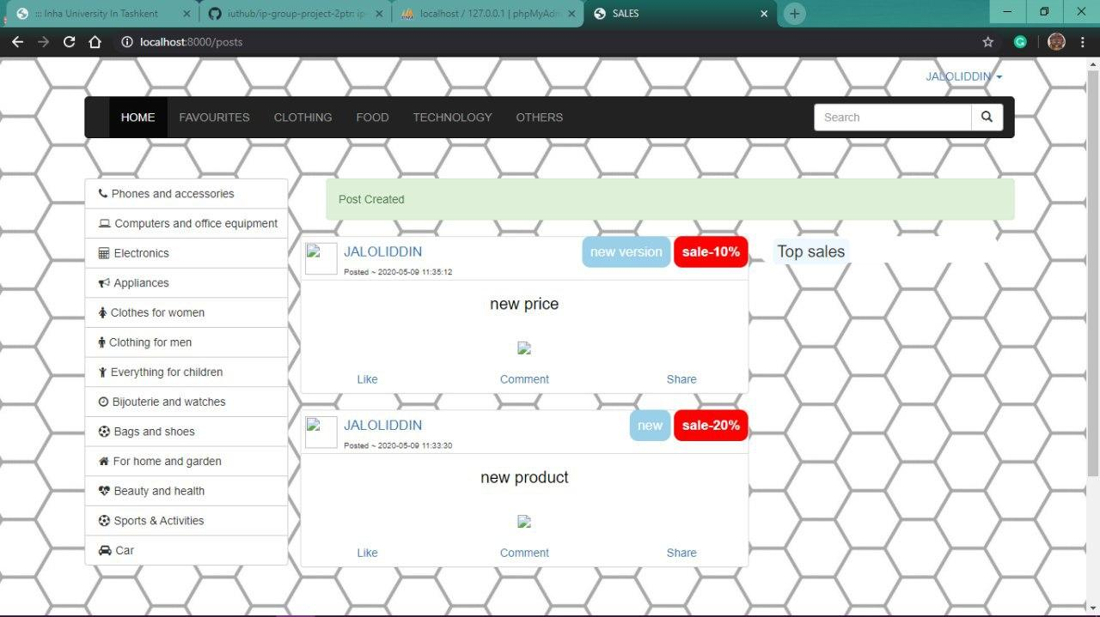

you can edit all the products you post, and this post differs from the previous version

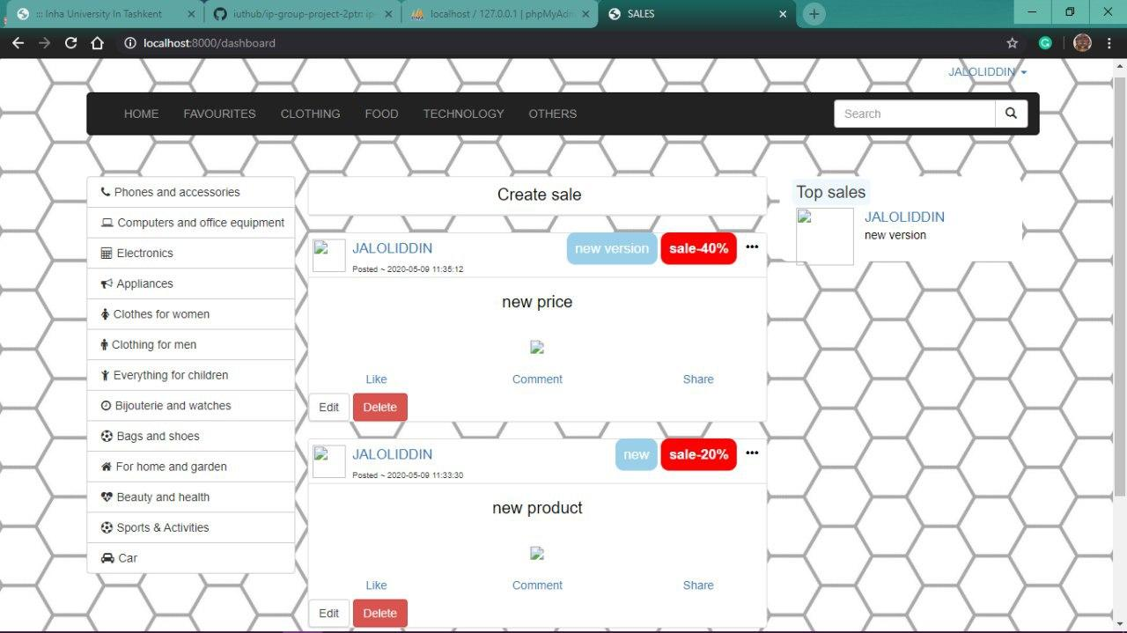

in this window you can see the process of registering a new user

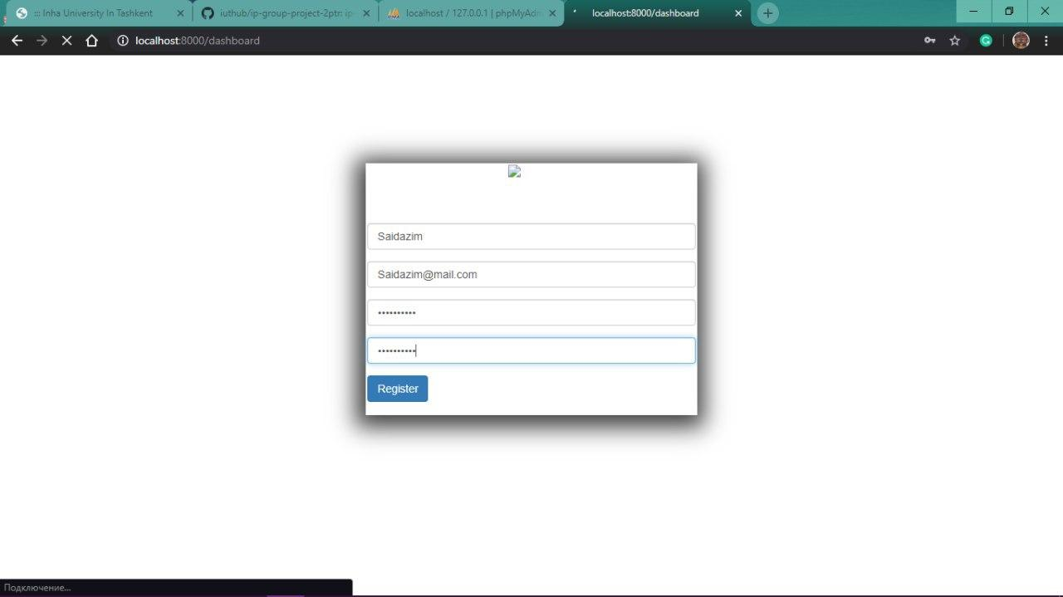

here you can see all the posts of the second user

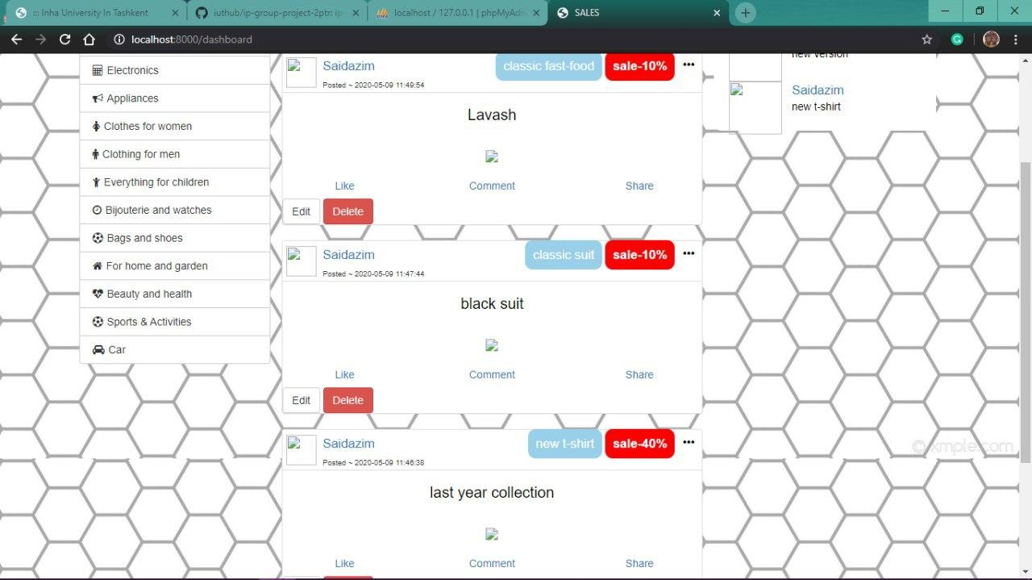

and in our last window you can see the products posted by Akobir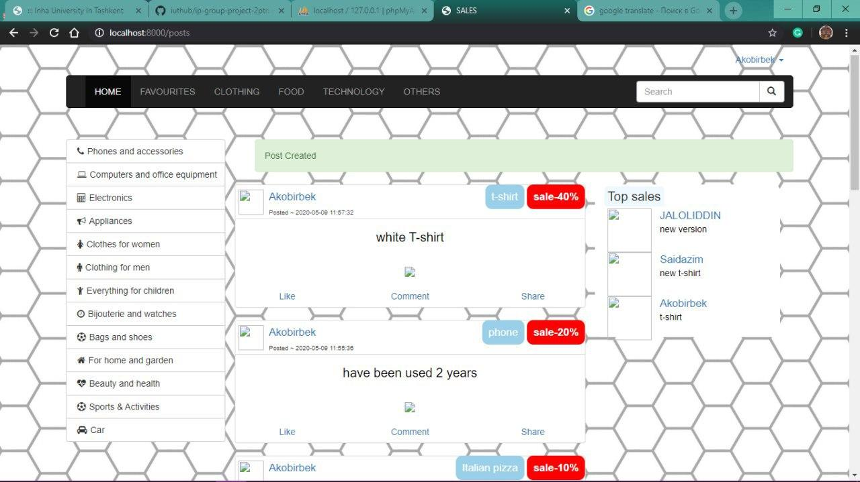

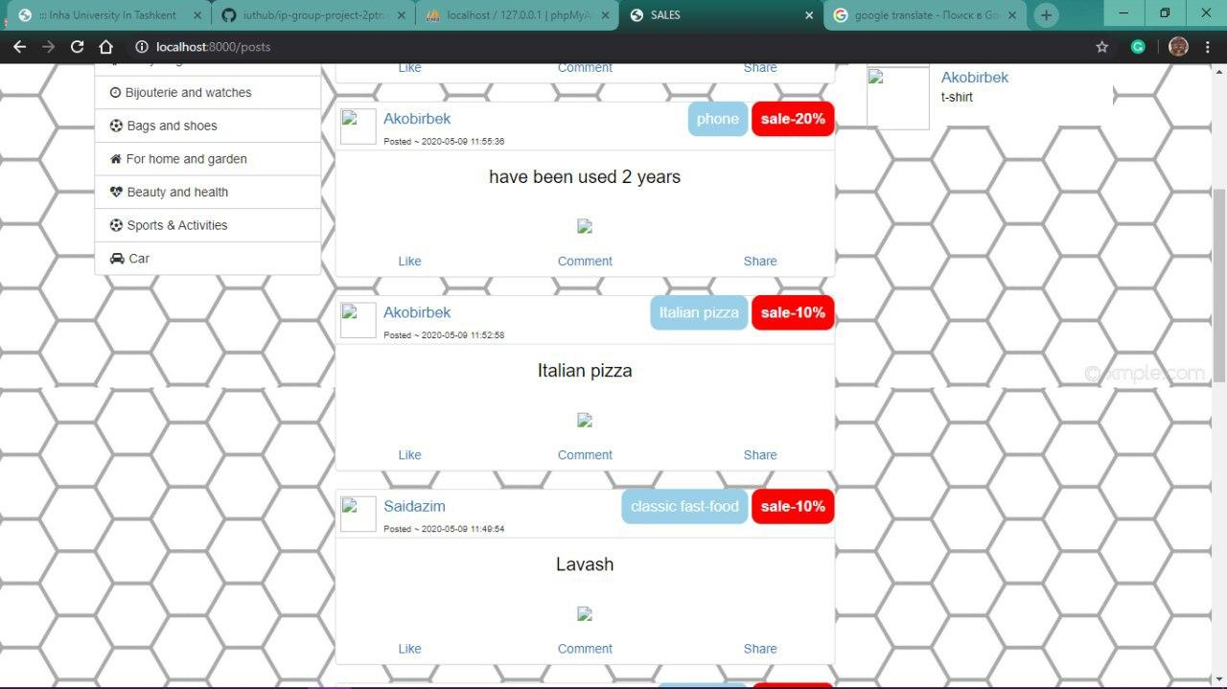

All products from different companies are shown in home page. And if customer chooses clothing option from navbar. All clothing products with sales in the server will be shown to the customer. This works for other categories, of course. So it will make the job of the customer easier.In this window, the user can see by categories, for example:clothes

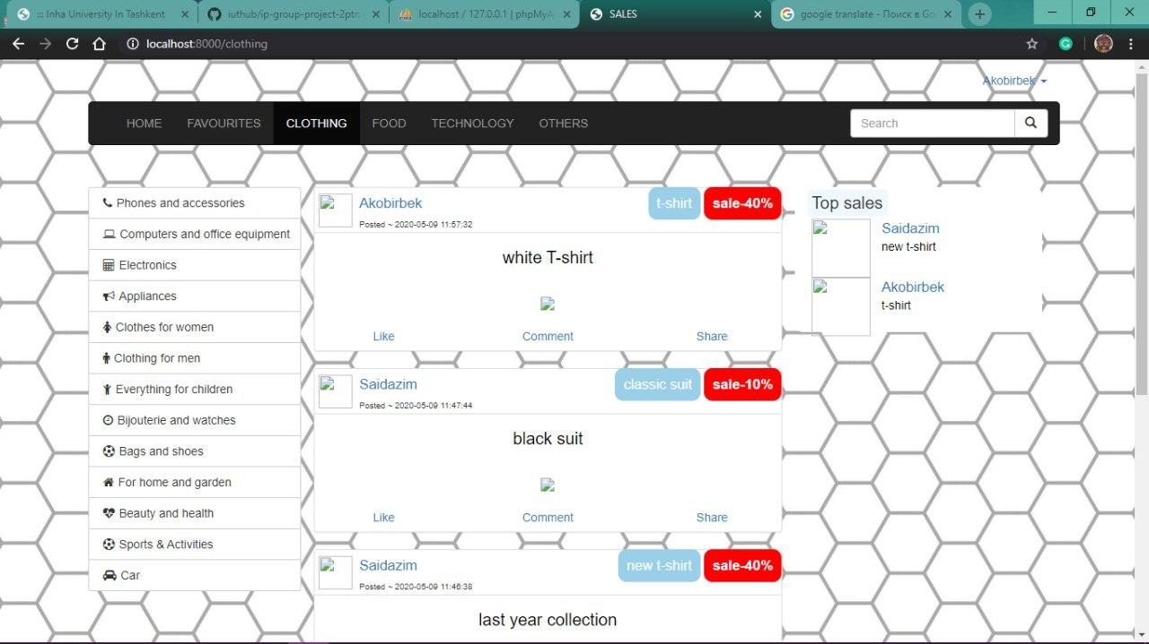

Food category:



you can see top sales in this window

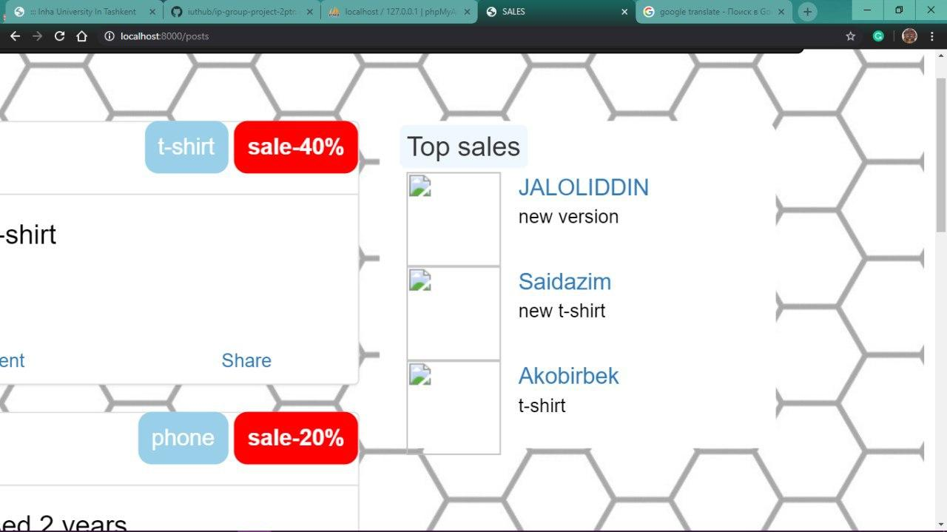

Php my admin localhost posts wtable

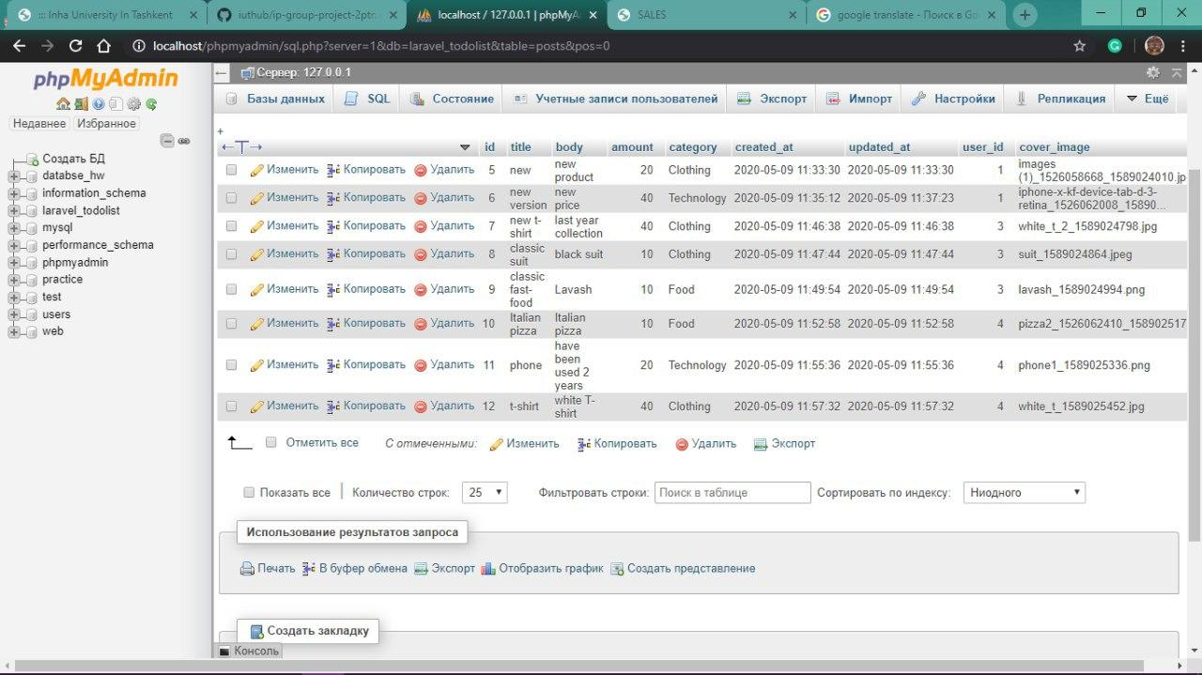

here you can see the code written in php

<?php

use Illuminate\Support\Facades\Schema;

use Illuminate\Database\Schema\Blueprint;

use Illuminate\Database\Migrations\Migration;

class AddCoverImageToPosts extends Migration

{

/

* Run the migrations.

*

* @return void

*/

public function up()

{

Schema::table('posts', function($table){

$table->string('cover_image');

});

}

/

* Reverse the migrations.

*

* @return void

*/

public function down()

{

Schema::table('posts', function($table){

$table->dropColumn('cover_image');

});

}

}

***Routes***

<?php

/*

|--------------------------------------------------------------------------

| Web Routes

|--------------------------------------------------------------------------

|

| Here is where you can register web routes for your application. These

| routes are loaded by the RouteServiceProvider within a group which

| contains the "web" middleware group. Now create something great!

|

*/

Route::get('/', 'PagesController@index');

Route::get('search', 'PostsController@search');

Route::get('/about', 'PagesController@about');

Route::get('/contact', 'PagesController@contact');

Route::get('/login', 'PagesController@login');

Route::resource('posts', 'PostsController');

Route::get('/clothing', 'PostsController@clothing');

Route::get('/food', 'PostsController@food');

Route::get('/technology', 'PostsController@technology');

Route::get('/others', 'PostsController@others');

Auth::routes();

Route::get('/dashboard', 'DashboardController@index');

Route::prefix('admin')->group(function(){

Route::get('/login', 'Auth\AdminLoginController@showLoginForm')->name('admin.login');

Route::post('/login', 'Auth\AdminLoginController@login')->name('admin.login.submit');

Route::get('/', 'AdminController@index')->name('admin.dashboard');

});

***Layout***

<!doctype html>

<html lang="{{ app()->getLocale() }}">

<head>

<meta charset="utf-8">

<meta http-equiv="X-UA-Compatible" content="IE=edge">

<meta name="viewport" content="width=device-width, initial-scale=1">

<!-- <link href="/css/app.css" rel="stylesheet">-->

<link href="/css/bootstrap.css" rel="stylesheet">

<link href="/css/home.css" rel="stylesheet">

<link href="/css/font-awesome.css" rel="stylesheet">

<link href="/css/categories.css" rel="stylesheet">

<link rel="stylesheet" href="/css/aboutus.css">

<link rel="stylesheet" href="/css/contactus.css">

<script src="js/jquery.min.js"></script>

<script src="js/bootstrap.js"></script>

<title>{{config('app.name', 'SALES')}}</title>

</head>

<body>

<div class="container container-fluid">

@include('inc.navbar')

<div class="container">

<div class="col-md-offset-3" >

@include('inc.messages')

</div>

<div class="container cont">

@yield('content')

</div>

</div></div>

@include('inc.footer')

</body>

</html>

Contributions of members:

--- Saidazimkhon Jasurbekov

- profile page of the company (dashboard), profile page of the other companies. Worked on logic of the website wholly, worked on bootstrap and css, contributed to other page’s design logic. Worked on laravel coding, models, postscontroller, dashboardcontoller, routing, constructed database, posts, user tables. Applied google map API to about page. Constructed search activity. Worked on edit, create pages.profile page of the company (dashboard). Worked on logic of the website, worked on bootstrap and css, contributed to other page’s design logic. Worked on pagescontroller, dashboardcontroller, contributed to logic of the login signup. How they interact with database.

---Jaloliddin Gulomov

- constructed about and contact page, worked on bootstrap efficiently helped with other pages, worked on css. Helped with the logic of placing the parts to other web pages. Worked on footer and navbar with Saidazimkhon. Worked on the design of edit page with Akobir.Constructed the design of login and signup page. Worked on their css and boostrap styles. Provided **regex** for user inputs. Constructed the left option navbar design on bootstrap.

--- Akobir Mirzoev

- worked on the logic of the clothing and technology pages. Worked on the bootstrap and css of those pages. Implemented transitions to photos. Worked on the top sales and helped Fazliddin to get products from database using laravel eloquent.

- worked on the logic of the food and others page. Worked on their bootstrap and css. Applied transition;Worked on related page part logic, and helped to Jalolidin to get products from database using laravel eloquent.