**INHA UNIVERSITY TASHKENT**

**SPRING SEMESTER 2020**

**Internet Programming**

**Submitted by**

**Student Name Student ID Section NO**

**Arifdjanov Sarvar U1810017 Section 4**

**Dadamyants David U1810067 Section 4**

**Nabijonov Kamoliddin U1810053 Section 4**

**Veliev Edem U1810033 Section 4**

**Tsoy Sergey U1810103 Section 3**

**Sophomore**

[**https://github.com/iuthub/ip-group-project-homehub**](https://github.com/iuthub/ip-group-project-homehub)

**/*website link*/**



Agenda

1. About HomeHub
2. Main Features
3. Members Contribution
4. Logins and passwords

1 HomeHub

Our key idea is about sharing own experience, knowledge, feelings in the form of short stories with support of some graphical tools (images, video, etc.). We decided to make such web site where will be included different type of topics for every age group. Here you can find and some coders hints and some adventure story.

2 Main Features

1. Like any blog, we have our main object on the page is “post”

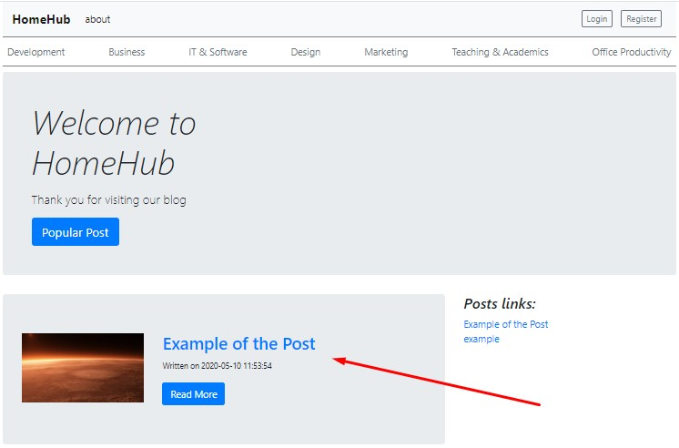

Our addition to default type of the blog that we made possible to add images into post.

1. It is also possible to see more details about exact post

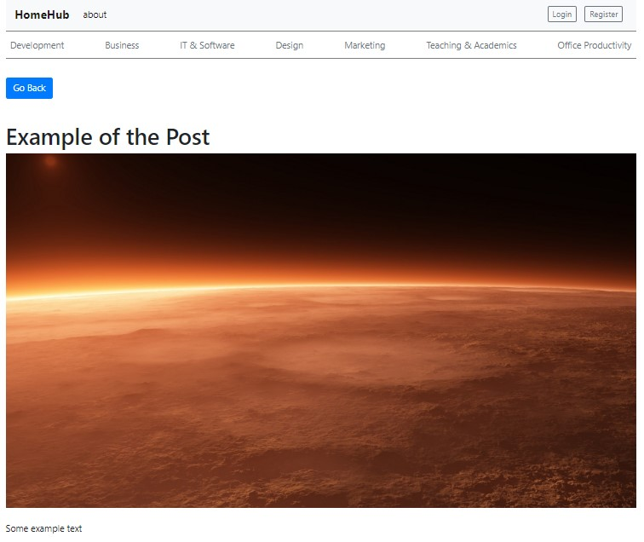

1. Registration is also available, simple, easy, and perfect

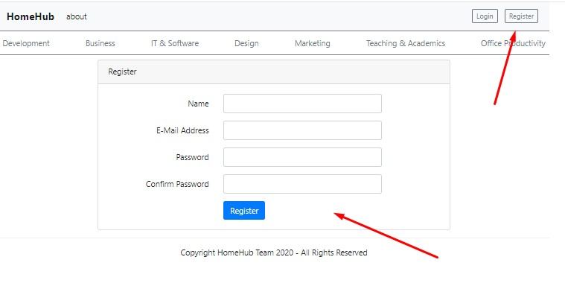

1. Login page is also perfect

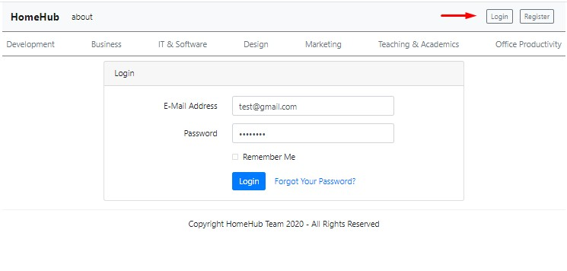

1. After login we can see the name of the user and his current posts

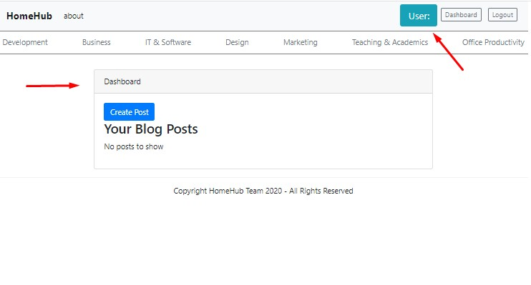

1. Here is the form for creating new post

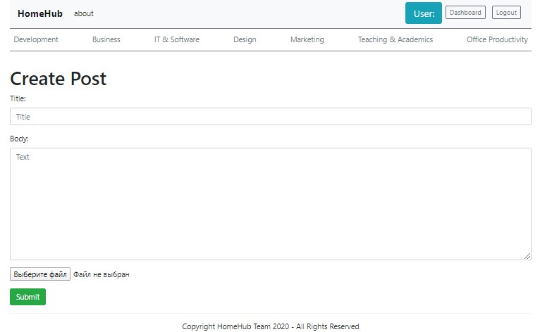

1. We made special menu where user can control all his posts. Create new one, edit post, which he created before, or delete it.

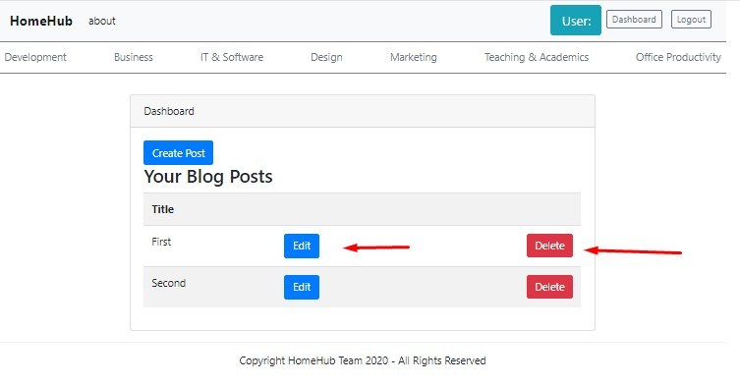

1. When we finished. We can logout from our profile.

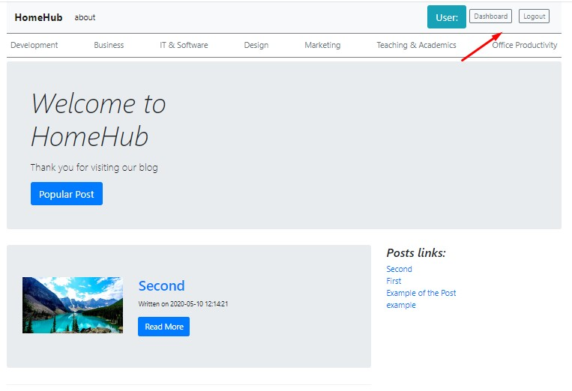

1. As you can observe there many categories which wave different topics and etc.

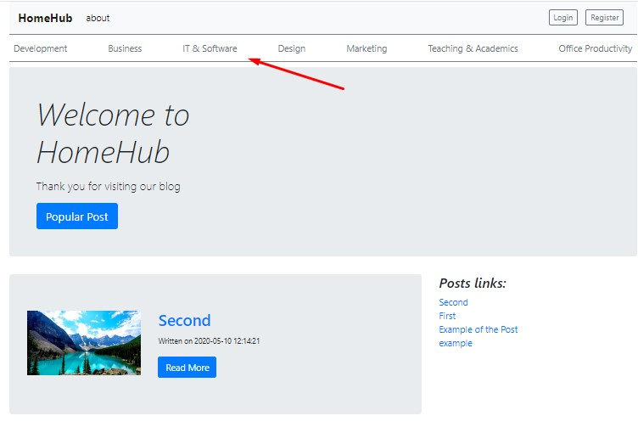

3 Members Contribution

1. Arifdjanov Sarvar (OverLordN7)

Responsible for the base project settings, maintenance of the hosting, and writing the report. Built basic skeleton and creating simple design for website. Helped with authentication together with Edem. Small corrections in routes.

1. Dadamyants David (justcontemplate)

Responsible for work with Middleware, worked with security of unauthorized access of users to posts. Made control system, which limit editing and deleting information of another user.

1. Nabijonov Kamoliddin (Kamoliddin)

Responsible for organizing of the database. Implemented such functions like add, edit, and delete post. Setup Eloquent Model. Adding images likes and comments to the post.

1. Veliev Edem(Edem2000)

Responsible for user authentication, their registration and their exit from the profile.

1. Tsoy Sergey (fletwhite)

Responsible for advanced design, implementing advanced css techniques and style. Correct placement of all objects on the page and their routes in the project (web.php)

4 Logins and passwords