**INHA University in Tashkent**

Internet Programming

Report

Group project

Team name: Nimble minds

Topic: **Master-planner**

Team members:

U1610206 Sardorbek Abdupattoyev

U1610180 Oybek Sayfullayev

Link: <https://github.com/iuthub/ip-group-project-nimble-minds>

**Description**: As we know in these days it's become a dreaded ritual in the business world: scheduling tag. What we came up in this project is simple and smart planner that u can schedule your daily routines and be more productive in your life. Now begins the tedious back and forth of figuring out a time that works for everyone’s schedule. That's where scheduling our project come in. No longer you have to spend hours trying to coordinate everyone's schedules, you just simply come in and set your own schedule if its needed you can edit your schedule depending on your works. If you teach classes, lead workshops, or offer rental services, our project master-planner interface will help your prospects enroll without a hitch. Interface is simple and very understandable.

To implement this project we used: HTML/CSS, PHP, Database, Bootstrap

It is a simple project that we implemented it doesn’t require any special user or server passwords.

Oybek Sayfullayev my team member implemented this project as a laravel project and implemented database side as well.

My part consists of working with containers.

What we did is a simple user can create his/her schedules for the week its very simple and convenient.

Here how it looks our app folder

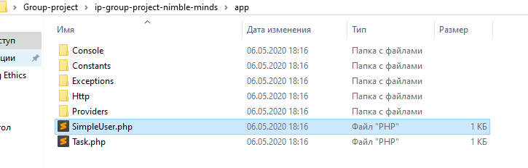

As constants we set colors which we used in project:

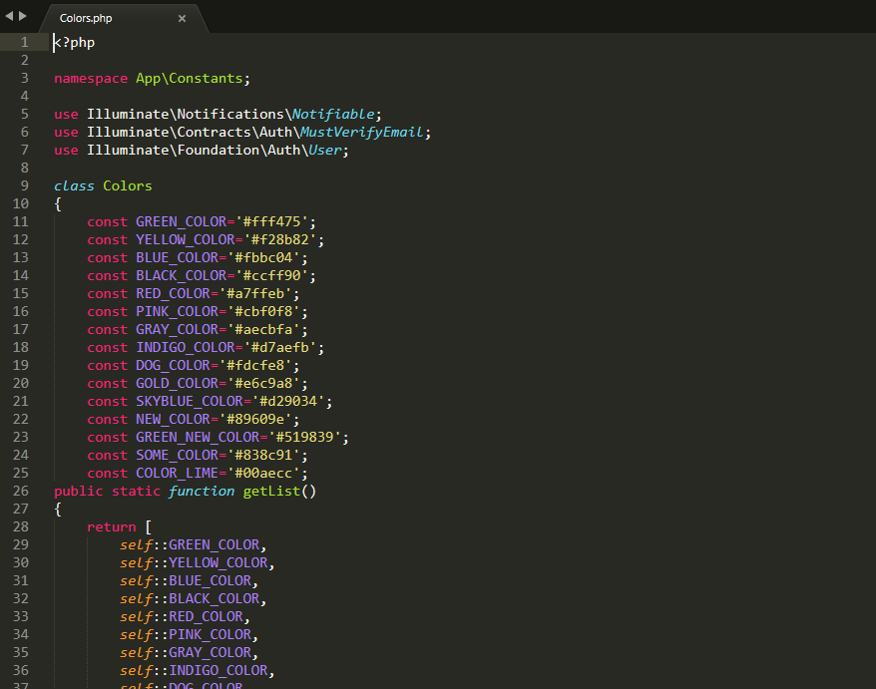

And used points as week days such as Monday, Tuesday …etc

Left 5 more mins to submit this report I apologize for not brief describing.

We have completed this project with the help of your lectures. Thank you in advance.