

Find the best deal!

**Team members:**

Abed Abdulaziz U1810001

Rakhumbaev Sarvar U1810077

Tulkunov Akobirkhuja U1710314

Shoakbar Agzamov U1810144

**GitHub Repo:** <https://github.com/iuthub/ip-group-project-team.git>

**Business activity:**

If you know all about sneakers and want to buy them at affordable prices, you will not find the best online store, other than this. We have the best models of all the top manufacturers of shoes: New Balance, Reebok, Asics, Saucony, Adidas, Nike and etc. On average 40% cheaper than retailers sell. How does it work? Our team constantly monitors discounts and sales and buys shoes in large quantities directly from the manufacturer. Thus, our prices remain so low throughout the year, and not just on a black Friday.

**Screenshots:**

* **Landing page –** advertises our store, shows examples of available products and demonstrates some articles from blog to attract customers. Landing page is written in plain html.

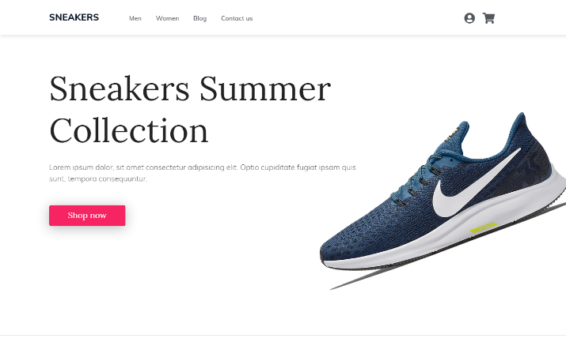

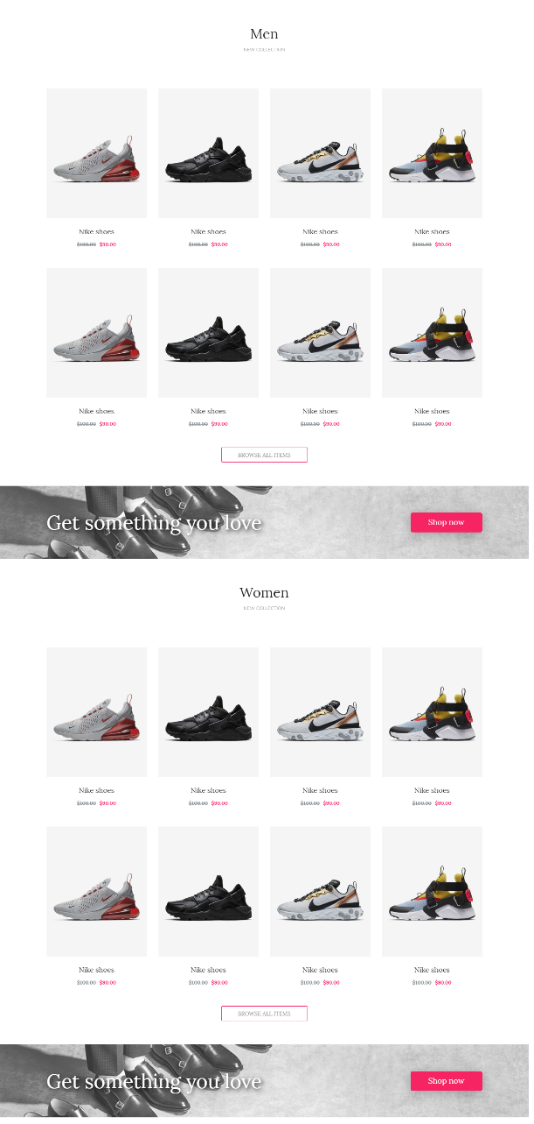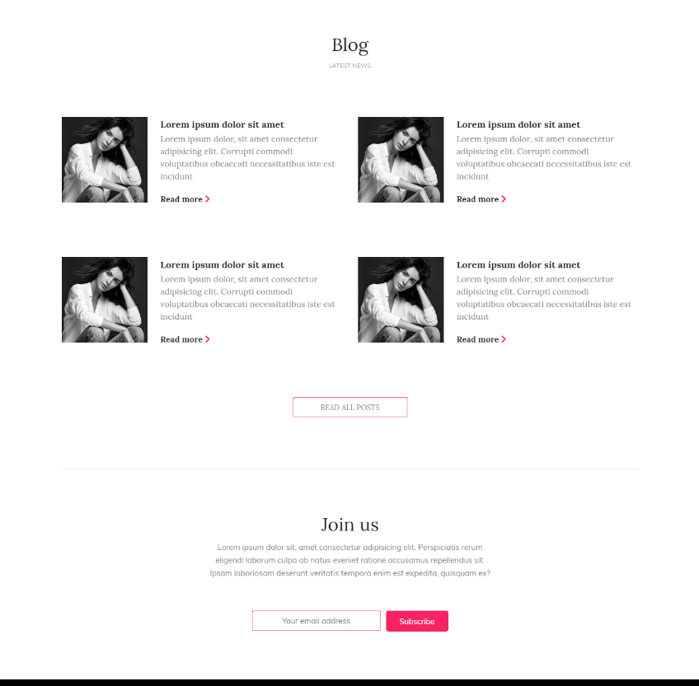

* **Product Page** demonstrates detailed information about selected product from the list and includes simple form to make add product to customer’s cart. Product page opens right from the product list as a “quick view”. It is implemented using bootstrap standard modal.

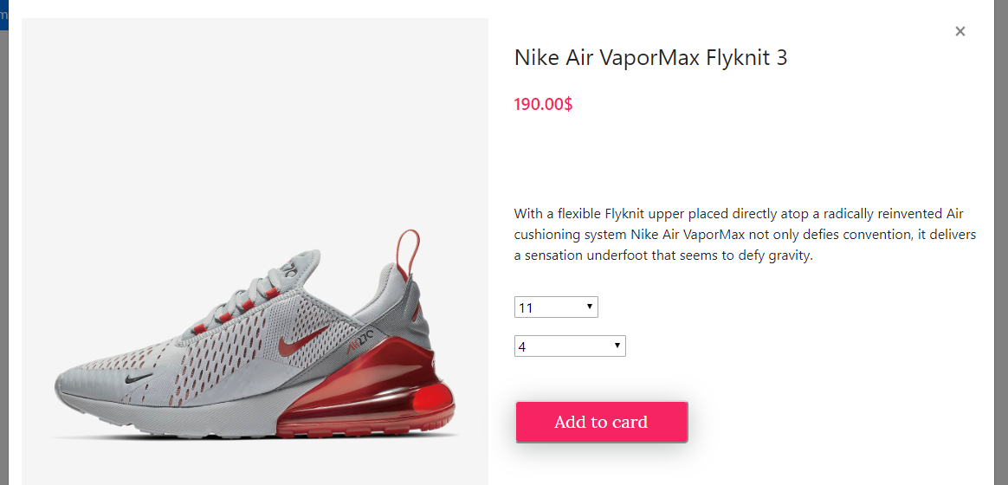

* **Registration and “Sign In” Pages:**

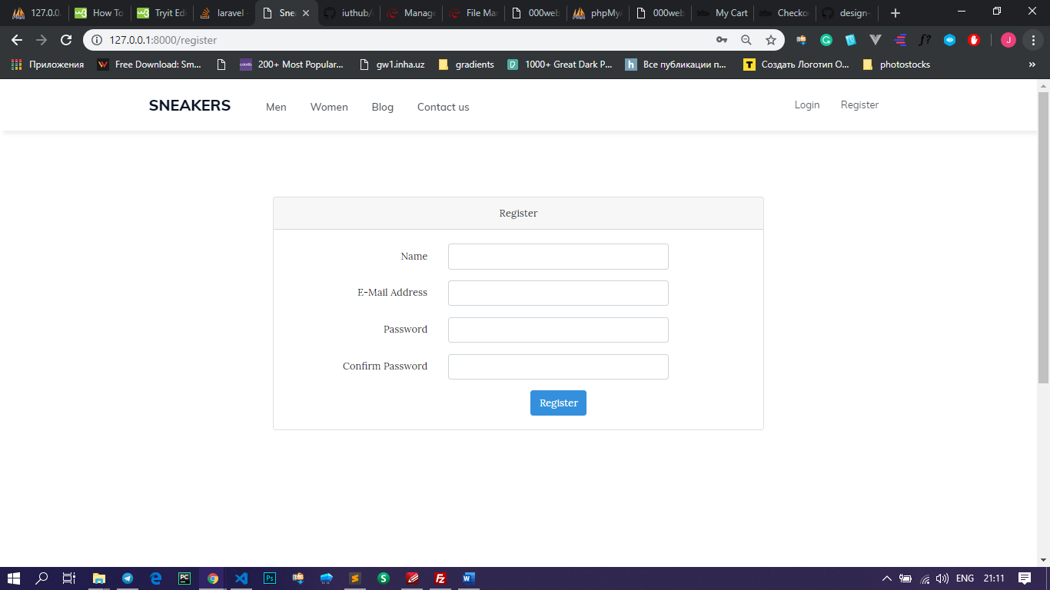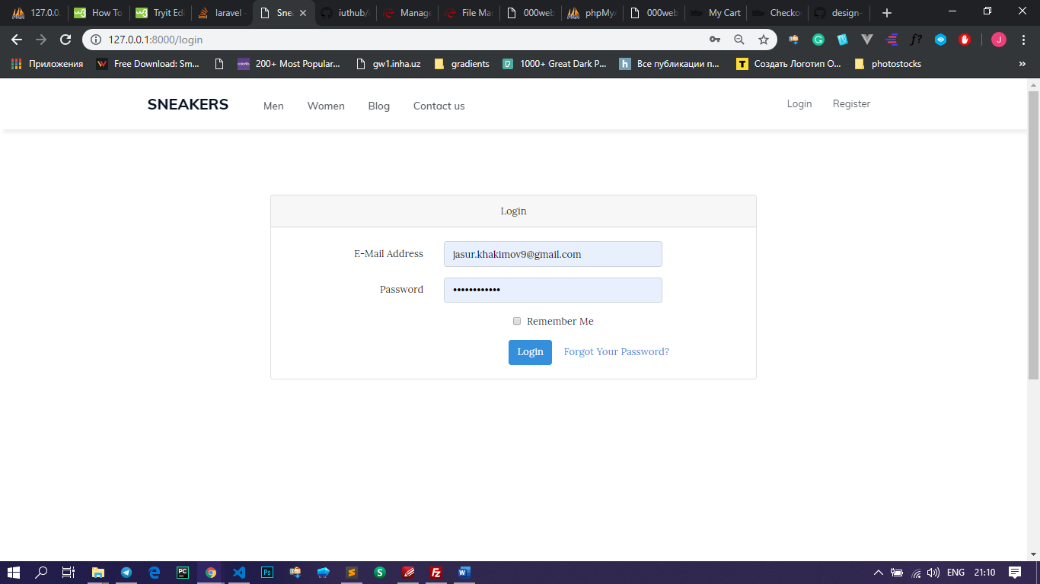

* **Make Order**

After selecting one or more products, customer can check the current status of his cart on cart page. There is the list with all items with corresponding information. This information is stored in database, so customer can leave our site with selected items and come back later and continue to checkout.

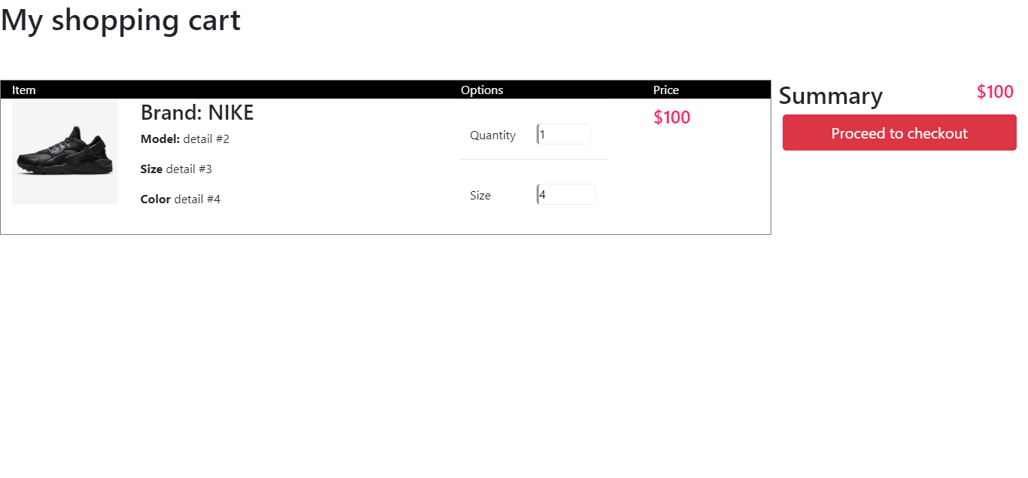

* **Process Order**

To process the order customer needs to go through three steps. We created 4 forms using post method for all 3 steps and also added quick pay button on the right side, if customer’s information is already in cookie. The three steps are combined in one accordion

1. Provide detailed information for shipment
2. Enter payment information
3. Review products and confirm

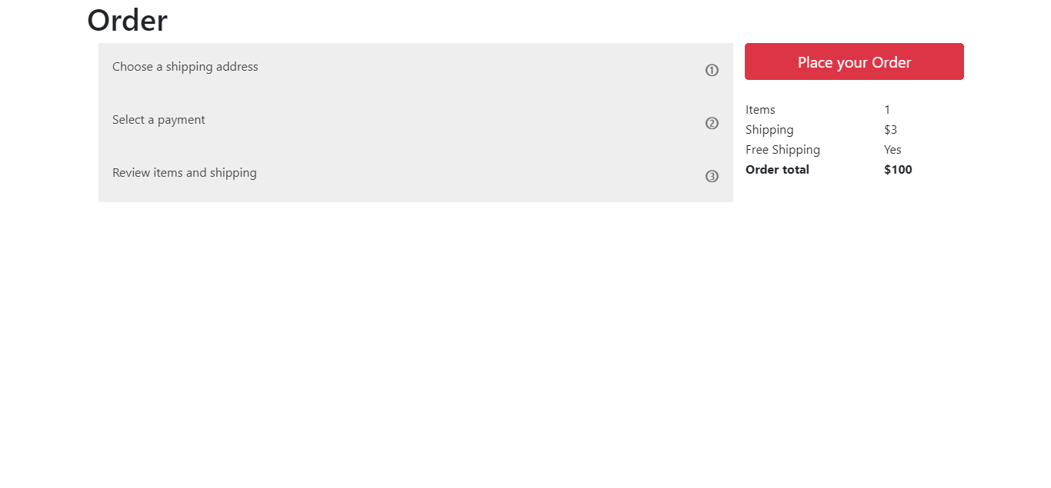

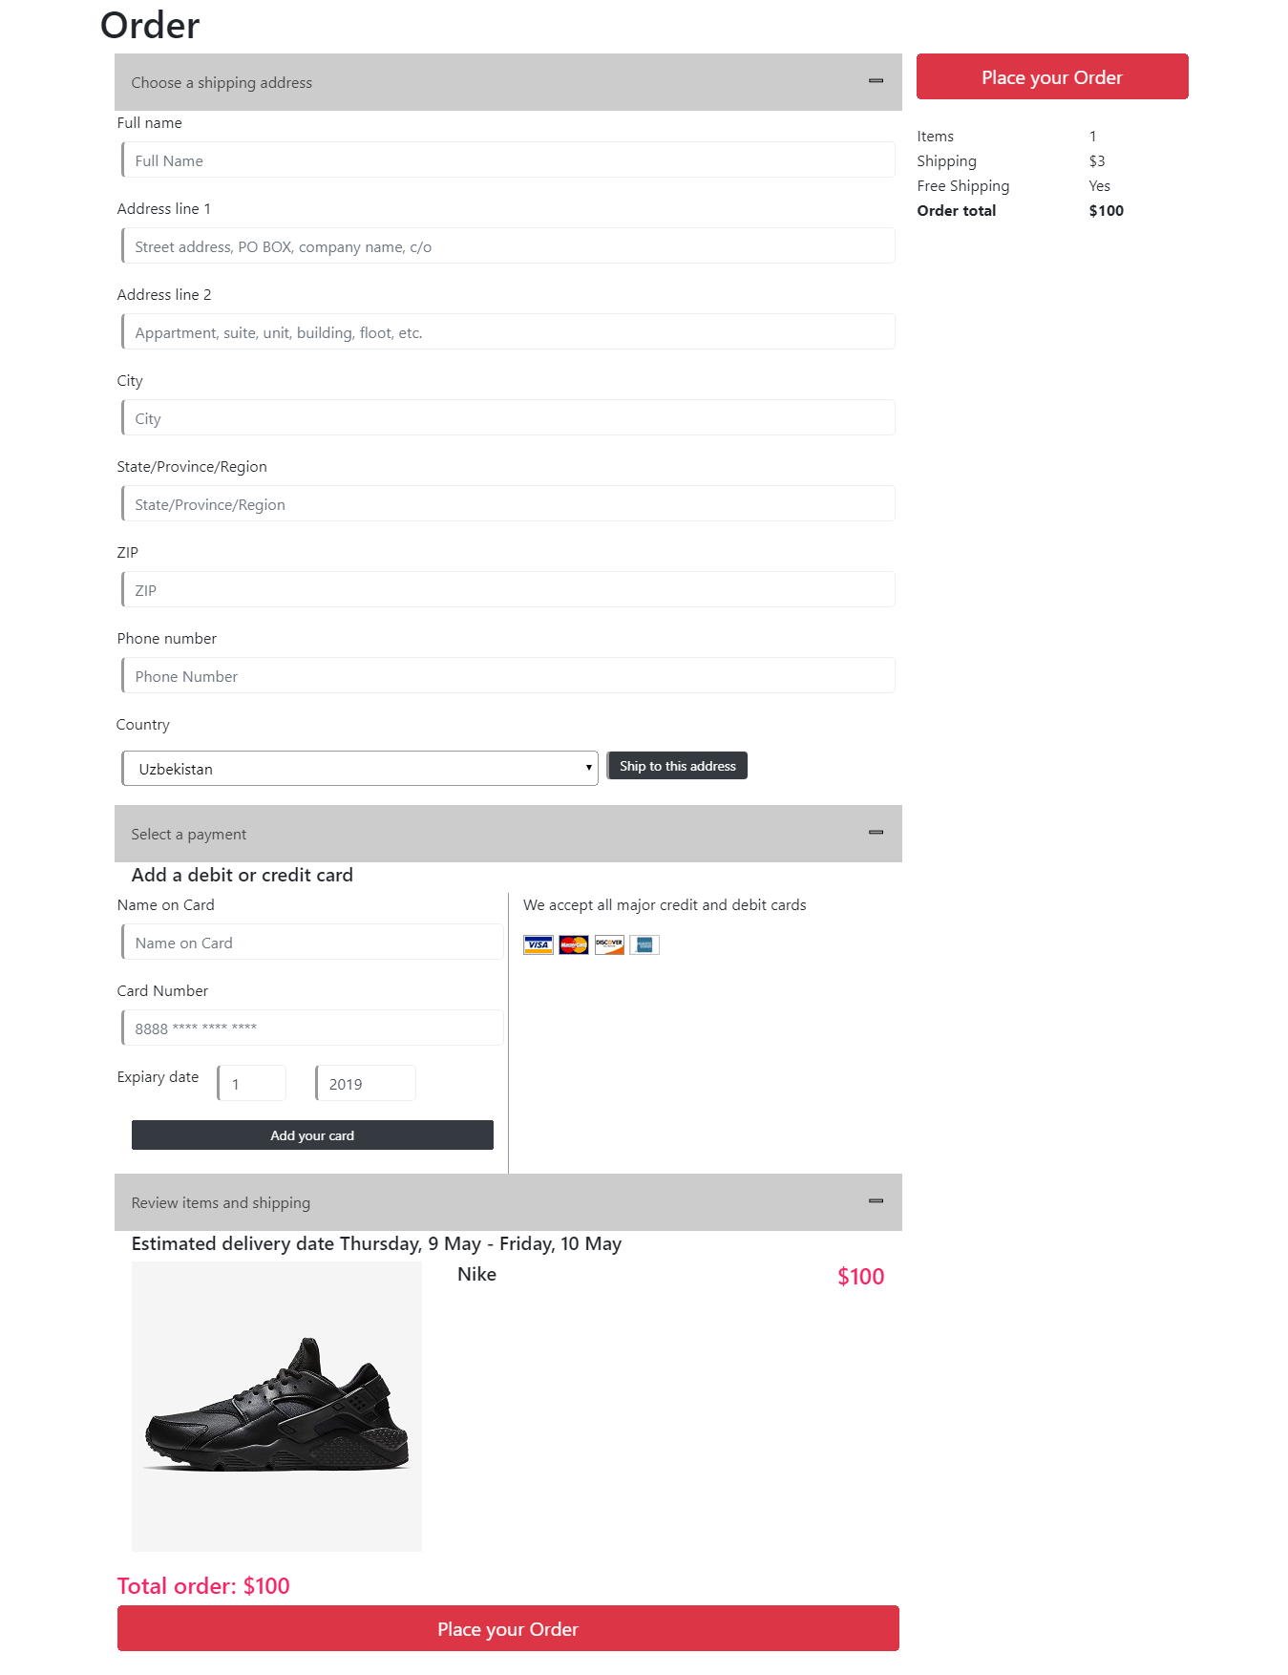

* **Contact Us Page:**

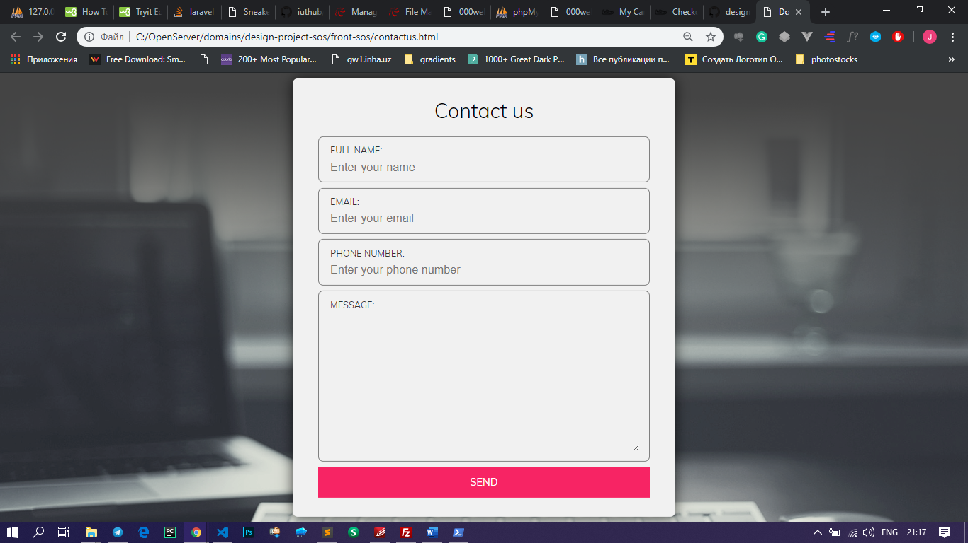

**Contribution:**

* Tulkunov Akobirkhuja (U1710314) – back-end (Laravel, db, functionality)
* Abed Abdulaziz (U1810001) – front-end (Cart, Order pages), report
* Rakhumbaev Sarvar (U1810077) – front-end (landing, quickview)
* Shoakbar Agzamov (U1810144) – project UI