Unique Registration Platform (URP)

“*Solve you event problems with us*”

**Team members:**

Abdulkodir Yusupov (back-end) U1710281

Ahmad Sanakulov (front-end) U1710240

Madina Akhmadjanova (report) U1710182

Mukhammadyor Juraev (front-end) U1710112

Link for Github repo: <https://github.com/iuthub/ip-group-project-urp>

Link for Hosting: <http://ip-urp.uz/>

When user visitis our website, they can see main page with its news and upcoming evets which can be intresting for others.



In the top right corner users can create or access to their accounts through the Log in or Sign in (Register) buttons.

In Register page new user should enter his/her name, e-mail address, password and confirmation of it. 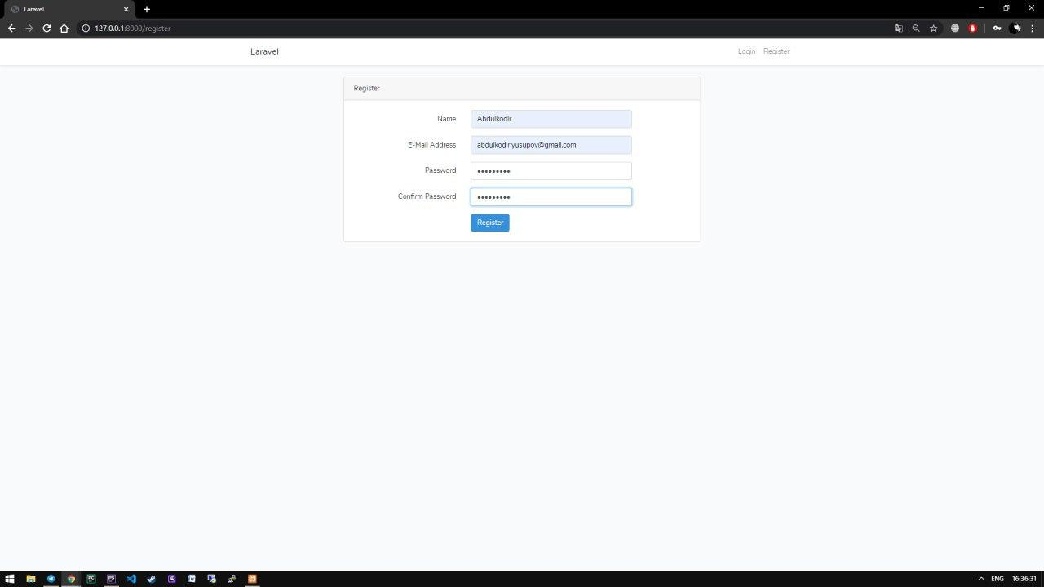

After Registration user automatically Log ins and goes to main page. If user already has an account he/she needs to Log in.

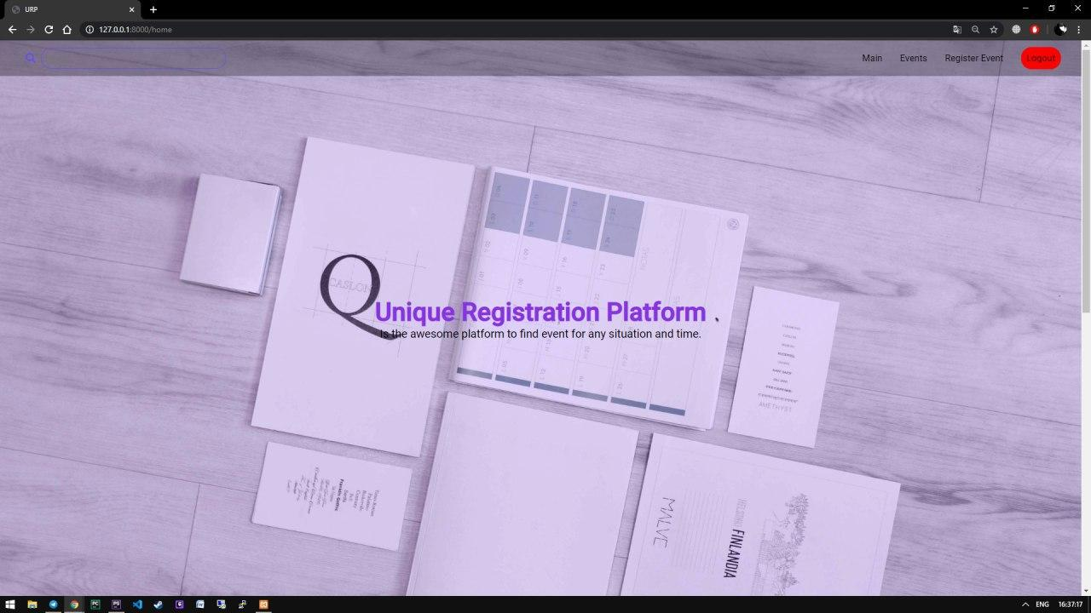

Figure 1Logged in

Изображение выглядит как снимок экрана

Описание создано с очень высокой степенью достоверности

Figure 2Log in

When user already in the system they can start registration of evet with the help of Register Event button which is located on the upper right side of our website. To create an event user, need to write required information which are name, organization name, day when even will held, place (address), requirements, description of event.

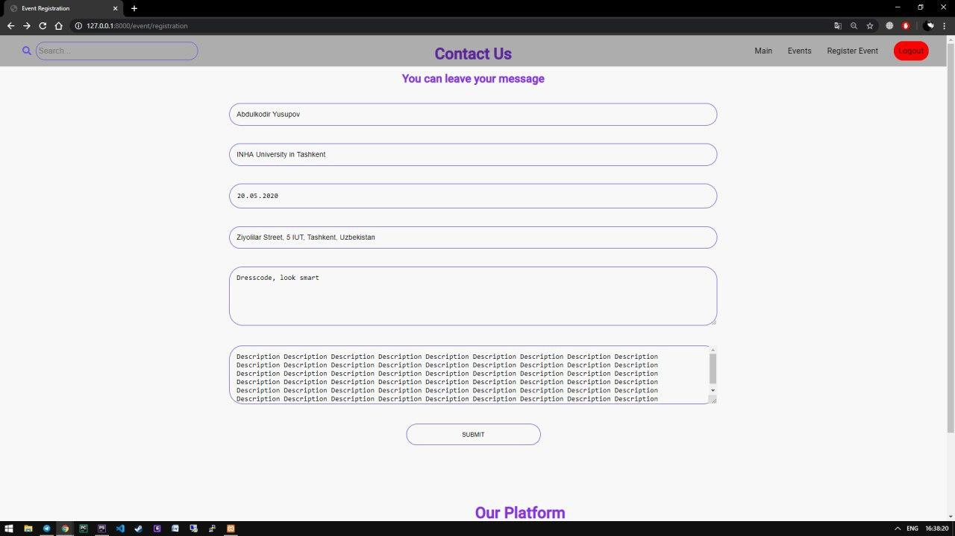

After filling all fields user submits and their event has been created. Created events pops up on the Popular events page.

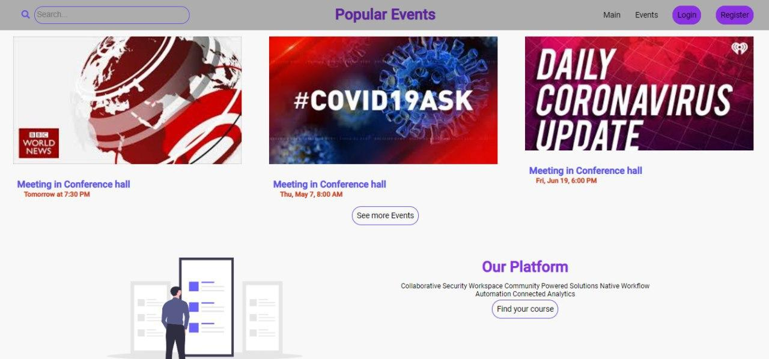

To look through all upcoming events user can click See More button and scroll until the end of the list.

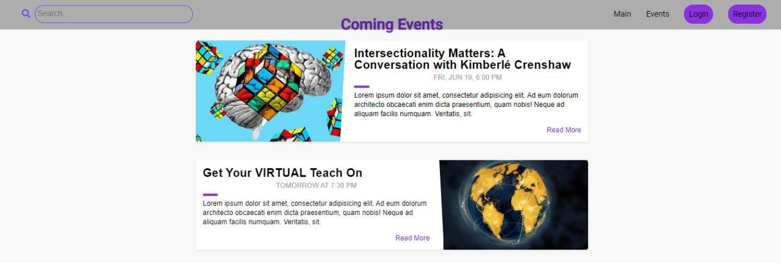

When user scrolls down till the end of the page in the bottom left corner there are three features events, about and contact us. As mentioned before user can look through of all events.



Figure 1 Events

About page is our main page.



Figure 2 About

In Contact us section user can send message with ideas, problems and feedbacks if they have. To send the message user needs to write name, e-mail address and the message, and press Submit button.

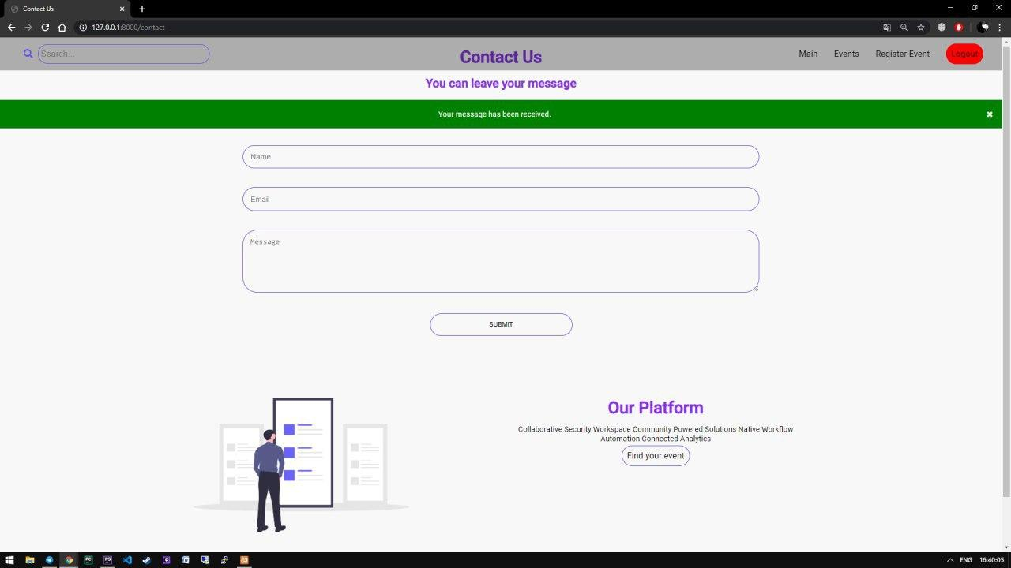

Figure 3Contact us