Online Store

Report

Team Members

U1810272 Raimov Alisher

U1810258 Abomuslimov Bobur

U1810205 Sultonov Umid

U1810252 Bekzod Askarov

U1810250 Azizov Muzaffar

U1810229 Erkinov Sardor

GitHub Repository: <https://github.com/iuthub/ip-group-project-whitehackers>

Website link:

The main purpose of the website is to provide a platform where users can buy and sell products.

Main objectives of the website:

1. Users must be able to view products
2. Buy products
3. Sell products
4. Website should have administrating panel
5. View products
   1. View a catalogue – show only some parts of a product: product name, price and add to cart button
      1. Search items
      2. View by category
      3. View products of a specific seller
   2. View a specific product
      1. Show all the details of the product: product name, description, price along with **Buy** and **Add** **to cart** buttons.
6. Buy product
   1. Buy a product directly
   2. Buy product after adding to a cart

Requirements:

1. User should be logged in
2. User should fill in the credit card details
3. Sell product
4. User must be authenticated
5. User should fill in the product adding form

4. Administrating panel (Optional)

1. Delete users
2. Delete products

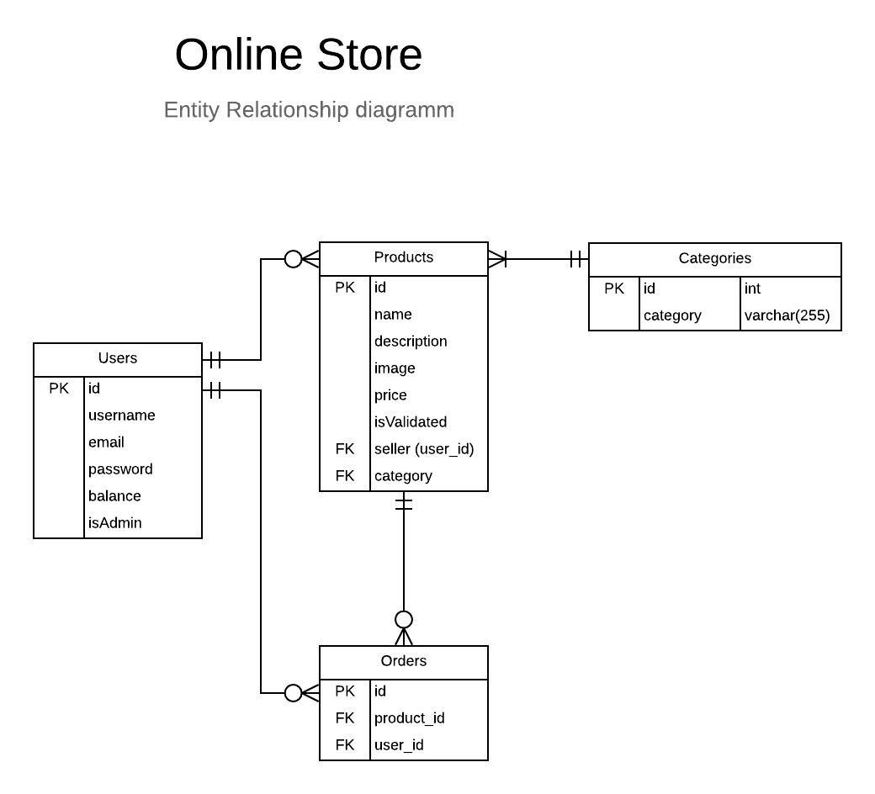

The entity relationship diagram above describes the database structure of our website. As you can see, we have four tables in the database: Users, Products, Categories and Orders. So once user signs up, the new record will be created in the user table and the **email, password and username** fields will be populated with entered data. The **isAdmin** flag in the table indicates if user has an admin rights, which is checked one user accessed the administrating panel.

Only authorized users are able to add products to the website. While the product adding is being proceeded, the seller and category fields will be populated with the id of user and id of category, respectively.

After user presses **Add to Cart** button, a new record will be created in the orders table, which will be linked to the products by **product_id** foreign key, which is the id of a product**.**

Use Case Diagram:

