**Dataset:Employee Earnings Report**

Each year, the City of Boston publishes payroll data for employees. This dataset contains employee names, department names, job details, and earnings information including base salary, overtime, and total earnings, etc.

**1. How have BPD paychecks changed year-over-year?**

To analyze how BPD paychecks have changed year-over-year, we use Employee Earnings Report Dataset from 2014 to 2024 and focused on the “Total Gross” pay for police department employees. After standardizing column names and cleaning the pay fields, we filtered the dataset to isolate BPD employees. We then calculated the average total gross income for BPD employees each year and compared it to non-BPD city employees. We visualized the year-over-year changes in average pay for both BPD and non-BPD employees using a line chart.

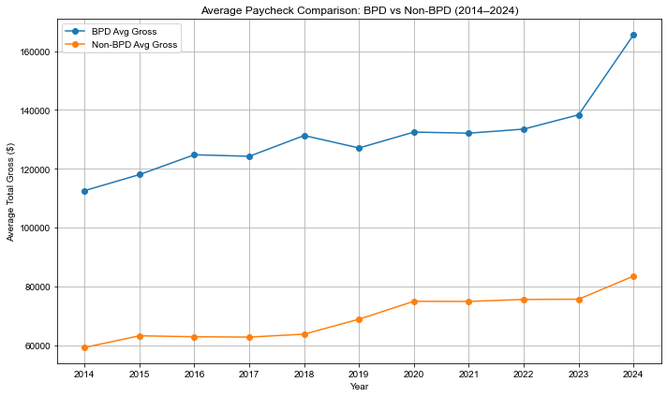

Observations: The results showed that the paycheck of both BPD and non-BPD employees have been increasing from 2014 to 2024. BPD paycheck have consistently been significantly higher than those of other city employees for around 60,000, with a notable increase in 2024. This suggests either an increase in base pay, overtime, or additional compensation categories such as injury or education incentives, which may warrant further investigation.

**2. How much BPD officer pay came from injury pay?**

To understand how much of BPD officer pay came from injury compensation, we analyzed the “Injured” pay column in relation to the total gross income from 2014 to 2024. After dropping records with missing injury pay data, we calculated the ratio of injury pay to total gross pay for each officer and examined how this ratio varied by year. We calculated the average injury pay ratio per year and plotted it as a bar chart to observe trends over time.

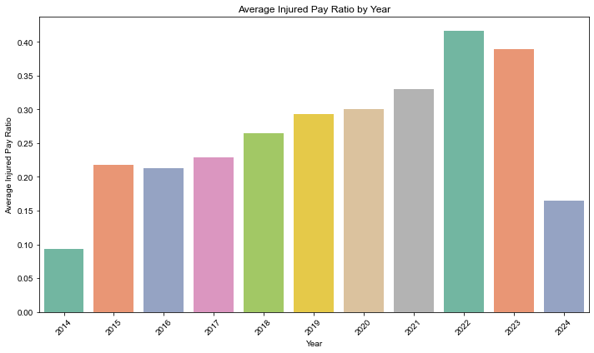

Observations: This chart illustrates the percentage of total gross pay that came from injury compensation for BPD officers from 2014 to 2024. In 2014, injury pay accounted for the lowest share of officer income for 9%. A significant increase followed in 2015 (21%), and from 2015 to 2021, the percentage rose steadily year over year, indicating a growing reliance on injury-related compensation. In 2022, there was a notable jump (41%), marking the peak of this trend. 2023 saw a slight decline (38%), and in 2024, the percentage dropped sharply (16%). The sharp decline in 2024 likely reflects a policy or enforcement shift aimed at reducing overuse or abuse of injury-related pay claims.

**3. What percentage of officers took injury pay in a given year?**

To determine what percentage of BPD officers received injury pay each year, we counted the number of officers who had a non-null injury pay value for each year, treating this as the number of officers who received injury compensation. And we calculate the proportion of injured officers by dividing the injury count by the total count. Then we visualized these percentages using a bar chart to highlight year-over-year trends in injury pay participation.

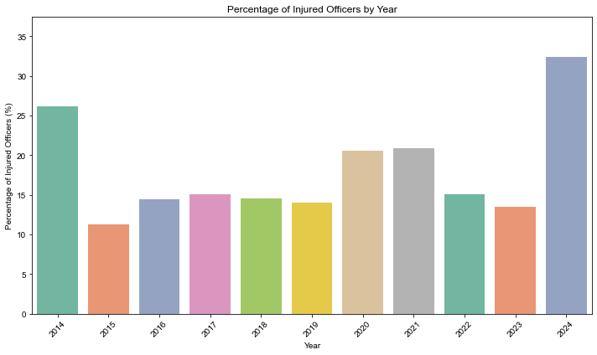

Observations: This chart shows the percentage of BPD officers who received injury pay each year. On average, around 17% of BPD officers received injury compensation annually. The data reveals significant spikes in the injury rate among Boston Police Department (BPD) officers in the years 2014, 2020, 2021, and 2024.

Possible reasons for the strikes are due to major social and operational events. In 2014, national protests following the deaths of Michael Brown and Eric Garner led to large-scale demonstrations in Boston. In 2020, the George Floyd protests triggered widespread unrest and confrontations with police. In 2021, a high-risk standoff in Dorchester resulted in officer injuries. Most recently, in 2024, pro-Palestinian demonstrations at Emerson College escalated, leading to over 100 arrests and several officer injuries. These findings suggest that surges in injury rates are closely tied to periods of civil unrest and intense policing demands.